Name: Bradley Willcott

ID: M198449

Date: 21 October 2021

Assessment Task (AT 2.5)

Jupiter Mining Corporation

Contents

Figures 2

Debugging 3

Testing 4

References 13

Tables

Table 1: Testing results 4

# Figures

Figure 1 – Showing value of String being passed to the WebView Engine 3

Figure 2 – Start-up GUI Application 4

Figure 3 – Display Help/About dialog - A 5

Figure 4 – Display About dialog - B 5

Figure 5 – Display About/Manual Help Window - A 6

Figure 6 - Display About/Manual Help Window - B 7

Figure 7 – Drag’N’Drop - A 8

Figure 8 - Drag’N’Drop - B 8

Figure 9 - Drag’N’Drop - C 9

Figure 10 – Drag’N’Drop - D 9

Figure 11 – Drag’N’Drop, back - A 10

Figure 12 – Drag’N’Drop, back - B 10

Figure 13 – Drag’N’Drop, back - C 11

Figure 14 – Drag’N’Drop, back - D 11

Figure 15 – File/Exit 12

# Debugging

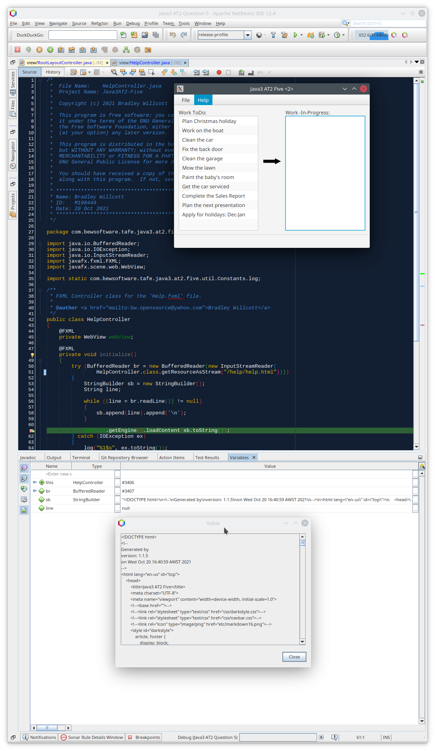

Figure – Showing value of String being passed to the WebView Engine

# Testing

Table 1: Testing results

|  |  |  |  |  |
| --- | --- | --- | --- | --- |
| Case | Description | Expected | Actual | Evidence |
| #1 | Start-up GUI Application | Initial application screen | As expected | Figure 2 |
| #2 | Display About dialog | Dialog displayed | As Expected | Figure 3  Figure 4 |
| #3 | Open Help window | Display About/Manual Help window | As expected | Figure 5  Figure 6 |
| #4 | Drag’N’Drop item from “Work ToDo” list to the “Work-In-Progress” list | Show progress of DND with visual cue from the arrow | As expected | Figure 7  Figure 8  Figure 9  Figure 10 |
| #5 | Drag’N’Drop item from “Work-In-Progress” list to the “Work ToDo” list | Show progress of DND with visual cue from the arrow | As expected | Figure 11  Figure 12  Figure 13  Figure 14 |
| #8 | Exit application | Program shutdown | As Expected | Figure 15 |

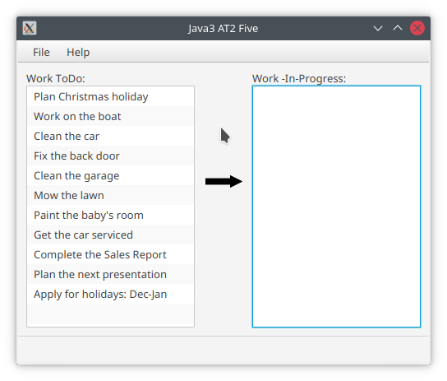

Figure – Start-up GUI Application

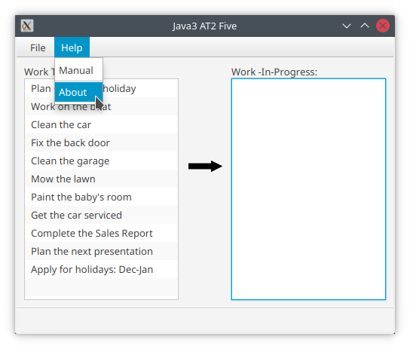

Figure – Display Help/About dialog - A

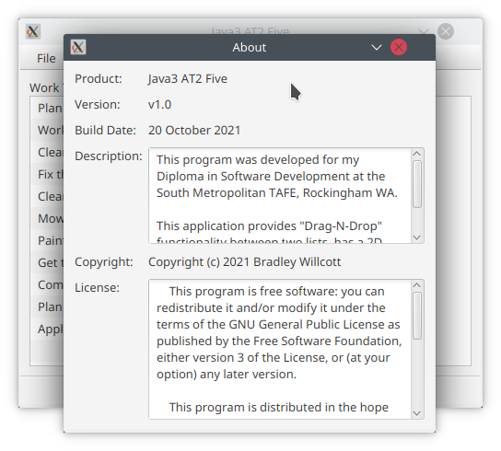

Figure 4 – Display About dialog - B

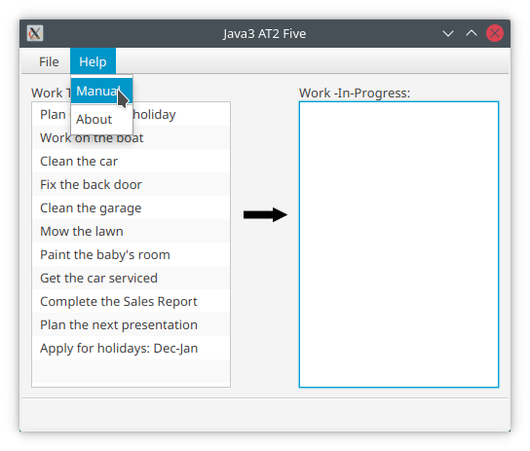

Figure 5 – Display About/Manual Help Window - A

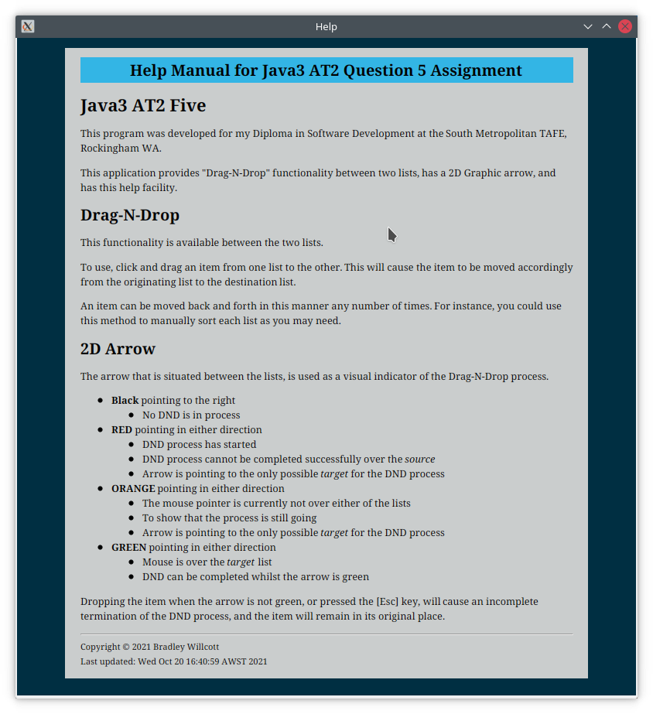

Figure 6 - Display About/Manual Help Window - B

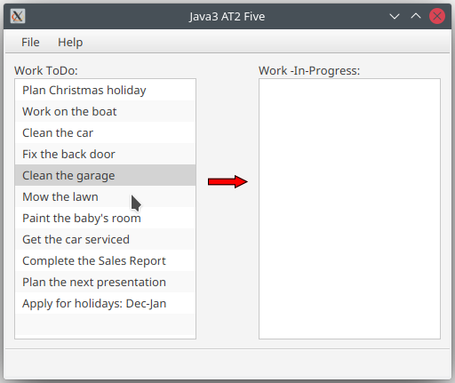

Figure 7 – Drag’N’Drop - A

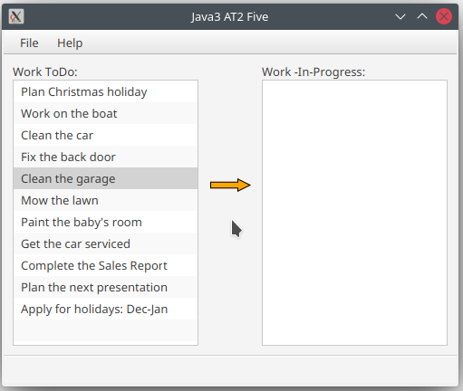

Figure 8 - Drag’N’Drop - B

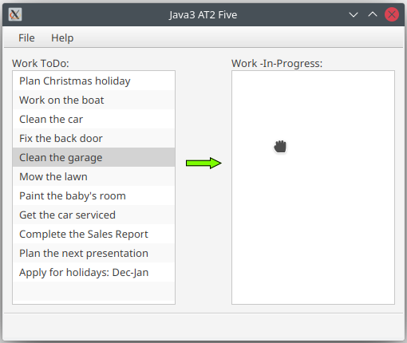

Figure 9 - Drag’N’Drop - C

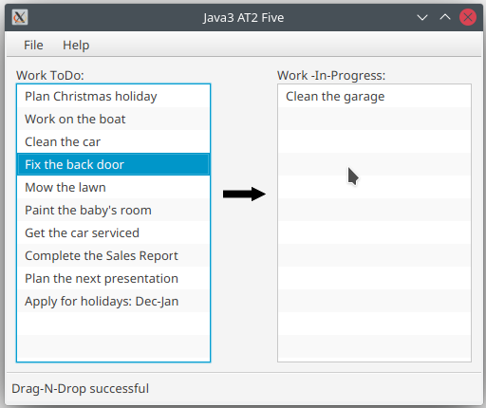

Figure 10 – Drag’N’Drop - D

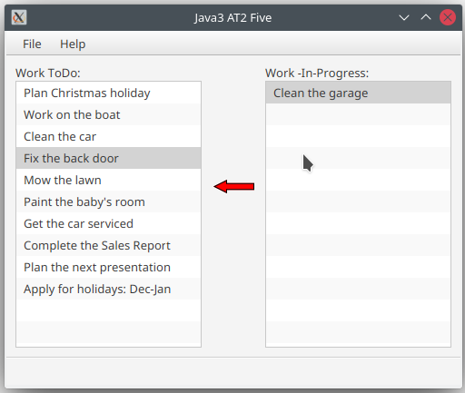

Figure 11 – Drag’N’Drop, back - A

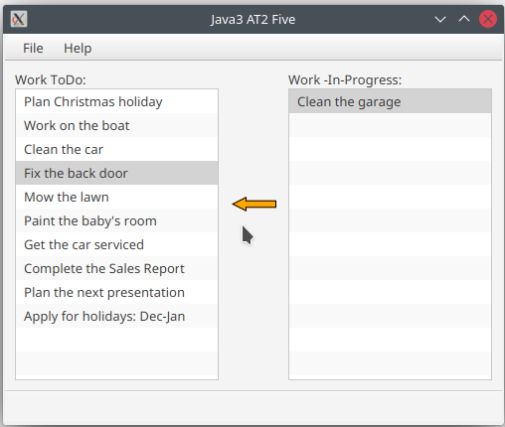

Figure – Drag’N’Drop, back - B

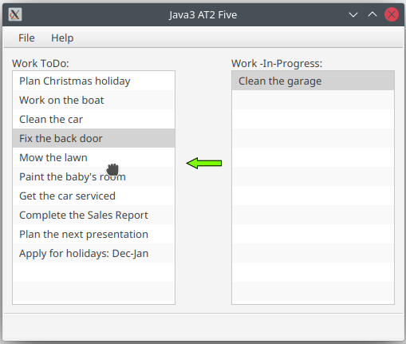

Figure – Drag’N’Drop, back - C

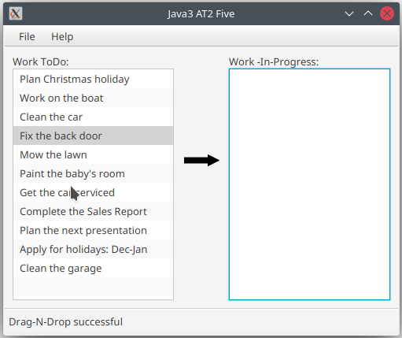

Figure – Drag’N’Drop, back - D

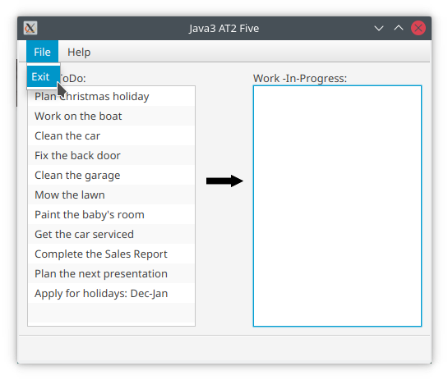

Figure – File/Exit

# References