*Prog3 AT2 Five*

Product Design Specification

Version *1.0*

*21/10/2021*

Name: Bradley Willcott

ID: M198449

Date: 21 October 2021

VERSION HISTORY

|  |  |  |  |  |  |
| --- | --- | --- | --- | --- | --- |
| **Version #** | **Implemented**  **By** | **Revision**  **Date** | **Approved**  **By** | **Approval**  **Date** | **Reason** |
| 1.0 | *Bradley Willcott* | *21/10/2021* | *<name>* | *<mm/dd/yy>* | Initial Design Definition draft |
|  |  |  |  |  |  |
|  |  |  |  |  |  |

**UP Template Version:** 12/31/07

TABLE OF CONTENTS

1 Introduction 4

1.1 Purpose of The Product Design Specification Document 4

2 General Overview and Design Guidelines/Approach 4

2.1 Assumptions / Constraints / Standards 4

3 Architecture Design 5

3.1 Logical View 5

3.2 Hardware Architecture 9

3.3 Software Architecture 9

4 System Design 10

4.1 Use-Cases 10

4.2 User Interface Design 10

4.3 Coding Compliance 10

Figures

Figure 1 - Overall Specification UML 5

Figure 2 - Common Library Specification UML 6

Figure 3 - GUI Client Specification UML 7

Figure 4 - RMI Server Specification UML 8

Figure 5 - Socket Server Specification UML 8

# Introduction

## Purpose of The Product Design Specification Document

The Product Design Specification document documents and tracks the necessary information required to effectively define architecture and system design in order to give the development team guidance on architecture of the system to be developed. The Product Design Specification document is created during the Planning Phase of the project. Its intended audience is the project manager, project team, and development team. Some portions of this document such as the user interface (UI) may on occasion be shared with the client/user, and other stakeholder whose input/approval into the UI is needed.

# General Overview and Design Guidelines/Approach

This section describes the principles and strategies to be used as guidelines when designing and implementing the system.

## Assumptions / Constraints / Standards

The program will provide the user with two lists: To-Do list and a Work-In-Progress list.

The users will be able to drag and drop items from one list onto the other, and if desired, back again.

A 2D graphic arrows will provide visual status cues as to the current progress of each drag and drop process.

There will be a Help facility, via a menu selection.

# Architecture Design

This section outlines the system and hardware architecture design of the system that is being built.

## Logical View

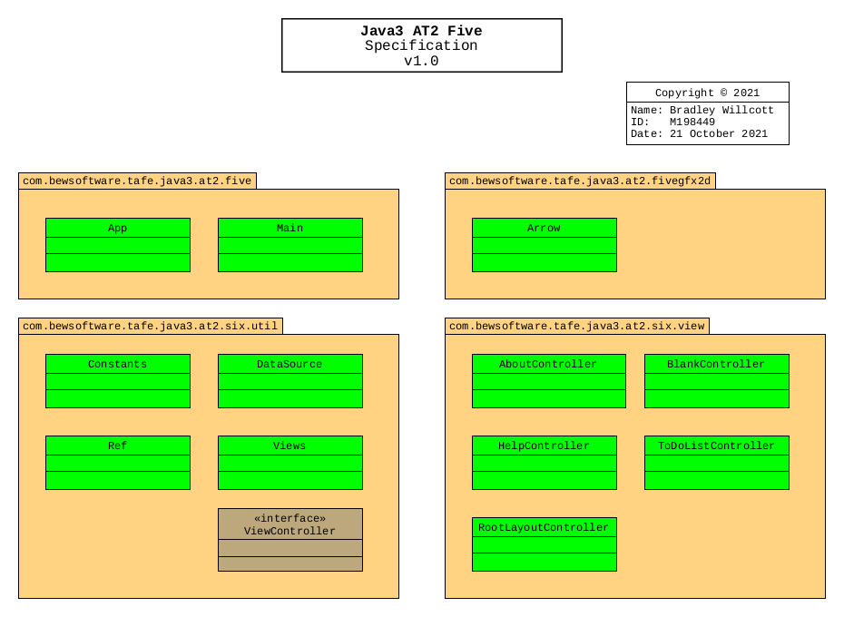

Figure - Overall Specification UML

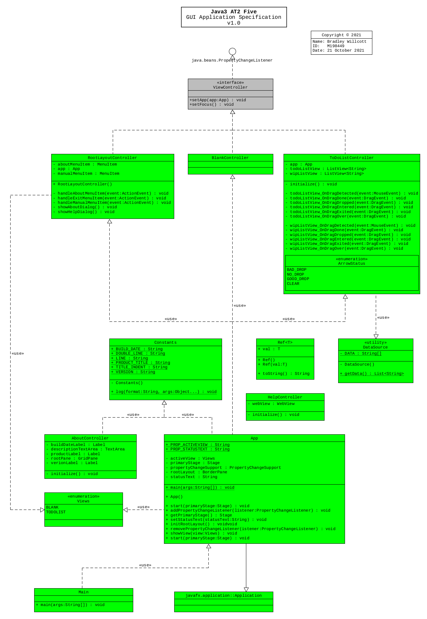

Figure - GUI Application Specification UML

## Hardware Architecture

The design only needs to allow for the program to be run on any Microsoft Windows 10 compatible desktop or portable hardware, be it Intel or AMD processor based.

## Software Architecture

The language to be used, need only be compatible with the Microsoft Windows 10 operating system.

Further, a source control system will be implemented to allow for version control of the project files. It is recommended that the GitHub site, which uses the git version control system and software, be used to provide this facility. It will be necessary that each team member obtain his/her own GitHub membership.

# System Design

## Use-Cases

JMC requires the implementation of a program that can provide drag and drop functionality between to lists of items. A help facility a 2D graphics are also required.

## User Interface Design

A Graphical User Interface is to be provided to allow the user to view to Lists with the ability to drag and drop items from one to the other, and back again.

There is to be a 2D graphic arrow that is to provide visual cues about the status of each drag and drop sequence.

Further, there is to be a help facility to display a help page.

## Coding Compliance

The following standards must be adhered to for software coding:

<https://docs.microsoft.com/en-us/dotnet/csharp/fundamentals/coding-style/coding-conventions>