*Prog3 AT2 Four*

Product Design Specification

Version *1.0*

*12/10/2021*

Name: Bradley Willcott

ID: M198449

Date: 12 October 2021

VERSION HISTORY

|  |  |  |  |  |  |
| --- | --- | --- | --- | --- | --- |
| **Version #** | **Implemented**  **By** | **Revision**  **Date** | **Approved**  **By** | **Approval**  **Date** | **Reason** |
| 1.0 | *Bradley Willcott* | *12/10/2021* | *<name>* | *<mm/dd/yy>* | Initial Design Definition draft |
|  |  |  |  |  |  |
|  |  |  |  |  |  |

**UP Template Version:** 12/31/07

TABLE OF CONTENTS

1 Introduction 4

1.1 Purpose of The Product Design Specification Document 4

2 General Overview and Design Guidelines/Approach 4

2.1 Assumptions / Constraints / Standards 4

3 Architecture Design 5

3.1 Logical View 5

3.2 Hardware Architecture 9

3.3 Software Architecture 9

4 System Design 10

4.1 Use-Cases 10

4.2 User Interface Design 10

4.3 Coding Compliance 10

Figures

Figure 1 - Overall Specification UML 5

Figure 2 - Common Library Specification UML 6

Figure 3 - GUI Client Specification UML 7

Figure 4 - RMI Server Specification UML 8

Figure 5 - Socket Server Specification UML 8

# Introduction

## Purpose of The Product Design Specification Document

The Product Design Specification document documents and tracks the necessary information required to effectively define architecture and system design in order to give the development team guidance on architecture of the system to be developed. The Product Design Specification document is created during the Planning Phase of the project. Its intended audience is the project manager, project team, and development team. Some portions of this document such as the user interface (UI) may on occasion be shared with the client/user, and other stakeholder whose input/approval into the UI is needed.

# General Overview and Design Guidelines/Approach

This section describes the principles and strategies to be used as guidelines when designing and implementing the system.

## Assumptions / Constraints / Standards

The program will allow the user to create new account, login to an existing account, and run a chat session.

# Architecture Design

This section outlines the system and hardware architecture design of the system that is being built.

## Logical View

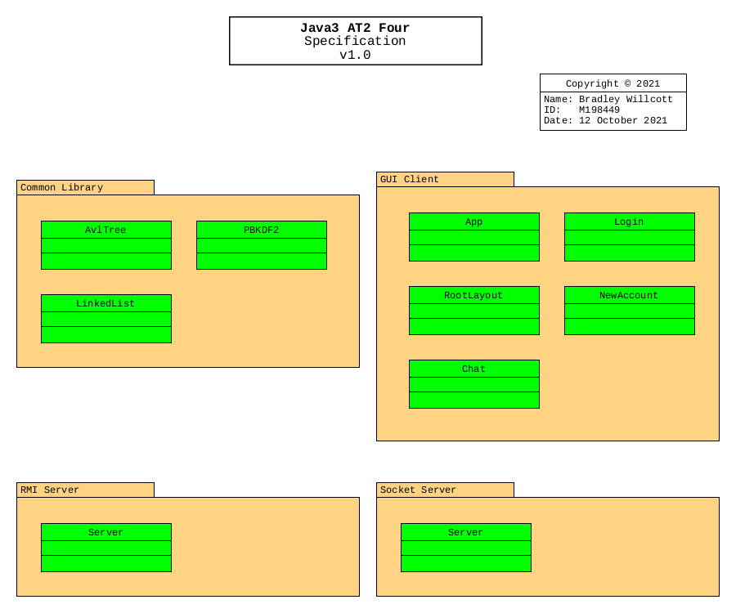

Figure - Overall Specification UML

Figure - Common Library Specification UML

Figure - GUI Client Specification UML

Figure - RMI Server Specification UML

Figure - Socket Server Specification UML

## Hardware Architecture

The design only needs to allow for the program to be run on any Microsoft Windows 10 compatible desktop or portable hardware, be it Intel or AMD processor based.

## Software Architecture

The language to be used, need only be compatible with the Microsoft Windows 10 operating system.

Further, a source control system will be implemented to allow for version control of the project files. It is recommended that the GitHub site, which uses the git version control system and software, be used to provide this facility. It will be necessary that each team member obtain his/her own GitHub membership.

# System Design

## Use-Cases

The project scenario is to make a list of different annual salaries for payroll in whole numbers (integers) that will need to be sorted. There should be multiple methods of sorting, so that the payroll staff can decide on which to use.

An application needs to be developed that creates lists of integer values between 10K and 10 million. The application must have the ability to sort in three different styles with timers to indicate the speed at which this happens. There must be at least 1 million items in the list as the future business strategy is to employ at least this many staff.

Only one sorting technique may be the in-built method (Array.Sort()), the rest must be written into the source code.

## User Interface Design

A Graphical User Interface is to be provided to allow the user to add, search and remove names from the list. Further, a console version is to be developed for testing purposes.

## Coding Compliance

The following standards must be adhered to for software coding:

<https://docs.microsoft.com/en-us/dotnet/csharp/fundamentals/coding-style/coding-conventions>