Name: Bradley Willcott

ID: M198449

Date: 18 October 2021

Assessment Task (AT 2.7)

Jupiter Mining Corporation

Contents

Figures 2

Debugging 3

Testing 5

References 14

Tables

Table 1: Testing results 5

# Figures

Figure 1 – SocketServer – FileEvent received 3

Figure 2 – SocketServer – File successfully written 4

Figure 3 – Start-up GUI Application 5

Figure 4 – Display About dialog - A 6

Figure 5 – Display About dialog - B 6

Figure 6 - Open a CSV file – File/Open 7

Figure 7 - Open a CSV file – File Open dialog 8

Figure 8 - Open a CSV file – Data in table 9

Figure 9 - Upload file – A 9

Figure 10 - Upload file – B 10

Figure 11 - Upload file - C - SocketServer 11

Figure 12 Upload file - D – download directory 12

Figure 13 - Exit application – File/Exit 13

# Debugging

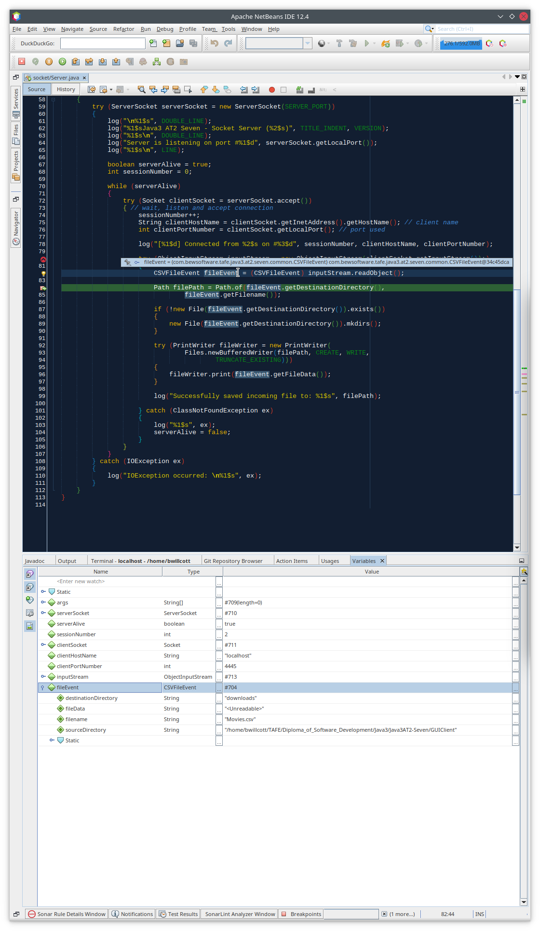

Figure – SocketServer – FileEvent received

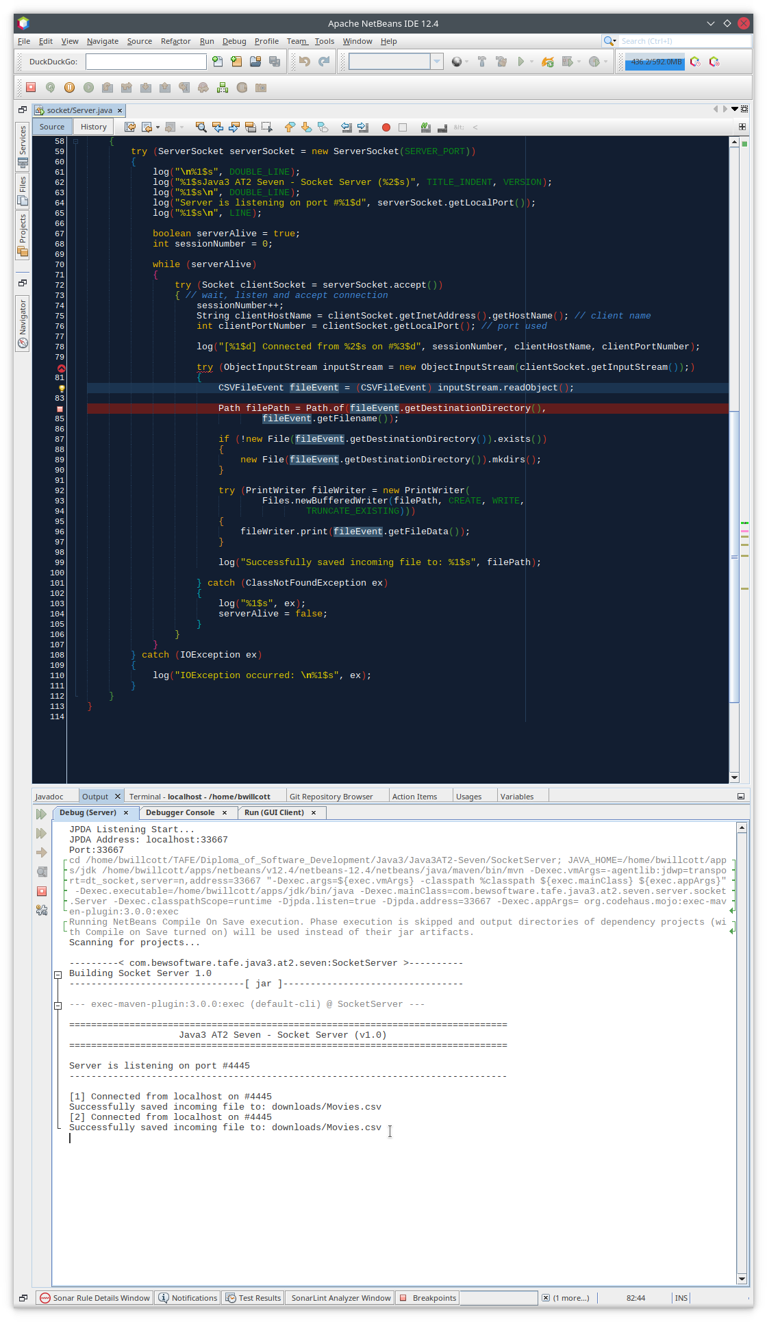

Figure – SocketServer – File successfully written

# Testing

Table 1: Testing results

|  |  |  |  |  |
| --- | --- | --- | --- | --- |
| Case | Description | Expected | Actual | Evidence |
| #1 | Start-up GUI Application | Initial application screen | As expected | Figure 3 |
| #2 | Display About dialog | Dialog displayed | As Expected | Figure 4  Figure 5 |
| #3 | Open a CSV file: “Movies.csv” | Display File Open dialog, then display selected file in a table | As expected | Figure 6  Figure 7  Figure 8 |
| #4 | Upload file to server | Status message:  “Upload Successful”  Console output from server and directory listing | As expected | Figure 9  Figure 10  Figure 11  Figure 12 |
| #5 | Exit application | Program shutdown | As Expected | Figure 13 |

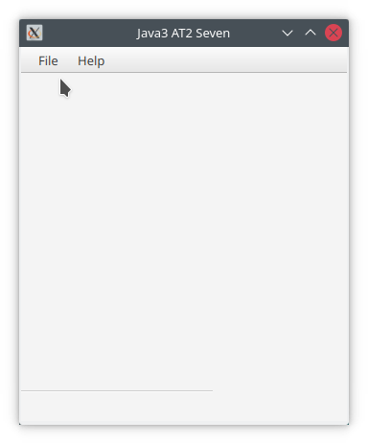

Figure – Start-up GUI Application

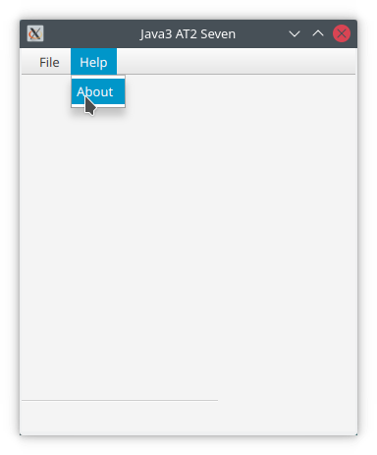

Figure – Display About dialog - A

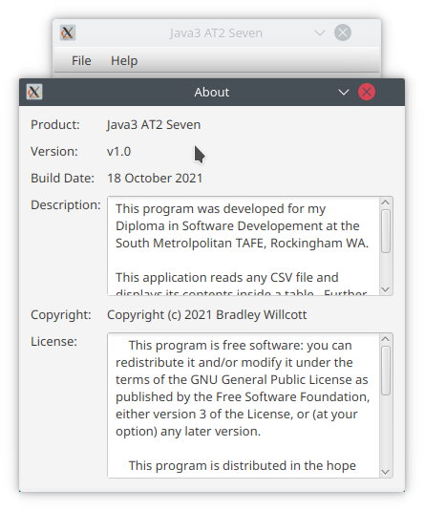

Figure 5 – Display About dialog - B

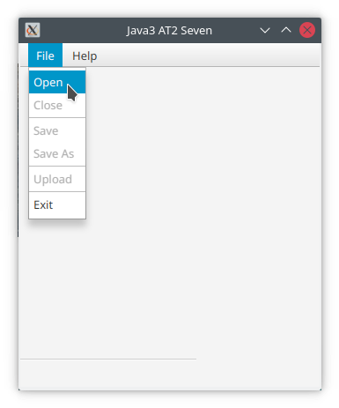

Figure 6 - Open a CSV file – File/Open

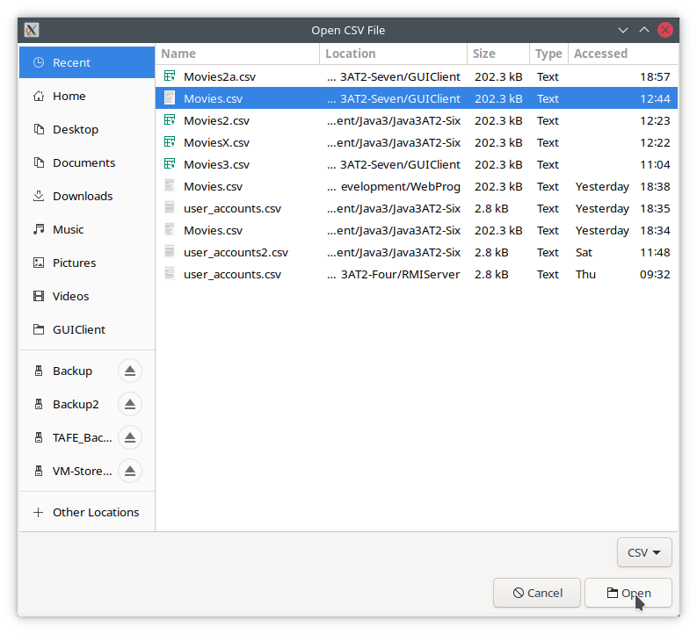

Figure 7 - Open a CSV file – File Open dialog

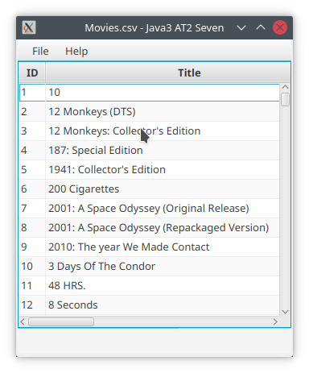

Figure 8 - Open a CSV file – Data in table

Figure - Upload file – A

Figure - Upload file – B

Figure - Upload file - C - SocketServer

Figure Upload file - D – download directory

Figure - Exit application – File/Exit

# References