*Prog3 AT2 Seven*

Product Design Specification

Version *1.0*

*18/10/2021*

Name: Bradley Willcott

ID: M198449

Date: 18 October 2021

VERSION HISTORY

|  |  |  |  |  |  |
| --- | --- | --- | --- | --- | --- |
| **Version #** | **Implemented**  **By** | **Revision**  **Date** | **Approved**  **By** | **Approval**  **Date** | **Reason** |
| 1.0 | *Bradley Willcott* | *18/10/2021* | *<name>* | *<mm/dd/yy>* | Initial Design Definition draft |
|  |  |  |  |  |  |
|  |  |  |  |  |  |

**UP Template Version:** 12/31/07

TABLE OF CONTENTS

1 Introduction 4

1.1 Purpose of The Product Design Specification Document 4

2 General Overview and Design Guidelines/Approach 4

2.1 Assumptions / Constraints / Standards 4

3 Architecture Design 5

3.1 Logical View 5

3.2 Hardware Architecture 8

3.3 Software Architecture 8

4 System Design 9

4.1 Use-Cases 9

4.2 User Interface Design 9

4.3 Coding Compliance 9

Figures

Figure 1 - Overall Specification UML 5

Figure 2 - GUI Application Specification UML 6

Figure 3 - Common Library 7

Figure 4 - Socket Server 8

# Introduction

## Purpose of The Product Design Specification Document

The Product Design Specification document documents and tracks the necessary information required to effectively define architecture and system design in order to give the development team guidance on architecture of the system to be developed. The Product Design Specification document is created during the Planning Phase of the project. Its intended audience is the project manager, project team, and development team. Some portions of this document such as the user interface (UI) may on occasion be shared with the client/user, and other stakeholder whose input/approval into the UI is needed.

# General Overview and Design Guidelines/Approach

This section describes the principles and strategies to be used as guidelines when designing and implementing the system.

## Assumptions / Constraints / Standards

The program will allow the user to load, edit, and save any standard format CSV file. In addition, it will allow the user to upload the currently loaded file, to a remote file on a server.

Minimum specification for compatible CSV files:

1. Delimiter is a comma: ','
2. Quote character is the double quote: '"'
3. First line is the column headings/field names

# Architecture Design

This section outlines the system and hardware architecture design of the system that is being built.

## Logical View

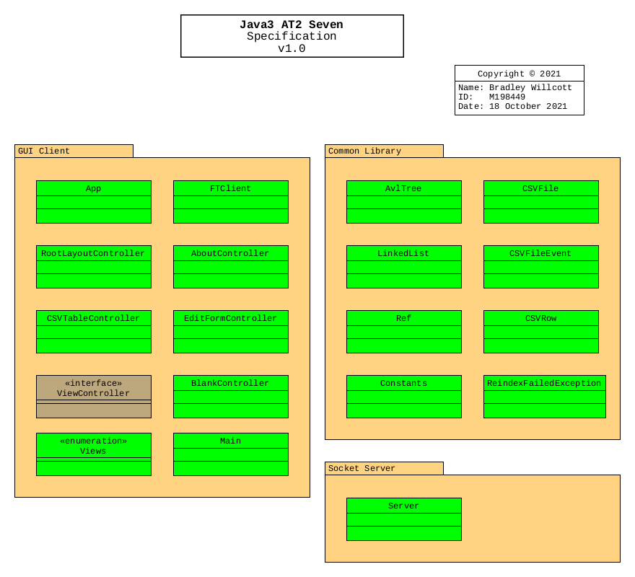

Figure - Overall Specification UML

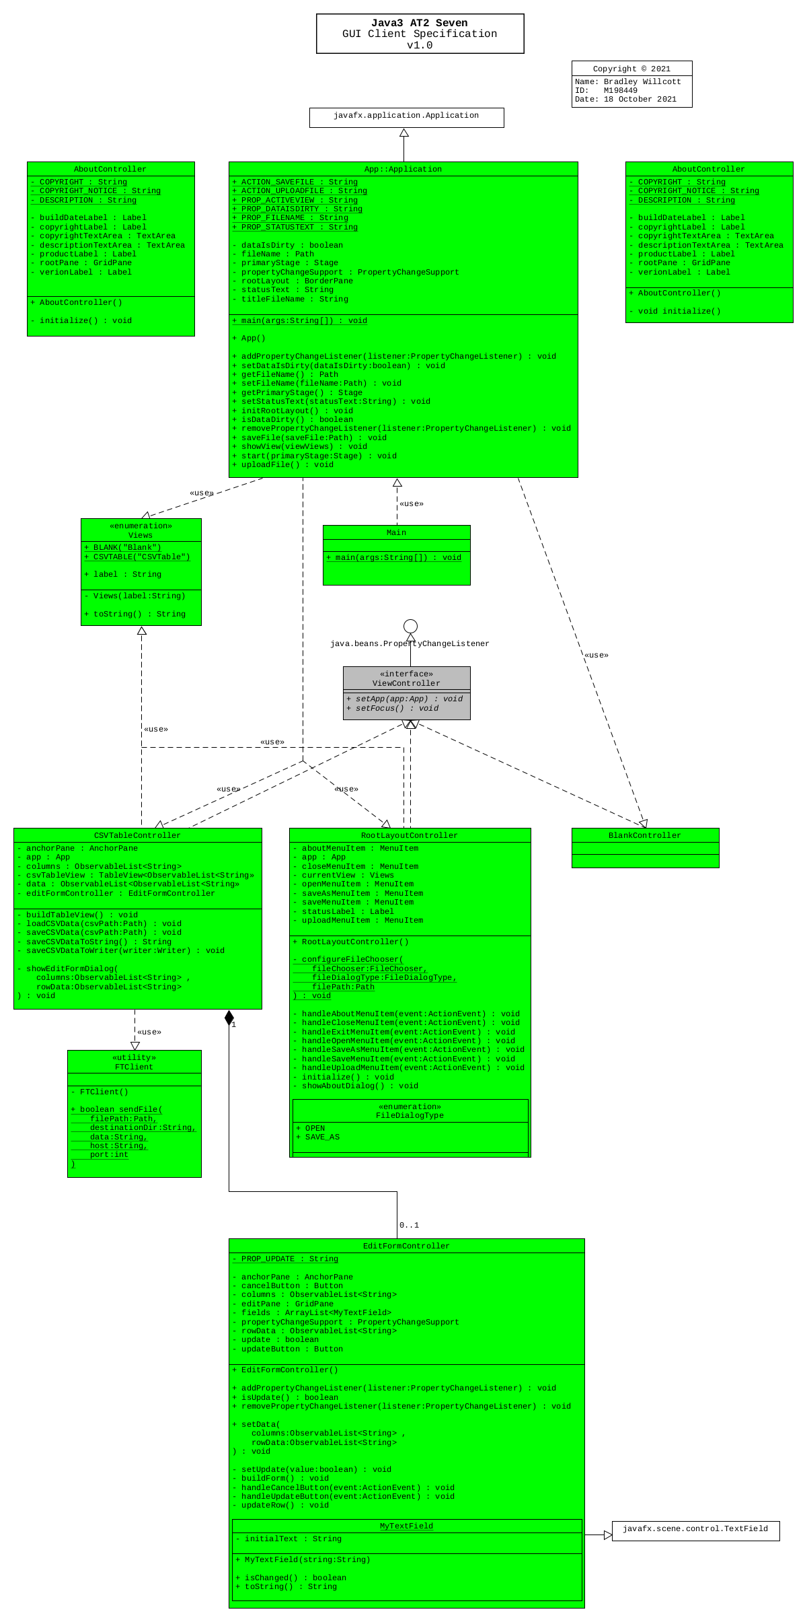

Figure - GUI Application Specification UML

Figure - Common Library

Figure - Socket Server

## Hardware Architecture

The design only needs to allow for the program to be run on any Microsoft Windows 10 compatible desktop or portable hardware, be it Intel or AMD processor based.

## Software Architecture

The language to be used, need only be compatible with the Microsoft Windows 10 operating system.

Further, a source control system will be implemented to allow for version control of the project files. It is recommended that the GitHub site, which uses the git version control system and software, be used to provide this facility. It will be necessary that each team member obtain his/her own GitHub membership.

# System Design

## Use-Cases

JMC needs a way to transfer data files (mainly CSV) using sockets in a client-server application.

## User Interface Design

A Graphical User Interface is to be provided to allow the user to open and display the contents of a CSV file. They will then be able to edit this data, and save it back to either the original file, or an alternative of their choice

Further, they will be able to upload the current file to the server, for ‘remote’ storage.

## Coding Compliance

The following standards must be adhered to for software coding:

<https://docs.microsoft.com/en-us/dotnet/csharp/fundamentals/coding-style/coding-conventions>