Name: Bradley Willcott

ID: M198449

Date: 4 October 2021

Assessment Task (AT 2.3)

Jupiter Mining Corporation

Contents

Figures 2

Debugging 3

Testing 4

References 11

Tables

Table 1: Testing results 4

# Figures

Figure 1 – Showing value of currently selected item 3

Figure 2 - Console program output 5

Figure 3 – Unit Test results – Sorting class 6

Figure 4 - Run GUI App 7

Figure 5 - Do Heap Sort - A 7

Figure 6 - Do Heap Sort - B 8

Figure 7 - Do Quick Sort - A 8

Figure 8 - Do Quick Sort - B 9

Figure 9 - Show Help/About - A 9

Figure 10 - Show Help/About - B 10

Figure 11 - Show File/Close 10

# Debugging

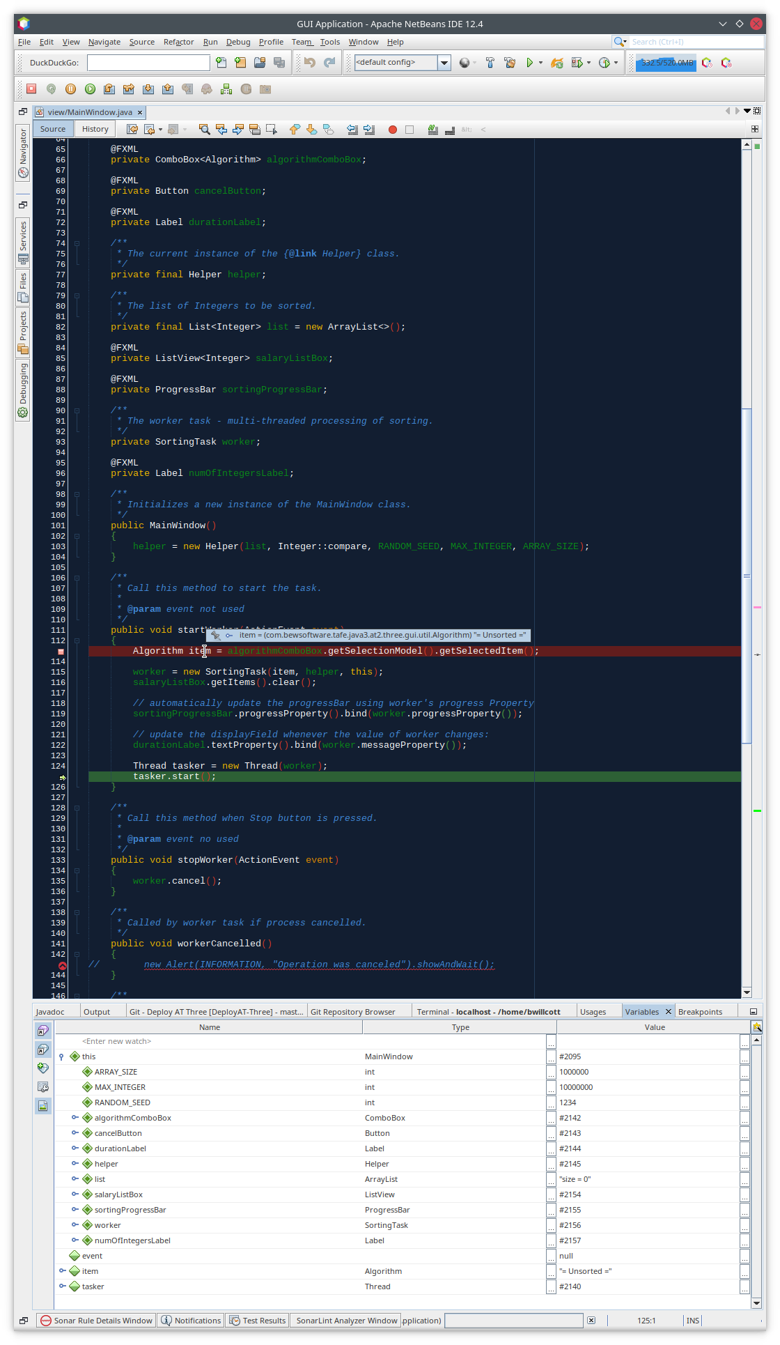

Figure 1 – Showing value of currently selected item

# Testing

Table : Testing results

|  |  |  |  |  |
| --- | --- | --- | --- | --- |
| Case | Description | Expected | Actual | Evidence |
| #1 | Run the console program | Display program output showing the results of the various sort algorithms | As expected | Figure 2 |
| #2 | Run Unit Test on Sorting class | Console output showing test results | As Expected | Figure 3 |
| #3 | Run GUI App | Application displays with Unsorted data | As expected | Figure 4 |
| #4 | Do Heap Sort | Show results | As expected | Figure 5  Figure 6 |
| #5 | Do Quick Sort | Show results | As expected | Figure 7  Figure 8 |
| #6 | Show Help/About | Display dialog | As expected | Figure 9  Figure 10 |
| #7 | Show File/Close | Show menu | As expected | Figure 11 |

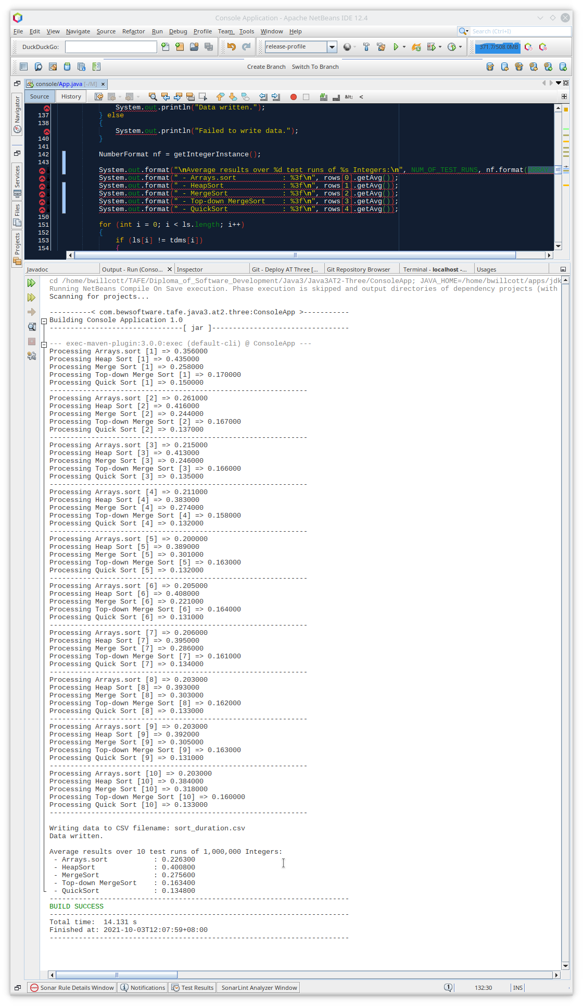

Figure 2 - Console program output

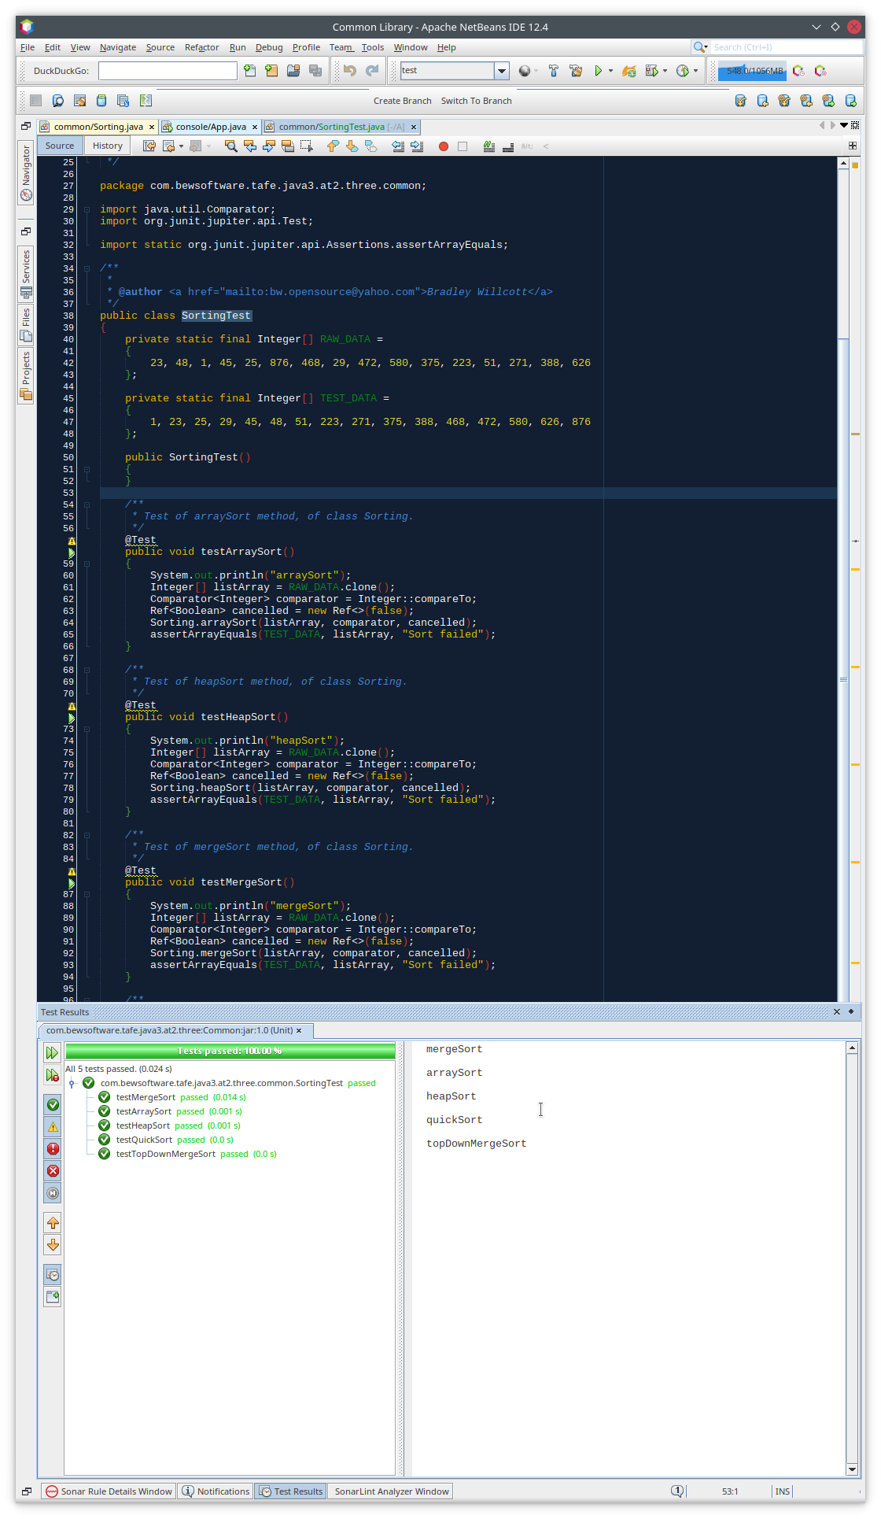

Figure 3 – Unit Test results – Sorting class

Figure - Run GUI App

Figure - Do Heap Sort - A

Figure - Do Heap Sort - B

Figure - Do Quick Sort - A

Figure - Do Quick Sort - B

Figure - Show Help/About - A

Figure - Show Help/About - B

Figure - Show File/Close

# References