Name: Bradley Willcott

ID: M198449

Date: 29 August 2021

Assessment Task (AT 2.2)

Jupiter Mining Corporation

Contents

Figures 2

Debugging 3

Testing 5

References 11

Tables

Table 1: Testing results 5

# Figures

Figure 1 – Showing method: totalValue() working - A 3

Figure 2 – Showing method: totalValue() working - B 4

Figure 3 - Console program output - A 6

Figure 4 – Console program output - B 7

Figure 5 – Console program output - C 8

Figure 6 – Search results 9

Figure 7 – Remove a part 9

Figure 8 - Add the part back in 9

Figure 9 – Try to add it again 9

Figure 10 – Testing totalValue() method 10

Figure 11 – Testing retailPrice() method 10

# Debugging

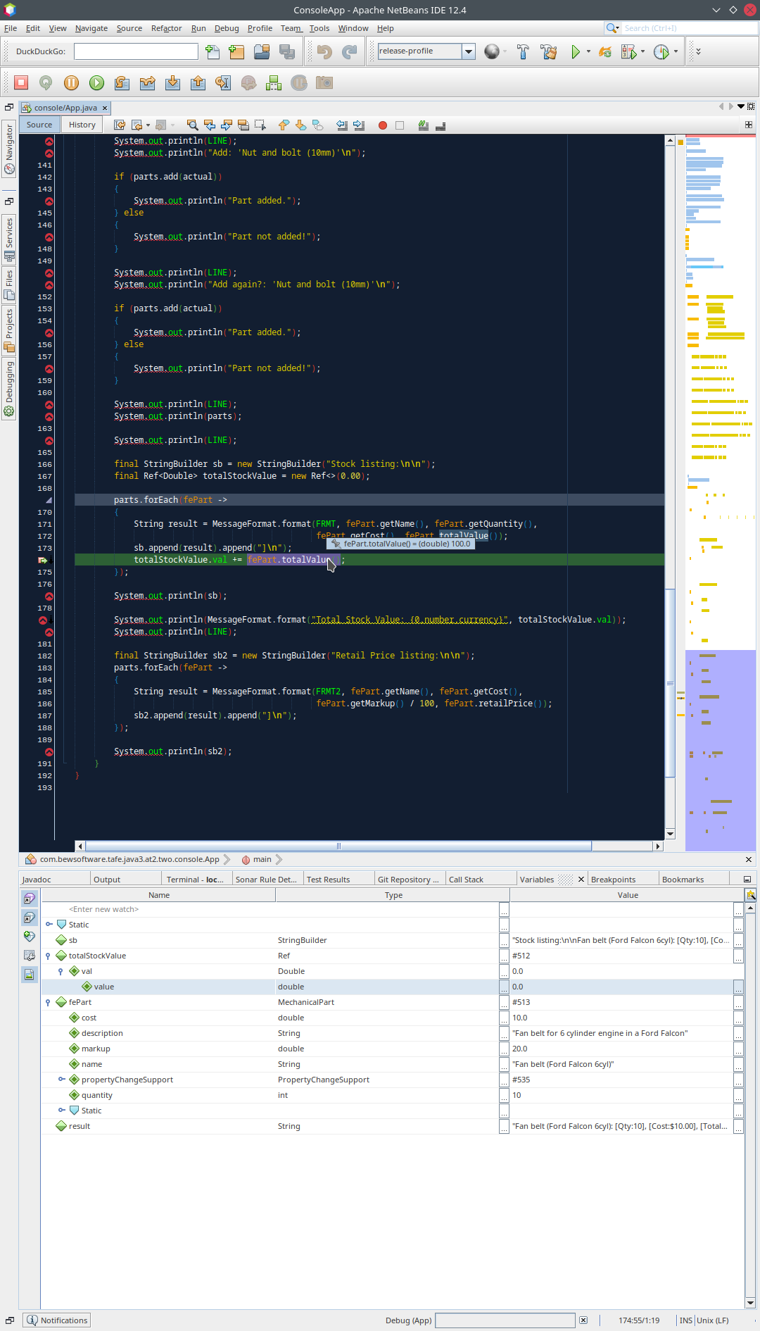

Figure 1 – Showing method: totalValue() working - A

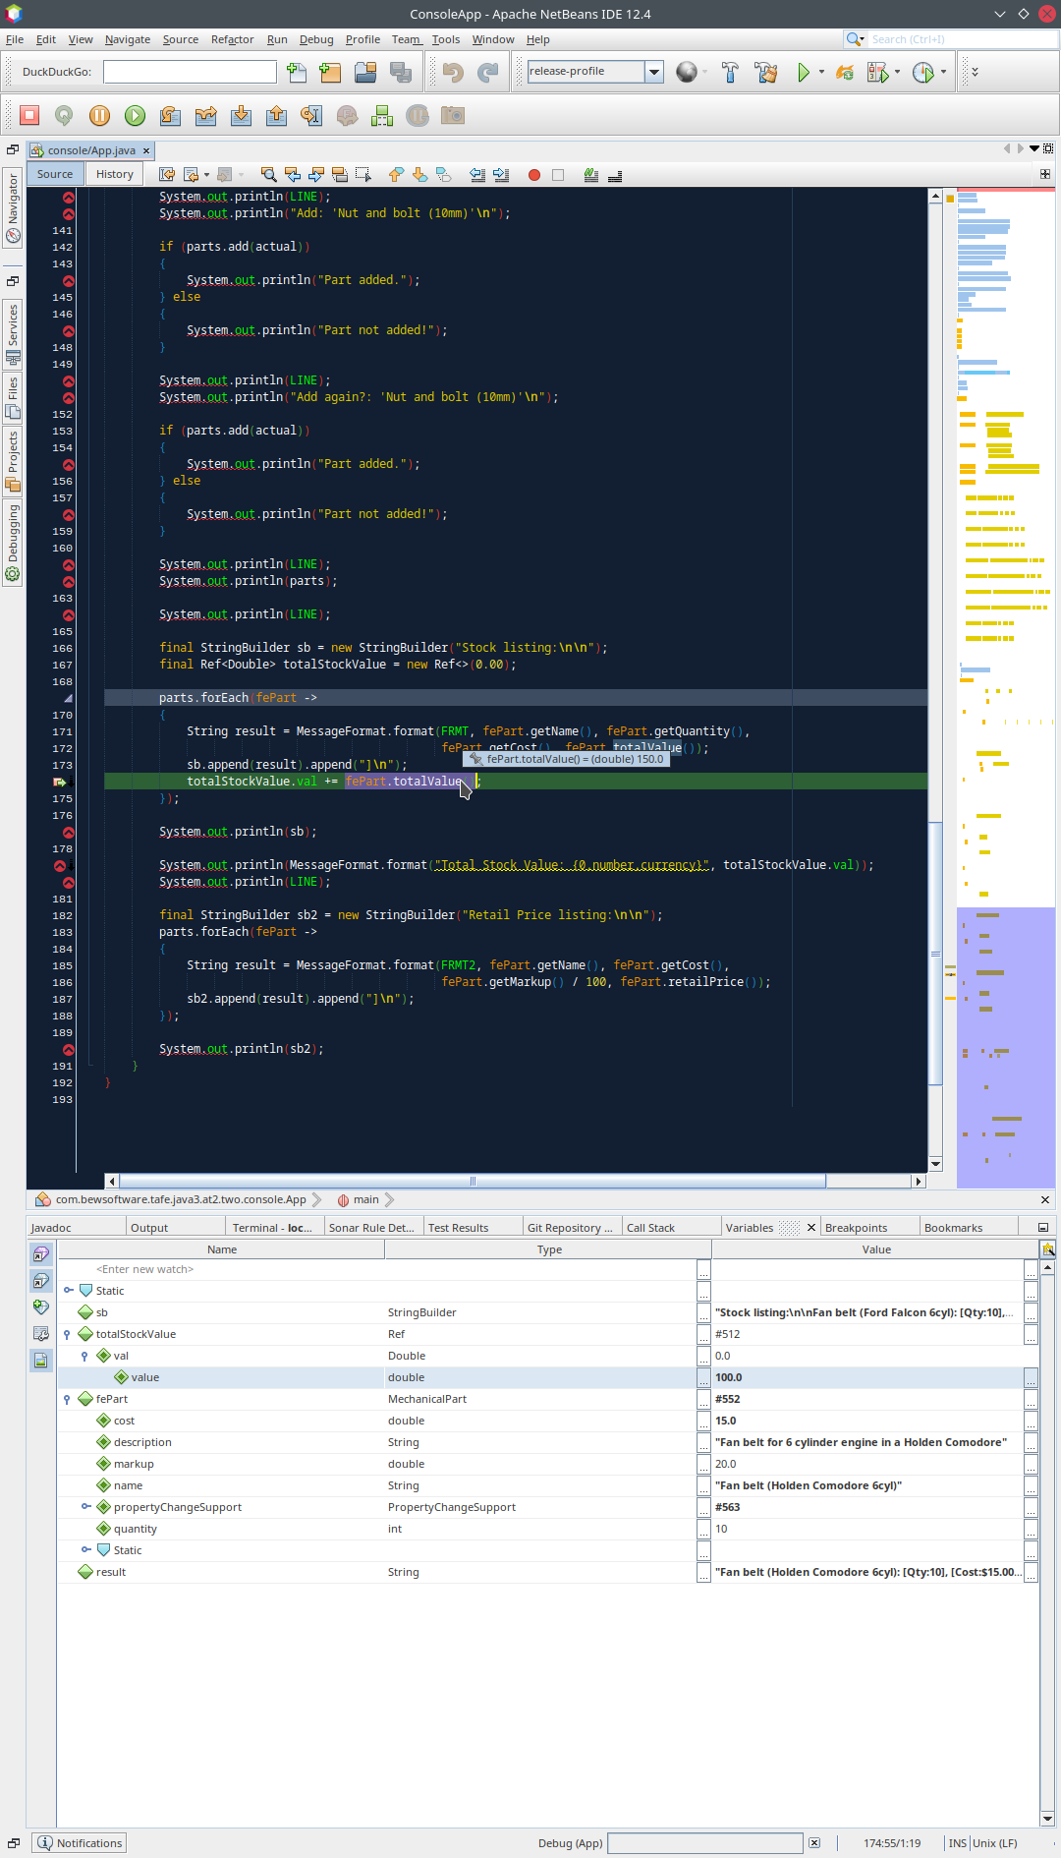

Figure 2 – Showing method: totalValue() working - B

# Testing

Table : Testing results

|  |  |  |  |  |
| --- | --- | --- | --- | --- |
| Case | Description | Expected | Actual | Evidence |
| #1 | Run the console program | Display program output showing the results of the various functions being tested | As expected | Figure 3  Figure 4  Figure 5 |
| #2 | Search for a part | Console output showing details of part | As Expected | Figure 6 |
| #3 | Remove a part | Console output showing results, including subsequent follow-up search for that part | As expected | Figure 7 |
| #4 | Add the part back in | Console output showing successful result | As expected | Figure 8 |
| #5 | Try to add it a second time | Console output showing an unsuccessful result | As expected | Figure 9 |
| #6 | Test the totalValue() method of the MechanicalPart class | Console output showing the results from all the items | As expected | Figure 10 |
| #7 | Test the retailPrice() method of the MechanicalPart class | Console output showing the results from all the items | As expected | Figure 11 |

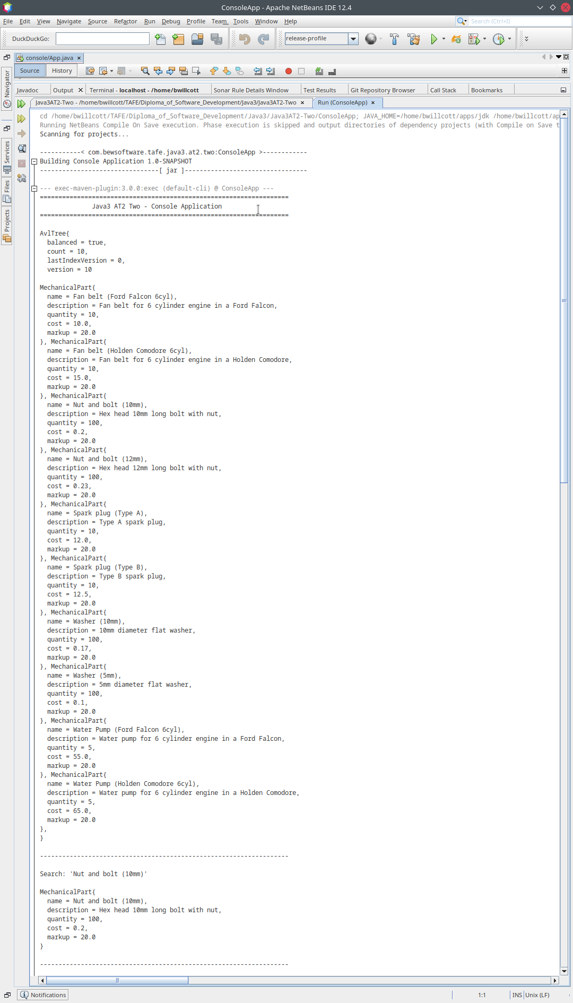

Figure 3 - Console program output - A

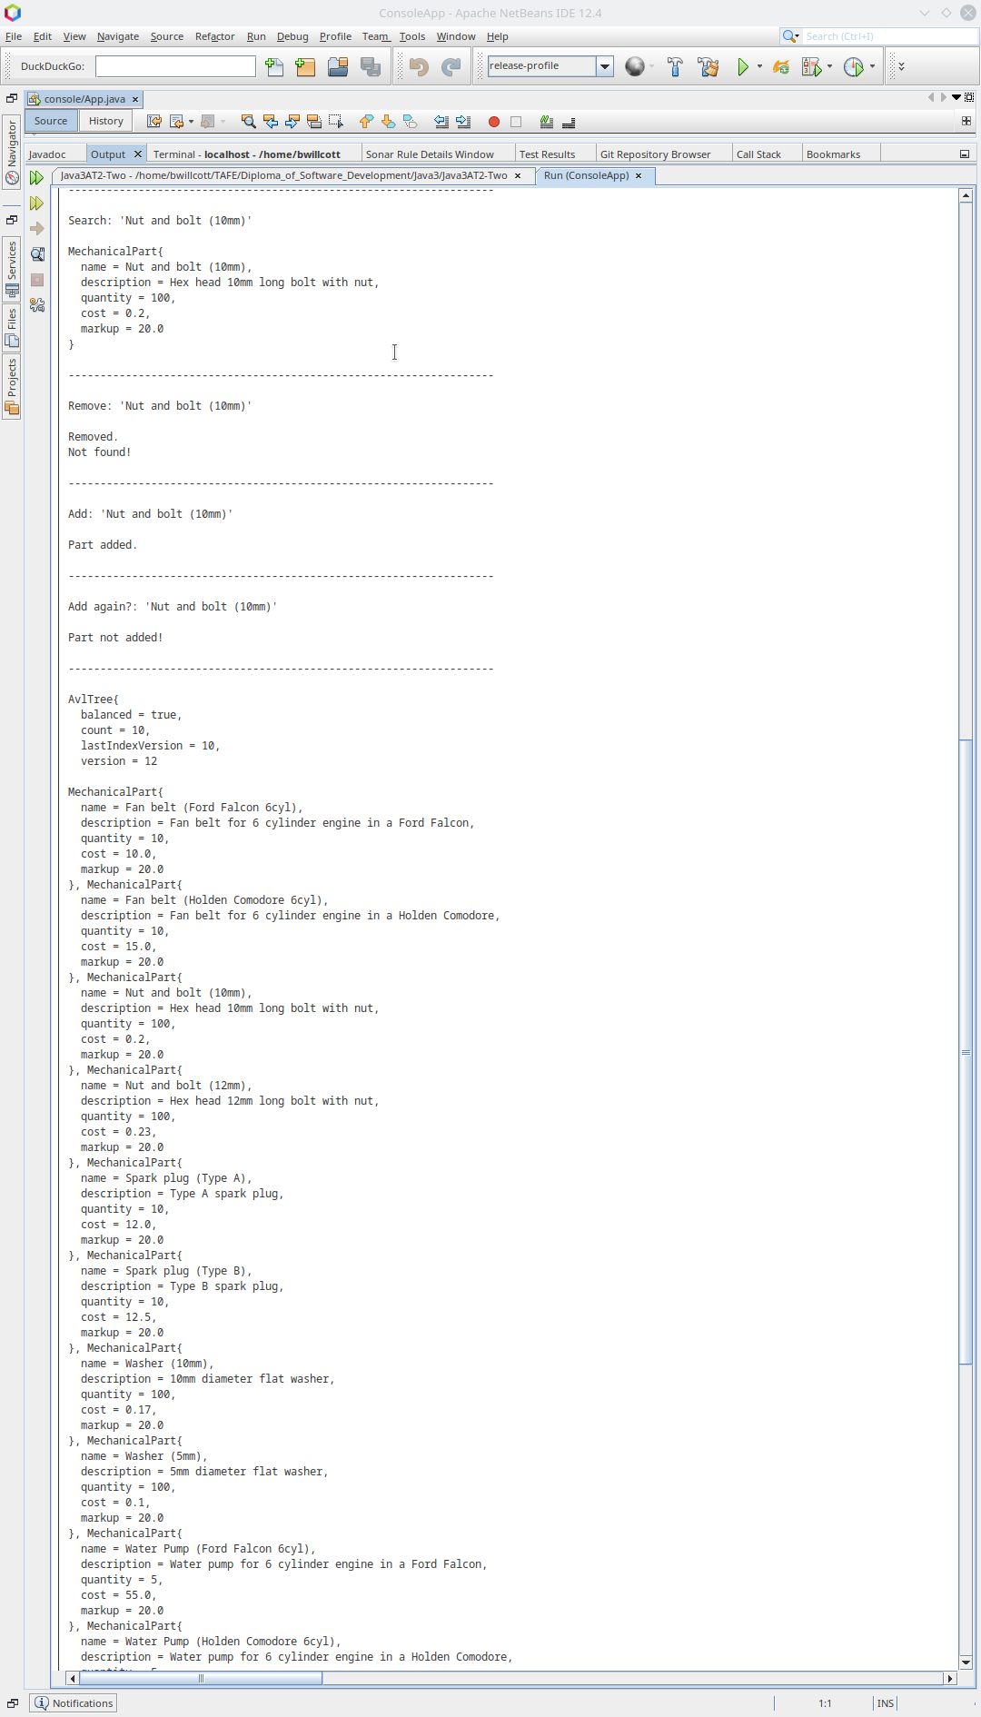

Figure 4 – Console program output - B

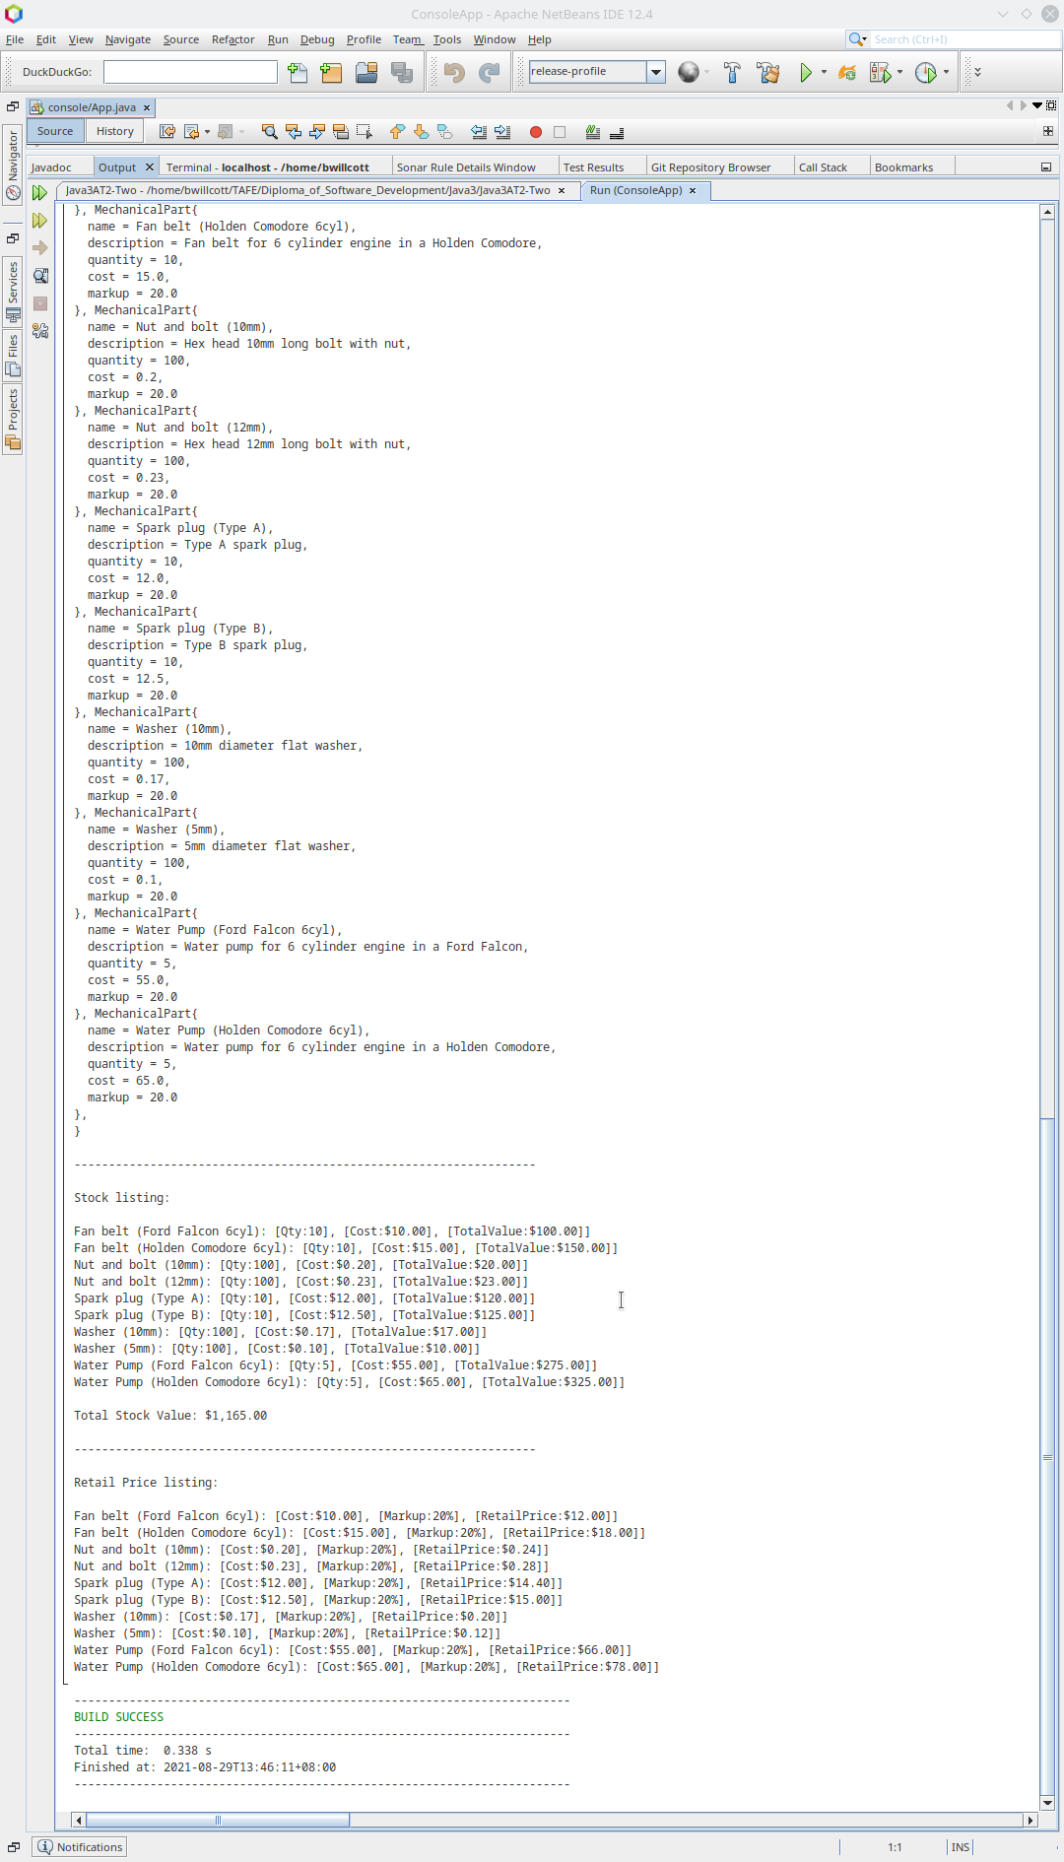

Figure 5 – Console program output - C

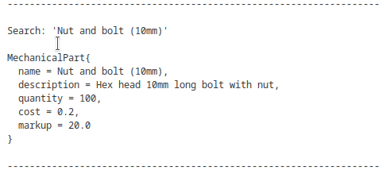

Figure 6 – Search results

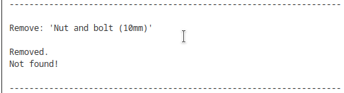

Figure 7 – Remove a part

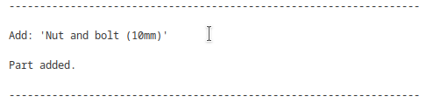

Figure 8 - Add the part back in

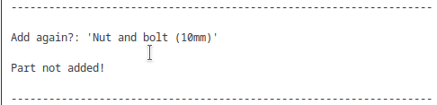

Figure 9 – Try to add it again

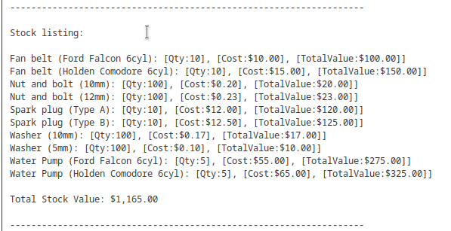

Figure 10 – Testing totalValue() method

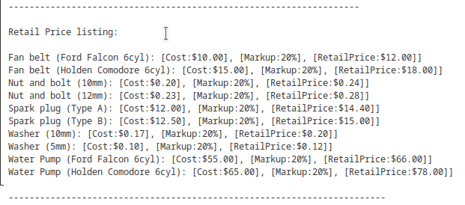

Figure 11 – Testing retailPrice() method

# References