Name: Bradley Willcott

ID: M198449

Date: 29 July 2021

Assessment Task (AT 2.1)

Jupiter Mining Corporation

Contents

Debugging 3

Part B. 9

References 10

# Debugging

Figure 1 : Test failed - insertAfter method

Figure 2 : current == null

Figure 3: Added method - foundDisallowedDuplicate

Figure 4: Substituted new method in 'if' statement

Figure 5: All tests passed

# Testing

|  |  |  |
| --- | --- | --- |
| Country | City | Population |
| India | Delhi | 28514000 |
|  | Mumbai | 19980000 |
|  | Chennai | 10456000 |
| Australia | Sydney | 5367206 |
|  | Melbourne | 5159211 |
|  | Brisbane | 2560720 |
|  | Perth | 2125760 |
|  | Adelaide | 1359760 |
|  | Canberra | 431834 |
|  | Hobart | 238834 |
|  | Darwin | 147231 |
| USA | New York City | 8175133 |
|  | Los Angeles | 3971883 |
|  | Chicago | 2720546 |
| Canada | Toronto | 5928040 |
|  | Montreal | 4098927 |
|  | Vancouver | 2463431 |

|  |  |  |  |  |
| --- | --- | --- | --- | --- |
| Case | Description | Expected | Actual | Evidence |
| #1 | Open application with no data file | Display empty listviews | As expected | Figure 6 |
| #2 | Add first country | Display country in listview | As expected | Figure 7  Figure 8 |
| #3 | Add first city to country (in #2) | Display city in listview | As expected | Figure 9  Figure 10 |
| #4 | Add next country | Display both countries in listview | As expected | Figure 11  Figure 12 |
| #5 | Add first city to country (in #4) | Display that city alone, in listview | As expected | Figure 13  Figure 14 |
| #6 | Add next country | Display all three countries in listview | As expected | Figure 15  Figure 16 |
| #7 | Add first city to country (in #6) | Display that city alone, in listview | As expected | Figure 17  Figure 18 |
| #8 | Select first country in listview | It’s one city will display, alone in listvew | As expected | Figure 19 |
| #9 | Add last country | Display all four countries in listview | As expected | Figure 20  Figure 21 |
| #10 | Add first city to country (in #9) | Display that city alone, in listview | As expected | Figure 22  Figure 23 |
| #11 | Add remaining cities to first country | Display cities from that country | As expected | Figure 24 |
| #12 | Add next city to the second country – but try to set the population to a text string | Error message will display, preventing the addition until fixed | As expected | Figure 25  Figure 26  Figure 27 |
| #13 | Add remaining cities to each of the countries, respectively | As per #11 | As expected | Figure 28  Figure 29  Figure 30  Figure31 |
|  |  |  |  |  |
|  |  |  |  |  |
|  |  |  |  |  |
|  |  |  |  |  |
|  |  |  |  |  |

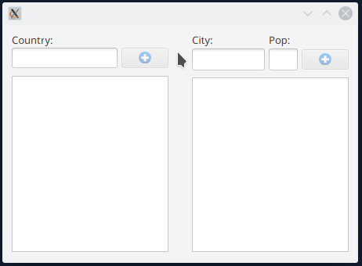

Figure : Open application - no data file

Figure : Add first country - A

Figure : Add first country - B

Figure : Add first city - A

Figure : Add first city - B

Figure : Add next country - A

Figure : Add next country - B

Figure : Add first city - A

Figure : Add first city - B

Figure : Add next country - A

Figure : Add next country - B

Figure : Add first city - A

Figure : Add first city - B

Figure : Select first country

Figure : Add last country - A

Figure : Add last country - B

Figure : Add first city - A

Figure : Add first city - B

Figure : Add remaining cities for first country

Figure : Add city with invalid population - A

Figure : Add city with invalid population - B

Figure : Add city with invalid population - C

Figure : Add remaining cities - A

Figure : ADD REMAINING CITIES - B

Figure : ADD REMAINING CITIES - D

# References