*Java3 AT2 Q1*

Product Design Specification

Version *1.0*

*28/07/2021*

VERSION HISTORY

|  |  |  |  |  |  |
| --- | --- | --- | --- | --- | --- |
| **Version #** | **Implemented**  **By** | **Revision**  **Date** | **Approved**  **By** | **Approval**  **Date** | **Reason** |
| 1.0 | *Bradley Willcott* | *28/07/2021* | *<name>* | *<mm/dd/yy>* | Initial Design Definition draft |
|  |  |  |  |  |  |
|  |  |  |  |  |  |

**UP Template Version:** 12/31/07

TABLE OF CONTENTS

1 Introduction 4

1.1 Purpose of The Product Design Specification Document 4

2 General Overview and Design Guidelines/Approach 4

2.1 Assumptions / Constraints / Standards 4

3 Architecture Design 5

3.1 Logical View 5

3.2 Hardware Architecture 5

3.3 Software Architecture 5

4 System Design 6

4.1 Use-Cases 6

4.2 User Interface Design 6

4.3 Coding Compliance 6

# Introduction

## Purpose of The Product Design Specification Document

The Product Design Specification document documents and tracks the necessary information required to effectively define architecture and system design in order to give the development team guidance on architecture of the system to be developed. The Product Design Specification document is created during the Planning Phase of the project. Its intended audience is the project manager, project team, and development team. Some portions of this document such as the user interface (UI) may on occasion be shared with the client/user, and other stakeholder whose input/approval into the UI is needed.

# General Overview and Design Guidelines/Approach

This section describes the principles and strategies to be used as guidelines when designing and implementing the system.

## Assumptions / Constraints / Standards

The program will have a graphical user interface and store the records in a binary file.

# Architecture Design

This section outlines the system and hardware architecture design of the system that is being built.

## Logical View

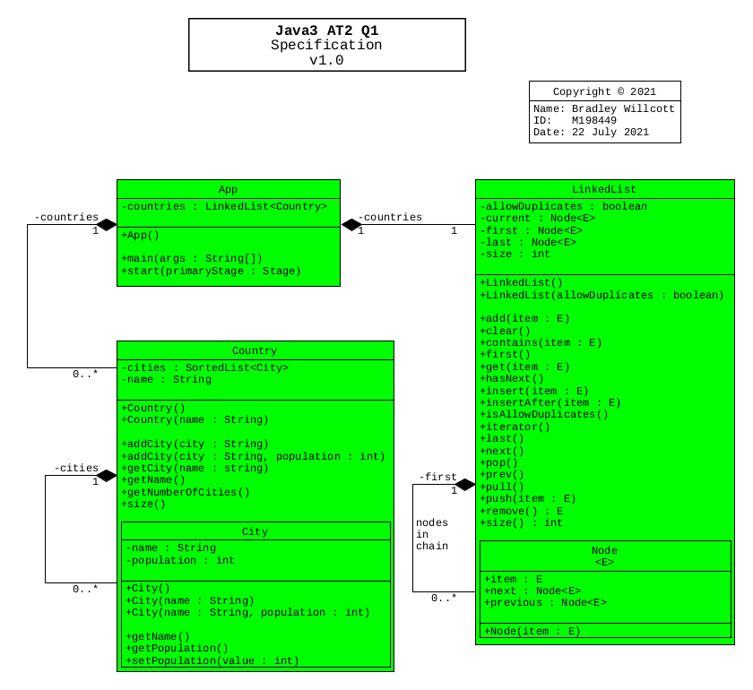

## Hardware Architecture

The design must allow for the program to be run on any type of desktop or portable hardware, be it Intel/AMD based of Apple design (Mac/OS).

## Software Architecture

The language to be used, must be cross-platform capable. The application must be capable of being run, without modification, on Windows 10+, Mac OS and Linux operating systems.

Further, a source control system will be implemented to allow for version control of the project files. It is recommended that the GitHub site, which uses the git version control system and software, be used to provide this facility. It will be necessary that each team member obtain his/her own GitHub membership.

# System Design

## Use-Cases

A program is required to provide a nested class that shows countries with cities inside. The countries are to be stored in a doubly linked list.

## User Interface Design

A Graphical User Interface is to be provided to allow the user to add and display countries and their cities.

## Coding Compliance

The following standards must be adhered to for software coding:

<https://www.oracle.com/technetwork/java/codeconventions-150003.pdf>