Name: Bradley Willcott

ID: M198449

Date: 21 October 2021

Assessment Task (AT 2.5)

Jupiter Mining Corporation

Contents

Figures 2

Debugging 3

Testing 4

References 8

Tables

Table 1: Testing results 4

# Figures

Figure 1 – Showing which key was pressed – Control-C 3

Figure 2 - Console program output – various keys pressed 5

Figure 4 – Ctrl-C pressed 6

Figure 4 – Programs continues until ‘X’ is pressed 7

# Debugging

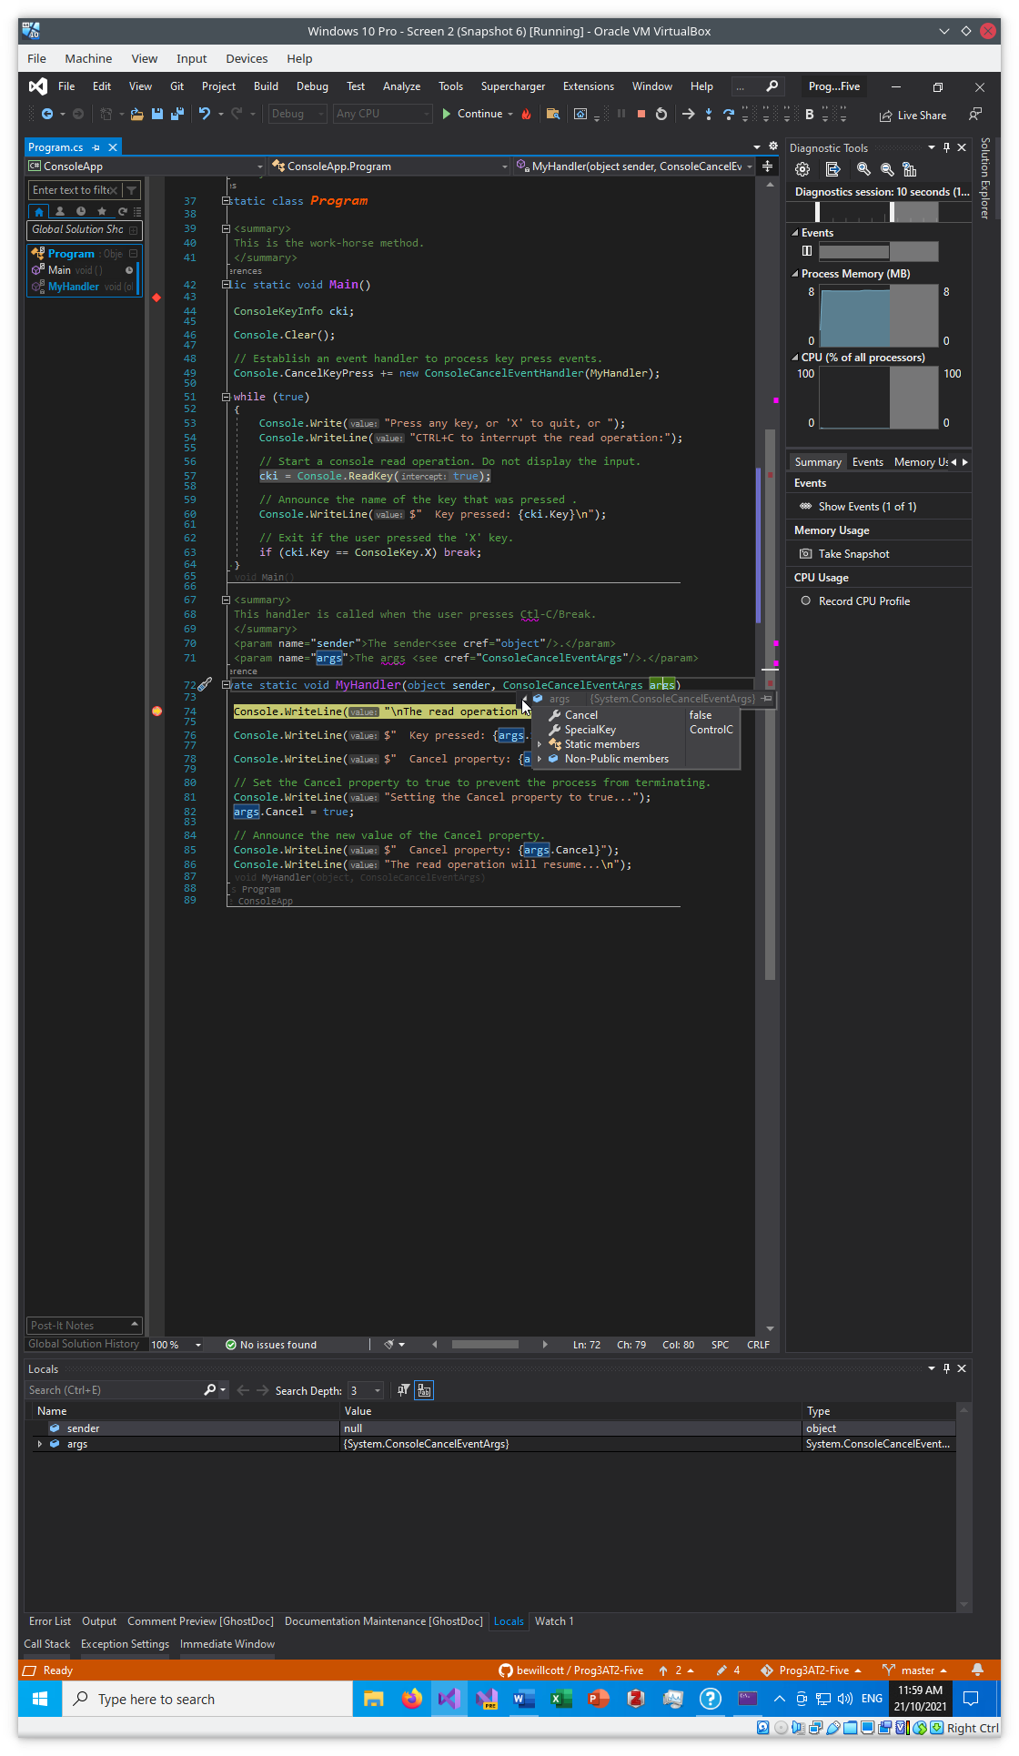

Figure 1 – Showing which key was pressed – Control-C

# Testing

Table : Testing results

|  |  |  |  |  |
| --- | --- | --- | --- | --- |
| Case | Description | Expected | Actual | Evidence |
| #1 | Run the console program | Display program output showing the results of the various keys being pressed | As expected | Figure 2 |
| #2 | Ctrl-C pressed | Show message proving it has been intercepted | As Expected | Figure 3 |
| #3 | Continues to read keys from console | Show still reading keys – program not yet terminated | As expected | Figure 4 |

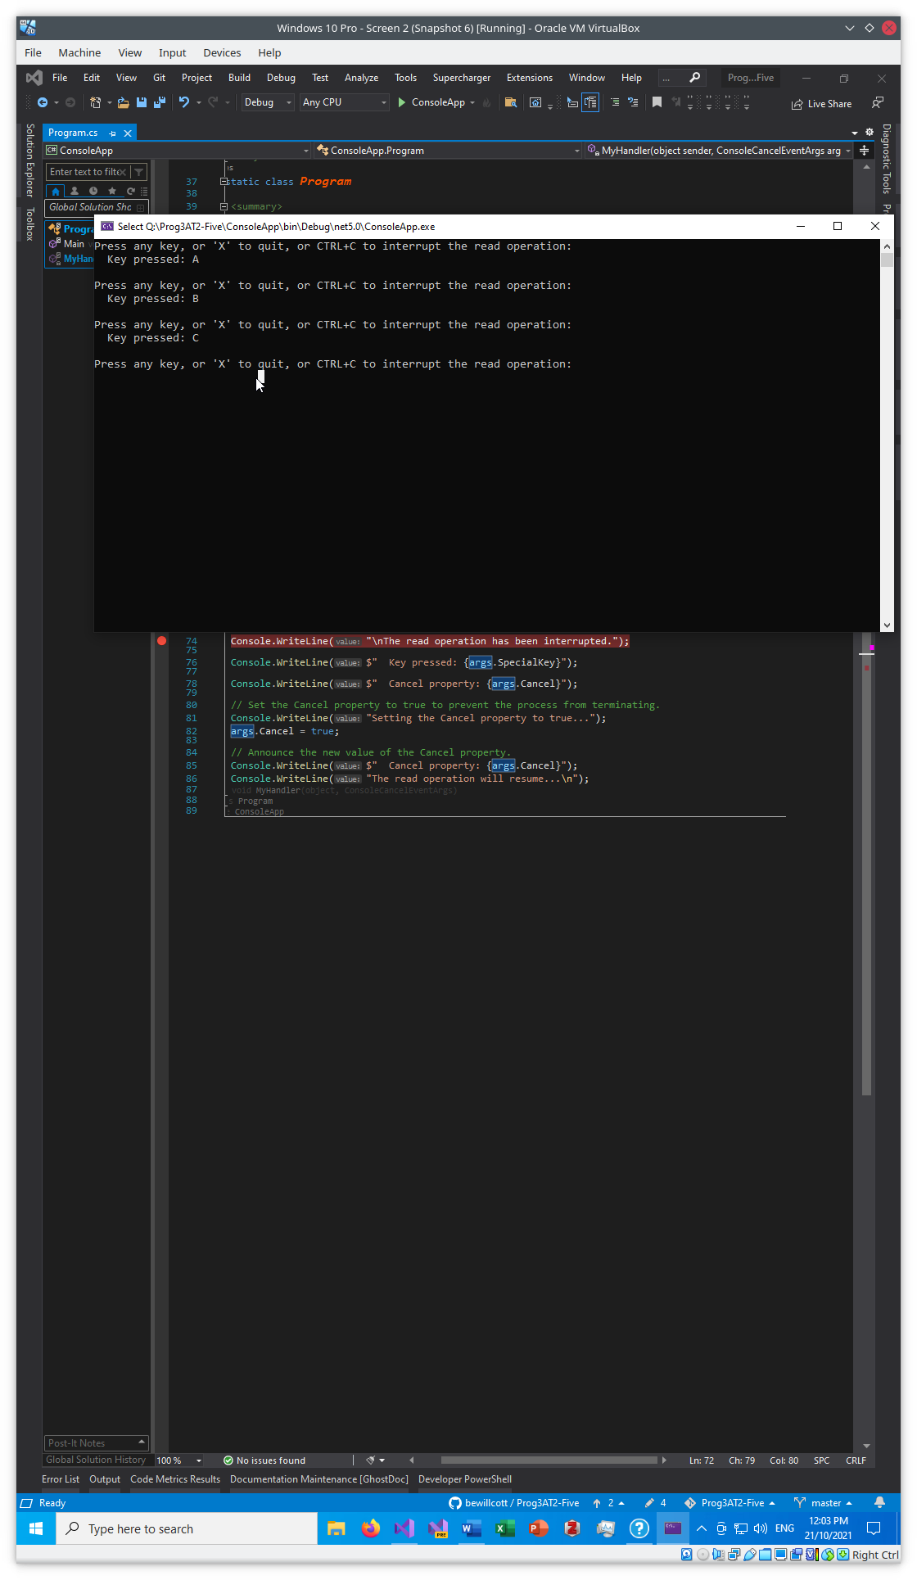

Figure 2 - Console program output – various keys pressed

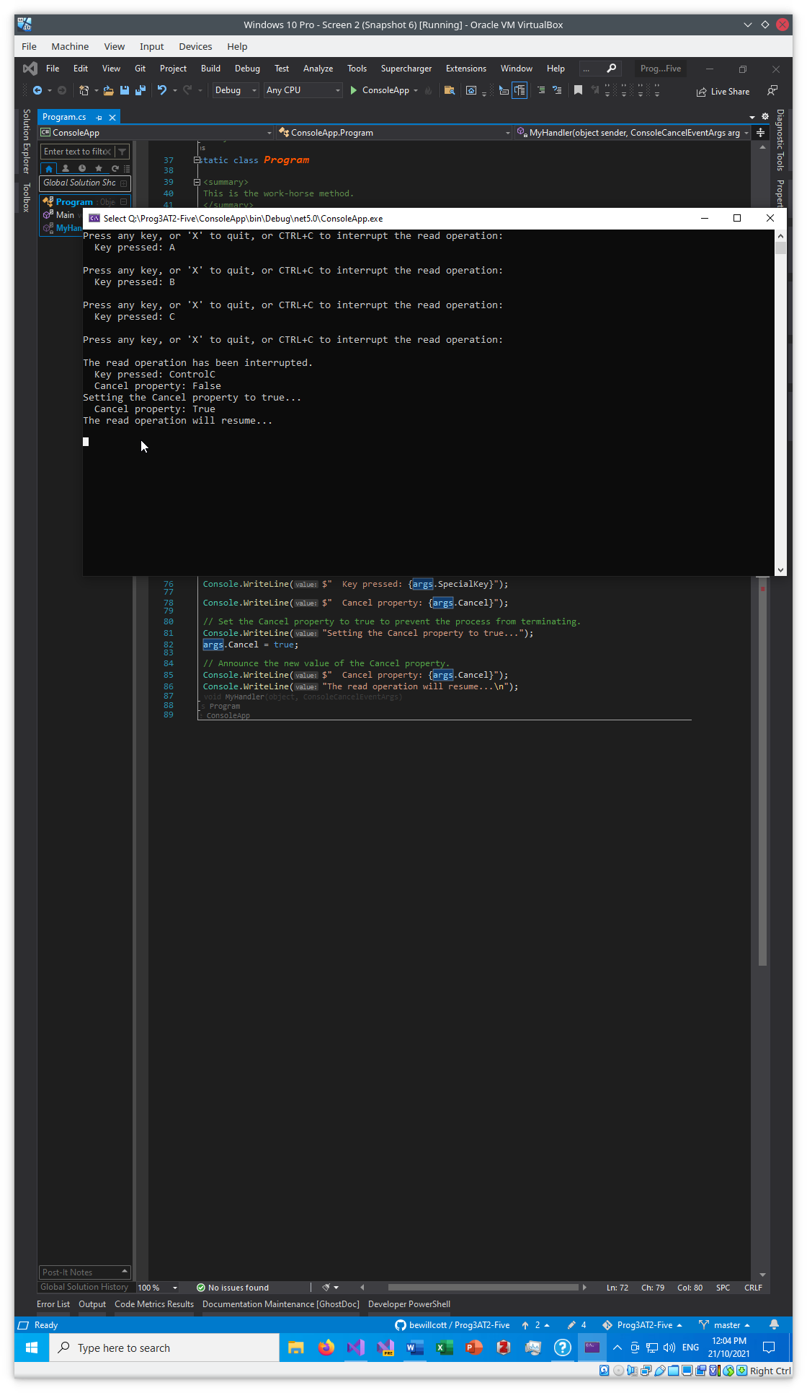

Figure 4 – Ctrl-C pressed

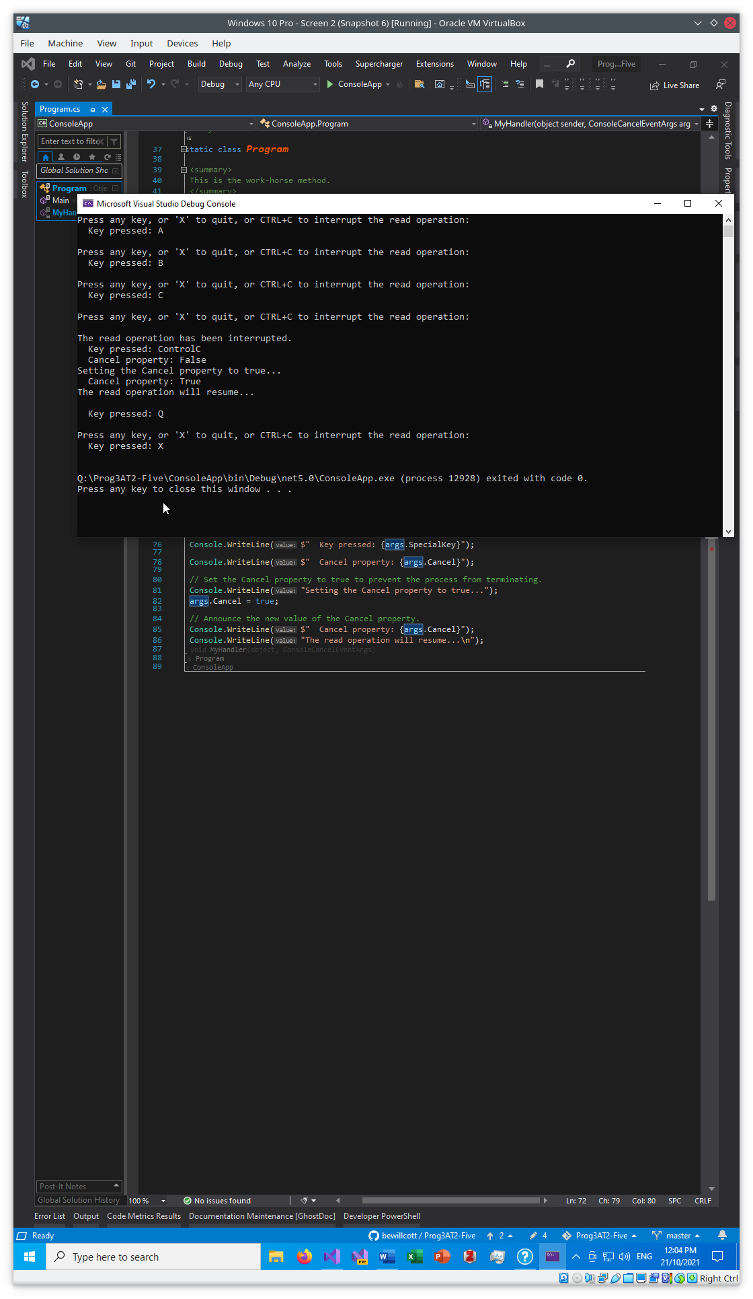

Figure 4 – Programs continues until ‘X’ is pressed

# References