Name: Bradley Willcott

ID: M198449

Date: 15 August 2021

Assessment Task (AT 2.1)

Jupiter Mining Corporation

Contents

Figures 2

Debugging 3

Testing 7

References 17

Tables

Table 1: Testing results 7

# Figures

Figure 1 - Constant (SUPPORTED_FORMAT) not usable 'case' string 3

Figure 2 – Changed constant value 4

Figure 3 - if statement picking up '-1' 5

Figure 4 - Added new if statement in front of previous one 6

Figure 5 - Application started 7

Figure 6 - File/Open menu 8

Figure 7 – File Open Dialog 8

Figure 8 - File in PlayList 9

Figure 9 - Select file/track to play 9

Figure 10 - Click [Play] 10

Figure 11 - Playing 10

Figure 12 - Add an Audio file 11

Figure 13 - File reference added to PlayList 11

Figure 14 - Add another audio file 12

Figure 15 - New file reference added to PlayList 12

Figure 16 - Go forward one track - A 13

Figure 17 - Go forward one track - B 13

Figure 18 – Go to start/first track- A 14

Figure 19 – Go to start/first track - B 14

Figure 20 - Go to End/Last track - A 15

Figure 21 - Go to End/Last track - B 15

Figure 22 – Go back one track - A 16

Figure 23 – Go back one track - B 16

# Debugging

Figure 1 - Constant (SUPPORTED_FORMAT) not usable 'case' string

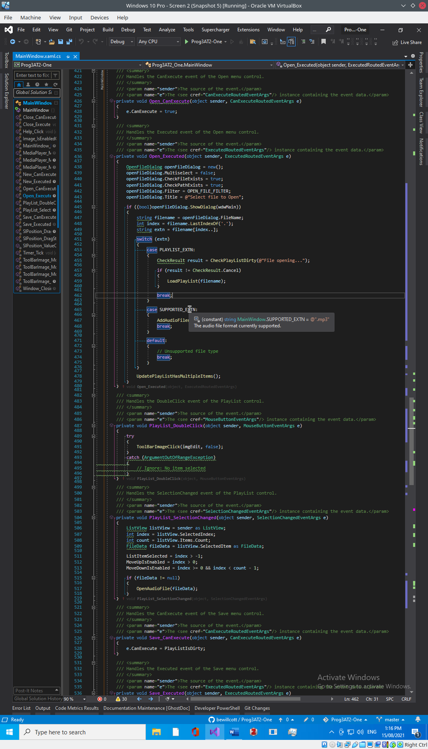

Figure 2 – Changed constant value

Figure 3 - if statement picking up '-1'

Figure 4 - Added new if statement in front of previous one

# Testing

Table : Testing results

|  |  |  |  |  |
| --- | --- | --- | --- | --- |
| Case | Description | Expected | Actual | Evidence |
| #1 | Open an audio file | File reference added to PlayList | As expected | Figure 5  Figure 6  Figure 7  Figure 8 |
| #2 | Play audio file | Audio file is loaded and played | As expected | Figure 9  Figure 10  Figure 11 |
| #3 | Add two more audio files | Both file references added to PlayList | As expected | Figure 12  Figure 13  Figure 14  Figure 15 |
| #4 | Go forward one file/track | Select second track | As expected | Figure 16  Figure 17 |
| #5 | Go to start/first track | Select first track | As expected | Figure 18  Figure 19 |
| #6 | Go to end/last track | Select last rack | As expected | Figure 20  Figure 21 |
| #7 | Go back one track | Select second track | As expected | Figure 22  Figure 23 |

Figure - Application started

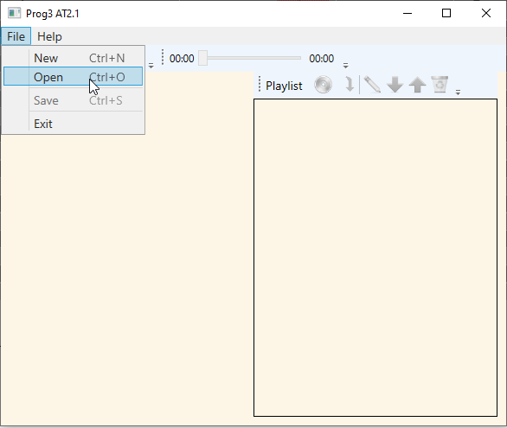

Figure - File/Open menu

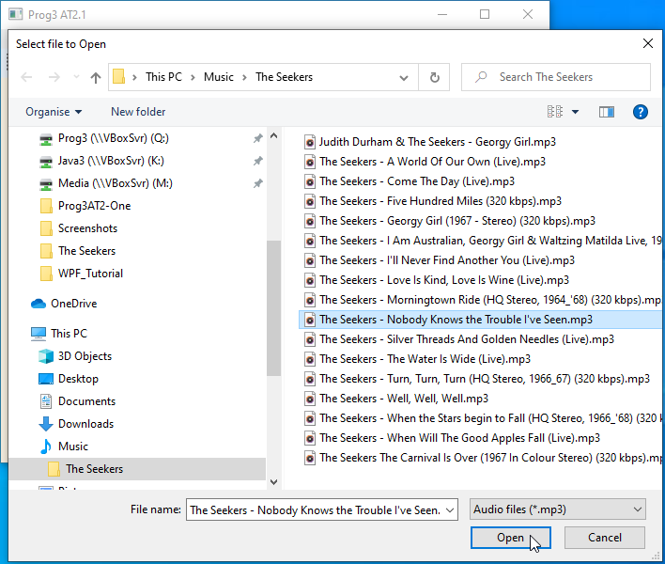

Figure – File Open Dialog

Figure - File in PlayList

Figure - Select file/track to play

Figure - Click [Play]

Figure - Playing

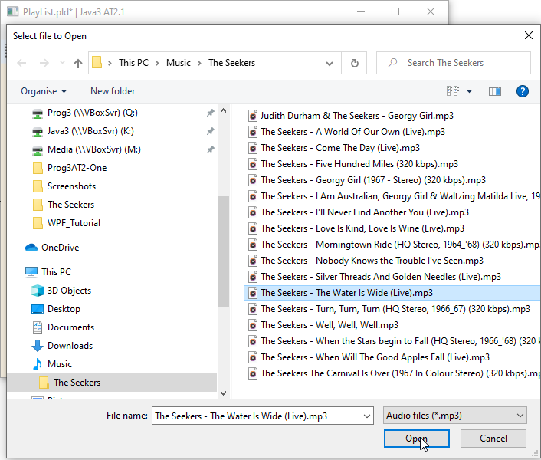

Figure - Add an Audio file

Figure - File reference added to PlayList

Figure - Add another audio file

Figure - New file reference added to PlayList

Figure - Go forward one track - A

Figure - Go forward one track - B

Figure – Go to start/first track- A

Figure – Go to start/first track - B

Figure - Go to End/Last track - A

Figure - Go to End/Last track - B

Figure – Go back one track - A

Figure – Go back one track - B

# References