Name: Bradley Willcott

ID: M198449

Date: 19 August 2021

Assessment Task (AT 2.2)

Jupiter Mining Corporation

Contents

Figures 2

Debugging 3

Testing 5

References 13

Tables

Table 1: Testing results 5

# Figures

Figure 1 – IndexIsDirty property not being updated 3

Figure 2 – ‘rtn’ variable not being set when item is added to tree 4

Figure 3 - Console Test program output 6

Figure 4 - Application started 7

Figure 5 - Add first person - A 7

Figure 6 - Add first person - B 7

Figure 7 - Add second person - A 8

Figure 8 - Add second person - B 8

Figure 9 - Add third person - A 8

Figure 10 - Add third person - B 9

Figure 11 - Add last seven names - A 9

Figure 12 - Add last seven names - B 9

Figure 13 - Search for name not in list - A 10

Figure 14 - Search for name not in list - B 10

Figure 15 - Search for name in list - A 10

Figure 16 - Search for name in list - B 11

Figure 17 - Remove a name from the list -A 11

Figure 18 - Remove a name from the list - B 11

# Debugging

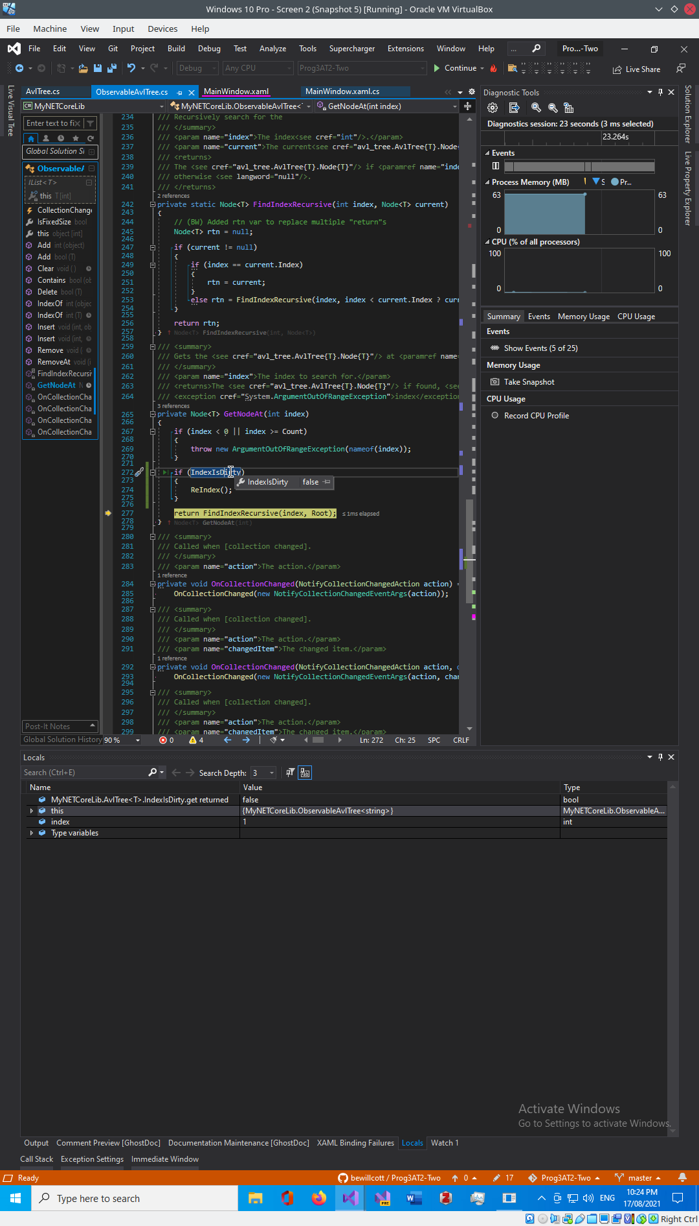

Figure – IndexIsDirty property not being updated

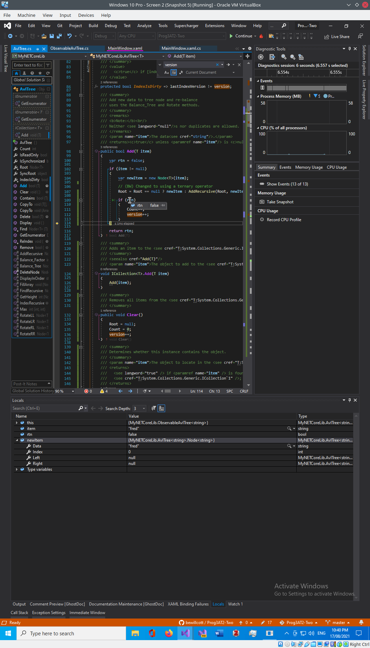

Figure – ‘rtn’ variable not being set when item is added to tree

# Testing

Table 1: Testing results

|  |  |  |  |  |
| --- | --- | --- | --- | --- |
| Case | Description | Expected | Actual | Evidence |
| #1 | Run the console test version of the program | Display program output showing the results of the various functions being tested | As expected | Figure 3 |
| #2 | Load GUI application | Program running | As Expected | Figure 4 |
| #3 | Add three names to the list | Names will be displayed, sorted, in the ListBox | As expected | Figure 5  Figure 6  Figure 7  Figure 8  Figure 9  Figure 10 |
| #4 | Populate the list with seven more names | Names will be displayed, sorted, in the ListBox | As expected | Figure 11  Figure 12 |
| #5 | Search for a name not in the list | Nothing will be selected in the ListBox | As expected | Figure 13  Figure 14 |
| #6 | Search for a name in the list | The name will be selected in the ListBox | As expected | Figure 15  Figure 16 |
| #7 | Remove a name from the list | Name will be remove from the ListBox | As expected | Figure 17  Figure 18 |

Figure - Console Test program output

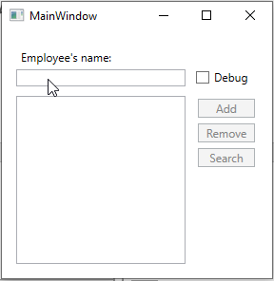

Figure - Application started

Figure - Add first person - A

Figure - Add first person - B

Figure - Add second person - A

Figure - Add second person - B

Figure - Add third person - A

Figure - Add third person - B

Figure - Add last seven names - A

Figure - Add last seven names - B

Figure - Search for name not in list - A

Figure - Search for name not in list - B

Figure - Search for name in list - A

Figure - Search for name in list - B

Figure - Remove a name from the list -A

Figure - Remove a name from the list - B

# References