*Prog3 AT2 Q2*

Product Design Specification

Version *1.0*

*19/08/2021*

Name: Bradley Willcott

ID: M198449

Date: 19 August 2021

VERSION HISTORY

|  |  |  |  |  |  |
| --- | --- | --- | --- | --- | --- |
| **Version #** | **Implemented**  **By** | **Revision**  **Date** | **Approved**  **By** | **Approval**  **Date** | **Reason** |
| 1.0 | *Bradley Willcott* | *19/08/2021* | *<name>* | *<mm/dd/yy>* | Initial Design Definition draft |
|  |  |  |  |  |  |
|  |  |  |  |  |  |

**UP Template Version:** 12/31/07

TABLE OF CONTENTS

1 Introduction 4

1.1 Purpose of The Product Design Specification Document 4

2 General Overview and Design Guidelines/Approach 4

2.1 Assumptions / Constraints / Standards 4

3 Architecture Design 5

3.1 Logical View 5

3.2 Hardware Architecture 5

3.3 Software Architecture 5

4 System Design 5

4.1 Use-Cases 5

4.2 User Interface Design 6

4.3 Coding Compliance 6

# Introduction

## Purpose of The Product Design Specification Document

The Product Design Specification document documents and tracks the necessary information required to effectively define architecture and system design in order to give the development team guidance on architecture of the system to be developed. The Product Design Specification document is created during the Planning Phase of the project. Its intended audience is the project manager, project team, and development team. Some portions of this document such as the user interface (UI) may on occasion be shared with the client/user, and other stakeholder whose input/approval into the UI is needed.

# General Overview and Design Guidelines/Approach

This section describes the principles and strategies to be used as guidelines when designing and implementing the system.

## Assumptions / Constraints / Standards

The program will be able to store staff names for the payroll system.

# Architecture Design

This section outlines the system and hardware architecture design of the system that is being built.

## Logical View

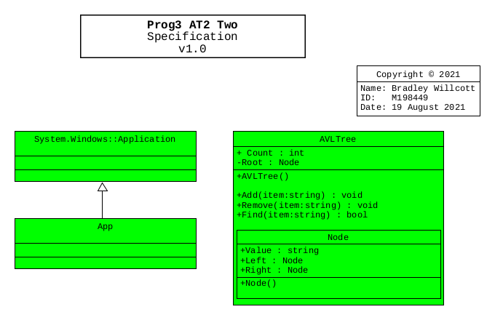

## Hardware Architecture

The design only needs to allow for the program to be run on any Microsoft Windows 10 compatible desktop or portable hardware, be it Intel or AMD processor based.

## Software Architecture

The language to be used, need only be compatible with the Microsoft Windows 10 operating system.

Further, a source control system will be implemented to allow for version control of the project files. It is recommended that the GitHub site, which uses the git version control system and software, be used to provide this facility. It will be necessary that each team member obtain his/her own GitHub membership.

# System Design

## Use-Cases

The project task is to develop a program to store the names of all staff for the payroll system. The list will be sorted alphabetically, and it is to be stored in a balanced binary search tree. This tree is to be developed for a dictionary of no less than 10 words. It must be possible to search the list, add and remove from the list.

## User Interface Design

A Graphical User Interface is to be provided to allow the user to add, search and remove names from the list. Further, a console version is to be developed for testing purposes.

## Coding Compliance

The following standards must be adhered to for software coding:

<https://docs.microsoft.com/en-us/dotnet/csharp/fundamentals/coding-style/coding-conventions>