Name: Bradley Willcott

ID: M198449

Date: 27 October 2021

Assessment Task (AT 2.6)

Jupiter Mining Corporation

Contents

Figures 2

Debugging 3

Testing 4

References 25

Tables

Table 1: Testing results 4

# Figures

Figure 1 – Showing the values of the new DateTime 3

Figure 2 – GUI program started 5

Figure 3 – Display Help/About - A 5

Figure 4 – Display Help/About – B 6

Figure 5 - File/New - A 6

Figure 6 - File/New - B (Untitled) 7

Figure 7 - Add a Reading - A 7

Figure 8 - Add a Reading - B (Sensor Reading Form) 8

Figure 9 - Add a Reading - C (Sensor Reading Form) 8

Figure 10 - Add a Reading - D (Sensor Reading Form) 9

Figure 11 - Add a Reading - B (Sensor reading added) 9

Figure 12 - Save to file- A 10

Figure 13 - Save to file- B (Save CSV File As) 11

Figure 14 - Save to file- C (Status message) 12

Figure 15 - File/Close 12

Figure 16 - file closed 13

Figure 17 - File/Open - A 13

Figure 18 - File/Open - B (Open CSV File) 14

Figure 19 - File opened 15

Figure 20 - Test data validation - A (Add reading) 15

Figure 21 - Test data validation - B (Add empty data) 16

Figure 22 - Test data validation - C (Validation failed) 16

Figure 23 - Test data validation - D (Bad data) 17

Figure 24 - Test data validation - E (Validation failed) 17

Figure 25 - Test data validation - F (One empty field) 18

Figure 26 - Test data validation - G (Validation failed) 18

Figure 27 - Test data validation - H (All correct - finally) 19

Figure 28 - Test data validation - I (Data added) 19

Figure 29 - File/Close - A 20

Figure 30 - File/Close - B (Closing File) 20

Figure 31 - File/Exit - A 21

Figure 32 - File/Exit - B (Warning dialog) 21

Figure 33 - 'X' Close - A 22

Figure 34 - 'X' Close - A (Warning dialog) 22

Figure 35 - Window control Close - A 23

Figure 36 - Window control Close - A (Warning Dialog) 23

Figure 37 - File/Save 24

Figure 38 - File/Exit 24

# Debugging

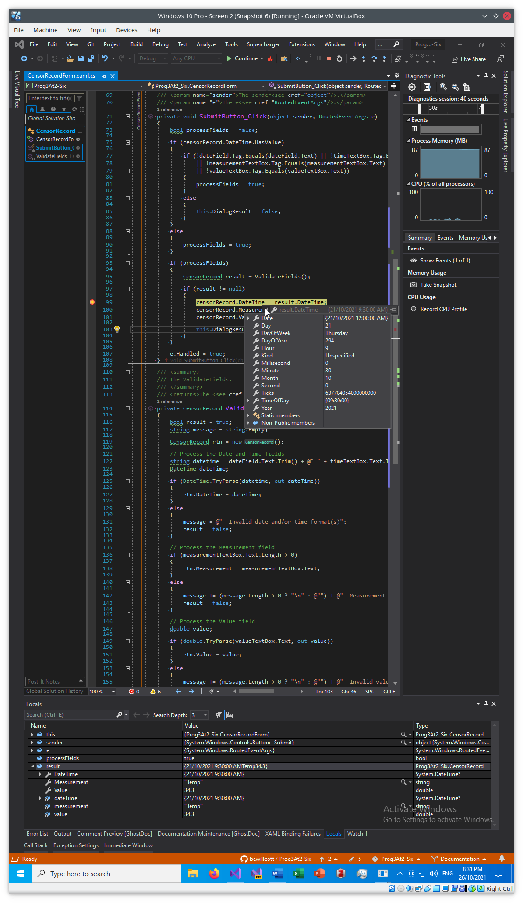

Figure – Showing the values of the new DateTime

# Testing

Table 1: Testing results

|  |  |  |  |  |
| --- | --- | --- | --- | --- |
| Case | Description | Expected | Actual | Evidence |
| #1 | Run the GUI program | Display the program | As expected | Figure 2 |
| #2 | Display Help/About | Show dialog box | As expected | Figure 3  Figure 4 |
| #3 | Do File/New | Show empty table | As expected | Figure 5  Figure 6 |
| #4 | Add a Reading | Display “Sensor Reading Form”, add new reading to table | As expected | Figure 7  Figure 8  Figure 9  Figure 10  Figure 11 |
| #5 | Save to file: “SensorData1.csv” | Show process of saving data to file | As expected | Figure 12  Figure 13  Figure 14 |
| #6 | Close file | Back to empty page | As expected | Figure 15  Figure 16 |
| #7 | Open csv file: “SensorData.csv” | Show table of data loaded | As expected | Figure 17  Figure 18  Figure 19 |
| #8 | Try to add incomplete or invalid data | Show various error messages | As expected | Figure 20  Figure 21  Figure 22  Figure 23  Figure 24  Figure 25  Figure 26  Figure 27  Figure 28 |
| #9 | Try to Close the file | Warning dialog | As expected | Figure 29  Figure 30 |
| #10 | Try to Exit program | Warning dialog | As expected | Figure 31  Figure 32  Figure 33  Figure 34  Figure 35  Figure 36 |
| #11 | Save and Exit | Program terminates without complaints. | As expected | Figure 37  Figure 38 |

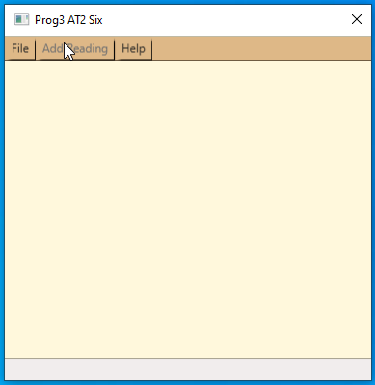

Figure – GUI program started

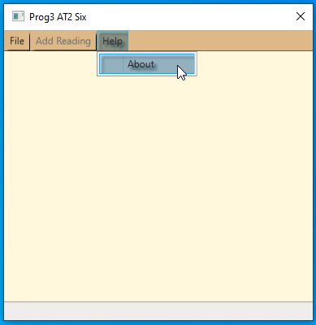

Figure – Display Help/About - A

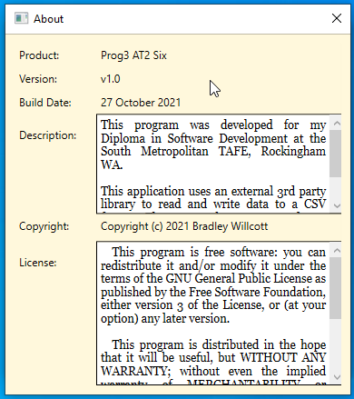

Figure – Display Help/About – B

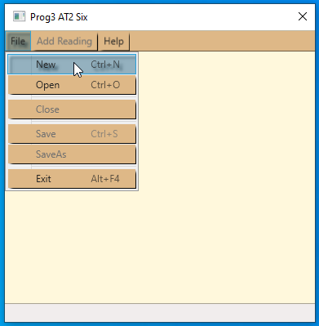

Figure - File/New - A

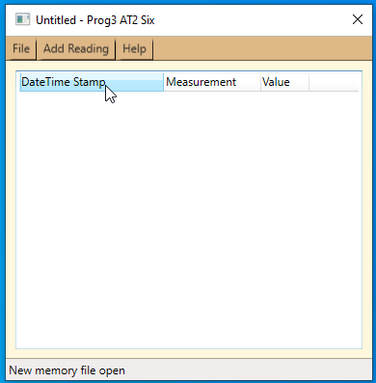

Figure - File/New - B (Untitled)

Figure - Add a Reading - A

Figure - Add a Reading - B (Sensor Reading Form)

Figure - Add a Reading - C (Sensor Reading Form)

Figure - Add a Reading - D (Sensor Reading Form)

Figure - Add a Reading - B (Sensor reading added)

Figure - Save to file- A

Figure - Save to file- B (Save CSV File As)

Figure - Save to file- C (Status message)

Figure - File/Close

Figure - file closed

Figure - File/Open - A

Figure - File/Open - B (Open CSV File)

Figure - File opened

Figure - Test data validation - A (Add reading)

Figure - Test data validation - B (Add empty data)

Figure - Test data validation - C (Validation failed)

Figure - Test data validation - D (Bad data)

Figure - Test data validation - E (Validation failed)

Figure - Test data validation - F (One empty field)

Figure - Test data validation - G (Validation failed)

Figure - Test data validation - H (All correct - finally)

Figure - Test data validation - I (Data added)

Figure - File/Close - A

Figure - File/Close - B (Closing File)

Figure - File/Exit - A

Figure - File/Exit - B (Warning dialog)

Figure - 'X' Close - A

Figure - 'X' Close - A (Warning dialog)

Figure - Window control Close - A

Figure - Window control Close - A (Warning Dialog)

Figure - File/Save

Figure - File/Exit

# References