Name: Bradley Willcott

ID: M198449

Date: 1 September 2021

Assessment Task – Portfolio (A 4)

Web Programming

Contents

Figures 2

Run Website 3

References 6

Tables

Table 1: Run results 4

# Figures

Figure 1 - QuoteOfToday.php 3

Figure 2 - Refresh page 4

Figure 3 - Refresh page 4

Figure 4 - Refresh page 5

# Run Website

Table : Run results

|  |  |  |  |  |
| --- | --- | --- | --- | --- |
| Case | Description | Expected | Actual | Evidence |
| #1 | Connect to “QuoteOfToday.php” | Display quote page | As expected | Figure 1 |
| #2 | Multiple page refreshes to get a different quote | Display each quote, one at a time | As expected | Figure 2  Figure 3  Figure 4 |

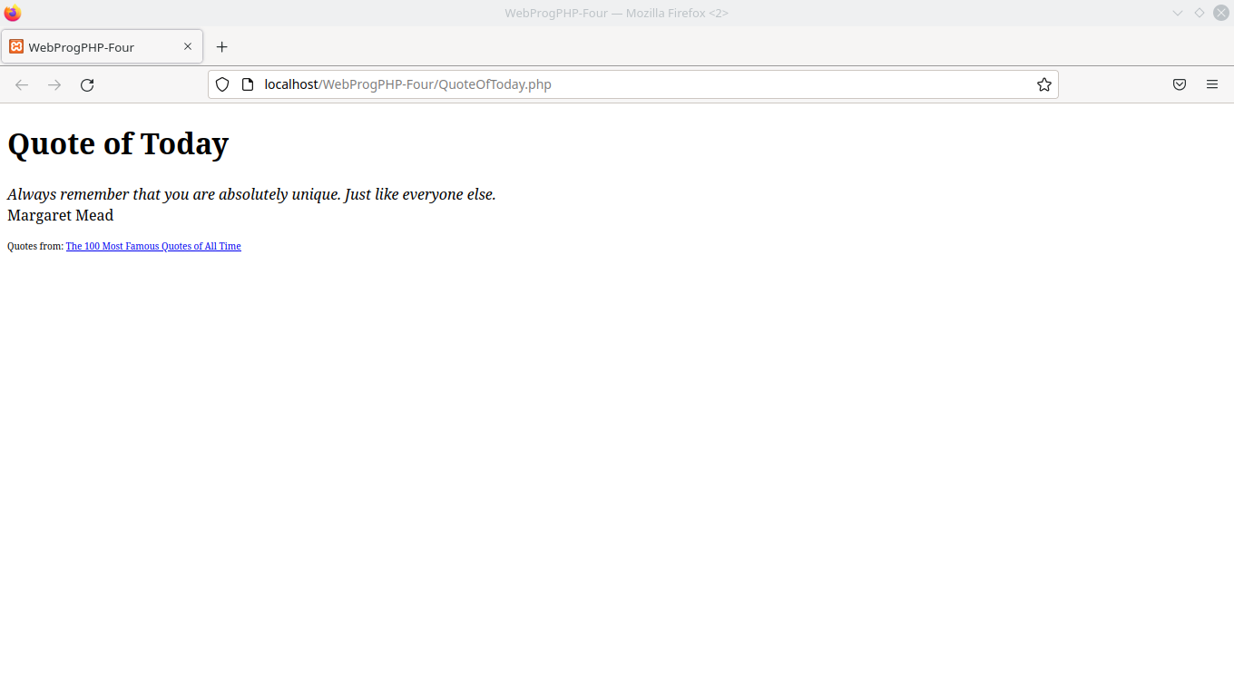

Figure - QuoteOfToday.php

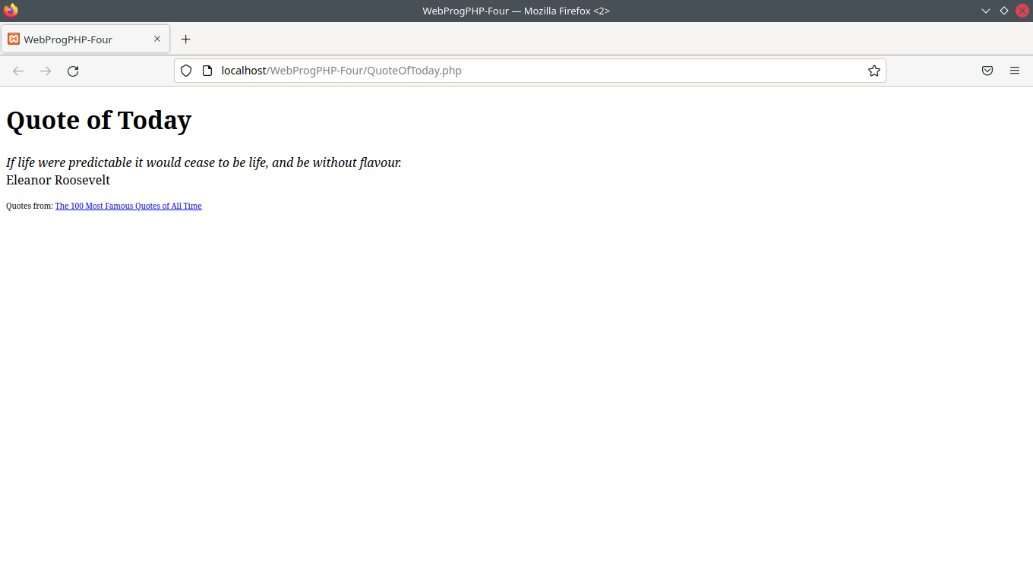

Figure - Refresh page

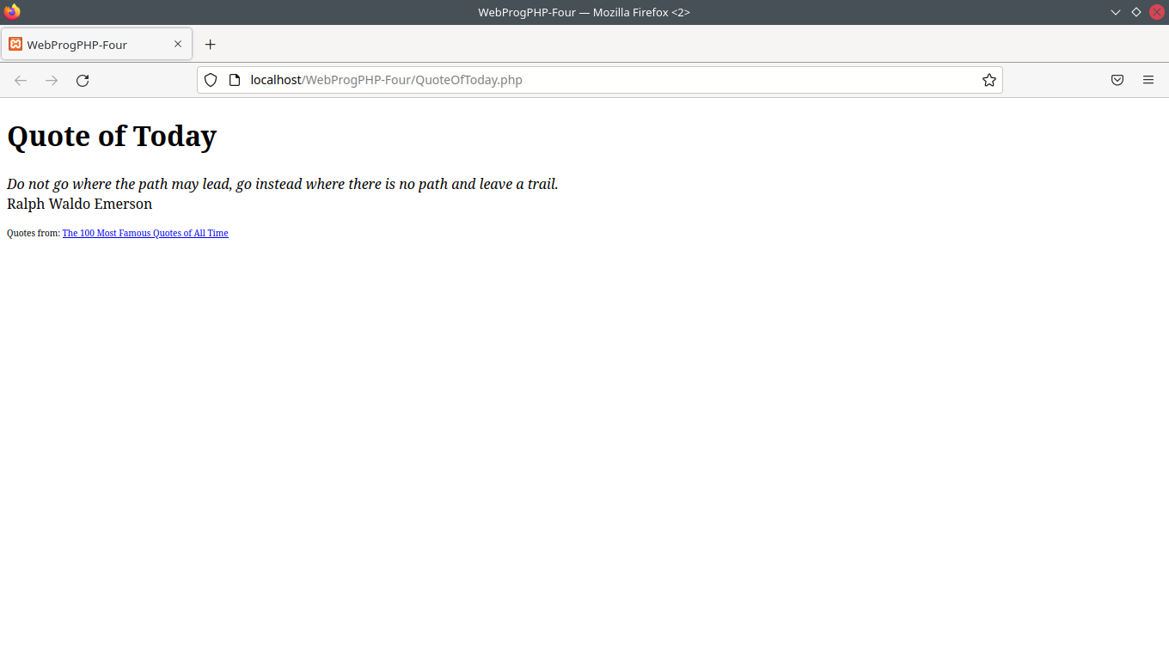

Figure - Refresh page

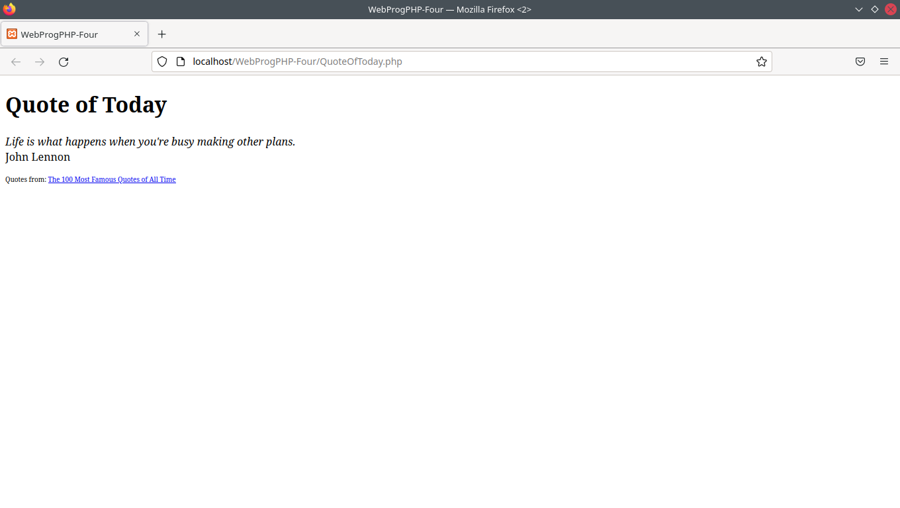

Figure 4 - Refresh page

# References