Name: Bradley Willcott

ID: M198449

Date: 7 September 2021

Assessment Task – Portfolio (A 6)

Web Programming

Contents

Figures 2

Run Website 3

References 6

Tables

Table 1: Run results 4

# Figures

Figure 1 - QuoteOfToday.php 3

Figure 2 - Refresh page 4

Figure 3 - Refresh page 4

Figure 4 - Refresh page 5

# Project Analysis

## Purpose of website and required functionality

The purpose of this website is to provide a means to administer user details. Specifically, their full name and their email address.

To achieve this purpose, the site must provide the ability to add new users and to list all current users.

## Functional Design and Architectural requirements

* Add user page
  + Will accept:
    - Name
    - Email
  + Information to be stored in a database
  + Data validation:
    - Name: regex => “[a-zA-Z]+([ ‘-]?[a-zA-Z]+)*”
    - Email: syntax ~><name>@<domain>
      * <name>: ”[a-zA-Z]+(\.[a-zA-Z0-9]+)*”
      * <domain>: ”[a-z]+[0-9]* (\.[a-z]+)*”
* Show all users page:
  + Display all the users created

### Architectural requirements

The Membership website must include navigation of:

* Add a user
* Show all users

## Prototype of Website UI Design

Figure 1 - Home page

Figure 2 - Add User page

Figure 3 - List Users page

Figure 4 - About page

Figure 5 - License page

## Target system of this application

This application is targeted at any operating system/hardware configuration that provides a web server that runs PHP/HTML 5.

Suggested system:

* Hardware:
  + Intel I5 CPU
  + 8 Gb RAM
  + 1Tb storage (HDD/SSD)
  + Fast network connection hardware (WiFi/Cable)
* Operating system:
  + Linux – Fedora v34+
* Software:
  + Apache v9+
  + PHP v8+

## The data storage design

* Database: Human Resources
  + Table: Users
    - Fields:
      * Id: integer, auto increment
      * LastName: string, 30 characters
      * FirstName: string, 30 characters
      * Email: string, 60 characters
    - Indexes:
      * ID_index: unique, primary key
      * Name_index: LastName (asc), FirstName (asc)

# Run Website

Table : Test results

|  |  |  |  |  |
| --- | --- | --- | --- | --- |
| Case | Description | Expected | Actual | Evidence |
| #1 | Home page | Display Home page | As expected | Figure 6 |
| #2 | Add User page | Display Add User page | As expected | Figure 7  Figure 8 |
| #3 | Add new user: John Mills,  jmills@gmail.com | New user added | As expected | Figure 9  Figure 10 |
| #4 | Add partial data:  Greg Jones, no email | Message displayed, no record added | As Expected | Figure 11  Figure 12  Figure 13 |
| #5 | Invalid email | HTML 5 message,  No new record. | As Expected | Figure 14  Figure 15  Figure 16 |
|  |  |  |  |  |

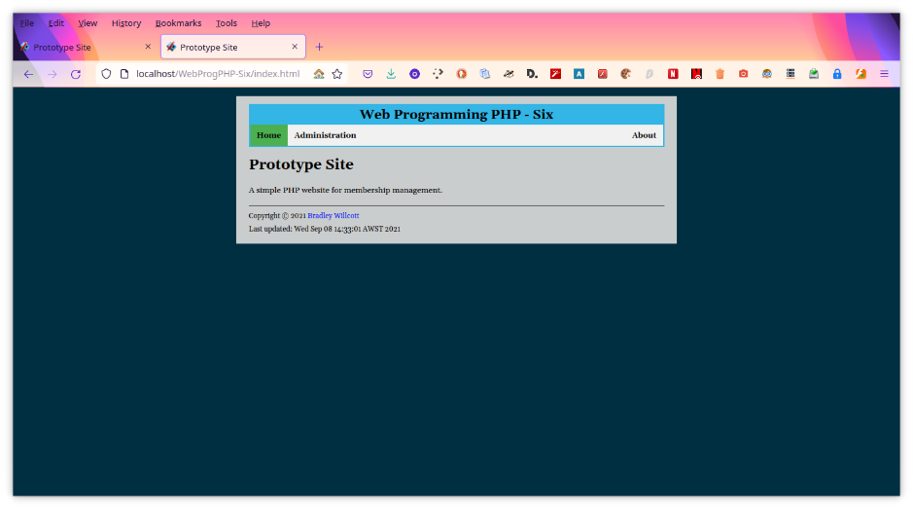

Figure – Home page

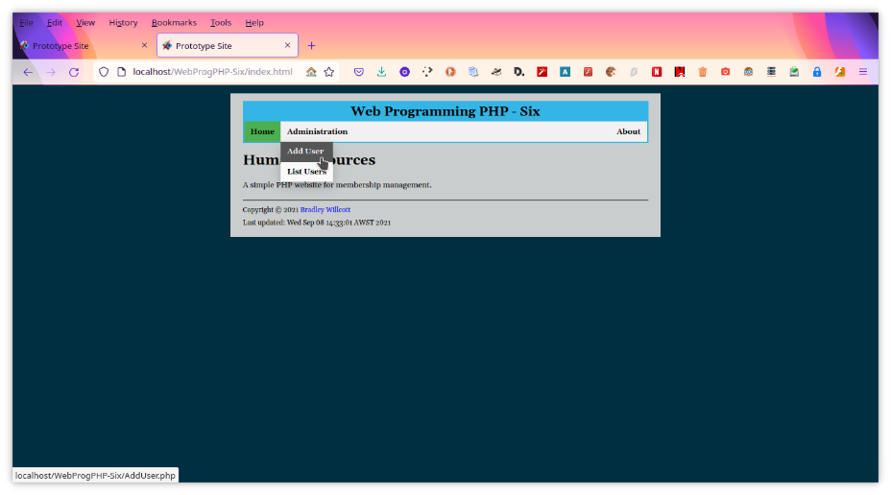

Figure – Add User page - A

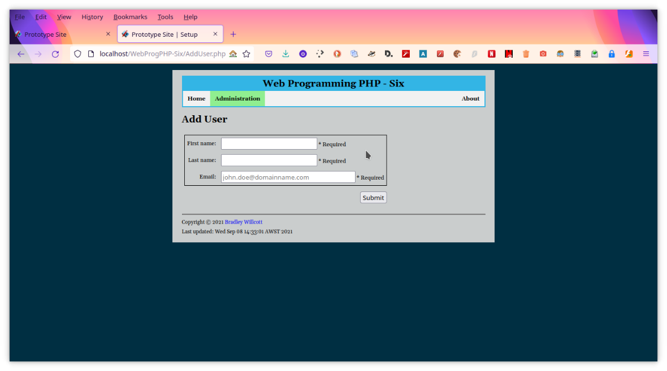

Figure – Add User page - B

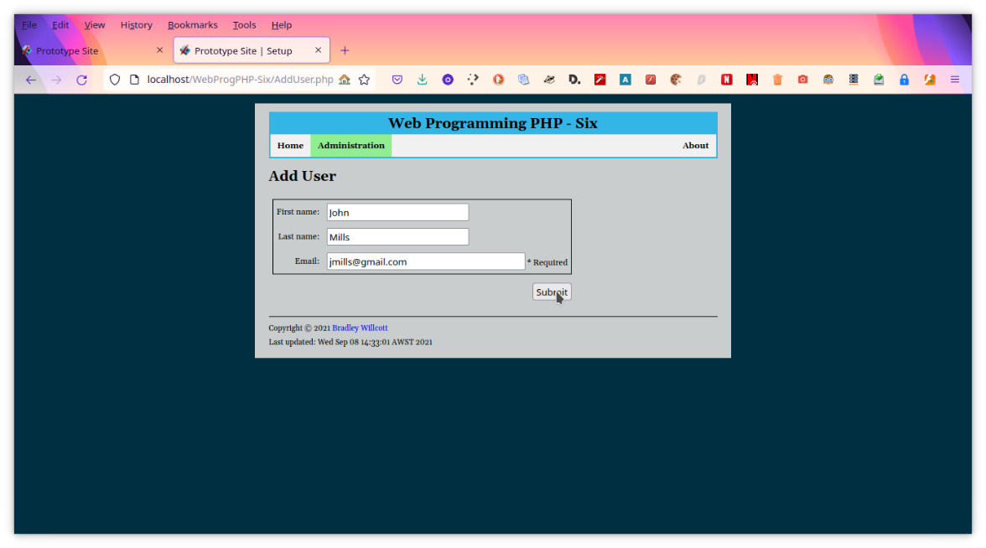

Figure 9 – Add user - A

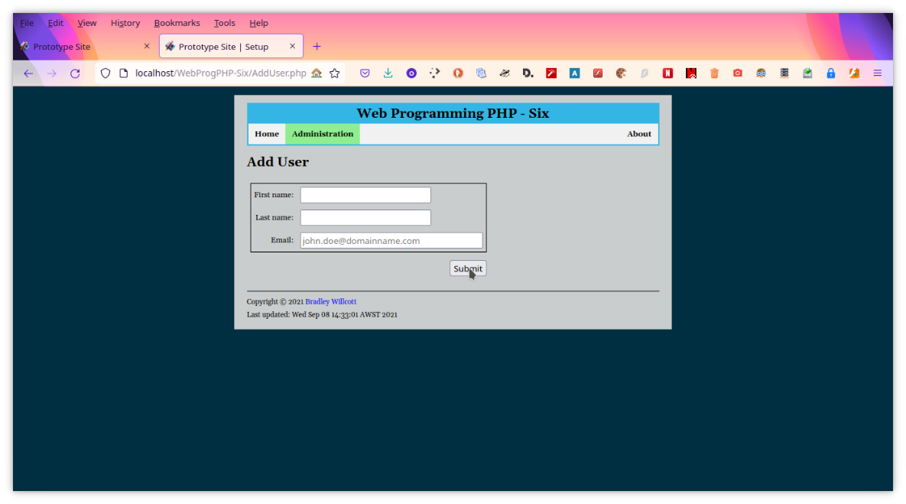

Figure 10 – Add user - B

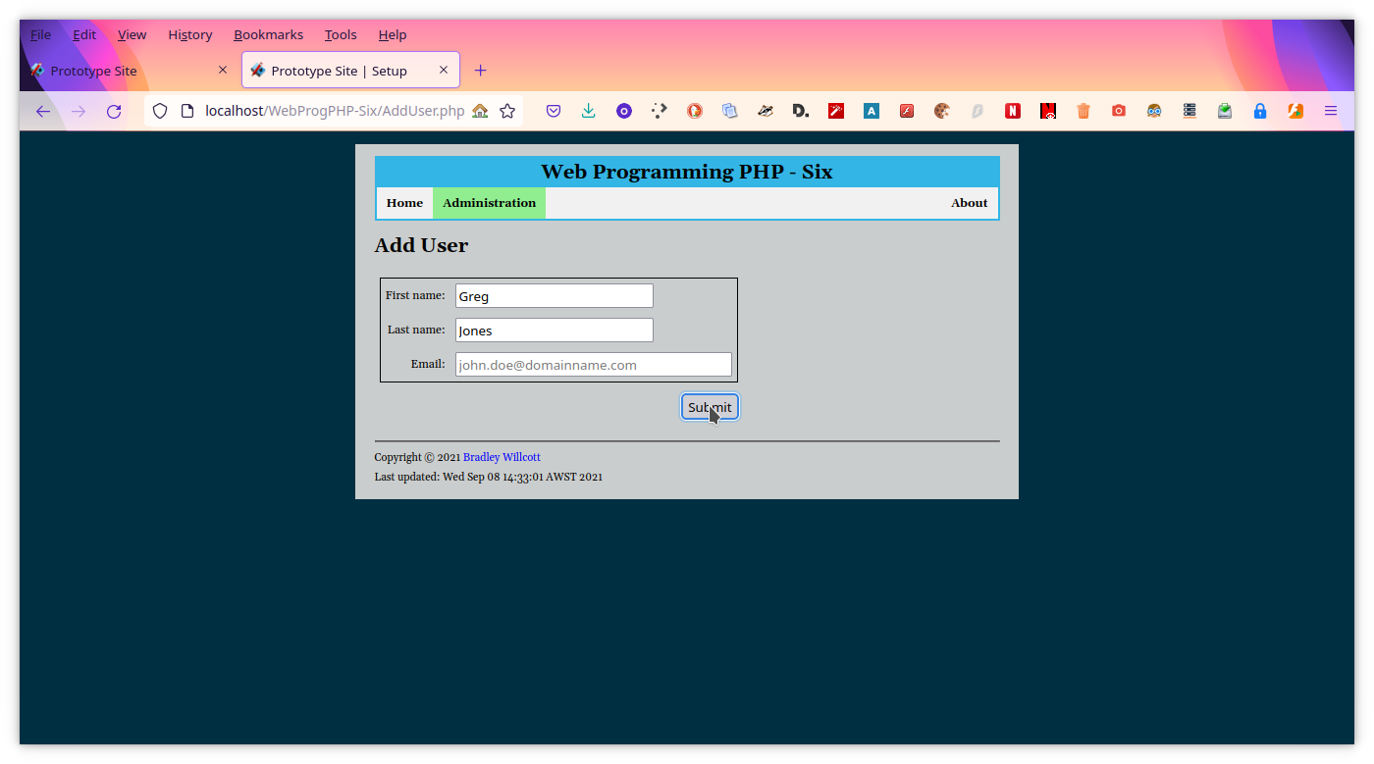

Figure 11 - Partial entry - A

Figure - Partial entry - B

Figure - Partial entry - C

Figure - Invalid email - A

Figure - Invalid email - B

Figure - Invalid email - C

# References