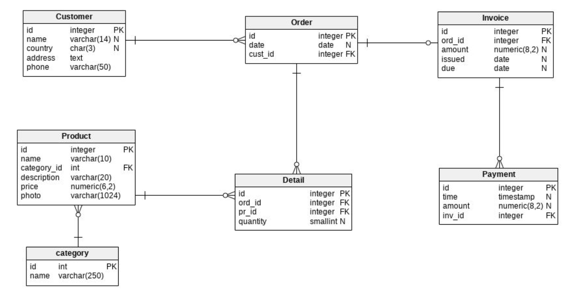

Tasks (Kapital bank -> real project Apelsin)

1.Shu Db sxemasini yaratib olish rasmga qarab.

2.Malumotlarni to’ldirish un insert zaproslarni yozish va ishlatish(customer,order,invoice,product,detail,category,payment kamida 5tadan)

3.Ma’lum bir customerga tegishli barcha orderlar ro’yxati()

4.Ma’lum bir orderga tegishli paymentlar ro’yxati

5.Ma’lum bir oraliqdagi barcha orderlar ro’yxati (2010-01-01 = > 2020-01-01)

6.Aynan qaysidir customerni orderini barcha infolari(masalan qanaqa mahsulot olgan nechta olgan nechchi pul bolgan xammasi)

7.Bitta order uchun bir nechta payment bo’lishi mn. Ortiqcha to’langan paymentlar qaysi invoicega tegishli ekanligi va qancha ortiqcha to’langanligi

8.10 tadan ko’p order(zakaz) qilingan mahsulotlarni ro’yxati

9.Har bir customerni eng oxirgi orderini ko’rsatish kerak.

10.2020-yilda umuman order(zakaz) qilmagan curstomerlar ro’yxati

11.2020-yildaa zakaz qilingan va country si Uzbekistan bo’lgan customerlar ularning barcha olgan productlari totali.

12.Ommaviy olinadigan productlar ro’yxati qachondr customer order qilganda kamida 8 ta shundan olgan bo’lishi kerak shu mahsulot nomi,price(agar shunaqa ommaviy mahsulot bo’lsa topilsin)

13. Eng qimmat 10 ta mahsulot ro’yxati

14. order qilishdan oldin berilgan(invoiceni issue si due date dan kattaroq)invoice(hisob fakturalar) invoice raqami,qaysi zakaz un ekanligi

15.Ma’lum bir yildagi eng ko’p sotib olingan mahsulotlar va ular qaysi countrydan olingani

Javoblar

3. **select** o.id, **date**, quantity, pr_id, p.name, p.price  
**from** orders o  
 **inner join** details **d on** o.id = **d**.ord_id  
 **inner join** product p **on** p.id = **d**.pr_id  
**where** cust_id = **'1'**;

4. **select** *\** **from** payment **join** invoice i **on** i.id = payment.inv_id  
 **join** orders **on** i.ord_id=orders.id **where** orders.id=**'1'**

5. **select** *\** **from** orders **where date between '2010-01-01' and '2021-01-01' order by date desc**

6.

**select** jami.id,jami.date, *sum*(total)  
**from** (**select** o.id, o.date, quantity * p.price **as** total  
 **from** orders o  
 **inner join** details **d on** o.id = **d**.ord_id  
 **inner join** product p **on** p.id = **d**.pr_id  
 ) **as** jami  
**group by** jami.date, jami.id

7. **select** i.ord_id,i.id,(*sum*(p.amount)-(i.amount)) **from** payment p  
 **inner join** invoice i **on** p.inv_id = i.id  
**group by** i.amount,i.ord_id,i.id

8. **select** *sum*(**d**.quantity),p.name **from** orders **inner join** details **d on** orders.id = **d**.ord_id **inner join** product p **on** p.id = **d**.pr_id  
**group by** p.name **having** *sum*(**d**.quantity)>**10**

9.   
**select name**, o.date  
**from** customer  
 **inner join** orders o **on** customer.id = o.cust_id  
**where** o.date **in** (**select** *max*(**date**) **from** orders **group by** orders.cust_id)  
**order by** o.date

10.   
**select distinct on**(customer.name) customer.name, o.date  
**from** customer  
 **inner join** orders o **on** customer.id = o.cust_id  
**where** o.date **not between '2020-01-01' and '2020-12-31' group by** customer.name,o.date

11. **select** *sum*(product.price*details.quantity) **as** total , customer.country,customer.name **from** customer **join** orders **using**(id) **join** details **using**(id)  
**inner join** product **using**(id) **where date between '2020-01-01' and '2020-12-31' and** country=**'Uzb' group by** customer.country,customer.name;

12. **select name**, price, **d**.quantity  
**from** product  
 **inner join** details **d on** product.id = **d**.pr_id  
 **inner join** orders o **on** o.id = **d**.ord_id **where d**.quantity >= **8**

13. select * from product order by price desc limit 10 ->

14. manosiz

15. **select** p.name, **d**.quantity, customer.country **from** customer **join** orders o **on** customer.id = o.cust_id  
**join** details **d on** o.id = **d**.ord_id **join** product p **on** p.id = **d**.pr_id  
**where date between '2020-01-01' and '2021-01-01'**;