实验六 微服务网关实践

【实验目的和要求】
- 上网搜索整理spring cloud中开源网关的资料；
- 加强熟悉JAVA开发环境：IDEA；
- 替换Fenix's Bookstore的网关组件以熟悉其作用
【实验步骤】

1. 上网搜索整理spring cloud中开源网关的资料
- 通过搜索引擎上网搜索整理spring cloud中开源网关的资料
- 关键字：Spring Cloud zuul、Spring Cloud gateway

2.了解springcloud中网关的作用
- 使用实验五中的nacos，启动startup.cmd

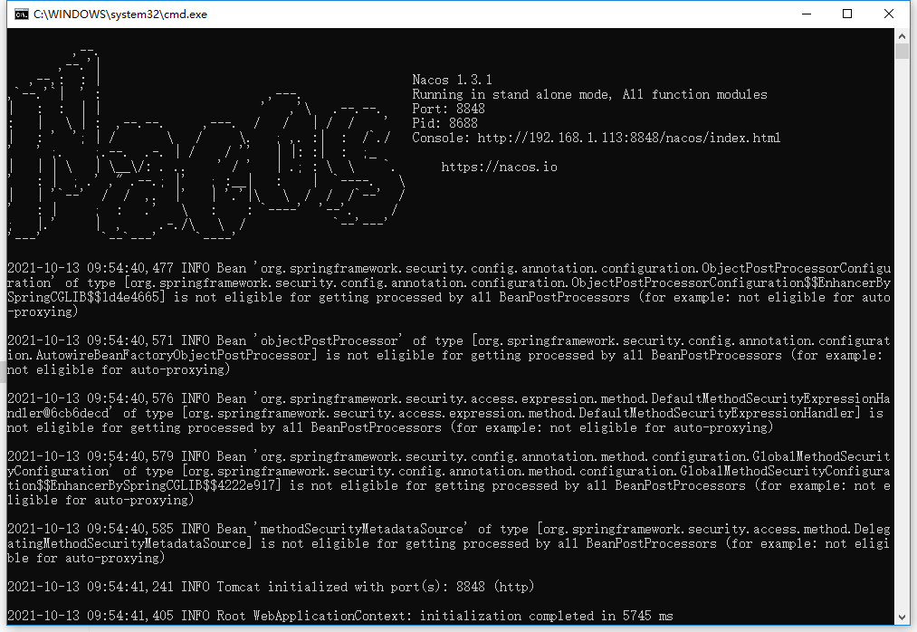

- 修改gatway的pom.xml，注释原有spring cloud zuul依赖，引入spring-cloud-starter-gateway依赖，reload maven修改启动类代码。

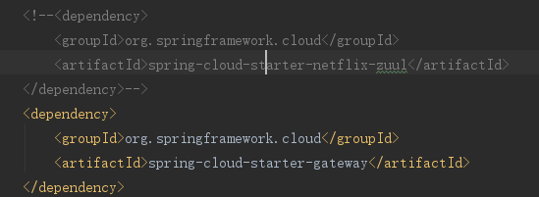
- 在启动类中删除zuul的import，并删除zuul的注解@EnableZuulProxy

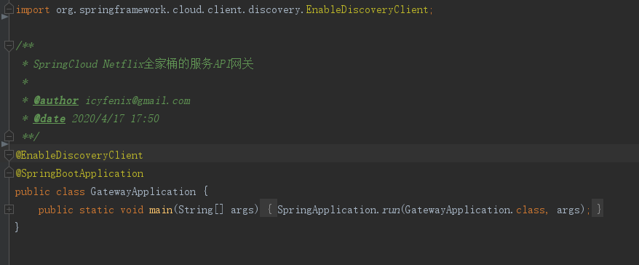

- 修改nacos的gateway.yaml配置文件

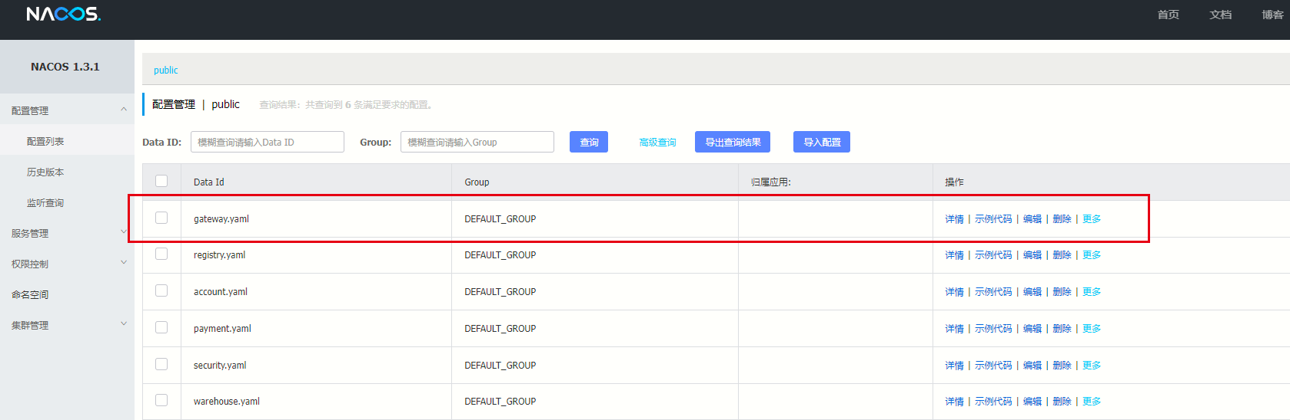
- eureka:
- client:
- serviceUrl:
- defaultZone: http://${REGISTRY_HOST:localhost}:${REGISTRY_PORT:8761}/eureka/
- spring:
- cloud:
- gateway:
- discovery:
- locator:
- # 开启从注册中心动态创建路由的功能，利用微服务名进行路由
- enabled: true
- # 忽略大小写匹配，默认为 false。
- # 当 eureka 自动大写 serviceId 时很有用。 所以 MYSERIVCE，会匹配 /myservice/**
- lowerCaseServiceId: true
- routes:
- - id: http
- uri: https://www.baidu.com/
- predicates:
- - Path=/restful/baidu/**
- # 某业务服务
- - id: account
- uri: lb://account
- predicates:
- - Path=/restful/accounts/**
- - id: payment
- uri: lb://payment
- predicates:
- - Path=/restful/pay/**,/restful/settlements/**
- - id: warehouse
- uri: lb://warehouse
- predicates:
- - Path=/restful/products/**,/restful/advertisements/**
- - id: security
- uri: lb://security
- predicates:
- - Path=/oauth/**

- hystrix:
- command:
- default:
- execution:
- isolation:
- thread:
- timeoutInMilliseconds: 20000
- warehouse:
- ribbon:
- # 代表Ribbon使用的负载均衡策略
- NFLoadBalancerRuleClassName: com.netflix.loadbalancer.RandomRule
- ribbon:
- ReadTimeout: 20000
- ConnectTimeout: 20000
- NFLoadBalancerRuleClassName: com.netflix.loadbalancer.RandomRule
- zuul:
- ignoredServices: '*'
- host:
- connect-timeout-millis: 20000
- socket-timeout-millis: 20000

- routes:
- #warehouse服务
- warehouse: /warehouse/**
- #角色服务
- spring-cloud-role: /role/**
- account1:
- path: /restful/accounts/**
- serviceId: account
- stripPrefix: false
- sensitiveHeaders: "*"

- payment:
- path: /restful/pay/**
- serviceId: payment
- stripPrefix: false
- sensitiveHeaders: "*"

- settlement:
- path: /restful/settlements/**
- serviceId: payment
- stripPrefix: false
- sensitiveHeaders: "*"

- advertisements:
- path: /restful/advertisements/**
- serviceId: warehouse
- stripPrefix: false
- sensitiveHeaders: "*"

- products:
- path: /restful/products/**
- serviceId: warehouse
- stripPrefix: false
- sensitiveHeaders: "*"

- security:
- path: /oauth/**
- serviceId: security
- stripPrefix: false
- sensitiveHeaders: "*"

- server:
- port: ${PORT:8080}

- logging:
- level:
- root: info

- 按照gateway、domain的顺序启动服务，启动成功后使用postman访问接口

http://127.0.0.1:8080/warehouse/restful/advertisements

http://127.0.0.1:8080/restful/baidu
- 
 