**Source Control**

**Questions to companies:**

* What is the current source control server for undergoing projects?
* Is the new project developed on single or multiple platforms?
* How many people will interact with the revision repository of the new project?
* Are developers going to work in one site or different sites?
* Is this position responsible for the setup of source control server?
* Why are there **two shell interfaces** for Git, Cygwin & msysGit?

Cygwin is a Linux shell, msysGit is a Windows shell.

* **Cygwin** **VS** **msysGit**?

|  |  |
| --- | --- |
| Cygwin | msysGit |
| **Support Chinese input and display perfectly** | Need specific configuration |
| Command line shell | **Provide visual shell TortoiseGit which integrated msysGit and windows file management** |

* **Traits of distributed revision control system** comparing with centralized revision control system.
* Revision repository is placed under the root of workspace.
* To secure repository, clone the repository and enable auto push.
* Editable username and email are not secure. Server repository can set up authentication (Gerrit).
* Why are **alias** used in Git?

Make it easier for CVS & SVN users to use CVS/SVN alike command in Git.

* Primary commands of **creating repository**

git init / git add / git commit / git config

* Benefits of Stage in Git
* **Traits** of Git **repository** implementation
  + Tree structure
  + Pointer reference
  + Stage
  + SHA1 hash
* Why not use **index** to mark submitting in Git?

Submitting is not in sequence in distributed revision control system, only universal unique number can identify submitting occurred at any time in anywhere.

* **Visual user tool** for Git
  + Why not use gitk, gitg, qgit? – They requires Linux or QT environment.
  + Why choose TortoiseGit? – Familiar to SVN users; free SW in windows; easy to port SVN repository to Git.
  + Install **TortoiseGit**
    - Read and follow setup instruction in <http://code.google.com/p/tortoisegit/wiki/SetupHowTo>, prerequisites: Windows Installer and Git for Windows. Check if the computer already installed Windows Installer: run->command window->msiexec.
    - Download installation package in <http://code.google.com/p/tortoisegit/wiki/Download> and execute it.
    - Refer to instruction in Youdao notes.
  + Install **gitk**
    - Much easier way is installing it in the Cygwin installation, just tick the “tcl –tk: Tcl X11 toolkit” in the package list.
    - The other way is downloading ActiveTcl Community Edition at <http://www.activestate.com/downloads#4> which is for windows and free.
    - Run the .exe to perform installation.
    - An error during installation, not sure to what extent it would affect the function, note down it here for future reference:



* Troubleshooting of running **gitk**
  + Run “$ gitk –all” in Cygwin, below error is displayed:

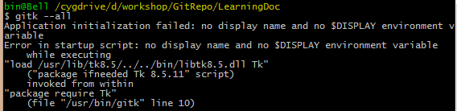

To solve this issue, install “XInit” in Cygwin installation by selecting the “XInit” package. Refer to Youdao notes for details.

* **Protocols** supported in Git and the corresponding URL. SSH, GIT and local are intelligent protocols.

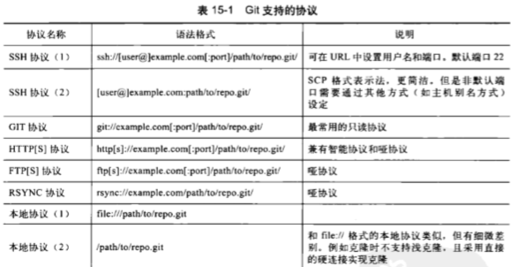

* A bare repository will be initiated under **Cygwin root drive** “C:\cygwin64” if only relative path is specified.



* **Ssh: could not resolve host name**



The issue occurred when push updats to remote repository. Reason is Cygwin recognises only paths in Cygwin format, the path of the remote repository was <file:///path/to/repo/shared.git>, later it was changed to C:\cygwin64\path\to\repo\shared.git when I clone repository for user2 in TortoiseGit.

To solve the issue, just specify the path in Cygwin:



* Disable non-fast-forward: $ git –git-dir=/path/to/repo/shared.git config \ receive.denyNonFastForwards true
* Source control tool cooperates with requirement and bug track tool?

Redmine?

**Chapter 5/6/7/8/9/10 to be read thoroughly to understand details of branches.**

**Chapter 7 – Git Reset -- unread.**

**Chapter 8 – Git Checkout – brief read.**

**Chapter 9 – Resume progress – brief read.**