**Привет! В этом документе содержаться ваши первые задания.**

Ваша задача:

1. Написать код для каждой задачи;
2. Скомпилировать в PyCharm или Python IDLE.
3. Закинуть в созданный вами репозиторий на GitHub.
4. До **27.02.2019** выполнить задания и отправить на WhatsUp **имя** вашего репозитория.

*\*Все задачи представлены на английском языке. Если есть вопросы по поводу перевода или условиям задачи,* ПОЖАЛУЙСТА НЕ СТЕСНЯЙТЕСЬ, СПРАШИВАЙТЕ, ПИШИТЕ В ГРУППУ!

**Удачи в выполнении!!!**

**№1 STRHH - Half of the half**

Given a sequence of 2\**k* characters, please print every second character from the first half of the sequence. Start printing with the first character.

**Input**

In the first line of input your are given the positive integer *t* (1<=*t*<=100) - the number of test cases. In the each of the next *t* lines, you are given a sequence of 2\**k* (1<=*k*<=100) characters.

**Output**

For each of the test cases please please print every second character from the first half of a given sequence (the first character should appear).

**Example**

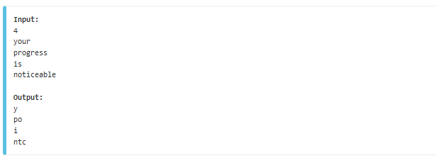

**№2 SMPWOW - Wow**

**Input**

Given a positive integer 0 < *x* < 50.

**Output**

Print one word: Wo...ow (letter o must be repeted *x* times).

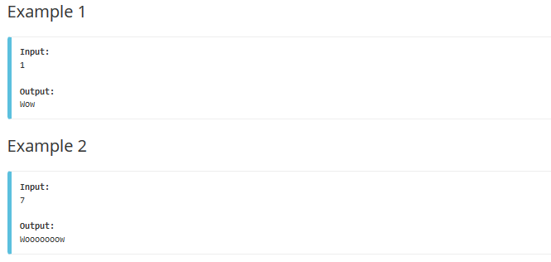

**№3 PRIME1 - Prime Generator**

Peter wants to generate some prime numbers for his cryptosystem. Help him! Your task is to generate all prime numbers between two given numbers!

**Input**

The input begins with the number t of test cases in a single line (t<=10). In each of the next t lines there are two numbers m and n (1 <= m <= n <= 1000000000, n-m<=100000) separated by a space.

**Output**

For every test case print all prime numbers p such that m <= p <= n, one number per line, test cases separated by an empty line.

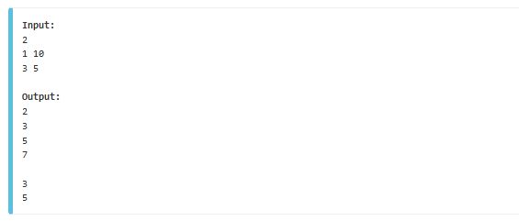

**№4 PALIN - The Next Palindrome**

A positive integer is called a *palindrome* if its representation in the decimal system is the same when read from left to right and from right to left. For a given positive integer *K* of not more than 1000000 digits, write the value of the smallest palindrome larger than *K* to output. Numbers are always displayed without leading zeros.

**Input**

The first line contains integer *t*, the number of test cases. Integers *K* are given in the next *t* lines.

**Output**

For each *K*, output the smallest palindrome larger than *K*.

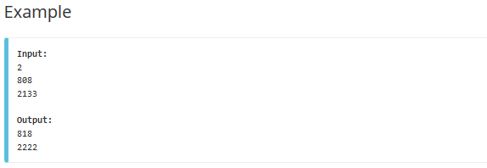

**№5 KPSUM - The Sum**

One of your friends wrote numbers 1, 2, 3, ..., N on the sheet of paper. After that he placed signs + and - between every pair of adjacent digits alternately. Now he wants to find the value of the expression he has made. Help him.   
  
For example, if N=12 then +1 -2 +3 -4 +5 -6 +7 -8 +9 -1+0 -1+1 -1+2 = 5

**Input**

Each line contains one integer number N (1≤ N ≤ 1015). Last line contains 0 and shouldn't be processed. Number of lines in the input does not exceed 40.

**Output**

For every line in the input write the answer on a separate line.

