**Привет! Все инструкции по выполнению остаются неизменными (см. Задачи 1)**

**Удачи в выполнении!**

**№1 Penney Game**

Penney’s game is a simple game typically played by two players.  One version of the game calls for each player to choose a unique three-coin sequence such as **HEADS TAILS HEADS (HTH)**.  A fair coin is tossed sequentially some number of times until one of the two sequences appears.  The player who chose the first sequence to appear wins the game.

For this problem, you will write a program that implements a variation on the Penney Game.  You willread a sequence of 40 coin tosses and determine how many times each three-coin sequence appears.  Obviously there are eight such three-coin sequences: **TTT**, **TTH**, **THT**, **THH**, **HTT**, **HTH**, **HHT** and **HHH**. Sequences may overlap.  For example, if all 40 coin tosses are heads, then the sequence HHH appears 38 times.

**Input**

The first line of input contains a single integer P, (1 ≤ P ≤ 1000), which is the number of data sets that follow.  Each data set consists of 2 lines.  The first line contains the data set number N.  The second line contains the sequence of 40 coin tosses.  Each toss is represented as an upper case H or an upper case T, for heads or tails, respectively.  There will be no spaces on any input line.

**Output**

For each data set there is one line of output.  It contains the data set number followed by a single space, followed by the number of occurrences of each three-coin sequence, in the order shown above, with a space between each one.  There should be a total of 9 space separated decimal integers on each output line.

**Example**

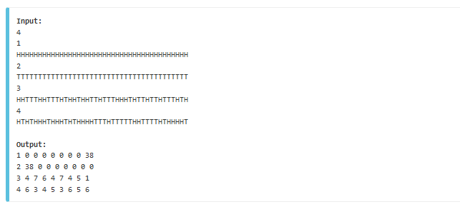

## №2 Black Widow Rings

Black Widow has a collection of **N** (numbered 1 to N) Rings. She uses the rings to attack the enemies. She has decided to use one ring for distraction. She will first throw the distraction ring and then all the other rings will be thrown through it (one at a time). Each ring has an inner and outer radius.

A ring R1 will pass through ring R2 only if the outer radius of R1 is less than the inner radius of R2.

If she can chose a distraction ring from the given collection print the index of the ring (1-based), else print -1.

### Input

The first line of the input contains an integer **T** denoting the number of test cases.  
The first line of each test case contains a single integer **N** denoting the number of Rings.  
Next **N** lines consists of Inner and Outer Radius of the ith Ring - **r**, **R**.

* **1** ≤ **T** ≤ **100**
* **2** ≤ **N** ≤ **1000**
* **1** ≤ **r** < **R** ≤ **107**

(**Edited: r** and **R** are integer)

### Output

For each test case print the desired result in separate line.

### Example

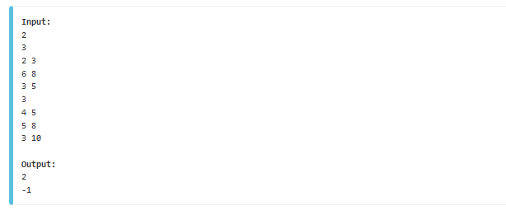

## №3 Beehive Numbers

A beehive is an enclosed structure in which some honey bee species live and raise their  
young. In this problem we consider a two-dimensional sketch of the beehives. Each  
beehive is composed of a certain number of cells, where each cell is a regular hexagon.  
Each cell may have some neighbors, which are other cells that share a side with that cell.  
A cell with exactly 6 neighbors is an internal cell, while a cell with fewer neighbors is an  
external one. Notice that an external cell can always be changed to internal by adding  
some neighbor cells.

We are interested in a particular class of beehives. This class of valid beehives is defined  
recursively as follows: a) a single cell is a valid beehive; and b) given a valid beehive B,  
if we add the minimum number of cells such that each external cell of B becomes an  
internal cell, the result is a valid beehive.

The number of cells in a valid beehive is called a beehive number. Given an integer N ,  
you must decide whether it is a beehive number.

### Input

Each test case is described using a single line. The line contains an integer N (1 ≤ N ≤  
109 ). The end of input is indicated with a line containing a single −1.

### Output

For each test case, output a single line containing an uppercase “Y” if N is a beehive  
number, or an uppercase “N” otherwise.

### Example

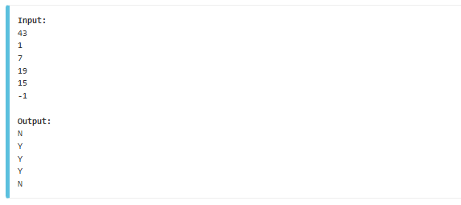

## №4 Wood, Axe and Grass

Danny has created a new civilization on a 2D grid. At the outset each grid location may be occupied by one of three life forms: Woods, Axe, or Grass. Each day, differing life forms occupying horizontally or vertically adjacent grid locations wage war. In each war, Woods always defeat Axe, Axe always defeat Grass, and Grass always defeat Woods. At the end of the day, the winner expands its territory to include the loser's grid position. The loser vacates the position.Determine the territory occupied by each life form after n days.

### Input

The first line of input contains t, the number of test cases. Each test case begins with three integers not greater than 100: r and c, the number of rows and columns in the grid, and n. The grid is represented by the r lines that follow, each with c characters. Each character in the grid is W, A, or G, indicating that it is occupied by Woods, Axe, or Grass respectively.

### Output

For each test case, print the grid as it appears at the end of the nth day.

### Example

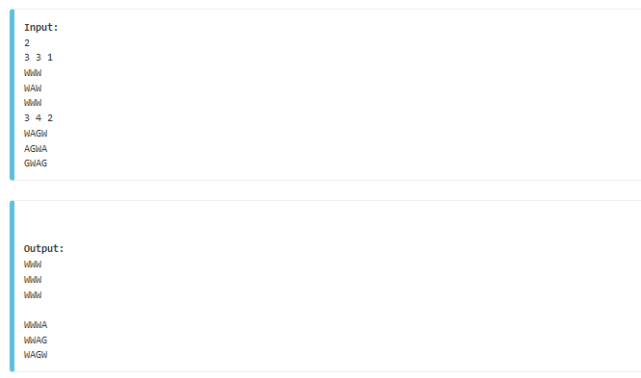

## №5 Silly Sort

Your younger brother has an assignment and needs some help. His teacher gave him a sequence of numbers to be sorted in ascending order. During the sorting process, the places of two numbers can be interchanged. Each interchange has a cost, which is the sum of the two numbers involved.

You must write a program that determines the minimal cost to sort the sequence of numbers.

### Input

The input file contains several test cases. Each test case consists of two lines. The first line contains a single integer n (n>1), representing the number of items to be sorted. The second line contains n different integers (each positive and less than 1000), which are the numbers to be sorted.

The input is terminated by a zero on a line by itself.

### Output

For each test case, the output is a single line containing the test case number and the minimal cost of sorting the numbers in the test case.

Place a blank line after the output of each test case.

### Example

