|  |  |  |  |  |
| --- | --- | --- | --- | --- |
|  |  | New Network addreess |  | First avail ip ADDRESS |
| VLAN 10 | Users | 192.168.0.0 | 255.255.254.0 | 192.168.0.1 vitual ip hsrp |
| VLAN 20 | Finance | 192.168.2.0 | 255.255.254.0 | 192.168.2.1 |
| VLAN 30 | Sales | 192.168.4.0 | 255.255.254.0 | 192.168.4.1 |
| VLAN 40 | Corp | 192.168.6.0 | 255.255.254.0 | 192.168.6.1 |
| VLAN 99  (default gateway) | Management | 192.168.8.0 | 255.255.240.0 | 192.168.8.1 |
| Vlan 50 | Router-connect | 10.10.10.8 | 255.255.255.252 | 10.10.10.9 - 10.10.10.10 |

sn

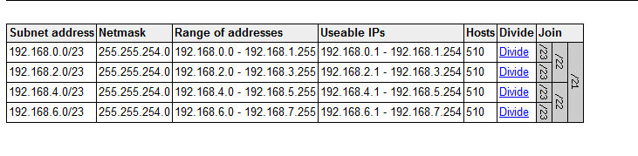

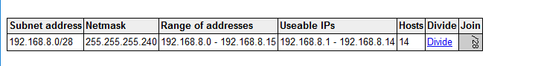

**Vlan 99** 255.255.240.0

|  |  |  |  |
| --- | --- | --- | --- |
| Dist_Switch_1 | 192.168.8.2 | .240 /28 |  |
| Dist_Switch_2 | 192.168.8.3 | .240 /28 |  |
| Acc_Switch_1 | 192.168.8.4 | .240 /28 |  |
| Acc_Switch_2 | 192.168.8.5 | .240 /28 |  |
| Acc_Switch_3 | 192.168.8.6 | .240 /28 |  |
|  |  |  |  |

Vlan 50

Dist 1 10.10.10.9 - dist 210.10.10.10

**End devices**

|  |  |  |  |
| --- | --- | --- | --- |
| Name | Vlan + IP | Subnet | Gateway |
| PC_Sales vlan 30 | Vlan 10 192.168.0.2 | 255.255.254.0 | 192.168.0.1 |
| HO_User | Vlan 20 192.168.2.2 | 255.255.254.0 | 192.168.2.1 |
| PC_Corp | Vlan 30 192.168.4.2 | 255.255.254.0 | 192.168.4.1 |
| PC_Finance | Vlan 40 192.168.6.2 | 255.255.254.0 | 192.168.6.1 |
|  |  |  |  |

**Dist_Switch_1**

|  |  |  |  |
| --- | --- | --- | --- |
| Fa0/1 | Connection to Acc_Switch_1 | 10,20,30,40,99 |  |
| Fa0/2 | Connection to Acc_Switch_1 | 10,20,30,40,99 |  |
| Fa0/3 | to Acc_Switch_2 | 10,20,30,40,99 |  |
| Fa0/4 | to Acc_Switch_2 | 10,20,30,40,99 |  |
| Fa0/5 | to Acc_Switch_3 | 10,20,30,40,99 |  |
| Fa0/7 | to Acc_Switch_3 | 10,20,30,40,99 |  |
| Fa0/8 | to Acc_Switch_3 | 10,20,30,40,99 |  |
| Fa0/9 | To Dist_Switch_2 | 10,20,30,40,99 |  |
| G0/1 | description Connection to Head Office Router 1 | 10,20,30,40,99 |  |

**Dist_Switch_2**

|  |  |  |  |
| --- | --- | --- | --- |
| Fa0/1 | Connection to Acc_Switch_2 | 10,20,30,40,99 |  |
| Fa0/2 | Connection to Acc_Switch_2 | 10,20,30,40,99 |  |
| Fa0/3 | to Acc_Switch_1 | 10,20,30,40,99 |  |
| Fa0/4 | to Acc_Switch_1 | 10,20,30,40,99 |  |
| Fa0/5 | to Acc_Switch_3 | 10,20,30,40,99 |  |
| Fa0/7 | To Dist_Switch_2 | 10,20,30,40,99 |  |
| Fa0/8 | to Acc_Switch_3 | 10,20,30,40,99 |  |
| Fa0/9 | To Dist_Switch_2 | 10,20,30,40,99 |  |
| G0/1 | description Connection to Head Office Router 2 | 10,20,30,40,99 |  |

HO LAN Routers

|  |  |  |  |
| --- | --- | --- | --- |
| HO Router 1 |  |  |  |
| Int g0/1 | description Connection to Head Office Router 2 | 192.168.0.2 | 255.255.255.252 |
| int s0/1/0 | description Connection to Site 1 Router 1 S | 192.168.0.1 | 255.255.255.252 |
|  |  |  |  |
|  |  |  |  |

4. <root bridge description>

6

Using portfast allows interfaces to connect to the network immediately, nbypassing the listening and learning states.Ports with the portfast command enabled are activated 6 times faster than a port using spanning tree. Portfast can only be enabled on access ports which accelerates the transition to a forwarding state. By ensuring we issue the portfast command on the appropriate interfaces we can increase the speed of our network.

7

The purpose of bpdu portfast guard is to disable all non-trunking ports from participating in the Spanning Tree Protocol process. Spanning tree can be problematic in the instance a switching loop occurs. When you apply BPDU guard on a switch, spanning tree will apply it to all portfast interfaces.

Ensure all switches do not participate in VTP. Explain why it is good to do this. [5 marks]

If you are confident with VTP it can be incredibly helpful as other devices can inherit vlans created on a single switch, as opposed to having to configure vlans manually on each and every switch. The danger with VTP lies in creating new vlans as a simple error could make a big mess. As long as the VTP revision number is greater than the vlan being replaced, thigs will be okay. If the number was lower, then this would affect other vlan configurations on the network, meaning the affected vlans would no longer work.VTP also leaves to room for human error to create a bigger mess than usual. Because we are working on a reasonably small network and because my VTP knowledge isn’t strong, it makes sense that we would not implement VTP on this network.

**vtp mode transparent**

**Holan routers**

**5 – premption**

**<document what pre-emption does>**

**HO_R1**

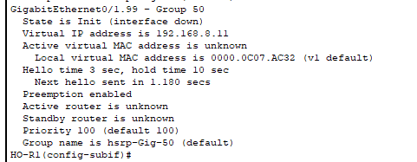

**HOR2**

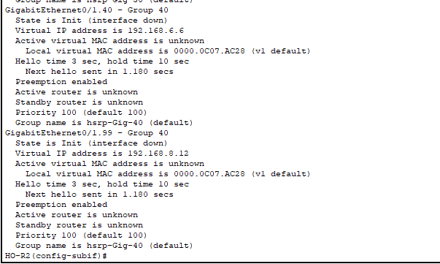

Describe the normal process for DR election. Describe how you influenced it to achieve the desired result.

Md 5 authentication

