# Week 12 Lab 1 Databases 3 Practical:

# User Accounts and Privileges 1 of 2

## Creating a new database

## Note – These tasks are to be completed on your database server running in a container under Docker.

## You have been given the task of creating a database for a car sales yard.

1. Open SQL Server management studio, connecting as SA to your containerized database.
2. On the object explorer panel, right click on "Databases" and select "New Database". Maximize the dialog box
3. In the database name field, type Cars. Make sure to set the owner "sa"
4. Under the database files section, take note of the columns and their values

Logical name, File Type, Filegroup, Initial Size, Autogrowth/Maxsize, Path File, Name

Cars_test, ROWS Data, PRIMARY, 8, By 64MB, Unlimited, /var/opt/mssql/data, blank

Cars_test_log, LOG, N/A, 8, By 64MB, Unlimited, /var/opt/mssql/data, blan

1. Enter "Cars.mdf" for the default primary data file's file name
2. Enter "Cars.ldf" for the default primary log file's file name.
3. The "Logical Name" is different to the "File Name". Describe what each one means. The logical name is

The logical name is what is displayed in user defined applications. A sysadmin specifies the logical name when creating the index. Here we might name the thing “Social Security Number” or something that the user will understand

The file name, or physical name, is the name the database uses to identify the table. This name is unique and system defined. Here “Social Security Number” wont do and the name will demominate this same object in a way that makes sense to the database, eg “soc_sec_num”

1. Click the script button at the top, and then check the query window to see the generated script. You can cancel out of the database creation dialog window.
2. A query window will have opened showing the scripts that will be run to create the Cars database with the options we just specified. Familiarize yourself with this process. You will be expected to create a databases for multiple users via a script.
3. Select "Master" as the database to execute the query on and click execute.
4. Close the query and refresh the database list.

## Creating new schemas and tables

## We are going to create new schemas to demonstrate their usefulness. We will be applying user permissions to schemas to allow fine-tuned access to any tables contained in the schema.

1. Create three new schemas from the code below

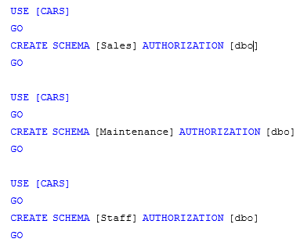

1. What is meant by the authorization clause?

Authorization is how the db discriminates between admins, users and their level of access

1. Let’s examine **(not run)** the CREATE TABLE syntax for use with a schema.

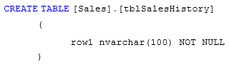

1. Now we have three new schemas, we will create some tables

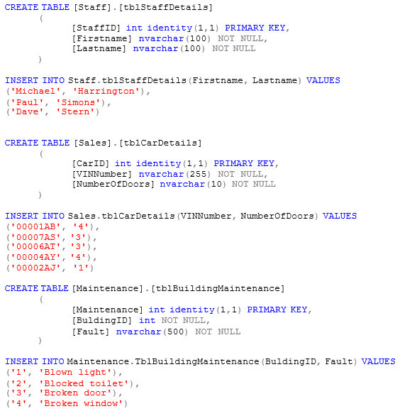

# Creating new logins and database users

## To allow humans to access the SQL Server database engine they first need a SQL Server login, which is created by the create login command. To then access a database they need a database user account which is mapped to their SQL Server login.

## Expand the security object from the tree in the object explorer

## Expand logins

1. This is the GUI container for all SQL Server logins that are present on the server. Where is DBMS getting this information from?

## A windows user is created in the Active Directory and assigned a SID to access domain resources.

1. There are some built in logins that are required for SQL Server to function correctly, list the login that is installed by default and cannot be removed.

##MS_PolicyEventProcessingLogin##,

##MS_PolicyTsqlExecutionLogin##,

BUILTIN\Administrators,

sa

1. Right click on the logins container and select "New Login"
2. We want to create a new login called Mary. Select SQL Server authentication
3. Enter "ComplexP@ssw0rd" for the password.
4. Un‐tick "User must change password at next login".
5. Click the script button and click cancel.
6. Make sure you understand this command syntax
7. Execute this script
8. Change it so that it will create a login for the username "Mike" with the password "veryComplexP@ssw0rd"
9. Using the object explorer connect tool, open a connection to your SQL Server using Mary's account.

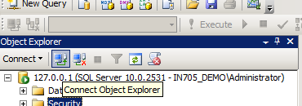

## Your object explorer should look like the following

## Using the Mary connection, expand databases then cars

1. Were you able to? _______________nope_______________________________________________

Why?

Because Mary does not have the correct permission to view cars, which was created from the admin dbo

## Under your first connection (this should be your administrative account) expand databases then expand cars

## Expand security then users, right click on users and select "New User"

## Enter Mary for the username and the login name. Enter "dbo" for the default schema

At this point, take a look at the available options for database role membership. Do not select any of the check boxes

1. Click the script button and click cancel
2. Make sure you understand this command syntax
3. Execute the commands
4. Expand schemas. Where did the maintenance, sales and staff schemas come from?

Because we have given Mary authority to access the same dbo object as admin ______________________________________________________________

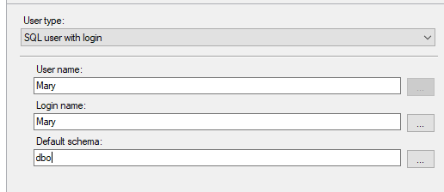

_________________________________________________________________________

1. Open the Maintenance schema and select permissions
2. Click search and look for the database user Mary. Select this user
3. Give Mary permissions to select **ONLY**. Click the script button and click cancel
4. Make sure you understand this command syntax
5. Execute the commands
6. What does "With Grant" mean?

With Grant means that the user, Mary, will be able to pass on permissions to other users. Grant would mean Mary had those permissions but couldn’t pass them on.

1. Collapse the connection tree for your administrative connection to the SQL Server and expand the one for the Mary connection. Your object explorer should now look like this (plus a few extra directories).

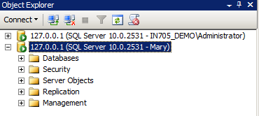

1. What do you think Mary will be able to access now?

I think Mary will be able to access the Cars tables and schemas. I don’t know if she’ll be able to modify data as we only gave her select permissions

1. Expand databases then try expanding the cars database
2. What tables can you see under the Mary connection?

System, File, External, Graph and Maintenance.tblBuildingMaintenance

1. Why can't we see the other tables using the Mary connection?

Because we updated permissions on the Maintenance schema only, not sales or staff

1. Right click on the cars database using the Mary connection, and select "New Query"
2. Run SELECT * FROM Maintenance.tblBuildingMaintenance
3. Did you get rows returned? Yes – as expected ^_^

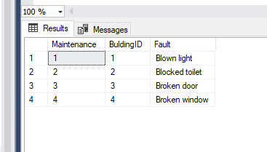

1. Run DELETE FROM Maintenance.tblBuildingMaintenance
2. What was the result

Permission denied

Even though we didn't set any deny permissions, by default, if a user is not granted with a permission the default action is to deny

1. Discuss how SQL Server knew not to let the delete command run. Also, how could we have enabled the select permission by default? The server knew not to run the delete command as we only gave Mary Select permission over the Maintenance schema. I’m not sure what is meant by default? I did some research and

*grant select on all tables in schema Cars to Mary*

seemed like an appropriate answer?

If we wanted to assign select (read) permissions to all the tables in the database, without using schemas, how could we do this?

GRANT SELECT permissions on all databases