|  |
| --- |
| PENANG |
|  |

|  |  |
| --- | --- |
| AUG 2017 | Penang tourism website |

|  |
| --- |
| ICT1102 INTRODUCTION TO INTERNET TECHNOLOGY PROJECT REPORT |

PENANG

Penang tourism website

# INDEX

The homepage of the website

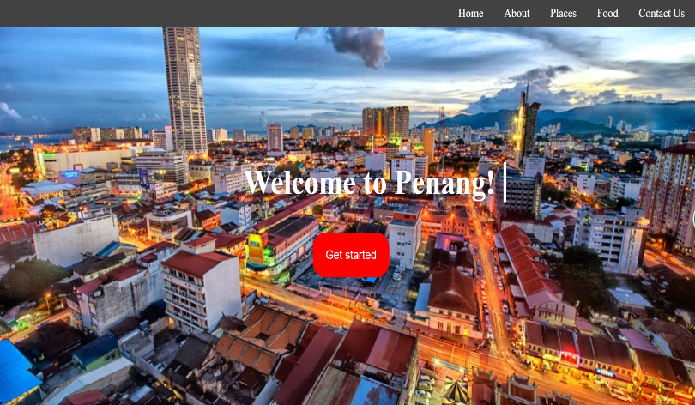

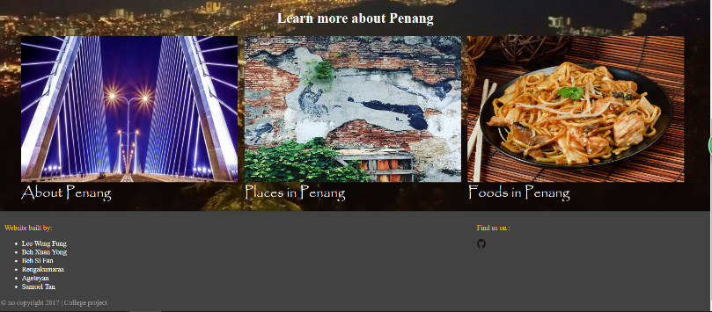

Every webpage consists of same header and footer. The header contains horizontal navigation bar form by unordered list and using inline display (CSS) to make it horizontal. The horizontal bar will also change the colour when hover to the word. The effect is done by using :hover element in CSS. The footer consists of name of every group member and link to github repository.

Furthermore, every webpage in the website is link to flexboxgrid library and jquery library, which being link by using CDN of the library. Every webpage also come with fadeIn effect, applied using @keyframes in CSS during the beginning of finish loading webpage.

In Index.html, it first serves with auto-type “Welcome to Penang” then a button “Get started” with bounce animation. The background image is also serve with parallax effect, which done by using background-attachment property in CSS. After click the “Get started” button, the webpage will bring to “Learn more about Penang”. The effect is done by jquery to change the CSS from display: none to display: block and scroll to the part. “Learn more about Penang” consists 3 pictures that link to about.html, places.html and food.html.

## Heading 2|two

Think a report that looks this good has to be difficult to format? Think again! To easily apply any text formatting you see in this document, on the Home tab of the ribbon, check out Styles. Some of the sample text in this document indicates the name of the style applied, so that you can easily apply the same formatting again. For example, this is the Normal style.

Quote

### Heading 3|three

View, edit, and seamlessly save your document to the cloud from Word on your Windows, Mac, Android, or iOS device.