Addis Ababa University
Data Science and Cloud Computing in Bioinformatics

Module 8

Big Data Analytics

Assignment 8

Name: Beyene Chalchisa
ID N_{O}: GSR/4596/18

1. Explain the 5 Vs of Big Data—Volume, Velocity, Variety, Veracity, and Value—and provide one relevant bioinformatics example for each.
Big Data involves very large volumes of data being created rapidly and having various characteristics, which require special tools for storage and analysis.
The 5Vs of Big Data involve five key features of big data.

1.Volume: The enormous amount of data generated, stored, and analyzed.

For example, Whole-genome sequencing produces big files that include FASTQ, BAM, and VCF files. Storage of thousands of genomes needs considerable storage space.

2.Velocity: The speed at which data are generated, transferred, and processed.

Example, in genomic sequencing, DNA sequencers can generate millions of sequencings reads continuously.
3. Variety: The different types, formats, and sources of data. For example, In bioinformatics, data can come in many forms, such as DNA sequences (FASTA), sequencing reads (FASTQ), gene-expression data (CSV), clinical records (Excel/CSV), and protein structures (PDB).
4.Veracity: The accuracy, reliability, completeness, and quality of data.

For example, Quality control, read alignment, variant filtering, and validation contribute to reducing the errors in genomic analysis.

5. Value: The useful biological or clinical knowledge obtained from data. For example, Genomic data analysis can help detect disease variants, develop drugs, and understand biological mechanisms.

2. A population genomics study creates 10,000 whole genomes with approximately 100 GB of data for each genome. Compute the total storage requirement and describe three major computational challenges faced when storing and analyzing the data set.

Answer:

Storage Calculation

Given:
- Number of whole genomes = 10,000
- Data per genome = 100 GB

Formula:

Total storage = Number of genomes × Data per genome

Calculation: =10,000×100 GB

=1,000,000 GB

Using the decimal storage system:

1,000,000 GB = 1,000 TB = 1 PB

Total storage requirement is 1 petabyte (PB)
Assuming 100 GB per genome and decimal storage units.
Th three major computational challenges
1. Storage and data management
- Use distributed storage systems such as HDFS or cloud object storage.
- Compress sequencing data using formats such as CRAM where appropriate.
- Organize data using standardized directory structures and metadata.
- Maintain backups and access controls.
2. High computational demands
- Implement High Performance Computing (HPC) cluster solutions.
- Concurrently perform genomic analyses that can be done independently.
- Use distributed computing tools like Apache Spark where appropriate.
3. Data transfer and analysis time
- Process data close to where they are stored (data locality).
- Use parallel data transfer and appropriate compression.
- Analyze data in partitions rather than transferring the entire dataset.
- Use cloud or HPC resources located near the data.

3. Compare traditional single-machine computing, HPC, and distributed Big Data computing for bioinformatics. Give a biological analysis example for which each approach would be appropriate.

Answer:
These three computing approaches differ in their processing capacity, storage capabilities, scalability, and suitability for different bioinformatics tasks.

- Comparison
Feature | Single-machine computing | High-Performance Computing (HPC) | Distributed Big Data computing
Definition | Uses one computer for data storage and processing. | Uses a cluster of interconnected computers to perform computationally intensive tasks. | Uses multiple interconnected computers to store and process very large datasets, often across distributed storage systems.
Processing | Uses one computer's CPU and memory. | Uses multiple CPUs and computing nodes, often with parallel processing. | Distributes data and computations across multiple machines.
Storage | Local disk or attached storage. | Shared or parallel file systems are commonly used. | Distributed file systems or cloud object storage.
Scalability | Limited by hardware capacity. | Can scale by adding computing nodes. | Can scale horizontally by adding machines and storage.
Data size | Small to moderate datasets. | Moderate to very large datasets, depending on the cluster. | Very large datasets, potentially petabytes.
Cost | Generally low for small projects. | Requires access to a cluster and associated resources. | Costs depend on infrastructure, data transfer, and computing usage.
Common tools | Python, R, Bioconductor, pandas. | SLURM, MPI, OpenMP, GATK, BWA. | Apache Spark, Hadoop, HDFS, cloud storage.
Main limitation | Limited CPU, memory, and storage. | Requires cluster management and suitable parallelization. | Distributed processing introduces data communication and management overhead.

Examples of biological analysis

1. Single Machine Computing

Small scale data

Example: Calculation of GC content and base pair composition of 100 bacterial genomes with the help of Python programming.

A single computer is sufficient to do such an analysis without having a computing cluster.

2. High Performance Computing (HPC)

Example: Whole genome alignment of reads and variant calling for 100 genomes of humans.

HPC helps us to run several samples or computations simultaneously.

3. Distributed Big Data Computing

Large scale data

Example: Analysis of millions of genomic variations present in 10,000 humans to find population specific variations or rare variations.

Distributed computing is helpful as the data set can be distributed across multiple computers.

4. Define the following terms: distributed storage, data partitioning, data locality, MapReduce, and Apache Spark. In what ways would these help in the analysis of large genomic datasets?
Answer:
A. Distributed storage
Distributed storage is a type of storage system which stores data in multiple connected computers rather than storing data in one computer.
Example: The Hadoop Distributed File System (HDFS) distributes the large genomic files in multiple storage nodes.

. Benefits in bioinformatics:
- Store’s datasets larger than the capacity of a single computer.
- Supports parallel access to data.
- Can provide fault tolerance through data replication.
- Allows storage capacity to grow by adding nodes.

B, Data partitioning

Data partitioning is the division of a large set of data into smaller sets known as partitions.

A set of 5,000 individuals can, for instance, be partitioned into 10 partitions each holding 500 individuals.
Benefits in bioinformatics:
- Enables parallel processing of different partitions.
- Reduces the memory required by individual processing tasks.
- Allows large datasets to be analyzed in smaller batches.
- Makes it easier to distribute workloads across computing nodes.
C. Data locality: Data locality involves processing data where the data is stored in the computer and not transmitting a lot of data over the network.
Example: For instance, when chromosome 1 data are stored on a particular node, then the processing task can be done by that particular node to process the chromosome 1 data.
Advantages of data locality in bioinformatics include:
- Less transfer of data unnecessarily
- Less network congestion
- Makes processing of data-intensive tasks more efficient
- Less time taken to transmit large sequencing files.
D. MapReduce: This refers to a parallel programming framework which breaks down a large computation problem into two components: the map phase and the reduce phase.
- The map phase involves processing of individual data records or partitions and creation of intermediate key-value pairs.
- The reduce phase involves combination of intermediate data items sharing the same key into final results.
Bioinformatics example: Nucleotide frequency count
Assuming there are three DNA sequences as follows:
Sequence 1: ATGC
Sequence 2: ATTA
Sequence 3: GGCA
Step 1: The map
Sequence | A | T | G | C
ATGC | 1 | 1 | 1 | 1
ATTA | 2 | 2 | 0 | 0
GGCA | 1 | 0 | 2 | 1

Step 2: Reduce
The intermediate counts are combined.
Nucleotide | Total count
A | 4
T | 3
G | 3
C | 2
Total | 12
E. Apache Spark: Apache Spark is an open-source distributed computing framework designed to process large datasets across multiple computers.
It supports distributed processing using in-memory computation when appropriate, as well as disk-based processing.
Important features:
  - Distributed data processing.
  - In-memory caching for repeated operations.
  - Support for Python, R, Scala, and Java.
  - DataFrame and SQL interfaces.
  - Integration with distributed storage systems.

F. How these concepts improve genomic data analysis
Concept | How it improves analysis
Distributed storage | Provides scalable storage for large datasets.
Data partitioning | Divides large tasks into smaller parallel tasks.
Data locality | Reduces unnecessary network transfers.
MapReduce | Enables parallel processing and aggregation.
Apache Spark | Supports distributed, reusable, and efficient data processing.

5. You have a dataset containing millions of genomic variants from 5,000 individuals. Design a scalable Big Data Analytics workflow to identify high-quality rare variants and genes enriched for rare variants. Include data storage, quality filtering, distributed processing, analysis, biological interpretation, and reproducibility.
Answer:

Workflow and Activity
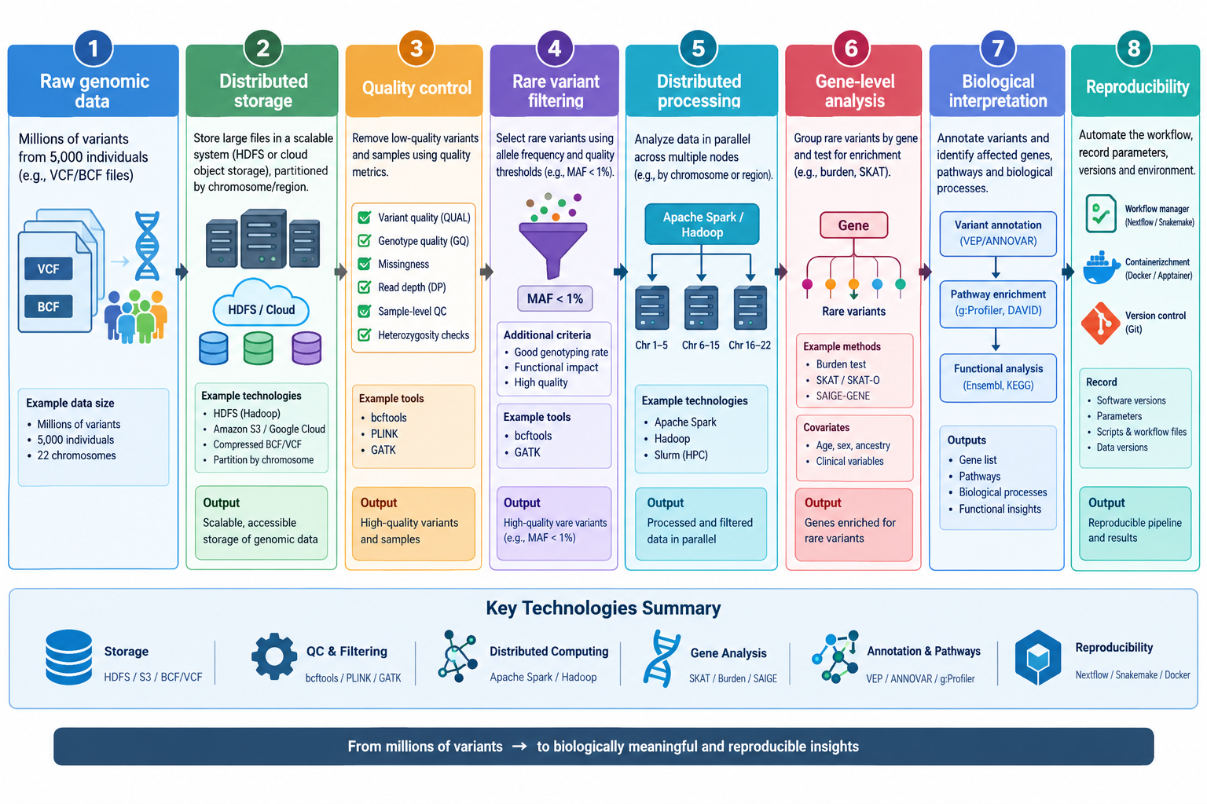
Step | Activity
1. Data storage | Store large VCF/BCF files in distributed storage rather than a single computer.
2. Quality control | Remove low-quality variants and samples using quality metrics.
3. Variant filtering | Select rare variants using allele frequency and quality thresholds.
4. Distributed processing | Process chromosomes or genomic regions in parallel across multiple computing nodes.
5. Rare variant analysis | Group rare variants by gene and test whether genes contain an excess of rare variants.
6. Biological interpretation | Annotate variants and identify affected genes and biological pathways.

