**Google News Personalization: Scalable Online**

**Collaborative Filtering**

Collaborative filtering：

1. **Memory-based algorithms**

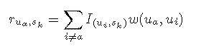

1. **Model-based algorithms**

i)latent semantic indexing(LSI)

ii)Bayesian clustering

iii)probabilistic latent semantic indexing (PLSI)

iv)multiple multiplicative Factor Model

v)Markov Decision process

v)Latent Dirichlet Allocation(LDA)