Nice paper title

# Introduction

DNA content is practically the same across all cells in an organism, but different cell types are capable of executing different functions. This is due to extensive regulation of the several processes involved in the production of a functional protein from its encoding gene.

* Biology of gene regulation
  + Transcription process
  + Transcription Factors
  + DNA methylation
  + Histone modifications / chromatin state

Epigenetic modifications, such as DNA methylation and histone modifications, also impact DNA structure and thus change how accessible it is to the transcriptional machinery.

* Methods for learning gene regulatory networks
  + Correlation as intro
  + Limitations of correlation
  + Linear regression vs mutual information

Analysis of gene-gene correlation is limited in multiple ways. Firstly, the expression of a gene is usually regulated by a variety of factors (e.g. different transcription factors)1, but gene-gene correlation is limited to independent analysis of gene pairs. Secondly, correlation is a symmetric measure of association that cannot be used for quantitative predictions. Thirdly, many indirect effects (i.e. correlations that exist between two genes due to the correlation of both to a third gene) are included in this way, which can lead to many false positive associations. The use of linear regression approaches can overcome these limitations by modelling quantitatively the impact of multiple genes in the expression of another (target) gene. By incorporating the L1 penalty in a regularized regression model, the number of predictive genes for a target can be minimized. Additionally, computation of partial correlations allows for the capture of indirect effects that can then be removed from the network.

In this work, we show that gene correlation is largely invariant across tissues. This motivates the learning of a global Gene Regulatory Network (GRN) based on regularized regression, expected to capture regulatory relationships between genes that are valid across different tissues and cell types. We show that this is indeed the case.

* Choice of data
* Loss of gene regulation with age

# Results

## Gene-gene correlation is largely invariant across tissues

<FRANCISCO’S HEATMAPS, WITH CROSS TISSUE ON TOP AND THEN TISSUE-SPECIFIC CORRELATIONS>

## Gene regulatory networks capture invariant gene-gene relationships

Gene-gene correlation analysis is limited to one gene pair at a time, includes many indirect effects and offers no predictive information. In order to overcome these issues, we used regularized regression (Lasso) combined with stability selection to identify stable predictors for each gene. These were then combined into a quantitative linear model that explains expression patterns of a given gene based on the expression patterns of their predictors (see Methods).

Figure 1: Distribution of centrality measures in the full human network. Residual edges were removed (see Methods).

* In-degree distribution is bimodal with indirect effects and becomes a power-law when they are removed. Why? We expect biological networks to be scale-free (i.e. the degree distribution can be modelled with a power law distribution), so this would suggest the network without indirect effects is more meaningful.
* Genes with high out-degree also have high in-degree (hubs).
* Transcription factors are not enriched in high out-degrees (not even after removing indirect effects), suggesting we actually don’t capture direct relationships between regulator and target, but rather a connection between the targets.

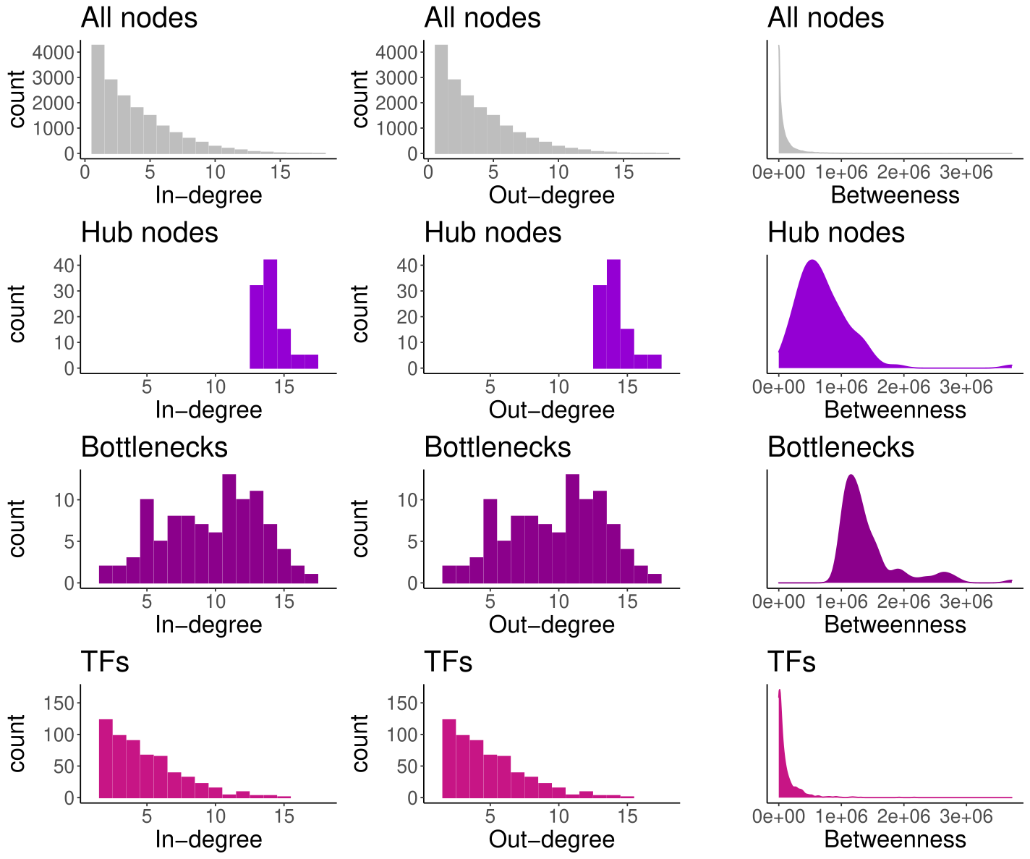

Figure 2: Distribution of centrality measures in the human network after removal of indirect effects. Residual edges were removed (see Methods).

<DECIDE WHICH NETWORK – FULL OR WITH NO INDIRECT EFFECTS – TO SHOW IN THE MAIN TEXT>

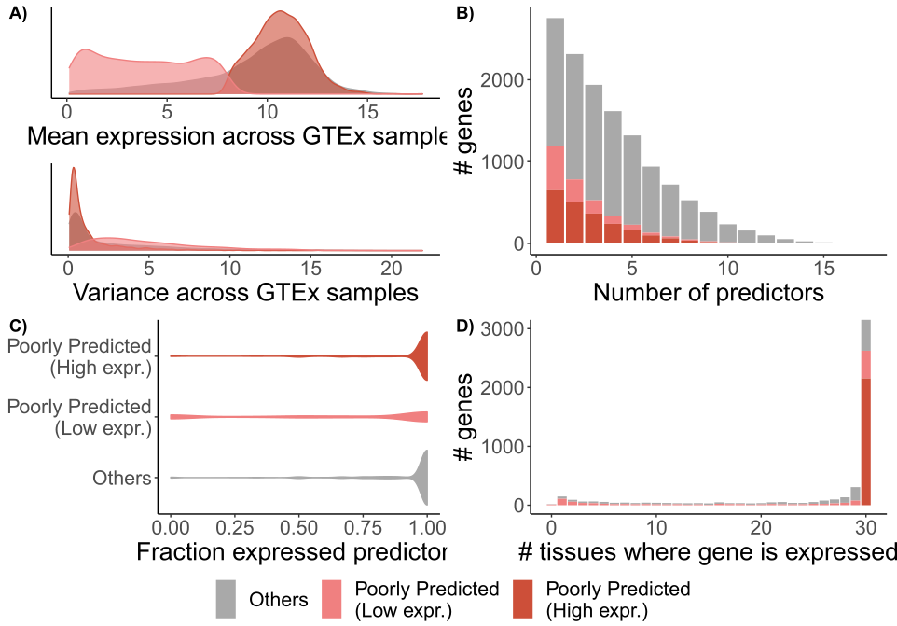

Figure : Characterization of genes poorly predicted by the regulatory network after removal of indirect effects. Poorly predicted genes were separated into highly (dark orange) and lowly (pink) expressed. A) Expression mean and variance of poorly predicted genes across GTEx samples. B) Distribution of number of predictors (in-degree) of poorly predicted genes. Bars are stacked. C) Fraction of predictors for each target gene that are expressed in the GTEx data, at mean > 2. D) Number of GTEx tissues where each target gene is expressed (mean > 2).

* Genes that are not well captured by the network are split into two groups: lowly expressed and highly expressed.
* Lowly expressed, poorly predicted genes, are themselves poorly expressed and have predictors that are also poorly expressed.
* Highly expressed, poorly predicted genes have extremely low variance and are ubiquitously expressed across tissues (housekeeping).

<PREDICTABILITY OF TISSUE-SPECIFIC GENES/MODULES>

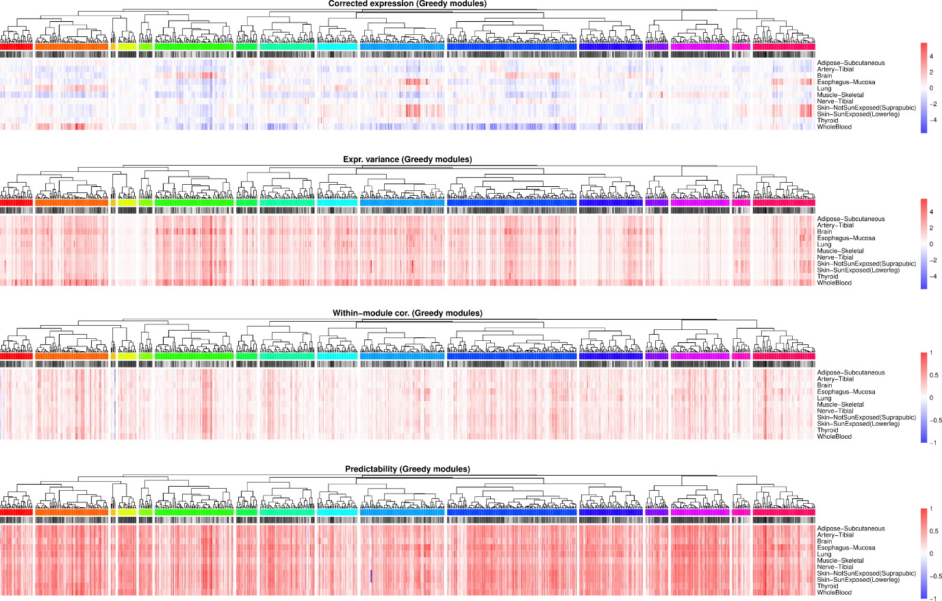

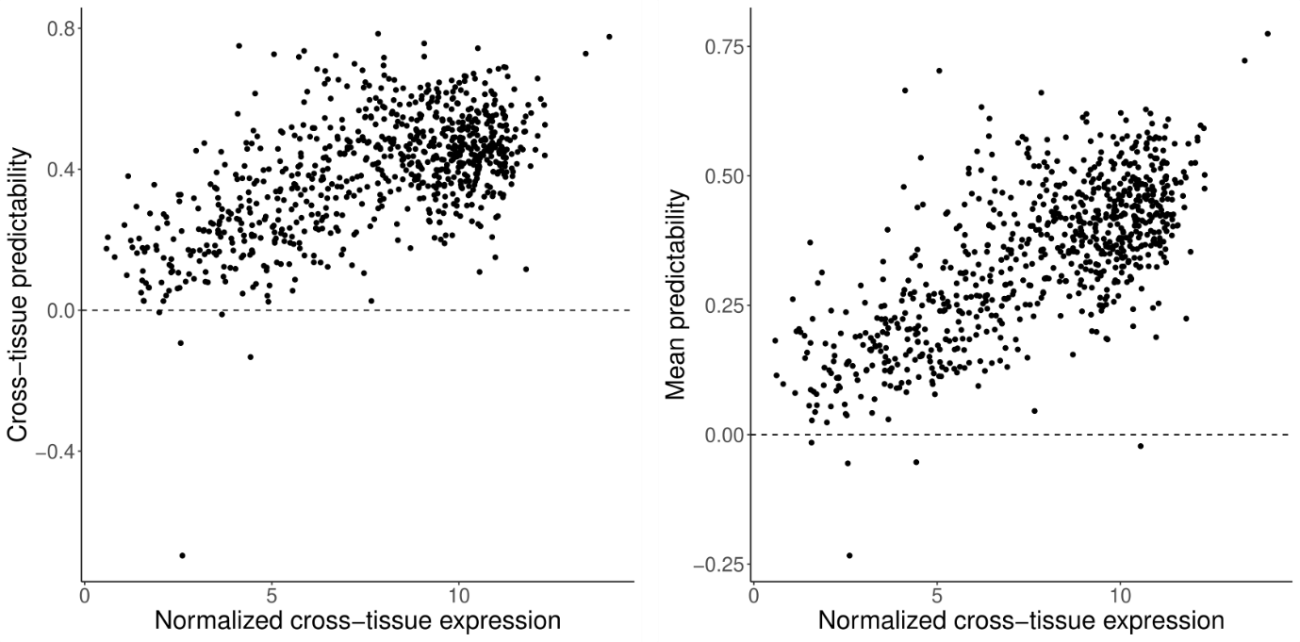

Figure 5: relationship between average predictability and average expression levels of genes in a given module. Predictability is quantified as the Pearson correlation coefficient between the centered expression levels across samples of a given tissue and the predicted centered expression by the network. Expression levels are normalized for library size.

* Expression levels are the main contributing factors for **module** predictability (and within-module correlation). Variance also plays a smaller role, as seen before for the analysis at the gene level.
* Module predictability is vastly consistent across tissues 😊

<DECIDE BETWEEN RANDOM WALK AND GREEDY ALGORITHMS>

# Discussion

It is necessary to point out that not all mechanisms of gene expression regulation are reflected in transcript levels. For instance, post-translation modifications of transcription factors that activate their regulatory function are independent of the expression level of those transcription factors and thus cannot be captured in such models. Given the limited availability of several molecular levels of high-throughput data, the current work is limited to modelling relationships between transcript levels only, at the risk of underestimating the complexity of regulatory interactions.

* Non-linear effects on gene regulation (e.g. TFs competing for the same binding site)
* Temporal delay from regulation to product - doesn’t matter because we are in steady state, right?

# Methods

## Learning gene regulatory networks

## Removal of indirect effects

## Removal of residual edges

## Topology analysis

## Module detection

## GTEx data preprocessing

# References

1. Balaji, S., Babu, M. M., Iyer, L. M., Luscombe, N. M. & Aravind, L. Comprehensive analysis of combinatorial regulation using the transcriptional regulatory network of yeast. *J. Mol. Biol.* **360**, 213–227 (2006).

# Supplementary Material