Supporting Information
First Author^{1,†}, Second Author^{2,†}, Third Author¹, and Corresponding Author^{2,*}
¹ Department of Biology, University of Example, City, Country
² Department of Medicine, Another University, City, Country
* Correspondence: corresponding.author@email.com
† Equal contribution
This PDF file includes:
- Supplementary Text
- Figures S1 to S2
- Tables S1

Supplementary Text

Note S1: Extended Methodology
Lorem ipsum dolor sit amet, consectetur adipiscing elit. Unlike the main text, here we provide the raw data derivation. The western blot analysis is shown in Figure 1 and primer sequences are listed in Table 1. These data complement the results shown in Figure 1 of the main manuscript. The methodology follows established protocols [1, 2].

Note S2: Additional Controls
Sed do eiusmod tempor incididunt ut labore et dolore magna aliqua. Representative histology samples are presented in Figure 2. Additional validation experiments were performed according to recent guidelines [3]. Statistical analysis followed the protocol described by [4].

Supplementary Figures
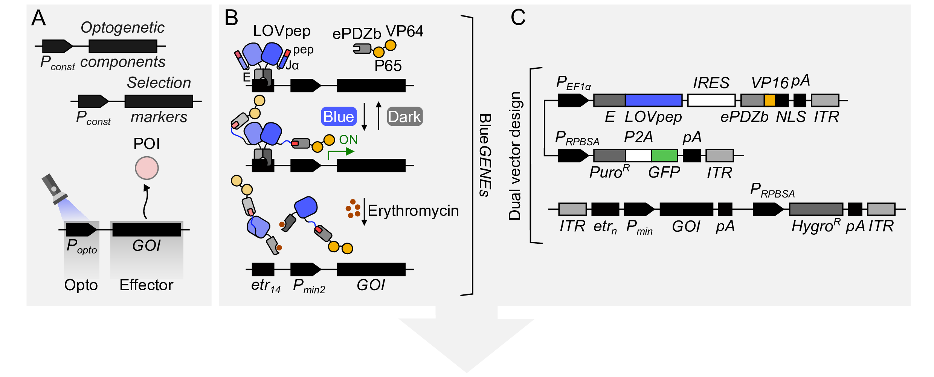
Figure 1: Raw Western Blot Data. This figure shows the unprocessed western blot data corresponding to Figure 1 in the main manuscript.
Figure 2: Title of Second Supplementary Figure. Histology samples at 40x magnification.

Supplementary Tables
Table 1: Primers used in this study. Sequences are listed 5’ to 3’.
Gene | Forward Sequence | Reverse Sequence
GAPDH | 5’-ACTG…-3’ | 5’-TGAC…-3’
ACTB | 5’-GGAA…-3’ | 5’-TTCC…-3’

Supplementary References
1. Smith SJ, Johnson M. Deep-tissue imaging with transparent mice using light-sheet microscopy. Nature Methods. 2024;21:112–20. https://doi.org/10.1038/s41592-024-01000-x.
2. Doe J, Ray S. Quantum coherence in photosynthesis at room temperature. Nature Communications. 2025;16:4501. https://doi.org/10.1038/s41467-025-22105-z.
3. Chen L, Muller H. The senescence-associated secretory phenotype in aging neurons. Cell. 2025;188:890–912. https://doi.org/10.1016/j.cell.2025.01.012.
4. Wilson R, Thompson E. Advanced statistical methods for biological data analysis. Bioinformatics. 2023;39:1234–45. https://doi.org/10.1093/bioinformatics/btad123.

