Manuscript
First Author1,†, Second Author2,†, Third Author1, and Corresponding Author2,*
1 Department of Biology, University of Example, City, Country
2 Department of Medicine, Another University, City, Country
* Correspondence: corresponding.author@email.com
† Equal contribution

Abstract
Objective: The objective of this study was to demonstrate the template capabilities. Results: We found that proper formatting improves readability.
Keywords: template; formatting; zettlr; pandoc

Introduction
This is the introduction. Here we cite a paper [1]. We also refer to the main findings in Figure 1 and the data in Table 1.

Methods
Describe your methods here.

Formatting Guide (Examples)
The following examples demonstrate common markup patterns.

Typography & Units
- Emphasis: Use italics for emphasis and bold for strong emphasis.
- Sub/Superscript: H₂O and E=mc².
- Non-breaking space: Use a backslash+space \ to keep numbers and units together (e.g., 10 kg, p < 0.05).
- En-dash: Use double hyphens -- for ranges (e.g., 10–20%) to create a proper en-dash (10–20%).

Lists
- First item in a numbered list
- Second item
  - Sub-item bullet
  - Another sub-item

Math Equations
Inline equations look like this: $P<0.05$. Block equations are enclosed in double dollar signs:
$$σ=\sqrt{\frac{∑(x_{i}-μ)^{2}}{N}}$$

Results

Main Findings
As shown in Figure 1, the trend is positive.
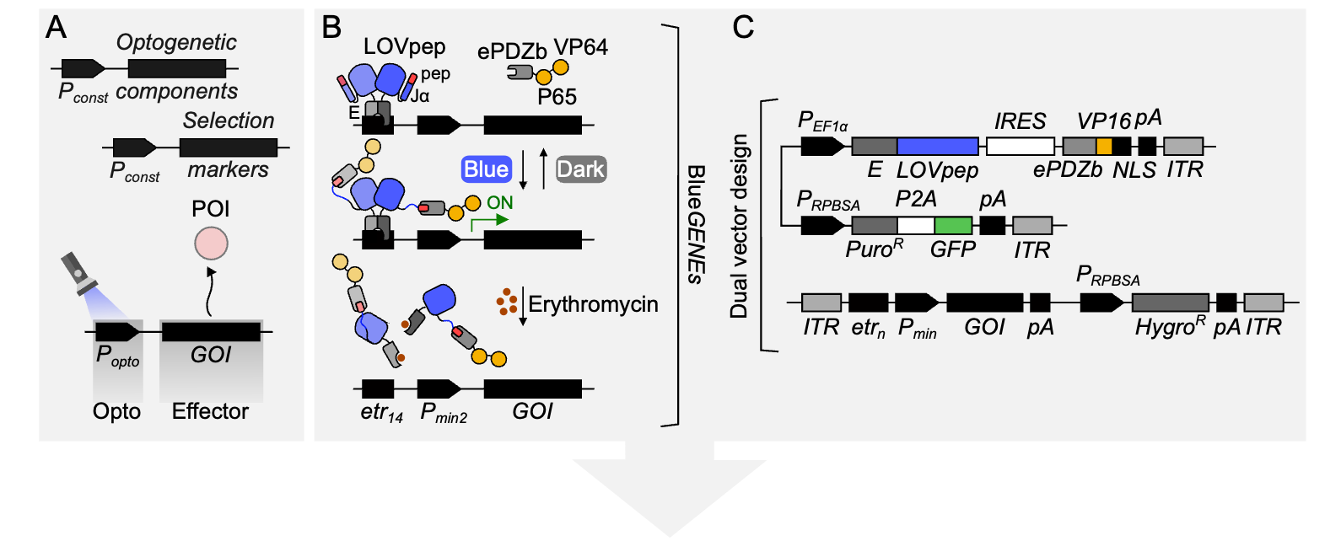
Figure 1: Title of the Figure. This is the detailed legend text.

Statistical Analysis
The summary statistics are presented in Table 1.
Table 1: Title of the Table. This text explains the columns.
Group | Mean (SD) | P-value
Control | 12.5 (1.2) | -
Treatment | 18.2 (2.1) | < 0.05

Discussion
Our results align with previous studies. Figure 1 highlights the key correlation.

Advanced Layout Tips

Footnotes
You can add footnotes inline like this.

Definition Lists
Term 1
Definition of term 1
Term 2
Definition of term 2

Declarations
Ethics approval: Not applicable.
Consent for publication: Not applicable.
Competing interests: The authors declare no competing interests.

References
1. Urrestizala-Arenaza N, Cerchio S, Cavaliere F, Magliaro C. Limitations of human brain organoids to study neurodegenerative diseases: a manual to survive. Front Cell Neurosci. 2024;18:1419526. https://doi.org/10.3389/fncel.2024.1419526.

This is a footnote text that will appear at the bottom of the page or document depending on the style.

