Manuscript
First Author^{1,†}, Second Author^{2,†}, Third Author¹, and Corresponding Author^{2,*}
¹ Department of Biology, University of Example, City, Country
² Department of Medicine, Another University, City, Country
* Correspondence: corresponding.author@email.com
† Equal contribution

Abstract
Objective: Lorem ipsum dolor sit amet, consectetur adipiscing elit. Sed do eiusmod tempor incididunt ut labore et dolore magna aliqua. Results: Ut enim ad minim veniam, quis nostrud exercitation ullamco laboris nisi ut aliquip ex ea commodo consequat. Duis aute irure dolor in reprehenderit in voluptate velit esse cillum.
Keywords: template; formatting; zettlr; pandoc

Introduction
Lorem ipsum dolor sit amet, consectetur adipiscing elit. Nullam in dui mauris. Vivamus hendrerit arcu sed erat molestie vehicula. Sed auctor neque eu tellus rhoncus ut eleifend nibh porttitor. Ut in nulla enim. Phasellus molestie magna non est bibendum non venenatis nisl tempor. Suspendisse dictum feugiat nisl ut dapibus. Mauris iaculis porttitor posuere [1].
Praesent id metus massa, ut blandit odio. Proin quis tortor orci. Etiam at risus et justo dignissim congue. Donec congue lacinia dui, a porttitor lectus condimentum laoreet. Nunc eu ullamcorper orci. Quisque eget odio ac lectus vestibulum faucibus eget in metus. In pellentesque faucibus vestibulum. Nulla at nulla justo, eget luctus tortor [2].
Maecenas ultricies mi eget mauris pharetra viverra. The main findings are illustrated in Figure 1 and the summary data is provided in Table 1. Additional data is available in the Supporting Information (see Figure S1 and Table S1).

Methods
Suspendisse potenti. Sed egestas, ante et vulputate volutpat, eros pede semper est, vitae luctus metus libero eu augue. Morbi purus libero, faucibus adipiscing, commodo quis, gravida id, est. Sed lectus. Praesent elementum hendrerit tortor. Sed semper lorem at felis. Vestibulum volutpat, lacus a ultrices sagittis, mi neque euismod dui, eu pulvinar nunc sapien ornare nisl. Phasellus pede arcu, dapibus eu, fermentum et, dapibus sed, urna [3].

Formatting Guide (Examples)
The following examples demonstrate common markup patterns.

Typography & Units
- Emphasis: Use italics for emphasis and bold for strong emphasis.
- Sub/Superscript: H₂O and E=mc².
- Non-breaking space: Use a backslash+space \ to keep numbers and units together (e.g., 10 kg, p < 0.05).
- En-dash: Use double hyphens -- for ranges (e.g., 10–20%) to create a proper en-dash (10–20%).

Lists
- First item in a numbered list
- Second item
  - Sub-item bullet
  - Another sub-item

Math Equations
Inline equations look like this: $P<0.05$. Block equations are enclosed in double dollar signs:
$$σ=\sqrt{\frac{∑(x_{i}-μ)^{2}}{N}}$$

Results

Main Findings
Fusce convallis metus id felis luctus adipiscing. Aliquam erat volutpat. Nam dui mi, tincidunt quis, accumsan porttitor, facilisis luctus, metus. As shown in Figure 1, phasellus ultrices nulla quis nibh. Raw unprocessed data for this analysis are provided in Figure S1 (Supporting Information).
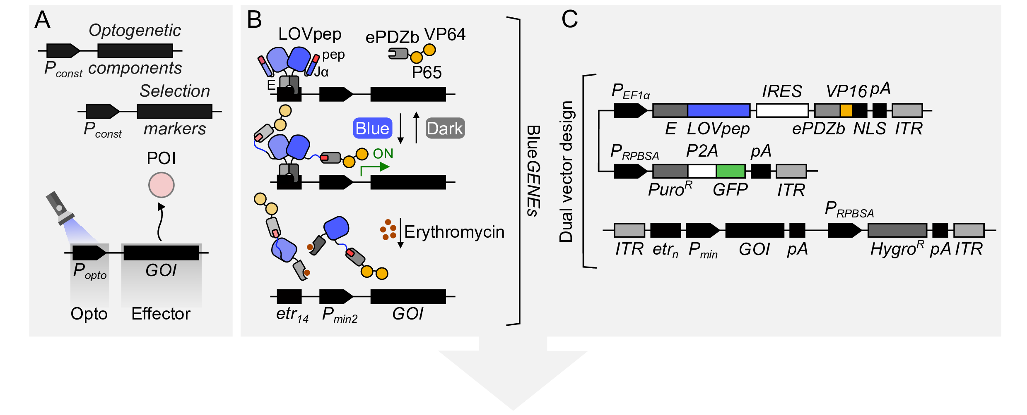
Figure 1: Title of the Figure. Lorem ipsum dolor sit amet, consectetur adipiscing elit.

Statistical Analysis
Curabitur malesuada erat sit amet massa. Fusce ac convallis erat, vel aliquet diam. The data is summarized in Table 1 below.
Table 1: Title of the Table. Ut wisi enim ad minim veniam, quis nostrud exerci tation.
Group | Mean (SD) | P-value
Control | 12.5 (1.2) | -
Treatment | 18.2 (2.1) | < 0.05

Discussion
Pellentesque habitant morbi tristique senectus et netus et malesuada fames ac turpis egestas. Vestibulum tortor quam, feugiat vitae, ultricies eget, tempor sit amet, ante. Donec eu libero sit amet quam egestas semper. Aenean ultricies mi vitae est. Mauris placerat eleifend leo. Additional western blot data is provided in Figure S1 and primer sequences are listed in Table S1 in the Supporting Information. Quisque sit amet est et sapien ullamcorper pharetra. Vestibulum erat wisi, condimentum sed, commodo vitae, ornare sit amet, wisi [4].
Aenean fermentum, elit eget tincidunt condimentum, eros ipsum rutrum orci, sagittis tempus lacus enim ac dui. Donec non enim in turpis pulvinar facilisis. Ut felis. Praesent dapibus, neque id cursus faucibus, tortor neque egestas augue, eu vulputate magna eros eu erat. Aliquam erat volutpat. Nam dui mi, tincidunt quis, accumsan porttitor, facilisis luctus, metus [5].

Advanced Layout Tips

Footnotes
You can add footnotes inline like this.

Definition Lists
Term 1
Definition of term 1
Term 2
Definition of term 2

Declarations
Ethics approval: Not applicable.
Consent for publication: Not applicable.
Competing interests: The authors declare no competing interests.

References
1. Chen L, Muller H. The senescence-associated secretory phenotype in aging neurons. Cell. 2025;188:890–912. https://doi.org/10.1016/j.cell.2025.01.012.
2. Smith SJ, Johnson M. Deep-tissue imaging with transparent mice using light-sheet microscopy. Nature Methods. 2024;21:112–20. https://doi.org/10.1038/s41592-024-01000-x.
3. Doe J, Ray S. Quantum coherence in photosynthesis at room temperature. Nature Communications. 2025;16:4501. https://doi.org/10.1038/s41467-025-22105-z.
4. Lee M-S, Park J-H. Carbon capture using novel metal-organic frameworks. Science Advances. 2026;12:eaaz1234. https://doi.org/10.1126/sciadv.aaz1234.
5. Garcia M, Dubois J. Social dynamics in remote work environments: A global survey. PLOS ONE. 2023;18:e0285678. https://doi.org/10.1371/journal.pone.0285678.
6. Wilson R, Thompson E. Advanced statistical methods for biological data analysis. Bioinformatics. 2023;39:1234–45. https://doi.org/10.1093/bioinformatics/btad123.

Lorem ipsum dolor sit amet, consectetuer adipiscing elit.

