Cisco scripts
The following items need to be configured on each Switch:
· Change the device name to the one on the diagram
· All passwords should be set to be encrypted
· Disable DNS lookups with the no ip domain-lookup command
· The enable secret password should be set to class
· The message displayed daily should be set to &Authorized Users only!& (or equivalent)
· The management interface (VLAN 1) should be configured with:
--An IP Address and subnet mask from the LAN the switch is part of
--Description of what the interface is used for
--No shutdown
--A Default-Gateway for the same network
· In Line Console 0 and the VTY ports:
--Set the password to cisco
--Set the ‘login’ command
--Configure so no connection timeout occurs
--Set ‘logging synchronous’
· Save the configurations in startup-config

Service password-encryption
No ip domain-lookup
Enable secret class
Banner motd &Authorized Users only!&
Line console 0
Password cisco
Login
No exec-timeout
Exec-timeout 5 0 {min sec}
Logging synchronous
Line vty 0 15
Password cisco
Login
No exec-timeout
Logging synchronous
Do Copy run start
Do Hostname PHX-SW-1A
Interface vlan 1
Interface

Line vty 0 4
Transport input ssh

Ipv6 unicast-routing
Ipv6 address 2001:DB8:CCCC:1::1/64
Ipv6 address FE80::1 link-local

Copy run start
Copy run tftp ……{ip address of tftp}

Ssh -l {username} {target ip}

Config Username admin password/secret class
Ip domain-name djnkdnjknf.com
crypto key generate rsa
Ip ssh version 2
username Admin1 privilege 15 secret Admin1pa55

username jdone privilege 1 password 7 08314D5D1A48
User EXEC mode = privilege level 1
Privileged EXEC mode = privilege level 15

VLAN CONFIGURATIONS
Vlan 16
Name research
Vlan 88
Ip address 192.24.223.2 255.255.255.0

ACCESS PORTS CONFIG ON SWITCHES
Interface range f0/1-2, f0/4
Interface fastethernet 0/11
Switchport mode access
Switchport access vlan 10

Interface fastethernet 0/11
Mls qos trust cos
Switchport voice vlan 150

3. Configure the trunk link with 802.1q tags.
switchport trunk encapsulation dot1q
switchport mode trunk

TRUNK CONFIGURATIONS ON SWITCHES
Interface g1/1
Switchport mode trunk
Switchport trunk allowed vlan 14,12,19
Switchport trunk native vlan 99

DISABLING DTP
SW-1/SW-2(config)#interface range GigabitEthernet0/1 - 2
SW-1/SW-2(config-if-range)#switchport mode trunk
SW-1/SW-2(config-if-range)#switchport nonegotiate

11.6.1
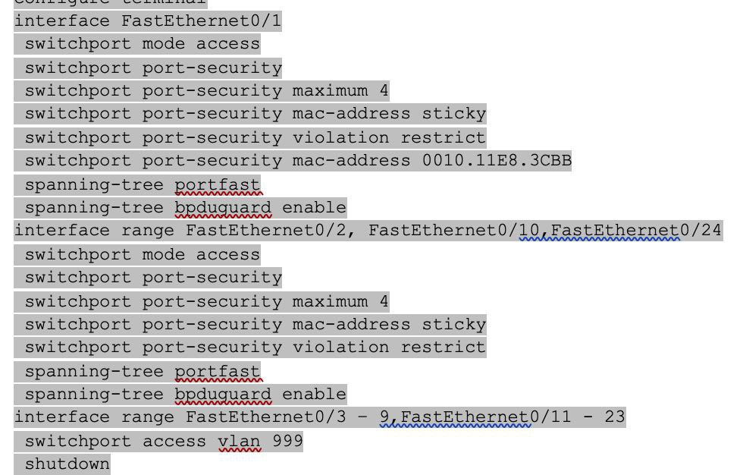

ROUTER SUBINTERFACES
Int g0/0
No Shut
Int g0/0.15 {advisable to use 15 because we are dealing with vlan 15}

Encapsulation dot1q 15 {because we are dealing with vlan 15}
Ip address 192.244.133.1 255.255.255.0
NATIVE VLAN
Int g0/0.99 {advisable to use 99 because we are dealing with vlan 99}
Encapsulation dot1q 99 native {because we are dealing with vlan 99 for native vlan}
Ip address 192.244.133.1 255.255.255.0

Interface s0/0/0
Clock rate 2000000

Show controllers s0/0/0

CONFIGURING DHCP SERVER
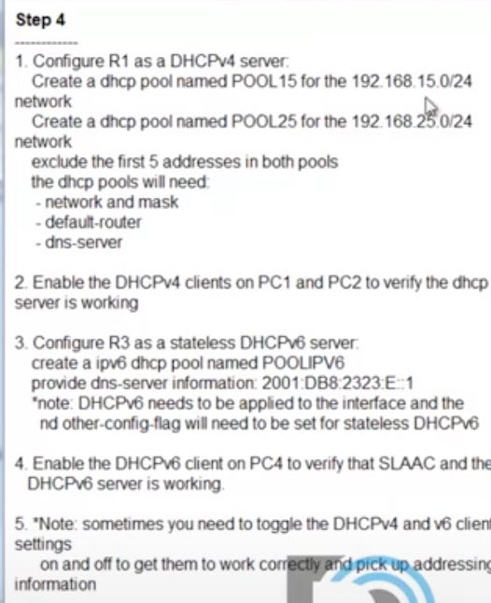
IPV4
Ip dhcp pool POOL15
Network 192.168.15.0 255.255.255.0
Default-router 192.168.15.1
Dns-server 192.168.35.253
Exit
Ip dhcp excluded-address 192.168.15.1 192.168.15.5

Ip address dhcp {to get address via dhcp}
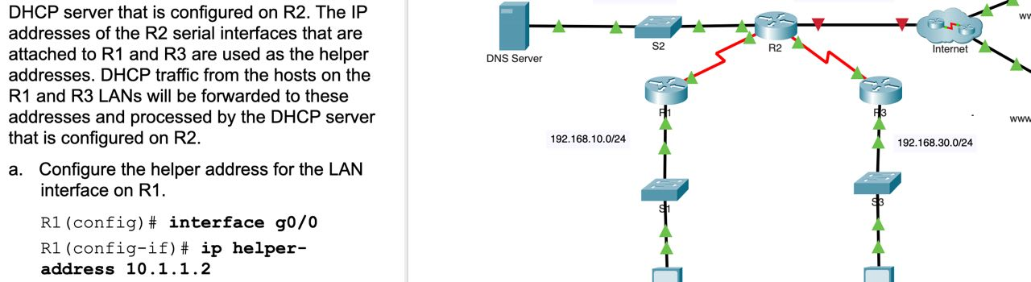

IPV6
Ipv6 dhcp pool POOLIPV6
Dns-server 2001:DB8:2323:E::1
exit
Int g 0/0 {INTERFACE OF THE SERVER HANDING IT OUT}
Ipv6 dhcp server POOLIPV6
Ipv6 nd other-config-flag {using SLAAC stateless also}

Swithport protected to configure Cisco edge ports (vlan)

OSPF CONFIGURATION
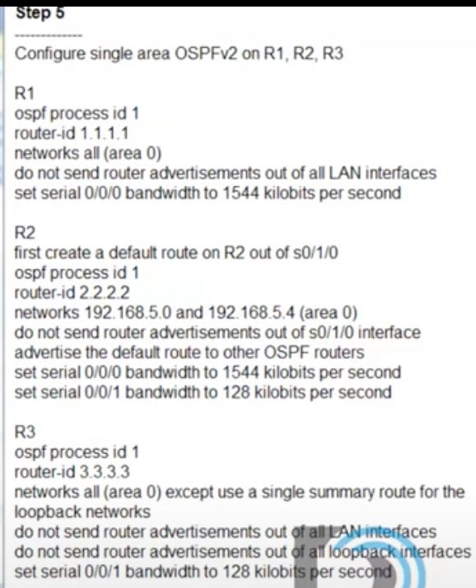
V4 OSPFV2

Passive-interface g0/0.15 {interfaces you don’t want to send ospf to and on interfaces without a router connected to}
Passive-interface g0/0.25
Passive-interface g0/0.35
Exit
Interface serial 0/0/0
Bandwidth 1544 (in kbs)
Network 172.16.4.0 0.0.3.255 area 0 {summary route}
(config)#Ip route 0.0.0.0 0.0.0.0 s0/1/0 {put a default route out of interface s0/1/0}

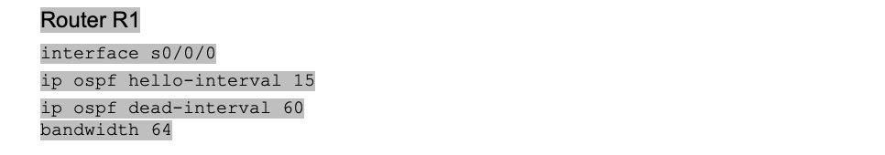

Router ospf 1 (process id can be any number)
Router-id 1.1.1.1

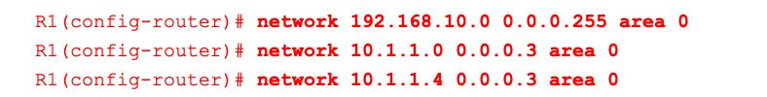

Show ip route connected
R1(config-router)# Network 192.168.15.0 0.0.0.255 area 0 (single area ospf is =0)
Network 192.168.25.0 0.0.0.255 area 0 {network attached to the interface}
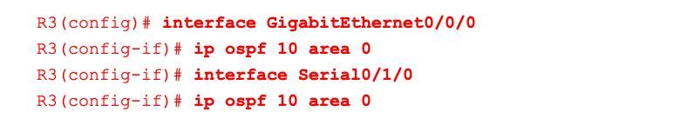
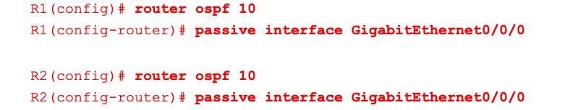

Configure the OSPF routers so that the Gigabit Ethernet interface cost will be 10 and the Fast Ethernet cost will be 100.

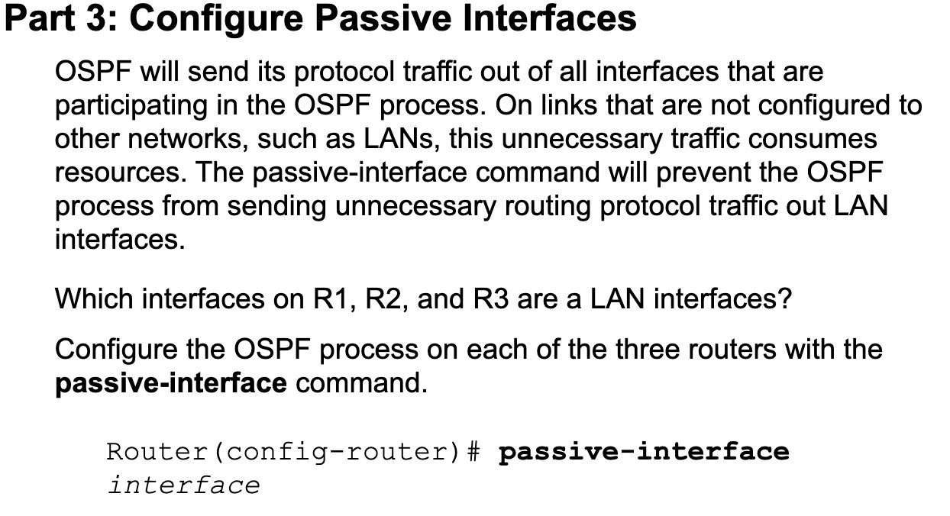

Router ospf 1
-information originate {tells other ospf routers about any default routes that we may have}
# clear ip ospf process {flushes previous settings}

MODIFYING OSPF DEFAULT SETTINGS

V6 OSPFV3
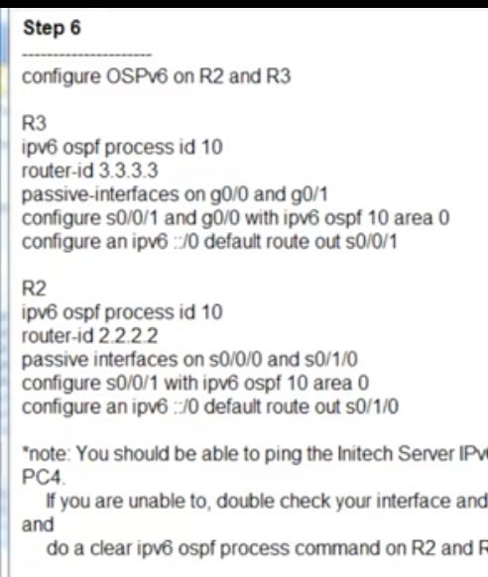
R3(config)# ipv6 router ospf 10
Router-id 3.3.3.3
Passive-interface g0/0
Passive-interface g0/1
Int g0/0. {Assuming ipv6 and link-local has been configured}
Ipv6 ospf 10 area 0
Int s0/0/1
Ipv6 ospf 10 area 0
Exit
Ipv6 route ::/0 s0/0/1

NAT
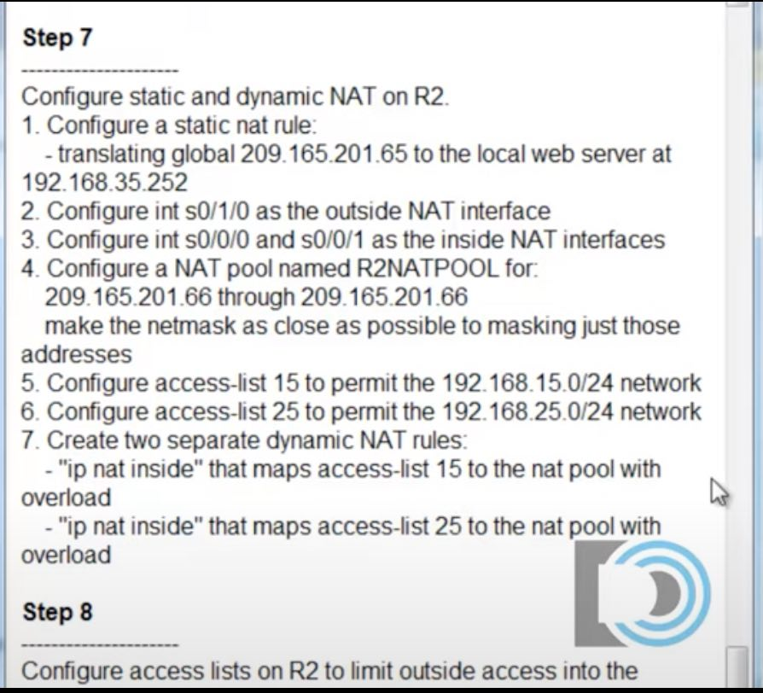
R2(config)# ip nat inside source static 192.168.35.252 {web server/ inside local} 209.165.201.65 {edge router interface/ inside global}
R2(config)# int s0/1/0
Ip nat outside {interface of the router leading outside}
Int s0/0/0
Ip nat inside {inside interfaces of the router}
Int s0/0/1
Ip nat inside

NAT POOL
R2(config)# ip nat pool R2NATPOOL 209.165.201.66 209.165.201.69 net mask 255.255.255.248 {a mask that contains 66-69 4 values/ a mask that houses 66-69}
NAT ACCESS LISTS
R2(config)# access-list 15 permit 192.168.15.0 0.0.0.255
R2(config)# access-list 25 permit 192.168.25.0 0.0.0.255
Rules { Associate ACL 1 with the NAT pool.}

PAT
R2(config)# ip nat inside source list 15 pool R2NATPOOL overload {translates from source 15 to the address list}
R2(config)# ip nat inside source list 25 pool R2NATPOOL overload

R2(config)# ip nat inside source list 2 interface s0/1/1 overload
Show ip nat translations

ACLS
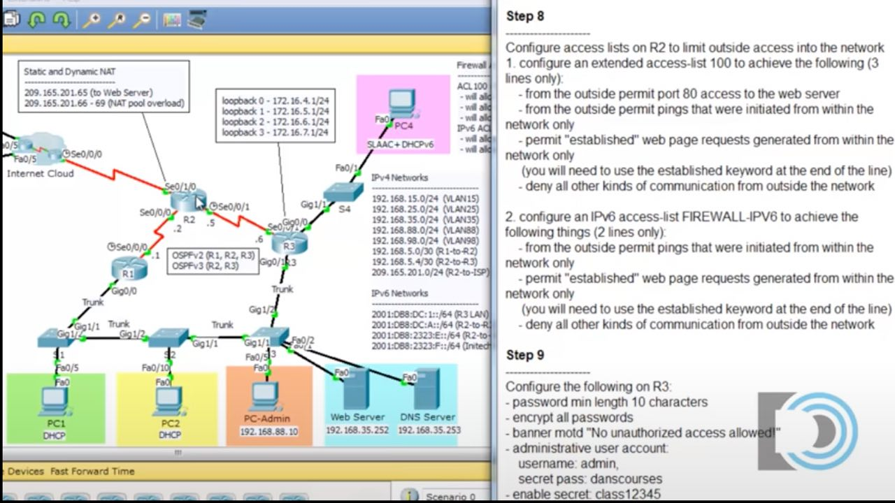

R2(config)# access-list 100 permit tcp any host 209.165.201.65 eq 80 {any source address the public address was used not the private}
R2(config)# access-list 100 permit icmp any any echo-reply {any source any dest}
R2(config)# access-list 100 permit tcp any eq 80 any established {any source address coming from port 80 web server}
{when we request web pages the destination port is port 80}

access-list access_list_number permit tcp source_address source_mask destination_address destination_mask [eq port_number]

R1(config)# ip access-list standard File_Server_Restrictions
R1(config-std-nacl)# permit host 192.168.20.4
R1(config-std-nacl)# permit host 192.168.100.100
R1(config-std-nacl)# deny any
R1(config-if)# ip access-group File_Server_Restrictions out

NAMED ACL START WITH IP
R1(config)# ip access-list extended HTTP_ONLY

R2(config)# ipv6 access-list FIREWALL-IPV6
R2(config -ipv6-acl)# permit icmp any any echo-reply
R2(config -ipv6-acl)# permit tcp any eq 80 any established

R2(config)# int s0/1/0
R2(config)# ip access-group 100 in
R2(config)# ipv6 traffic-filter FIREWALL-IPV6 in

R3(config)# access-list 1 remark Allow R1 LANs Access
R2(config)# access-list 1 deny 192.168.11.0 0.0.0.255
R2(config)# access-list 1 permit any
R2(config)# interface GigabitEthernet0/0
R2(config-if)# ip access-group 1 out

STANDARD ACLS {1-99 ,1300-1999}
Apply as close to the destination as possible
NUMBERED
R1(config-if) # ip access-group number {in | out} ip wildcardMask {Matches only the source}
OUTBOUND AND INBOUND SHOULD BE APPLIED AS CLOSE AS POSSIBLE TO THE DESTINATION (STANDARD ACL)

NAMED
R1(config)# ip access-list standard acl-name
R1(config-std-nacl)# [entry-number] {deny | permit) ip wildcard-mask
R1 (config)#ip access-list standard BLOCK_BOB
R1 (config-std-nac1)#5 deny 1.1.1.1
R1 (config-std-nacl)#10 permit any
R1 (config-std-nacl)#remark ## CONFIGURED NOV 21 2020 ##
R1(config-std-nacl)#interface g0/0
R1(config-if)#ip access-group BLOCK_BOB in

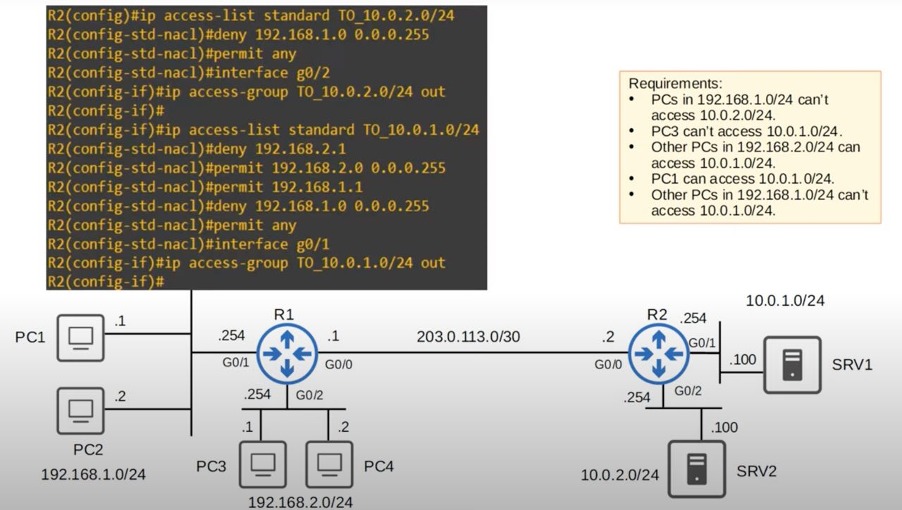

EXTENDED ACLS {100-199 ,2000-2699}
Apply as close to the source as possible

NUMBERED
R1 (config)# access-list number [permit | deny] protocol src-ip dest-ip
src network. Destination
access-list 100 permit icmp 172.22.34.64 0.0.0.31 host 172.22.34.62

NAMED
R1 (config)# ip access-list extended {name | number}
R1 (config-ext-nacl)# [seq-num] [permit | deny] protocol src-ip dest-ip

R1 (config-ext-nacl)#permit ip any any

R1 (config-ext-nacl)#deny tcp src-ip dest-ip

R1(config-ext-nacl)#deny tcp src-ip eq src-port-num dest-ip eq dst-port-num

2. Prevent 10.0.0.0/16 from sending UDP traffic to 192.168.1.1/32
R1 (config-ext-nacl)#deny udp 10.0.0.0 0.0.255.255 host 192.168.1.1

3. Prevent 172.16.1.1/32 from pinging hosts in 192.168.0.0/24
R1 (config-ext-nacl)#deny icmp host 172.16.1.1 192.168.0.0 0.0.0.255

1. Allow traffic from 10.0.0.0/16 to access the server at 2.2.2.2/32 using HTTPS.
R1 (config-ext-nacl)#permit tcp 10.0.0.0 0.0.255.255 2.2.2.2 0.0.0.0 eq 443

2. Prevent all hosts using source UDP port numbers from 20000 to 30000 from accessing the server at 3.3.3.3/32.
R1 (config-ext-nacl)#deny udp any range 20000 30000 host 3.3.3.3

3. Allow hosts in 172.16.1.0/24 using a TCP source port greater than 9999 to access all TCP ports on server 4.4.4.4/32 except port 23.
R1 (config-ext-nacl)#permit tcp 172.16.1.0 0.0.0.255 gt 9999 host 4.4.4.4 neq 23

Hosts in 192.168.1.0/24 can't use HTTPS to access SRV1.
R1(config)#ip access-list extended HTTP SRV1
R1 (config-ext-nacl)#deny tcp 192.168.1.0 0.0.0.255 host 10.0.1.100 eq 443
R1 (contig-ext-nacl)#permit ip any any

• Hosts in 192.168.2.0/24 can't access 10.0.2.0/24.
R1 (contig)#1p access-list extended BLOCK_ 10.0.2.0/24
R1 (config-ext-nacl)#deny ip 192.168.2.0 0.0.0.255 10.0.2.0 0.0.0.255
R1(config-ext-nacl)#permit ip any any

• None of the hosts in 192.168.1.0/24 or 192.168.2.0/24 can ping 10.0.1.0/24 or 10.0.2.0/24.
R1 (config)#ip access-list extended BLOCK_ICMP
R1 (config-ext-nacl)#deny ісmр 192.168.1.0 0.0.0.255 10.0.1.0 0.0.0.255
R1 (config-ext-nacl)#deny ісmр 192.168.1.0 0.0.0.255 10.0.2.0 0.0.0.255
R1 (config-ext-nacl)#deny icmp 192.168.2.0 0.0.0.255 10.0.1.0 0.0.0.255
R1 (config-ext-nacl)#permit ip any any
R1 (config-ext-nacl)#interface g0/0
R1 (config-if)#ip access-group BLOCK_ICMP out
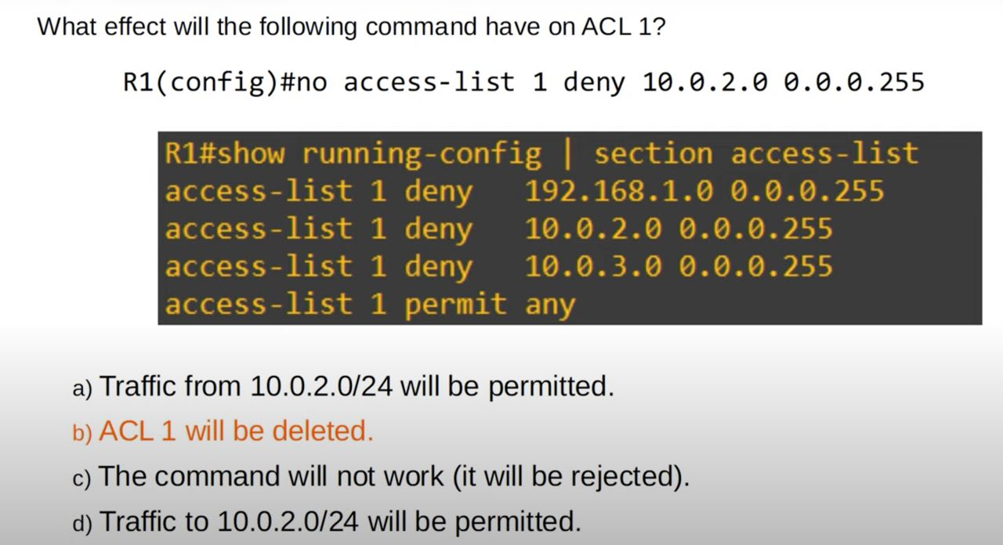

88- eigrp, 89- ospf

Mask - if the are the same eq 0, if they are diff 1 and you will use the higher ip

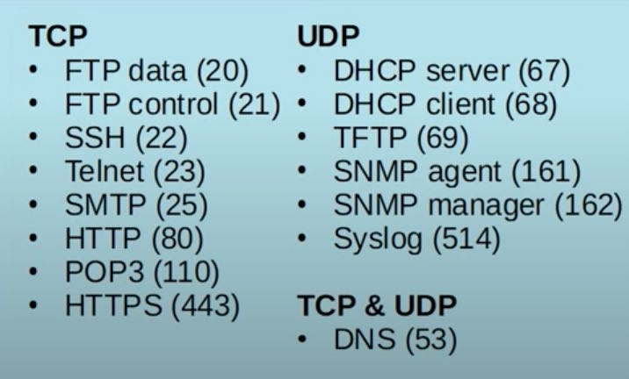
SOEI

NUMBERED IN NAME
- Can easily be deleted individually instead of having to delete all access-lists “no {acl number}”

R1 (config)#ip access-list standard 1
R1 (config-std-nacl)#deny 192.168.1.1
R1 (config-std-nacl)#permit any

R1 (config)#ip access-list resequence 1 10 10

SWITCHPORT SECURITY

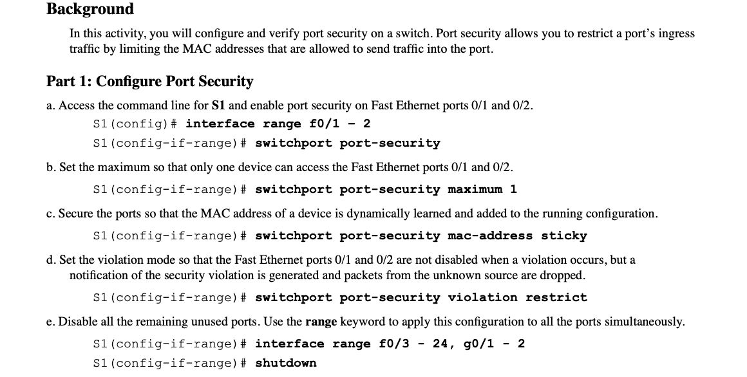

15.6.1 STATIC ROUTING

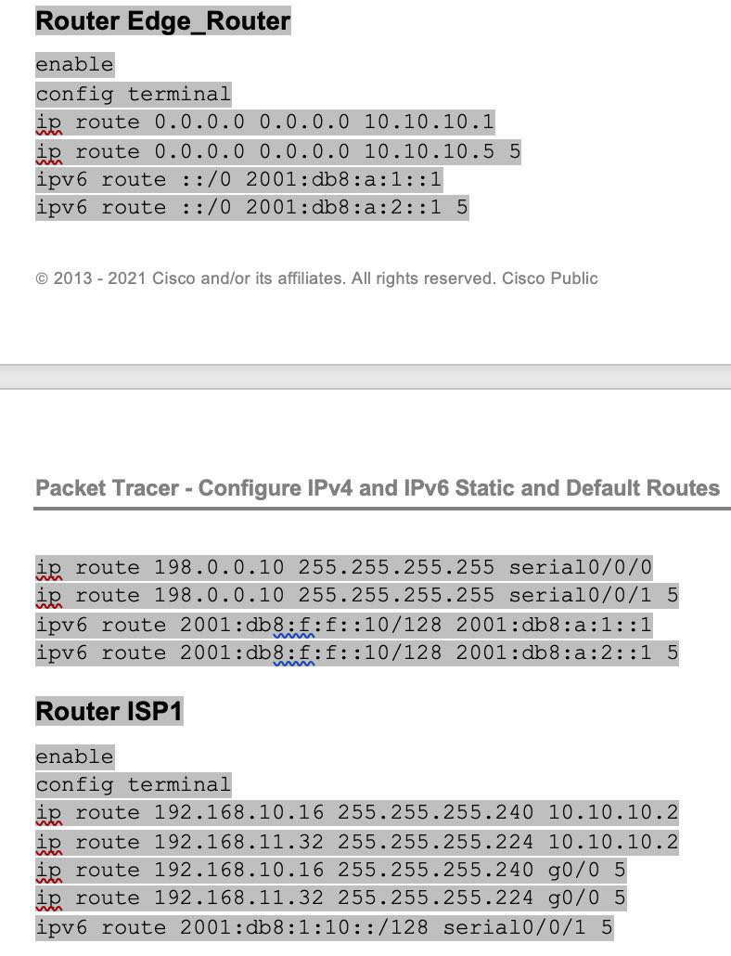

HSRP
R1(config-if)# standby version 2 {version numnber}
R1(config-if)# standby 1 ip 192.168.1.254 {DGW of virtual router / virtual ip}
R1(config-if)# standby 1 priority 150 {router priority higher is used the default is 100}
R1(config-if)# standby 1 preempt {for the router to continue as the DGW when it picks up}
Show standby
Show standby brief

PAGP
S1(config)# interface range f0/21 – 22
S1(config-if-range)# shutdown
S1(config-if-range)# channel-group 1 mode desirable
S1(config-if-range)# no shutdown
S1(config)# interface port-channel 1
S1(config-if)# switchport mode trunk

LACP
S1(config)# interface range g0/1 - 2
S1(config-if-range)# shutdown
S1(config-if-range)# channel-group 2 mode active
S1(config-if-range)# no shutdown
S1(config-if-range)# interface port-channel 2
S1(config-if)# switchport mode trunk
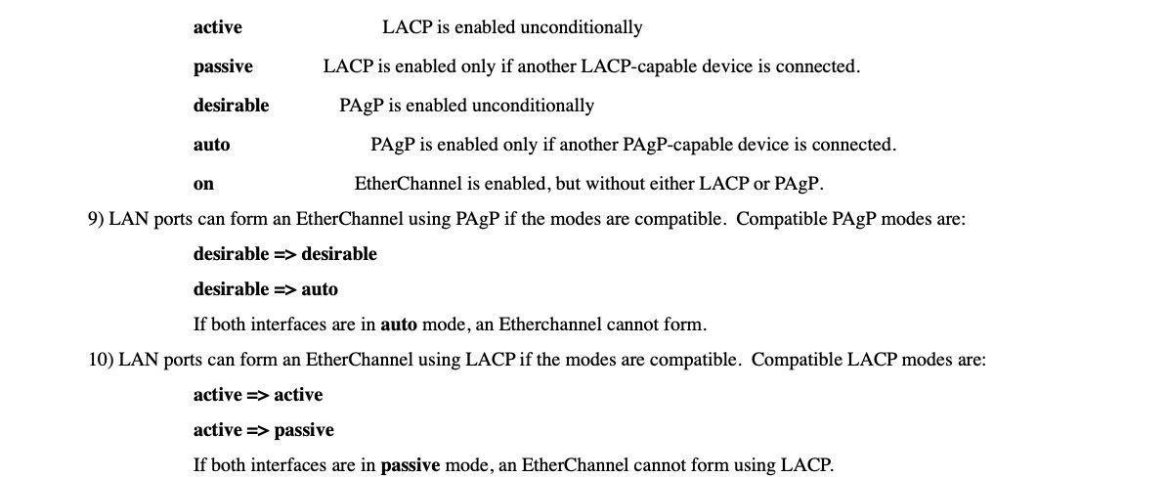

REDUNDANT LINKS
S2(config)# interface range f0/23 - 24
S2(config-if-range)# shutdown
S2(config-if-range)# channel-group 3 mode passive/ auto
S2(config-if-range)# no shutdown
S2(config-if-range)# interface port-channel 3
S2(config-if)# switchport mode trunk

active Enable LACP unconditionally
auto Enable PAgP only if a PAgP device is detected
desirable Enable PAgP unconditionally
on Enable Etherchannel only
passive Enable LACP only if a LACP device is detected

[110/343]. - AD/METRIC {the smaller metric the more favourable. Lowest metric}

NTP

