Problem 1. Website Header

Problem 2. Website Footer

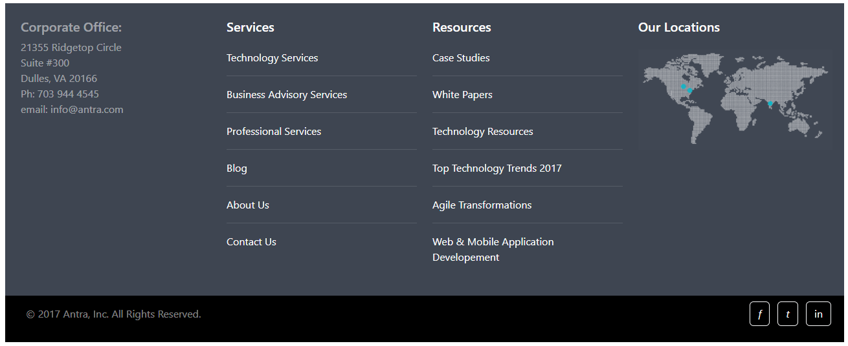

Problem 3. The Antra News

