Velocity Marketing is a leading BTL (Below-the-Line) marketing agency delivering innovative, result-driven on-ground brand activation solutions across India. We specialize in creating impactful consumer experiences through product sampling, retail branding, outdoor advertising, transit branding, rural marketing, corporate activations, and promotional campaigns. With a skilled execution team and nationwide network, we help brands increase visibility, engage target audiences, generate quality leads, and drive measurable business growth through customized marketing solutions

- Door-to-Door Marketing : Connect directly with your target audience through our Door-to-Door Marketing services. Our trained Inhouse brand promoters visit residential communities, apartments, and neighborhoods to distribute leaflets, conduct product sampling, demonstrate products, and generate qualified leads. This personalized, face-to-face approach builds customer trust, increases brand awareness, and delivers measurable results for product launches, promotions, and awareness campaigns across urban and rural India.

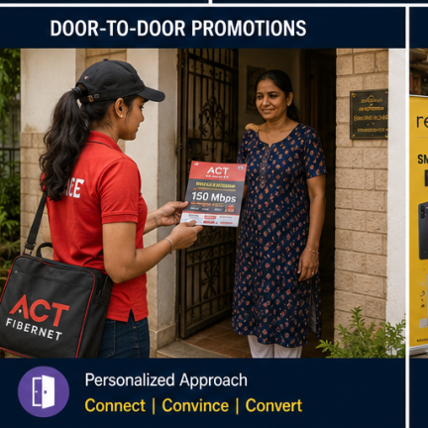

- Leaflet Insertion (In News Papers): Reach thousands of households through targeted Newspaper Leaflet Insertion campaigns that deliver your promotional flyers directly with leading daily newspapers. This cost-effective marketing solution ensures wide local coverage, increases brand awareness, and drives customer response for product launches, retail offers, events, and promotional campaigns. We provide city-wise and area-specific distribution for maximum reach and measurable impact.
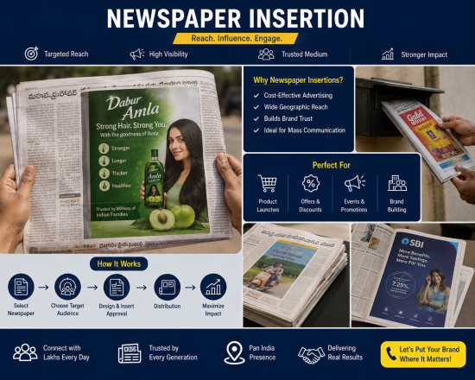

- Product Sampling: Deliver your products directly into customers' hands through strategic sampling campaigns in supermarkets, malls, residential communities, corporate offices, and public events, creating first-hand product experiences that boost awareness and trial.

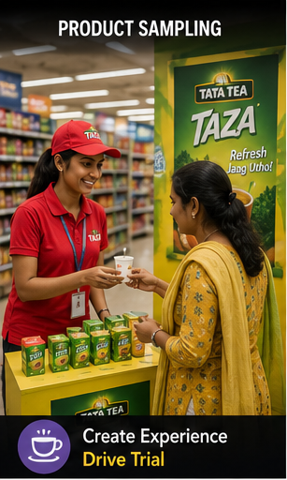

- Leaflet Distribution: Maximize local brand visibility with targeted leaflet distribution campaigns executed by trained promoters across residential areas, commercial hubs, educational institutions, and high-footfall locations.
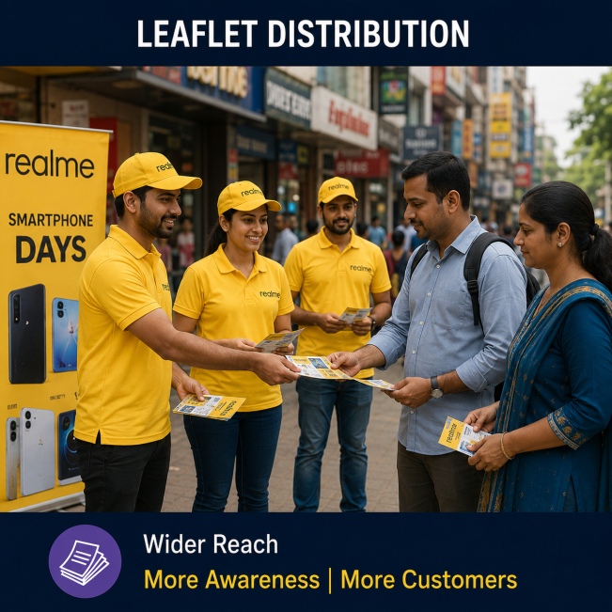

- Audio Announcement Campaigns: Spread your promotional message across target locations using professionally managed audio announcement vehicles equipped with high-quality public address systems.

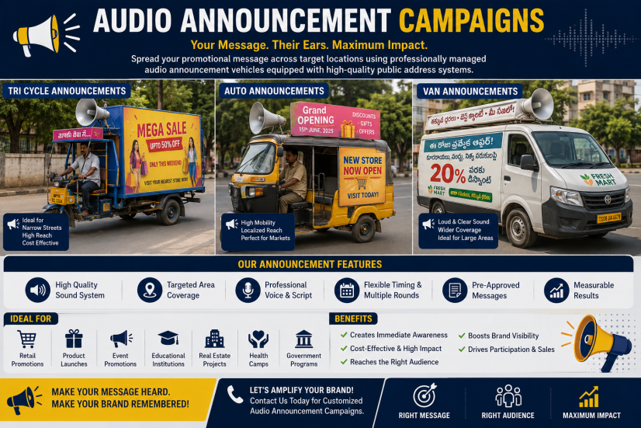

- Retail Branding: Enhance your in-store presence with eye-catching retail branding solutions, including shelf branding, POS displays, danglers, standees, floor graphics, and promotional installations that influence purchase decisions.

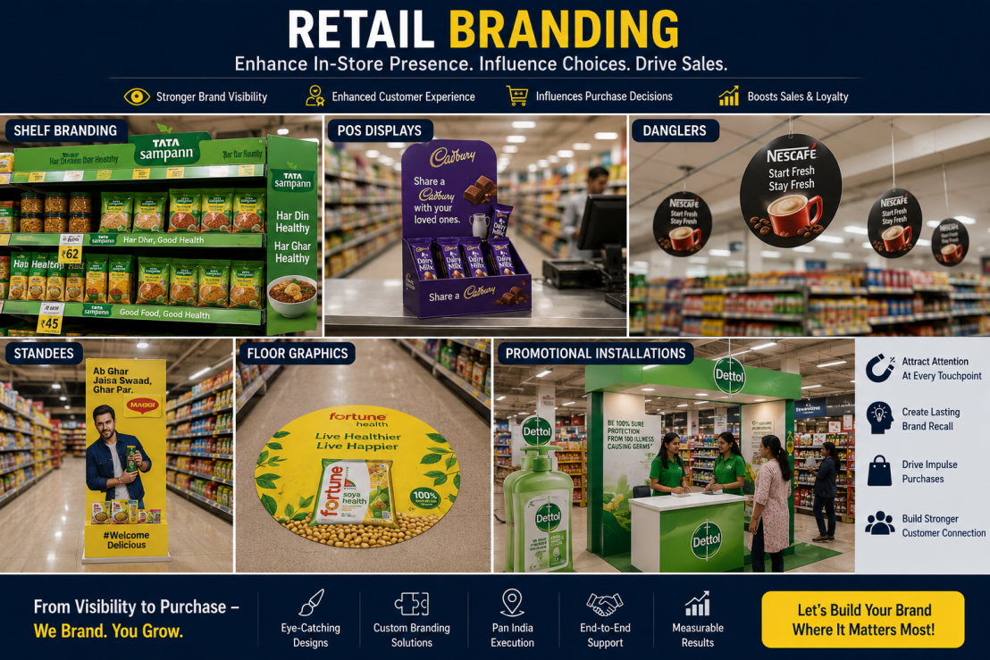

- Auto Branding: Turn auto-rickshaws into moving advertisements with creative branding solutions that deliver continuous brand exposure across cities and towns, reaching thousands of consumers every day.

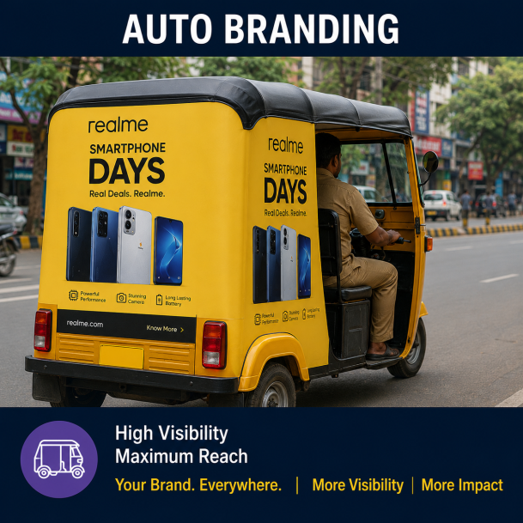

- Van Campaigns: Promote your brand through customized promotional vans equipped with product displays, audio systems, LED screens, and sampling activities to maximize customer engagement across multiple locations.
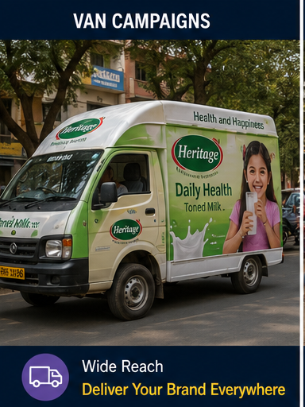

- Hoardings & Outdoor Advertising: Build strong brand visibility with premium hoardings, billboards, unipoles, bus shelters, and outdoor advertising solutions strategically placed in high-traffic locations.
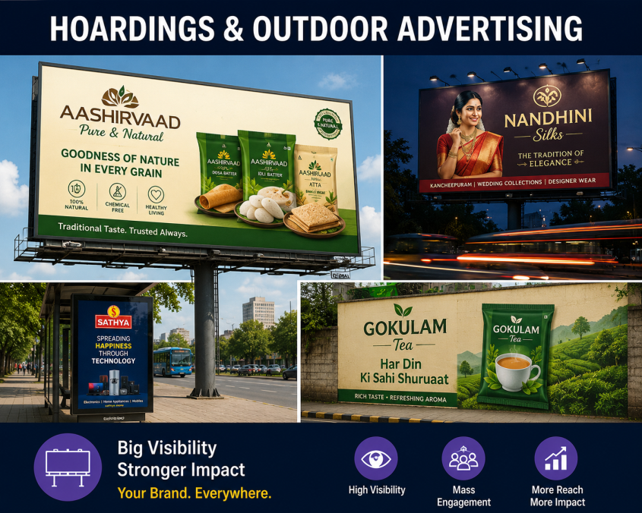

- No Parking Board Branding: Utilize branded "No Parking" boards as a cost-effective outdoor advertising medium that delivers continuous visibility in residential, commercial, and high-traffic areas.

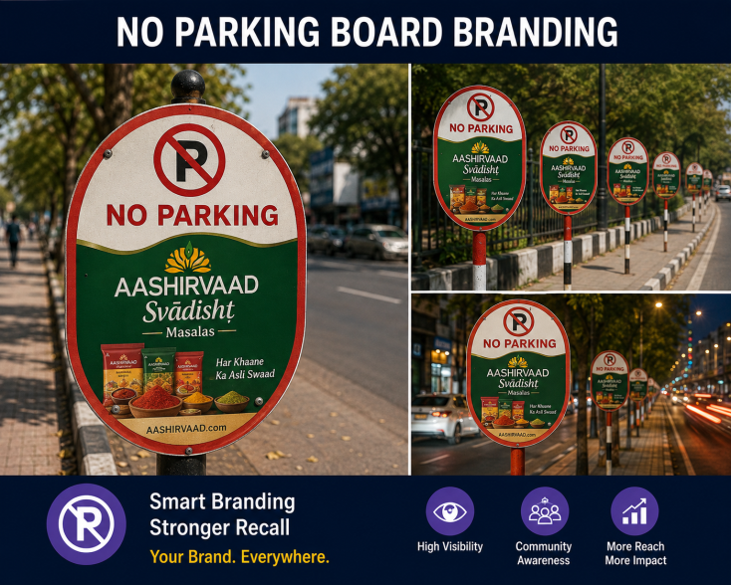

- Theatre Branding: Reach captive audiences through cinema advertising with screen commercials, lobby branding, standees, ticket branding, and food counter promotions for maximum brand recall.

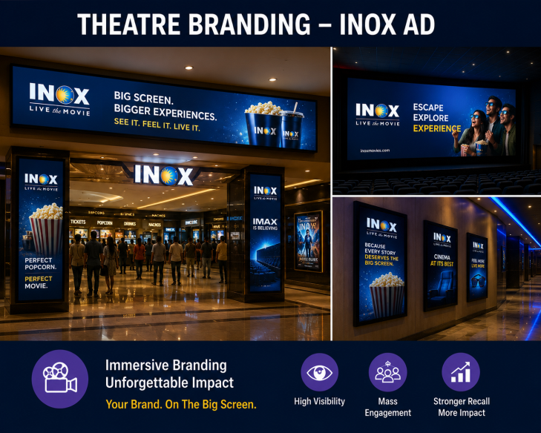

- Mall Activations: Create memorable customer experiences with interactive mall activations, product demonstrations, contests, and promotional events that increase engagement and generate quality leads.
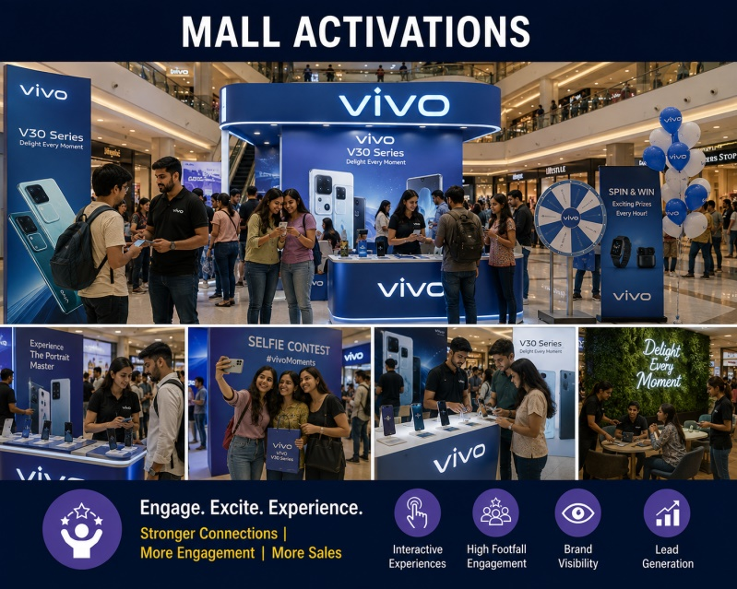

- Wall Painting: Create long-lasting outdoor brand visibility with professionally designed wall paintings in strategic urban and rural locations for continuous advertising impact.

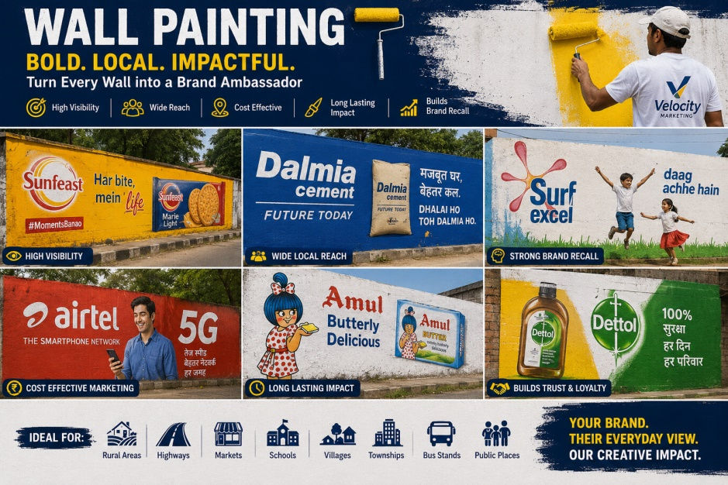

- Rural Marketing: Expand your brand's reach into rural markets through village activations, haat promotions, van campaigns, wall paintings, product sampling, and community engagement programs.

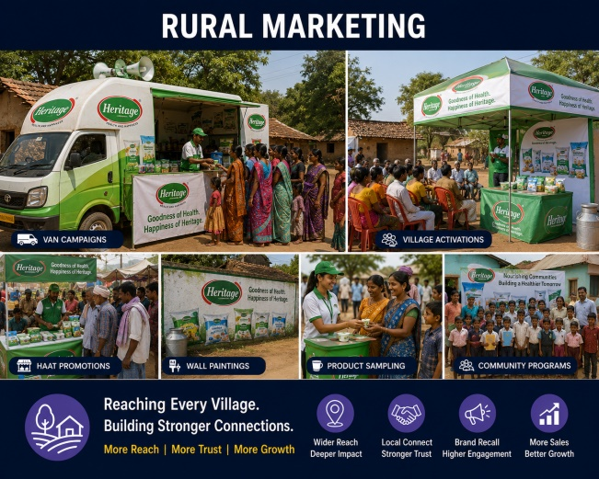

- Apartment Activations: Connect directly with families through apartment marketing campaigns featuring product sampling, society events, promotional kiosks, and lead generation activities.

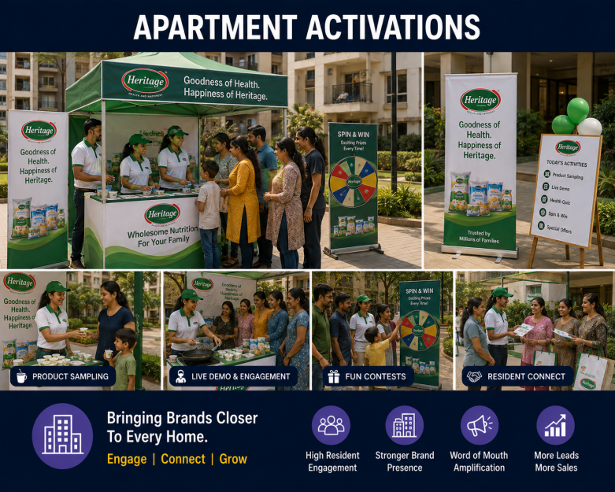

- Corporate Activations: Promote your products and services within corporate offices through employee engagement activities, wellness programs, product displays, and experiential marketing campaigns.

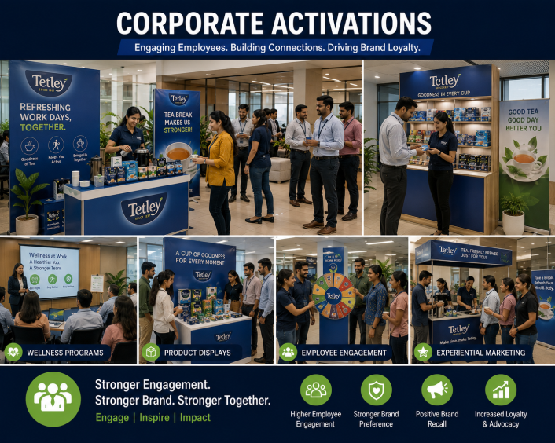

- School & College Campaigns: Increase brand awareness among students through educational promotions, campus activations, product launches, awareness drives, competitions, and engagement activities.

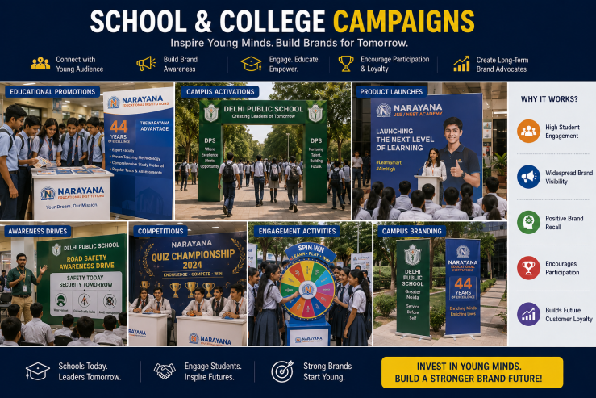

- Merchandising Services: Ensure excellent in-store product visibility through professional merchandising, stock management, shelf placement, planogram execution, and retail display optimization.

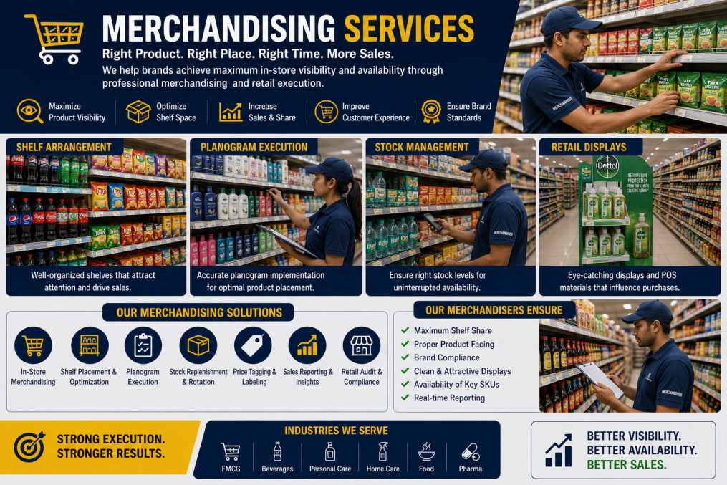

- Retail Audits: Monitor retail performance with detailed store audits covering product availability, pricing, visibility, competitor analysis, and merchandising compliance.

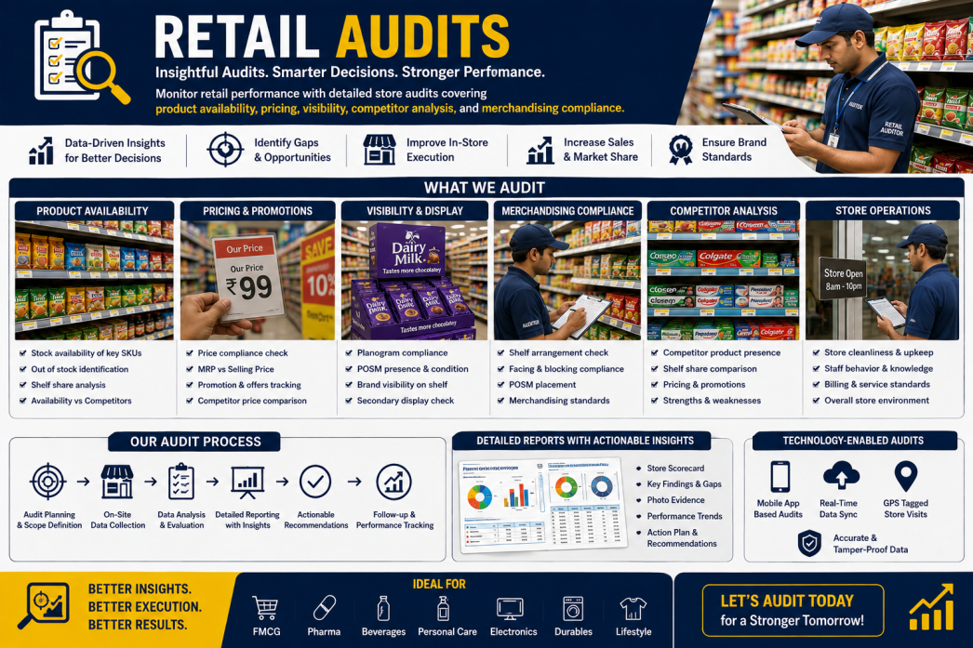

- Brand Promoters: Our professionally trained brand promoters represent your brand with confidence, delivering product demonstrations, customer engagement, sampling activities, and lead generation.

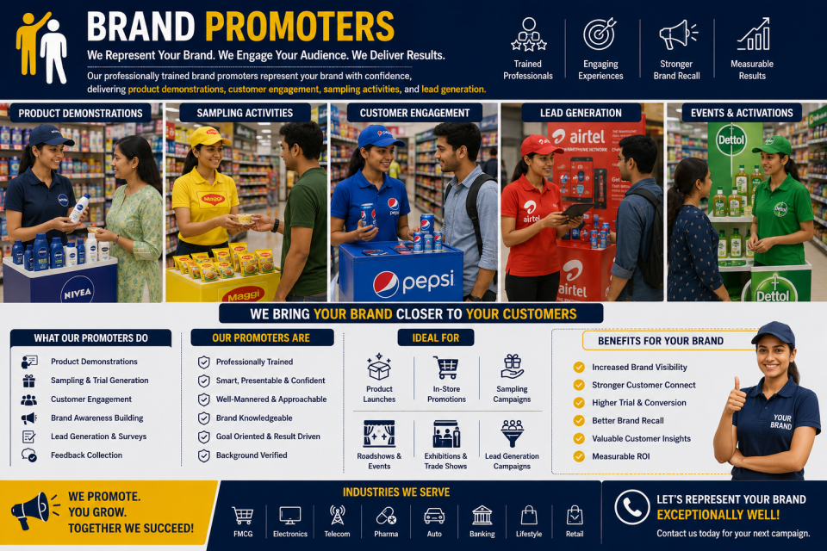

- Consumer Surveys: Collect valuable customer insights through structured surveys, market research, product feedback, satisfaction studies, and brand perception analysis to support business decisions.

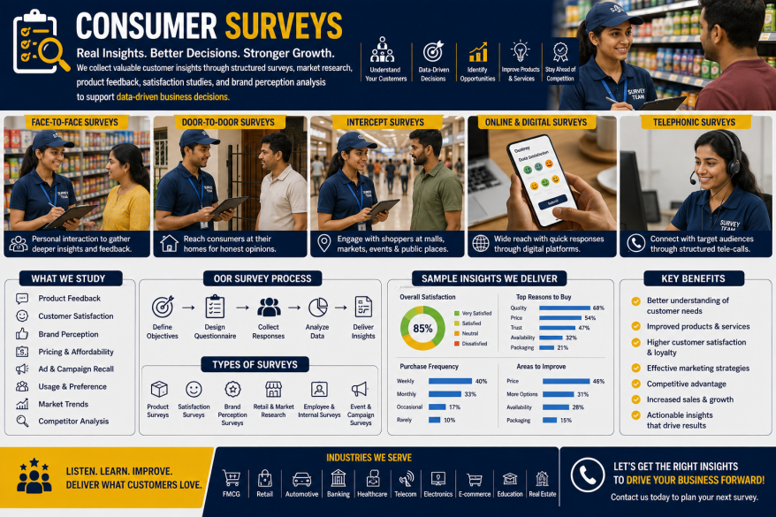

- Event Management & Brand Activations: Plan and execute impactful promotional events, product launches, exhibitions, roadshows, corporate events, and experiential marketing campaigns that strengthen brand awareness and customer engagement.
