**РУСЕНСКИ УНИВЕРСИТЕТ „АНГЕЛ КЪНЧЕВ“**

**КУРСОВА РАБОТА**

ПО

ИНТЕГРИРАНИ СРЕДИ

Студент:

Факултетен номер:

Група:

Специалност: **КСТ**

Оценка**:**

Дата: Проверил:

/ /

# Съдържание

Съдържание 2

1. Задание 3

2. UML проект 4

2.1 Диаграма на случаите на употреба 4

2.2 Диаграма на дейностите 5

2.3 Диаграма на класовете 6

3. Тестови примери 6

4. Език и среда за разработване 8

5. Използвана литература 9

6. Код на програмата 9

6.1 Program.cs 9

6.2 Elements.cs 9

6.3 DrawingUtils.cs 10

6.4 DrawingElementEnum.cs 12

6.5 VectorUtils.cs 12

6.6 MainForm.cs 12

6.7 MainForm.Designer.cs 16

6.8 AboutForm.cs 26

6.9 AboutForm.Designer.cs 26

# Задание

Да се проектира и реализира като Windows приложение графичен редактор на 2D елементи със системно меню, лента с инструменти и панел с елементи. Освен командите на менюто File (New, Open, Save, Save As, Exit), About и за изписване на текст инструменталното средство да предоставя на потребителя и следните възможности:

* Изчертаване на елипса и окръжност;
* Изчертаване на квадрат и правоъгълник;
* Изчертаване на хоризонтална линия;
* Изчертаване на начупена линия;
* Смяна на размера на писалката;
* Смяна на стила на четката;
* Запазване в .bmp, .jpeg файл и векторен файл.

# UML проект



## Диаграма на случаите на употреба

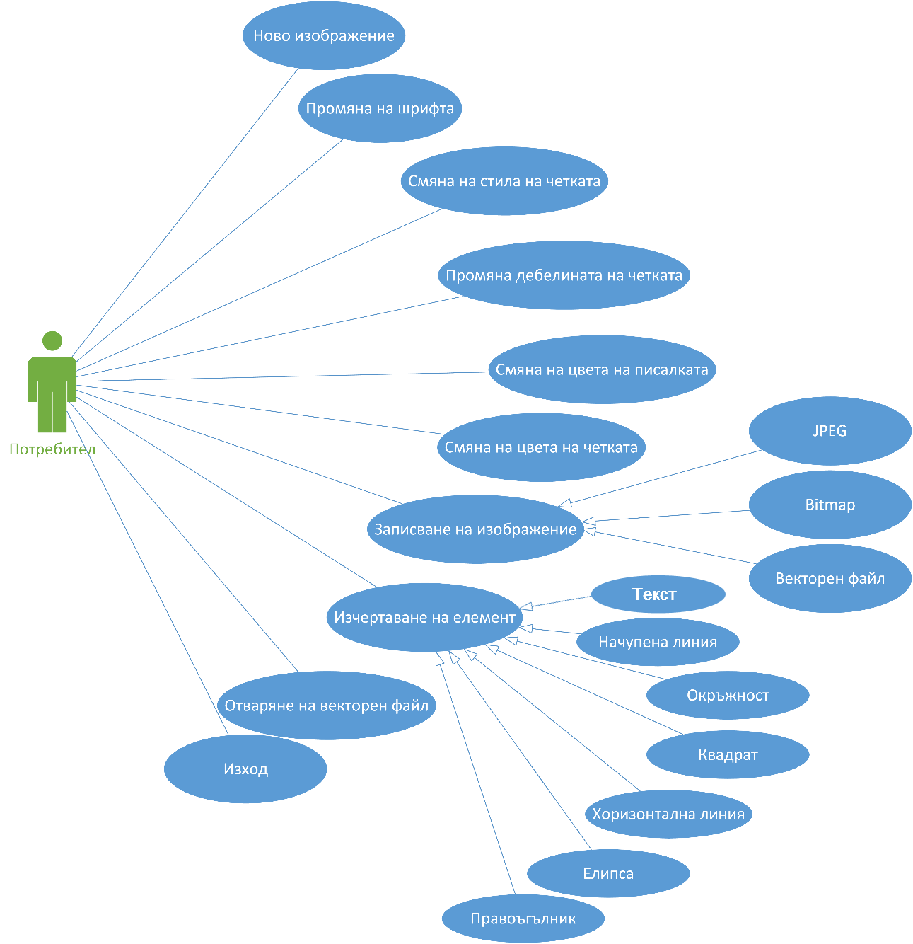

Фиг. 1 Use case диаграма

Първата UML диаграма, създадена в процеса на проектиране на системата бе диаграмата на случаите на употреба (use case diagram) (фиг. 1). Тази диаграма позволява да се опишат на най-високо ниво целите на потребителя, които системата трябва да изпълнява. Тези цели не е необходимо да са задачи или действия, а може да са по общи изисквания към функционалността на системата. С други думи това е техника за определяне на функционалните изисквания на една система. Те описват типичните взаимодействия между потребителите и системата, предоставят описание на начина, по който тя се използва [1].

## Диаграма на дейностите

Диаграмата на дейността (activity диаграмата) показва последователността и логиката на действията, които протичат в програмната система.

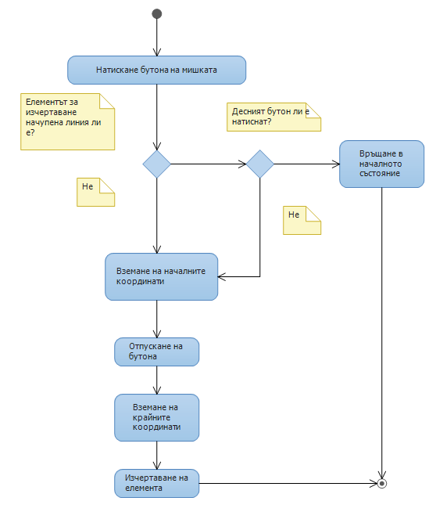

Фиг. 2 Activity диаграма на логиката за изчертаване

## Диаграма на класовете

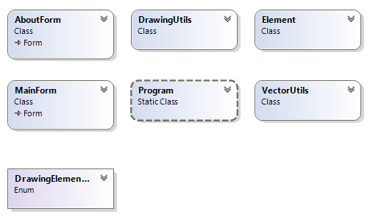

Фиг. 3 Class диаграма

# Тестови примери

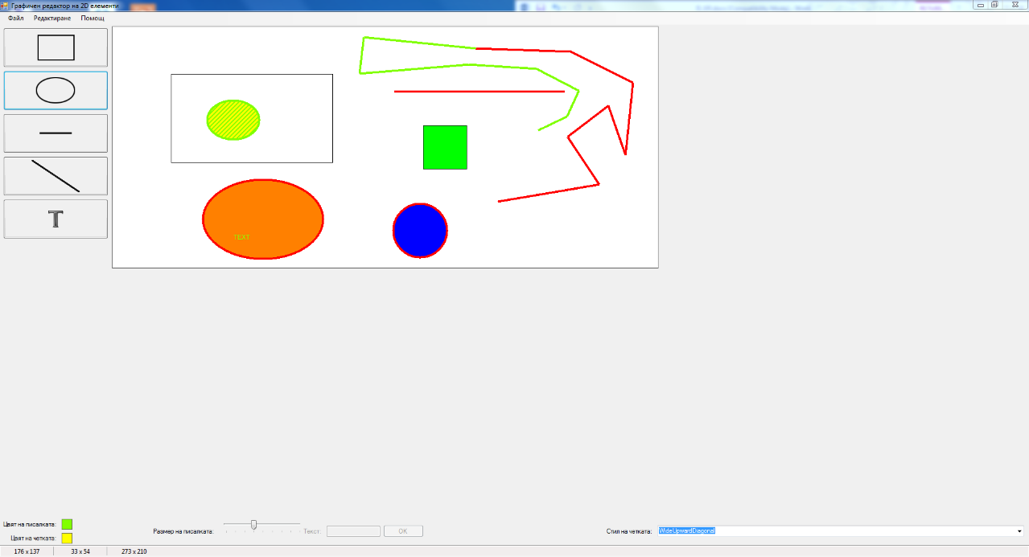

Фиг. 4 Изчертана схема

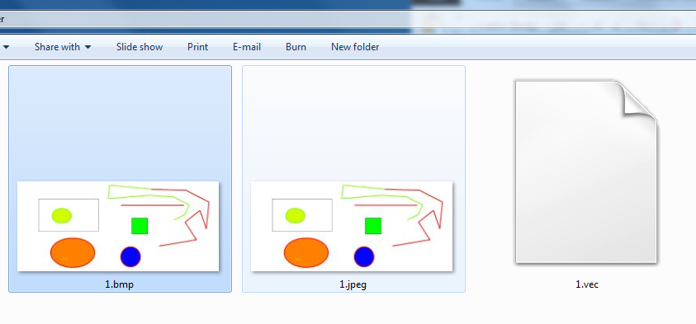

Фиг. 5 Схемата е записана като BMP, JPEG и векторен файл с разширение VEC

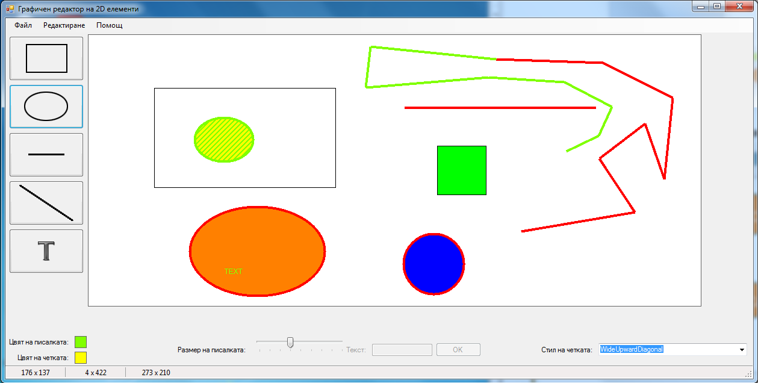

Фиг. 6 Отвореният векторен файл

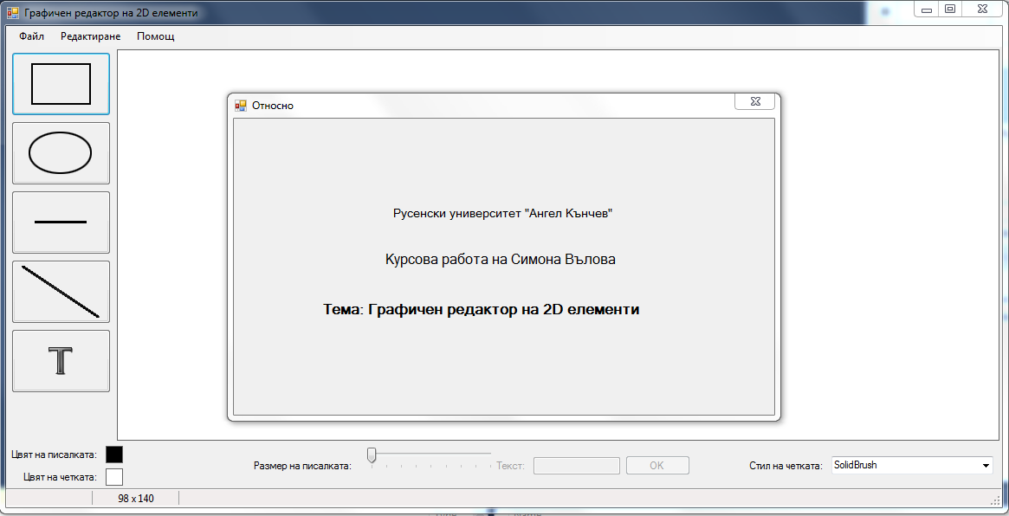

Фиг. 7 Прозорец "Относно"

# Език и среда за разработване

* Средата за разработване е Microsoft Visual Studio 2015, .NET 4.5.
* Езикът за програмиране е C#.

# Използвана литература

1. <http://refg.tu-sofia.bg/~bogi/StopFak/SoftEngr/uml_lab1.pdf>, 2013
2. http://refg.tu-sofia.bg/~bogi/StopFak/SoftEngr/uml_lab3.pdf

# Код на програмата

## Program.cs

namespace IS_2D

{

using System;

using System.Windows.Forms;

static class Program

{

[STAThread]

static void Main()

{

Application.EnableVisualStyles();

Application.SetCompatibleTextRenderingDefault(false);

Application.Run(new MainForm());

}

}

}

## Elements.cs

namespace IS_2D

{

using System;

using System.Drawing;

using System.Drawing.Drawing2D;

[Serializable()]

public class Element

{

private DrawingElementEnum elementType;

private Point startPoint;

private Point endPoint;

private Font textFont;

private Color penColor;

private float penWidth;

private Color brushColor;

private string text;

private HatchStyle hatchStyle;

private Color brushForeColor;

public DrawingElementEnum ElementType

{

get

{

return elementType;

}

set

{

elementType = value;

}

}

public Point StartPoint

{

get

{

return startPoint;

}

set

{

startPoint = value;

}

}

public Point EndPoint

{

get

{

return endPoint;

}

set

{

endPoint = value;

}

}

public Font TextFont

{

get

{

return textFont;

}

set

{

textFont = value;

}

}

public Color PenColor

{

get

{

return penColor;

}

set

{

penColor = value;

}

}

public float PenWidth

{

get

{

return penWidth;

}

set

{

penWidth = value;

}

}

public Color BrushColor

{

get

{

return brushColor;

}

set

{

brushColor = value;

}

}

public string Text

{

get

{

return text;

}

set

{

text = value;

}

}

public HatchStyle HatchStyle

{

get

{

return hatchStyle;

}

set

{

hatchStyle = value;

}

}

public Color BrushForeColor

{

get

{

return brushForeColor;

}

set

{

brushForeColor = value;

}

}

public Element(DrawingElementEnum elementType, Point startPoint, Point endPoint, Font textFont, Color penColor, float penWidth, Color brushColor, HatchStyle hatchStyle, Color brushForeColor, String text)

{

this.ElementType = elementType;

this.StartPoint = startPoint;

this.EndPoint = endPoint;

this.TextFont = textFont;

this.PenColor = penColor;

this.PenWidth = penWidth;

this.BrushColor = brushColor;

this.HatchStyle = hatchStyle;

this.BrushForeColor = brushForeColor;

this.Text = text;

}

}

}

## DrawingUtils.cs

namespace IS_2D

{

using System;

using System.Drawing;

using System.Drawing.Drawing2D;

class DrawingUtils

{

private const int IOLineLenght = 20;

private const int IOCircleRadius = 5;

private readonly FontFamily fontFamily = new FontFamily("Arial");

private Font innerTextFont;

private Graphics graphics;

private Pen pen;

private HatchBrush brush;

private Font font;

public Pen Pen

{

get

{

return pen;

}

set

{

pen = value;

}

}

public HatchBrush Brush

{

get

{

return brush;

}

set

{

brush = value;

}

}

public Font Font

{

get

{

return font;

}

set

{

font = value;

}

}

public Graphics Graphics

{

get

{

return graphics;

}

set

{

graphics = value;

}

}

public DrawingUtils(Graphics graphics, Pen pen, HatchBrush brush, Font font)

{

this.graphics = graphics;

this.pen = pen;

this.brush = brush;

this.font = font;

}

public void HandleCoordinates(ref Point start, ref Point end)

{

if (start.X > end.X)

{

int swap = start.X;

start.X = end.X;

end.X = swap;

}

if (start.Y > end.Y)

{

int swap = start.Y;

start.Y = end.Y;

end.Y = swap;

}

}

public void Draw(DrawingElementEnum element, Point start, Point end, String text = null)

{

switch (element)

{

case DrawingElementEnum.RECTANGLE:

DrawRectangle(start, end);

break;

case DrawingElementEnum.ELLIPSE:

DrawEllipse(start, end);

break;

case DrawingElementEnum.HORIZONTAL_LINE:

DrawHorizontalLine(start, end);

break;

case DrawingElementEnum.LINE:

DrawLine(start, end);

break;

case DrawingElementEnum.TEXT:

DrawText(text, start);

break;

}

}

private void DrawLine(Point start, Point end)

{

this.Graphics.DrawLine(this.pen, start, end);

}

private void DrawText(string text, Point start)

{

SolidBrush b = new SolidBrush(this.pen.Color);

this.Graphics.DrawString(text, this.font, b, start);

}

private void DrawHorizontalLine(Point start, Point end)

{

Point endPoint = new Point(end.X, start.Y);

this.Graphics.DrawLine(this.pen, start, endPoint);

}

private void DrawEllipse(Point start, Point end)

{

HandleCoordinates(ref start, ref end);

this.Graphics.FillEllipse(this.Brush, start.X, start.Y, Math.Abs(end.X - start.X), Math.Abs(end.Y - start.Y));

this.Graphics.DrawEllipse(this.Pen, start.X, start.Y, Math.Abs(end.X - start.X), Math.Abs(end.Y - start.Y));

}

private void DrawRectangle(Point start, Point end)

{

HandleCoordinates(ref start, ref end);

this.Graphics.FillRectangle(this.Brush, start.X, start.Y, Math.Abs(end.X - start.X), Math.Abs(end.Y - start.Y));

this.Graphics.DrawRectangle(this.Pen, start.X, start.Y, Math.Abs(end.X - start.X), Math.Abs(end.Y - start.Y));

}

}

}

## DrawingElementEnum.cs

namespace IS_2D

{

public enum DrawingElementEnum

{

RECTANGLE,

ELLIPSE,

HORIZONTAL_LINE,

LINE,

TEXT

}

}

## VectorUtils.cs

namespace IS_2D

{

using System;

using System.Collections.Generic;

using System.Drawing;

using System.Drawing.Drawing2D;

using System.IO;

class VectorUtils

{

private static List<Element> elements = new List<Element>();

public static void AddElement(DrawingElementEnum elementType, Point startPoint, Point endPoint, Font font, Color penColor, float penWidth, Color brushColor, HatchStyle hatchStyle, Color brushForeColor, String text)

{

if (elementType == DrawingElementEnum.TEXT)

{

Element el = new Element(elementType, startPoint, Point.Empty, font, penColor, penWidth, brushColor, hatchStyle, brushForeColor, text);

elements.Add(el);

}

else

{

Element el = new Element(elementType, startPoint, endPoint, null, penColor, penWidth, brushColor, hatchStyle, brushForeColor, null);

elements.Add(el);

}

}

public static void SaveVector(String fileName)

{

using (Stream stream = File.Open(fileName, FileMode.Create))

{

var binaryFormatter = new System.Runtime.Serialization.Formatters.Binary.BinaryFormatter();

binaryFormatter.Serialize(stream, VectorUtils.elements);

}

}

public static List<Element> OpenVector(String fileName)

{

using (Stream stream = File.Open(fileName, FileMode.Open))

{

var binaryFormatter = new System.Runtime.Serialization.Formatters.Binary.BinaryFormatter();

VectorUtils.elements = (List<Element>)binaryFormatter.Deserialize(stream);

return VectorUtils.elements;

}

}

public static void ClearElements()

{

VectorUtils.elements.Clear();

}

}

}

## MainForm.cs

namespace IS_2D

{

using System;

using System.Collections.Generic;

using System.Drawing;

using System.Drawing.Drawing2D;

using System.Drawing.Imaging;

using System.Windows.Forms;

public partial class MainForm : Form

{

private String fileName;

private DrawingElementEnum currentElementForDrawing;

private DrawingUtils dutils;

private Point startPosition;

private Point endPosition;

private Bitmap bmp;

private Graphics gr;

private bool paint;

private bool line;

public MainForm()

{

InitializeComponent();

FontFamily fontFamily = new FontFamily("Arial");

Font font = new Font(

fontFamily,

12,

FontStyle.Regular,

GraphicsUnit.Pixel);

bmp = new Bitmap(panelCanvas.Width, panelCanvas.Height);

Graphics g = Graphics.FromImage(bmp);

g.Clear(Color.White);

gr = panelCanvas.CreateGraphics();

Pen pen = new Pen(panelPenColor.BackColor, trackBarPenStroke.Value);

HatchBrush brush = new HatchBrush(HatchStyle.BackwardDiagonal, panelPenColor.BackColor, panelBrushColor.BackColor);

dutils = new DrawingUtils(g, pen, brush, font);

panelCanvas.Image = bmp;

startPosition = new Point();

endPosition = new Point();

comboBoxBrushStyle.Items.Add("SolidBrush");

foreach (string styleName in Enum.GetNames(typeof(HatchStyle)))

{

comboBoxBrushStyle.Items.Add(styleName);

}

comboBoxBrushStyle.SelectedIndex = 0;

}

private void panelCanvas_MouseDown(object sender, MouseEventArgs e)

{

if (currentElementForDrawing == DrawingElementEnum.LINE)

{

if (e.Button == MouseButtons.Right)

{

line = false;

return;

}

if (!line)

{

startPosition.X = e.X;

startPosition.Y = e.Y;

}

}

else

{

startPosition.X = e.X;

startPosition.Y = e.Y;

}

startToolStripStatusLabel.Text = e.X + " x " + e.Y;

paint = true;

}

private void panelCanvas_MouseUp(object sender, MouseEventArgs e)

{

if (paint)

{

bool jmp = false;

if (currentElementForDrawing == DrawingElementEnum.LINE)

{

if (!line)

{

endPosition.X = e.X;

endPosition.Y = e.Y;

line = true;

}

else

{

startPosition = endPosition;

}

}

else if (currentElementForDrawing == DrawingElementEnum.RECTANGLE ||

currentElementForDrawing == DrawingElementEnum.ELLIPSE)

{

jmp = (Control.ModifierKeys & Keys.Control) == Keys.Control;

if (jmp)

{ // ако е натиснат Ctrl изчертай квадрат/окръжност

endPosition.X = e.X;

endPosition.Y = e.Y;

dutils.HandleCoordinates(ref startPosition, ref endPosition);

int width = Math.Abs(endPosition.X - startPosition.X);

int height = Math.Abs(endPosition.Y - startPosition.Y);

if (width > height)

{

endPosition.X = startPosition.X + height;

}

else

{

endPosition.Y = startPosition.Y + width;

}

}

}

if (!jmp)

{

endPosition.X = e.X;

endPosition.Y = e.Y;

}

endToolStripStatusLabel.Text = e.X + " x " + e.Y;

dutils.Draw(currentElementForDrawing, startPosition, endPosition);

VectorUtils.AddElement(currentElementForDrawing, startPosition,

endPosition, dutils.Font, dutils.Pen.Color, dutils.Pen.Width,

dutils.Brush.BackgroundColor, dutils.Brush.HatchStyle,

dutils.Brush.ForegroundColor, null);

gr.DrawImage(bmp, Point.Empty);

paint = false;

}

}

private void panelCanvas_MouseMove(object sender, MouseEventArgs e)

{

currentToolStripStatusLabel.Text = e.X + " x " + e.Y;

}

private void buttonRectangle_Click(object sender, EventArgs e)

{

this.currentElementForDrawing = DrawingElementEnum.RECTANGLE;

tableLayoutPanel3.Enabled = false;

}

private void buttonEllipse_Click(object sender, EventArgs e)

{

this.currentElementForDrawing = DrawingElementEnum.ELLIPSE;

tableLayoutPanel3.Enabled = false;

}

private void buttonHorizontalLine_Click(object sender, EventArgs e)

{

this.currentElementForDrawing = DrawingElementEnum.HORIZONTAL_LINE;

tableLayoutPanel3.Enabled = false;

}

private void buttonLine_Click(object sender, EventArgs e)

{

this.currentElementForDrawing = DrawingElementEnum.LINE;

tableLayoutPanel3.Enabled = false;

line = false;

}

private void buttonText_Click(object sender, EventArgs e)

{

this.currentElementForDrawing = DrawingElementEnum.TEXT;

tableLayoutPanel3.Enabled = true;

}

private void panelPenColor_Click(object sender, EventArgs e)

{

DialogResult dlgResult = colorDialog1.ShowDialog();

if (dlgResult == DialogResult.OK)

{

if (comboBoxBrushStyle.SelectedIndex != 0)

{

dutils.Brush = new HatchBrush(dutils.Brush.HatchStyle, colorDialog1.Color, dutils.Brush.BackgroundColor);

}

dutils.Pen = new Pen(colorDialog1.Color, dutils.Pen.Width);

panelPenColor.BackColor = colorDialog1.Color;

}

}

private void panelBrushColor_Click(object sender, EventArgs e)

{

DialogResult dlgResult = colorDialog1.ShowDialog();

if (dlgResult == DialogResult.OK)

{

if (comboBoxBrushStyle.SelectedIndex == 0)

{

dutils.Brush = new HatchBrush(dutils.Brush.HatchStyle, colorDialog1.Color, colorDialog1.Color);

}

else

{

dutils.Brush = new HatchBrush(dutils.Brush.HatchStyle, dutils.Brush.ForegroundColor, colorDialog1.Color);

}

panelBrushColor.BackColor = colorDialog1.Color;

}

}

private void trackBarPenStroke_Scroll(object sender, EventArgs e)

{

dutils.Pen = new Pen(dutils.Pen.Color, trackBarPenStroke.Value);

}

private void fontToolStripMenuItem_Click(object sender, EventArgs e)

{

DialogResult dlgResult = fontDialog1.ShowDialog();

if (dlgResult == DialogResult.OK)

{

dutils.Font = fontDialog1.Font;

}

}

private void newToolStripMenuItem_Click(object sender, EventArgs e)

{

//TODO: логика за проверка дали потребителят иска да запази направените промени

fileName = null;

dutils.Graphics.Clear(Color.White);

gr.DrawImage(bmp, Point.Empty);

gr.Clear(Color.White);

VectorUtils.ClearElements();

}

private void exitToolStripMenuItem_Click(object sender, EventArgs e)

{

//TODO: логика за проверка дали потребителят иска да запази направените промени

Application.Exit();

}

private void saveToolStripMenuItem_Click(object sender, EventArgs e)

{

if (String.IsNullOrEmpty(this.fileName))

{

saveAsToolStripMenuItem.PerformClick();

}

else

{

int indexOfLastDot = fileName.LastIndexOf('.');

string extension = fileName.Substring(indexOfLastDot + 1);

if (extension == "vec")

{

VectorUtils.SaveVector(fileName);

}

else

{

bmp.Save(fileName);

}

}

}

private void saveAsToolStripMenuItem_Click(object sender, EventArgs e)

{

DialogResult dlgResult = saveFileDialog1.ShowDialog();

if (dlgResult == DialogResult.OK)

{

fileName = saveFileDialog1.FileName;

int indexOfLastDot = fileName.LastIndexOf('.');

string extension = fileName.Substring(indexOfLastDot + 1);

switch (extension)

{

case "bmp":

bmp.Save(fileName, ImageFormat.Bmp);

break;

case "jpeg":

bmp.Save(fileName, ImageFormat.Jpeg);

break;

case "vec":

VectorUtils.SaveVector(fileName);

break;

}

}

}

private void buttonOK_Click(object sender, EventArgs e)

{

dutils.Draw(currentElementForDrawing, startPosition, endPosition, textBoxMessage.Text);

gr.DrawImage(bmp, Point.Empty);

VectorUtils.AddElement(currentElementForDrawing, startPosition, Point.Empty,

dutils.Font, dutils.Pen.Color, dutils.Pen.Width, dutils.Brush.BackgroundColor,

dutils.Brush.HatchStyle, dutils.Brush.ForegroundColor, textBoxMessage.Text);

textBoxMessage.Clear();

}

private void openToolStripMenuItem_Click(object sender, EventArgs e)

{

DialogResult dlgResult = openFileDialog1.ShowDialog();

if (dlgResult == DialogResult.OK)

{

dutils.Graphics.Clear(Color.White);

gr.Clear(Color.White);

fileName = openFileDialog1.FileName;

List<Element> list = VectorUtils.OpenVector(fileName);

Color penColor = dutils.Pen.Color;

float penWidth = dutils.Pen.Width;

HatchStyle hs = dutils.Brush.HatchStyle;

Color brushColor = dutils.Brush.BackgroundColor;

Color brushForeColor = dutils.Brush.ForegroundColor;

Font font = dutils.Font;

for (int i = 0; i < list.Count; i++)

{

dutils.Pen = new Pen(list[i].PenColor, list[i].PenWidth);

dutils.Brush = new HatchBrush(list[i].HatchStyle, list[i].BrushForeColor, list[i].BrushColor);

dutils.Font = list[i].TextFont;

dutils.Draw(list[i].ElementType, list[i].StartPoint, list[i].EndPoint, list[i].Text);

}

gr.DrawImage(bmp, Point.Empty);

dutils.Pen = new Pen(penColor, penWidth);

dutils.Brush = new HatchBrush(hs, brushForeColor, brushColor);

dutils.Font = font;

}

}

private void aboutToolStripMenuItem_Click(object sender, EventArgs e)

{

AboutForm aboutForm = new AboutForm();

aboutForm.Show();

}

private void comboBoxBrushStyle_SelectedIndexChanged(object sender, EventArgs e)

{

if (comboBoxBrushStyle.SelectedIndex == 0)

{

dutils.Brush = new HatchBrush(dutils.Brush.HatchStyle, dutils.Brush.BackgroundColor, dutils.Brush.BackgroundColor);

}

else

{

HatchStyle hs = (HatchStyle)Enum.Parse(typeof(HatchStyle),

comboBoxBrushStyle.SelectedItem.ToString(), true);

dutils.Brush = new HatchBrush(hs, panelPenColor.BackColor, dutils.Brush.BackgroundColor);

}

}

}

}

## MainForm.Designer.cs

namespace IS_2D

{

partial class MainForm

{

/// <summary>

/// Required designer variable.

/// </summary>

private System.ComponentModel.IContainer components = null;

/// <summary>

/// Clean up any resources being used.

/// </summary>

/// <param name="disposing">true if managed resources should be disposed; otherwise, false.</param>

protected override void Dispose(bool disposing)

{

if (disposing && (components != null))

{

components.Dispose();

}

base.Dispose(disposing);

}

#region Windows Form Designer generated code

/// <summary>

/// Required method for Designer support - do not modify

/// the contents of this method with the code editor.

/// </summary>

private void InitializeComponent()

{

System.ComponentModel.ComponentResourceManager resources = new System.ComponentModel.ComponentResourceManager(typeof(MainForm));

this.menuStripMainForm = new System.Windows.Forms.MenuStrip();

this.fileToolStripMenuItem = new System.Windows.Forms.ToolStripMenuItem();

this.newToolStripMenuItem = new System.Windows.Forms.ToolStripMenuItem();

this.openToolStripMenuItem = new System.Windows.Forms.ToolStripMenuItem();

this.saveToolStripMenuItem = new System.Windows.Forms.ToolStripMenuItem();

this.saveAsToolStripMenuItem = new System.Windows.Forms.ToolStripMenuItem();

this.toolStripMenuItem1 = new System.Windows.Forms.ToolStripSeparator();

this.exitToolStripMenuItem = new System.Windows.Forms.ToolStripMenuItem();

this.editToolStripMenuItem = new System.Windows.Forms.ToolStripMenuItem();

this.fontToolStripMenuItem = new System.Windows.Forms.ToolStripMenuItem();

this.helpToolStripMenuItem = new System.Windows.Forms.ToolStripMenuItem();

this.aboutToolStripMenuItem = new System.Windows.Forms.ToolStripMenuItem();

this.statusStripMainForm = new System.Windows.Forms.StatusStrip();

this.startToolStripStatusLabel = new System.Windows.Forms.ToolStripStatusLabel();

this.currentToolStripStatusLabel = new System.Windows.Forms.ToolStripStatusLabel();

this.endToolStripStatusLabel = new System.Windows.Forms.ToolStripStatusLabel();

this.tableLayoutPanelMain = new System.Windows.Forms.TableLayoutPanel();

this.splitContainerMainFormContent = new System.Windows.Forms.SplitContainer();

this.tableLayoutPanelIButtons = new System.Windows.Forms.TableLayoutPanel();

this.buttonText = new System.Windows.Forms.Button();

this.buttonLine = new System.Windows.Forms.Button();

this.buttonHorizontalLine = new System.Windows.Forms.Button();

this.buttonEllipse = new System.Windows.Forms.Button();

this.buttonRectangle = new System.Windows.Forms.Button();

this.panelCanvas = new System.Windows.Forms.PictureBox();

this.panel1 = new System.Windows.Forms.Panel();

this.tableLayoutPanel4 = new System.Windows.Forms.TableLayoutPanel();

this.labelBrushStyle = new System.Windows.Forms.Label();

this.comboBoxBrushStyle = new System.Windows.Forms.ComboBox();

this.tableLayoutPanel1 = new System.Windows.Forms.TableLayoutPanel();

this.tableLayoutPanel3 = new System.Windows.Forms.TableLayoutPanel();

this.labelText = new System.Windows.Forms.Label();

this.textBoxMessage = new System.Windows.Forms.TextBox();

this.buttonOK = new System.Windows.Forms.Button();

this.tableLayoutPanelColors = new System.Windows.Forms.TableLayoutPanel();

this.labelPenColor = new System.Windows.Forms.Label();

this.panelBrushColor = new System.Windows.Forms.Panel();

this.panelPenColor = new System.Windows.Forms.Panel();

this.label1 = new System.Windows.Forms.Label();

this.tableLayoutPanel2 = new System.Windows.Forms.TableLayoutPanel();

this.labelPenStroke = new System.Windows.Forms.Label();

this.trackBarPenStroke = new System.Windows.Forms.TrackBar();

this.colorDialog1 = new System.Windows.Forms.ColorDialog();

this.fontDialog1 = new System.Windows.Forms.FontDialog();

this.saveFileDialog1 = new System.Windows.Forms.SaveFileDialog();

this.openFileDialog1 = new System.Windows.Forms.OpenFileDialog();

this.menuStripMainForm.SuspendLayout();

this.statusStripMainForm.SuspendLayout();

this.tableLayoutPanelMain.SuspendLayout();

((System.ComponentModel.ISupportInitialize)(this.splitContainerMainFormContent)).BeginInit();

this.splitContainerMainFormContent.Panel1.SuspendLayout();

this.splitContainerMainFormContent.Panel2.SuspendLayout();

this.splitContainerMainFormContent.SuspendLayout();

this.tableLayoutPanelIButtons.SuspendLayout();

((System.ComponentModel.ISupportInitialize)(this.panelCanvas)).BeginInit();

this.panel1.SuspendLayout();

this.tableLayoutPanel4.SuspendLayout();

this.tableLayoutPanel1.SuspendLayout();

this.tableLayoutPanel3.SuspendLayout();

this.tableLayoutPanelColors.SuspendLayout();

this.tableLayoutPanel2.SuspendLayout();

((System.ComponentModel.ISupportInitialize)(this.trackBarPenStroke)).BeginInit();

this.SuspendLayout();

//

// menuStripMainForm

//

this.menuStripMainForm.Items.AddRange(new System.Windows.Forms.ToolStripItem[] {

this.fileToolStripMenuItem,

this.editToolStripMenuItem,

this.helpToolStripMenuItem});

this.menuStripMainForm.Location = new System.Drawing.Point(0, 0);

this.menuStripMainForm.Name = "menuStripMainForm";

this.menuStripMainForm.Size = new System.Drawing.Size(1150, 24);

this.menuStripMainForm.TabIndex = 0;

//

// fileToolStripMenuItem

//

this.fileToolStripMenuItem.DropDownItems.AddRange(new System.Windows.Forms.ToolStripItem[] {

this.newToolStripMenuItem,

this.openToolStripMenuItem,

this.saveToolStripMenuItem,

this.saveAsToolStripMenuItem,

this.toolStripMenuItem1,

this.exitToolStripMenuItem});

this.fileToolStripMenuItem.Name = "fileToolStripMenuItem";

this.fileToolStripMenuItem.Size = new System.Drawing.Size(48, 20);

this.fileToolStripMenuItem.Text = "Файл";

//

// newToolStripMenuItem

//

this.newToolStripMenuItem.Name = "newToolStripMenuItem";

this.newToolStripMenuItem.ShortcutKeyDisplayString = "";

this.newToolStripMenuItem.ShortcutKeys = ((System.Windows.Forms.Keys)((System.Windows.Forms.Keys.Control | System.Windows.Forms.Keys.N)));

this.newToolStripMenuItem.Size = new System.Drawing.Size(167, 22);

this.newToolStripMenuItem.Text = "Нов";

this.newToolStripMenuItem.Click += new System.EventHandler(this.newToolStripMenuItem_Click);

//

// openToolStripMenuItem

//

this.openToolStripMenuItem.Name = "openToolStripMenuItem";

this.openToolStripMenuItem.ShortcutKeyDisplayString = "";

this.openToolStripMenuItem.ShortcutKeys = ((System.Windows.Forms.Keys)((System.Windows.Forms.Keys.Control | System.Windows.Forms.Keys.O)));

this.openToolStripMenuItem.Size = new System.Drawing.Size(167, 22);

this.openToolStripMenuItem.Text = "Отвори...";

this.openToolStripMenuItem.Click += new System.EventHandler(this.openToolStripMenuItem_Click);

//

// saveToolStripMenuItem

//

this.saveToolStripMenuItem.Name = "saveToolStripMenuItem";

this.saveToolStripMenuItem.ShortcutKeys = ((System.Windows.Forms.Keys)((System.Windows.Forms.Keys.Control | System.Windows.Forms.Keys.S)));

this.saveToolStripMenuItem.Size = new System.Drawing.Size(167, 22);

this.saveToolStripMenuItem.Text = "Запиши";

this.saveToolStripMenuItem.Click += new System.EventHandler(this.saveToolStripMenuItem_Click);

//

// saveAsToolStripMenuItem

//

this.saveAsToolStripMenuItem.Name = "saveAsToolStripMenuItem";

this.saveAsToolStripMenuItem.Size = new System.Drawing.Size(167, 22);

this.saveAsToolStripMenuItem.Text = "Запиши като...";

this.saveAsToolStripMenuItem.Click += new System.EventHandler(this.saveAsToolStripMenuItem_Click);

//

// toolStripMenuItem1

//

this.toolStripMenuItem1.Name = "toolStripMenuItem1";

this.toolStripMenuItem1.Size = new System.Drawing.Size(164, 6);

//

// exitToolStripMenuItem

//

this.exitToolStripMenuItem.Name = "exitToolStripMenuItem";

this.exitToolStripMenuItem.ShortcutKeys = ((System.Windows.Forms.Keys)((System.Windows.Forms.Keys.Alt | System.Windows.Forms.Keys.F4)));

this.exitToolStripMenuItem.Size = new System.Drawing.Size(167, 22);

this.exitToolStripMenuItem.Text = "Изход";

this.exitToolStripMenuItem.Click += new System.EventHandler(this.exitToolStripMenuItem_Click);

//

// editToolStripMenuItem

//

this.editToolStripMenuItem.DropDownItems.AddRange(new System.Windows.Forms.ToolStripItem[] {

this.fontToolStripMenuItem});

this.editToolStripMenuItem.Name = "editToolStripMenuItem";

this.editToolStripMenuItem.Size = new System.Drawing.Size(88, 20);

this.editToolStripMenuItem.Text = "Редактиране";

//

// fontToolStripMenuItem

//

this.fontToolStripMenuItem.Name = "fontToolStripMenuItem";

this.fontToolStripMenuItem.Size = new System.Drawing.Size(122, 22);

this.fontToolStripMenuItem.Text = "Шрифт...";

this.fontToolStripMenuItem.Click += new System.EventHandler(this.fontToolStripMenuItem_Click);

//

// helpToolStripMenuItem

//

this.helpToolStripMenuItem.DropDownItems.AddRange(new System.Windows.Forms.ToolStripItem[] {

this.aboutToolStripMenuItem});

this.helpToolStripMenuItem.Name = "helpToolStripMenuItem";

this.helpToolStripMenuItem.Size = new System.Drawing.Size(62, 20);

this.helpToolStripMenuItem.Text = "Помощ";

//

// aboutToolStripMenuItem

//

this.aboutToolStripMenuItem.Name = "aboutToolStripMenuItem";

this.aboutToolStripMenuItem.Size = new System.Drawing.Size(122, 22);

this.aboutToolStripMenuItem.Text = "Относно";

this.aboutToolStripMenuItem.Click += new System.EventHandler(this.aboutToolStripMenuItem_Click);

//

// statusStripMainForm

//

this.statusStripMainForm.Items.AddRange(new System.Windows.Forms.ToolStripItem[] {

this.startToolStripStatusLabel,

this.currentToolStripStatusLabel,

this.endToolStripStatusLabel});

this.statusStripMainForm.Location = new System.Drawing.Point(0, 534);

this.statusStripMainForm.Name = "statusStripMainForm";

this.statusStripMainForm.Size = new System.Drawing.Size(1150, 22);

this.statusStripMainForm.TabIndex = 2;

//

// startToolStripStatusLabel

//

this.startToolStripStatusLabel.AutoSize = false;

this.startToolStripStatusLabel.BorderSides = System.Windows.Forms.ToolStripStatusLabelBorderSides.Right;

this.startToolStripStatusLabel.Name = "startToolStripStatusLabel";

this.startToolStripStatusLabel.Size = new System.Drawing.Size(100, 17);

this.startToolStripStatusLabel.ToolTipText = "Начална точка";

//

// currentToolStripStatusLabel

//

this.currentToolStripStatusLabel.AutoSize = false;

this.currentToolStripStatusLabel.BorderSides = System.Windows.Forms.ToolStripStatusLabelBorderSides.Right;

this.currentToolStripStatusLabel.Name = "currentToolStripStatusLabel";

this.currentToolStripStatusLabel.Size = new System.Drawing.Size(100, 17);

this.currentToolStripStatusLabel.ToolTipText = "Текуща позиция на мишката";

//

// endToolStripStatusLabel

//

this.endToolStripStatusLabel.AutoSize = false;

this.endToolStripStatusLabel.Name = "endToolStripStatusLabel";

this.endToolStripStatusLabel.Size = new System.Drawing.Size(100, 17);

this.endToolStripStatusLabel.ToolTipText = "Крайна точка";

//

// tableLayoutPanelMain

//

this.tableLayoutPanelMain.ColumnCount = 1;

this.tableLayoutPanelMain.ColumnStyles.Add(new System.Windows.Forms.ColumnStyle(System.Windows.Forms.SizeType.Percent, 100F));

this.tableLayoutPanelMain.Controls.Add(this.splitContainerMainFormContent, 0, 0);

this.tableLayoutPanelMain.Controls.Add(this.panel1, 0, 1);

this.tableLayoutPanelMain.Dock = System.Windows.Forms.DockStyle.Fill;

this.tableLayoutPanelMain.Location = new System.Drawing.Point(0, 24);

this.tableLayoutPanelMain.Name = "tableLayoutPanelMain";

this.tableLayoutPanelMain.RowCount = 2;

this.tableLayoutPanelMain.RowStyles.Add(new System.Windows.Forms.RowStyle(System.Windows.Forms.SizeType.Percent, 100F));

this.tableLayoutPanelMain.RowStyles.Add(new System.Windows.Forms.RowStyle());

this.tableLayoutPanelMain.Size = new System.Drawing.Size(1150, 510);

this.tableLayoutPanelMain.TabIndex = 3;

//

// splitContainerMainFormContent

//

this.splitContainerMainFormContent.Dock = System.Windows.Forms.DockStyle.Fill;

this.splitContainerMainFormContent.Location = new System.Drawing.Point(3, 3);

this.splitContainerMainFormContent.Name = "splitContainerMainFormContent";

//

// splitContainerMainFormContent.Panel1

//

this.splitContainerMainFormContent.Panel1.AutoScroll = true;

this.splitContainerMainFormContent.Panel1.Controls.Add(this.tableLayoutPanelIButtons);

//

// splitContainerMainFormContent.Panel2

//

this.splitContainerMainFormContent.Panel2.AutoScroll = true;

this.splitContainerMainFormContent.Panel2.Controls.Add(this.panelCanvas);

this.splitContainerMainFormContent.Size = new System.Drawing.Size(1144, 452);

this.splitContainerMainFormContent.SplitterDistance = 121;

this.splitContainerMainFormContent.TabIndex = 0;

//

// tableLayoutPanelIButtons

//

this.tableLayoutPanelIButtons.AutoScroll = true;

this.tableLayoutPanelIButtons.ColumnCount = 1;

this.tableLayoutPanelIButtons.ColumnStyles.Add(new System.Windows.Forms.ColumnStyle(System.Windows.Forms.SizeType.Percent, 100F));

this.tableLayoutPanelIButtons.Controls.Add(this.buttonText, 0, 4);

this.tableLayoutPanelIButtons.Controls.Add(this.buttonLine, 0, 3);

this.tableLayoutPanelIButtons.Controls.Add(this.buttonHorizontalLine, 0, 2);

this.tableLayoutPanelIButtons.Controls.Add(this.buttonEllipse, 0, 1);

this.tableLayoutPanelIButtons.Controls.Add(this.buttonRectangle, 0, 0);

this.tableLayoutPanelIButtons.Dock = System.Windows.Forms.DockStyle.Fill;

this.tableLayoutPanelIButtons.Location = new System.Drawing.Point(0, 0);

this.tableLayoutPanelIButtons.Name = "tableLayoutPanelIButtons";

this.tableLayoutPanelIButtons.RowCount = 6;

this.tableLayoutPanelIButtons.RowStyles.Add(new System.Windows.Forms.RowStyle(System.Windows.Forms.SizeType.Absolute, 80F));

this.tableLayoutPanelIButtons.RowStyles.Add(new System.Windows.Forms.RowStyle(System.Windows.Forms.SizeType.Absolute, 80F));

this.tableLayoutPanelIButtons.RowStyles.Add(new System.Windows.Forms.RowStyle(System.Windows.Forms.SizeType.Absolute, 80F));

this.tableLayoutPanelIButtons.RowStyles.Add(new System.Windows.Forms.RowStyle(System.Windows.Forms.SizeType.Absolute, 80F));

this.tableLayoutPanelIButtons.RowStyles.Add(new System.Windows.Forms.RowStyle(System.Windows.Forms.SizeType.Absolute, 80F));

this.tableLayoutPanelIButtons.RowStyles.Add(new System.Windows.Forms.RowStyle());

this.tableLayoutPanelIButtons.Size = new System.Drawing.Size(121, 452);

this.tableLayoutPanelIButtons.TabIndex = 1;

//

// buttonText

//

this.buttonText.Dock = System.Windows.Forms.DockStyle.Fill;

this.buttonText.Image = ((System.Drawing.Image)(resources.GetObject("buttonText.Image")));

this.buttonText.Location = new System.Drawing.Point(3, 323);

this.buttonText.Name = "buttonText";

this.buttonText.Padding = new System.Windows.Forms.Padding(5);

this.buttonText.Size = new System.Drawing.Size(115, 74);

this.buttonText.TabIndex = 4;

this.buttonText.UseVisualStyleBackColor = false;

this.buttonText.Click += new System.EventHandler(this.buttonText_Click);

//

// buttonLine

//

this.buttonLine.Dock = System.Windows.Forms.DockStyle.Fill;

this.buttonLine.Image = ((System.Drawing.Image)(resources.GetObject("buttonLine.Image")));

this.buttonLine.Location = new System.Drawing.Point(3, 243);

this.buttonLine.Name = "buttonLine";

this.buttonLine.Padding = new System.Windows.Forms.Padding(5);

this.buttonLine.Size = new System.Drawing.Size(115, 74);

this.buttonLine.TabIndex = 3;

this.buttonLine.UseVisualStyleBackColor = false;

this.buttonLine.Click += new System.EventHandler(this.buttonLine_Click);

//

// buttonHorizontalLine

//

this.buttonHorizontalLine.Dock = System.Windows.Forms.DockStyle.Fill;

this.buttonHorizontalLine.Image = ((System.Drawing.Image)(resources.GetObject("buttonHorizontalLine.Image")));

this.buttonHorizontalLine.Location = new System.Drawing.Point(3, 163);

this.buttonHorizontalLine.Name = "buttonHorizontalLine";

this.buttonHorizontalLine.Padding = new System.Windows.Forms.Padding(5);

this.buttonHorizontalLine.Size = new System.Drawing.Size(115, 74);

this.buttonHorizontalLine.TabIndex = 2;

this.buttonHorizontalLine.UseVisualStyleBackColor = false;

this.buttonHorizontalLine.Click += new System.EventHandler(this.buttonHorizontalLine_Click);

//

// buttonEllipse

//

this.buttonEllipse.Dock = System.Windows.Forms.DockStyle.Fill;

this.buttonEllipse.Image = ((System.Drawing.Image)(resources.GetObject("buttonEllipse.Image")));

this.buttonEllipse.Location = new System.Drawing.Point(3, 83);

this.buttonEllipse.Name = "buttonEllipse";

this.buttonEllipse.Padding = new System.Windows.Forms.Padding(5);

this.buttonEllipse.Size = new System.Drawing.Size(115, 74);

this.buttonEllipse.TabIndex = 1;

this.buttonEllipse.UseVisualStyleBackColor = false;

this.buttonEllipse.Click += new System.EventHandler(this.buttonEllipse_Click);

//

// buttonRectangle

//

this.buttonRectangle.Dock = System.Windows.Forms.DockStyle.Fill;

this.buttonRectangle.Image = ((System.Drawing.Image)(resources.GetObject("buttonRectangle.Image")));

this.buttonRectangle.Location = new System.Drawing.Point(3, 3);

this.buttonRectangle.Name = "buttonRectangle";

this.buttonRectangle.Padding = new System.Windows.Forms.Padding(5);

this.buttonRectangle.Size = new System.Drawing.Size(115, 74);

this.buttonRectangle.TabIndex = 0;

this.buttonRectangle.UseVisualStyleBackColor = false;

this.buttonRectangle.Click += new System.EventHandler(this.buttonRectangle_Click);

//

// panelCanvas

//

this.panelCanvas.BackColor = System.Drawing.Color.White;

this.panelCanvas.BorderStyle = System.Windows.Forms.BorderStyle.FixedSingle;

this.panelCanvas.Location = new System.Drawing.Point(0, 0);

this.panelCanvas.Name = "panelCanvas";

this.panelCanvas.Size = new System.Drawing.Size(1019, 452);

this.panelCanvas.TabIndex = 0;

this.panelCanvas.TabStop = false;

this.panelCanvas.MouseDown += new System.Windows.Forms.MouseEventHandler(this.panelCanvas_MouseDown);

this.panelCanvas.MouseMove += new System.Windows.Forms.MouseEventHandler(this.panelCanvas_MouseMove);

this.panelCanvas.MouseUp += new System.Windows.Forms.MouseEventHandler(this.panelCanvas_MouseUp);

//

// panel1

//

this.panel1.Controls.Add(this.tableLayoutPanel4);

this.panel1.Controls.Add(this.tableLayoutPanel1);

this.panel1.Dock = System.Windows.Forms.DockStyle.Fill;

this.panel1.Location = new System.Drawing.Point(0, 458);

this.panel1.Margin = new System.Windows.Forms.Padding(0);

this.panel1.Name = "panel1";

this.panel1.Size = new System.Drawing.Size(1150, 52);

this.panel1.TabIndex = 1;

//

// tableLayoutPanel4

//

this.tableLayoutPanel4.ColumnCount = 2;

this.tableLayoutPanel4.ColumnStyles.Add(new System.Windows.Forms.ColumnStyle(System.Windows.Forms.SizeType.Percent, 35.48387F));

this.tableLayoutPanel4.ColumnStyles.Add(new System.Windows.Forms.ColumnStyle(System.Windows.Forms.SizeType.Percent, 64.51613F));

this.tableLayoutPanel4.Controls.Add(this.labelBrushStyle, 0, 0);

this.tableLayoutPanel4.Controls.Add(this.comboBoxBrushStyle, 1, 0);

this.tableLayoutPanel4.Dock = System.Windows.Forms.DockStyle.Fill;

this.tableLayoutPanel4.Location = new System.Drawing.Point(840, 0);

this.tableLayoutPanel4.Name = "tableLayoutPanel4";

this.tableLayoutPanel4.RowCount = 1;

this.tableLayoutPanel4.RowStyles.Add(new System.Windows.Forms.RowStyle(System.Windows.Forms.SizeType.Percent, 100F));

this.tableLayoutPanel4.RowStyles.Add(new System.Windows.Forms.RowStyle(System.Windows.Forms.SizeType.Absolute, 52F));

this.tableLayoutPanel4.Size = new System.Drawing.Size(310, 52);

this.tableLayoutPanel4.TabIndex = 8;

//

// labelBrushStyle

//

this.labelBrushStyle.Anchor = System.Windows.Forms.AnchorStyles.Right;

this.labelBrushStyle.AutoSize = true;

this.labelBrushStyle.Location = new System.Drawing.Point(16, 19);

this.labelBrushStyle.Name = "labelBrushStyle";

this.labelBrushStyle.Size = new System.Drawing.Size(91, 13);

this.labelBrushStyle.TabIndex = 1;

this.labelBrushStyle.Text = "Стил на четката:";

//

// comboBoxBrushStyle

//

this.comboBoxBrushStyle.Anchor = ((System.Windows.Forms.AnchorStyles)((System.Windows.Forms.AnchorStyles.Left | System.Windows.Forms.AnchorStyles.Right)));

this.comboBoxBrushStyle.FormattingEnabled = true;

this.comboBoxBrushStyle.Location = new System.Drawing.Point(113, 15);

this.comboBoxBrushStyle.Margin = new System.Windows.Forms.Padding(3, 3, 10, 3);

this.comboBoxBrushStyle.Name = "comboBoxBrushStyle";

this.comboBoxBrushStyle.Size = new System.Drawing.Size(187, 21);

this.comboBoxBrushStyle.TabIndex = 2;

this.comboBoxBrushStyle.SelectedIndexChanged += new System.EventHandler(this.comboBoxBrushStyle_SelectedIndexChanged);

//

// tableLayoutPanel1

//

this.tableLayoutPanel1.ColumnCount = 3;

this.tableLayoutPanel1.ColumnStyles.Add(new System.Windows.Forms.ColumnStyle(System.Windows.Forms.SizeType.Percent, 33.33333F));

this.tableLayoutPanel1.ColumnStyles.Add(new System.Windows.Forms.ColumnStyle(System.Windows.Forms.SizeType.Percent, 33.33333F));

this.tableLayoutPanel1.ColumnStyles.Add(new System.Windows.Forms.ColumnStyle(System.Windows.Forms.SizeType.Percent, 33.33333F));

this.tableLayoutPanel1.Controls.Add(this.tableLayoutPanel3, 2, 0);

this.tableLayoutPanel1.Controls.Add(this.tableLayoutPanelColors, 0, 0);

this.tableLayoutPanel1.Controls.Add(this.tableLayoutPanel2, 1, 0);

this.tableLayoutPanel1.Dock = System.Windows.Forms.DockStyle.Left;

this.tableLayoutPanel1.Location = new System.Drawing.Point(0, 0);

this.tableLayoutPanel1.Margin = new System.Windows.Forms.Padding(0);

this.tableLayoutPanel1.Name = "tableLayoutPanel1";

this.tableLayoutPanel1.RowCount = 1;

this.tableLayoutPanel1.RowStyles.Add(new System.Windows.Forms.RowStyle(System.Windows.Forms.SizeType.Percent, 100F));

this.tableLayoutPanel1.Size = new System.Drawing.Size(840, 52);

this.tableLayoutPanel1.TabIndex = 5;

//

// tableLayoutPanel3

//

this.tableLayoutPanel3.ColumnCount = 3;

this.tableLayoutPanel3.ColumnStyles.Add(new System.Windows.Forms.ColumnStyle());

this.tableLayoutPanel3.ColumnStyles.Add(new System.Windows.Forms.ColumnStyle());

this.tableLayoutPanel3.ColumnStyles.Add(new System.Windows.Forms.ColumnStyle());

this.tableLayoutPanel3.Controls.Add(this.labelText, 0, 0);

this.tableLayoutPanel3.Controls.Add(this.textBoxMessage, 1, 0);

this.tableLayoutPanel3.Controls.Add(this.buttonOK, 2, 0);

this.tableLayoutPanel3.Dock = System.Windows.Forms.DockStyle.Fill;

this.tableLayoutPanel3.Enabled = false;

this.tableLayoutPanel3.Location = new System.Drawing.Point(560, 0);

this.tableLayoutPanel3.Margin = new System.Windows.Forms.Padding(0);

this.tableLayoutPanel3.Name = "tableLayoutPanel3";

this.tableLayoutPanel3.RowCount = 1;

this.tableLayoutPanel3.RowStyles.Add(new System.Windows.Forms.RowStyle(System.Windows.Forms.SizeType.Percent, 100F));

this.tableLayoutPanel3.Size = new System.Drawing.Size(280, 52);

this.tableLayoutPanel3.TabIndex = 5;

//

// labelText

//

this.labelText.Anchor = System.Windows.Forms.AnchorStyles.Right;

this.labelText.AutoSize = true;

this.labelText.Location = new System.Drawing.Point(3, 19);

this.labelText.Name = "labelText";

this.labelText.Size = new System.Drawing.Size(40, 13);

this.labelText.TabIndex = 0;

this.labelText.Text = "Текст:";

//

// textBoxMessage

//

this.textBoxMessage.Anchor = ((System.Windows.Forms.AnchorStyles)((System.Windows.Forms.AnchorStyles.Left | System.Windows.Forms.AnchorStyles.Right)));

this.textBoxMessage.Location = new System.Drawing.Point(49, 16);

this.textBoxMessage.Name = "textBoxMessage";

this.textBoxMessage.Size = new System.Drawing.Size(100, 20);

this.textBoxMessage.TabIndex = 3;

//

// buttonOK

//

this.buttonOK.Anchor = System.Windows.Forms.AnchorStyles.Left;

this.buttonOK.Location = new System.Drawing.Point(155, 14);

this.buttonOK.Name = "buttonOK";

this.buttonOK.Size = new System.Drawing.Size(75, 23);

this.buttonOK.TabIndex = 4;

this.buttonOK.Text = "OK";

this.buttonOK.UseVisualStyleBackColor = true;

this.buttonOK.Click += new System.EventHandler(this.buttonOK_Click);

//

// tableLayoutPanelColors

//

this.tableLayoutPanelColors.AutoSize = true;

this.tableLayoutPanelColors.ColumnCount = 2;

this.tableLayoutPanelColors.ColumnStyles.Add(new System.Windows.Forms.ColumnStyle());

this.tableLayoutPanelColors.ColumnStyles.Add(new System.Windows.Forms.ColumnStyle(System.Windows.Forms.SizeType.Absolute, 201F));

this.tableLayoutPanelColors.Controls.Add(this.labelPenColor, 0, 0);

this.tableLayoutPanelColors.Controls.Add(this.panelBrushColor, 1, 1);

this.tableLayoutPanelColors.Controls.Add(this.panelPenColor, 1, 0);

this.tableLayoutPanelColors.Controls.Add(this.label1, 0, 1);

this.tableLayoutPanelColors.Dock = System.Windows.Forms.DockStyle.Fill;

this.tableLayoutPanelColors.Location = new System.Drawing.Point(0, 0);

this.tableLayoutPanelColors.Margin = new System.Windows.Forms.Padding(0);

this.tableLayoutPanelColors.Name = "tableLayoutPanelColors";

this.tableLayoutPanelColors.RowCount = 2;

this.tableLayoutPanelColors.RowStyles.Add(new System.Windows.Forms.RowStyle());

this.tableLayoutPanelColors.RowStyles.Add(new System.Windows.Forms.RowStyle());

this.tableLayoutPanelColors.Size = new System.Drawing.Size(280, 52);

this.tableLayoutPanelColors.TabIndex = 3;

//

// labelPenColor

//

this.labelPenColor.Anchor = System.Windows.Forms.AnchorStyles.Right;

this.labelPenColor.AutoSize = true;

this.labelPenColor.Location = new System.Drawing.Point(3, 6);

this.labelPenColor.Name = "labelPenColor";

this.labelPenColor.Size = new System.Drawing.Size(106, 13);

this.labelPenColor.TabIndex = 0;

this.labelPenColor.Text = "Цвят на писалката:";

this.labelPenColor.TextAlign = System.Drawing.ContentAlignment.MiddleRight;

//

// panelBrushColor

//

this.panelBrushColor.Anchor = System.Windows.Forms.AnchorStyles.Left;

this.panelBrushColor.BackColor = System.Drawing.Color.White;

this.panelBrushColor.BorderStyle = System.Windows.Forms.BorderStyle.FixedSingle;

this.panelBrushColor.Location = new System.Drawing.Point(115, 29);

this.panelBrushColor.Name = "panelBrushColor";

this.panelBrushColor.Size = new System.Drawing.Size(20, 20);

this.panelBrushColor.TabIndex = 2;

this.panelBrushColor.Click += new System.EventHandler(this.panelBrushColor_Click);

//

// panelPenColor

//

this.panelPenColor.Anchor = System.Windows.Forms.AnchorStyles.Left;

this.panelPenColor.BackColor = System.Drawing.Color.Black;

this.panelPenColor.BorderStyle = System.Windows.Forms.BorderStyle.FixedSingle;

this.panelPenColor.Location = new System.Drawing.Point(115, 3);

this.panelPenColor.Name = "panelPenColor";

this.panelPenColor.Size = new System.Drawing.Size(20, 20);

this.panelPenColor.TabIndex = 1;

this.panelPenColor.Click += new System.EventHandler(this.panelPenColor_Click);

//

// label1

//

this.label1.Anchor = System.Windows.Forms.AnchorStyles.Right;

this.label1.AutoSize = true;

this.label1.Location = new System.Drawing.Point(17, 32);

this.label1.Name = "label1";

this.label1.Size = new System.Drawing.Size(92, 13);

this.label1.TabIndex = 2;

this.label1.Text = "Цвят на четката:";

this.label1.TextAlign = System.Drawing.ContentAlignment.MiddleRight;

//

// tableLayoutPanel2

//

this.tableLayoutPanel2.ColumnCount = 2;

this.tableLayoutPanel2.ColumnStyles.Add(new System.Windows.Forms.ColumnStyle());

this.tableLayoutPanel2.ColumnStyles.Add(new System.Windows.Forms.ColumnStyle());

this.tableLayoutPanel2.Controls.Add(this.labelPenStroke, 0, 0);

this.tableLayoutPanel2.Controls.Add(this.trackBarPenStroke, 1, 0);

this.tableLayoutPanel2.Dock = System.Windows.Forms.DockStyle.Fill;

this.tableLayoutPanel2.Location = new System.Drawing.Point(280, 0);

this.tableLayoutPanel2.Margin = new System.Windows.Forms.Padding(0);

this.tableLayoutPanel2.Name = "tableLayoutPanel2";

this.tableLayoutPanel2.RowCount = 1;

this.tableLayoutPanel2.RowStyles.Add(new System.Windows.Forms.RowStyle(System.Windows.Forms.SizeType.Percent, 100F));

this.tableLayoutPanel2.Size = new System.Drawing.Size(280, 52);

this.tableLayoutPanel2.TabIndex = 4;

//

// labelPenStroke

//

this.labelPenStroke.Anchor = System.Windows.Forms.AnchorStyles.Right;

this.labelPenStroke.AutoSize = true;

this.labelPenStroke.Location = new System.Drawing.Point(3, 19);

this.labelPenStroke.Name = "labelPenStroke";

this.labelPenStroke.Size = new System.Drawing.Size(120, 13);

this.labelPenStroke.TabIndex = 0;

this.labelPenStroke.Text = "Размер на писалката:";

//

// trackBarPenStroke

//

this.trackBarPenStroke.Anchor = System.Windows.Forms.AnchorStyles.Left;

this.trackBarPenStroke.Location = new System.Drawing.Point(129, 3);

this.trackBarPenStroke.Minimum = 1;

this.trackBarPenStroke.Name = "trackBarPenStroke";

this.trackBarPenStroke.Size = new System.Drawing.Size(181, 45);

this.trackBarPenStroke.TabIndex = 1;

this.trackBarPenStroke.Value = 1;

this.trackBarPenStroke.Scroll += new System.EventHandler(this.trackBarPenStroke_Scroll);

//

// saveFileDialog1

//

this.saveFileDialog1.Filter = "Bitmap Image (*.bmp)|*.bmp|JPEG Image (*.jpeg)|*.jpeg|Vector Image (*.vec)|*.vec";

//

// openFileDialog1

//

this.openFileDialog1.Filter = "Vector Image (*.vec)|*.vec";

//

// MainForm

//

this.AutoScaleDimensions = new System.Drawing.SizeF(6F, 13F);

this.AutoScaleMode = System.Windows.Forms.AutoScaleMode.Font;

this.ClientSize = new System.Drawing.Size(1150, 556);

this.Controls.Add(this.tableLayoutPanelMain);

this.Controls.Add(this.statusStripMainForm);

this.Controls.Add(this.menuStripMainForm);

this.KeyPreview = true;

this.MainMenuStrip = this.menuStripMainForm;

this.Name = "MainForm";

this.StartPosition = System.Windows.Forms.FormStartPosition.CenterScreen;

this.Text = "Графичен редактор на 2D елементи";

this.menuStripMainForm.ResumeLayout(false);

this.menuStripMainForm.PerformLayout();

this.statusStripMainForm.ResumeLayout(false);

this.statusStripMainForm.PerformLayout();

this.tableLayoutPanelMain.ResumeLayout(false);

this.splitContainerMainFormContent.Panel1.ResumeLayout(false);

this.splitContainerMainFormContent.Panel2.ResumeLayout(false);

((System.ComponentModel.ISupportInitialize)(this.splitContainerMainFormContent)).EndInit();

this.splitContainerMainFormContent.ResumeLayout(false);

this.tableLayoutPanelIButtons.ResumeLayout(false);

((System.ComponentModel.ISupportInitialize)(this.panelCanvas)).EndInit();

this.panel1.ResumeLayout(false);

this.tableLayoutPanel4.ResumeLayout(false);

this.tableLayoutPanel4.PerformLayout();

this.tableLayoutPanel1.ResumeLayout(false);

this.tableLayoutPanel1.PerformLayout();

this.tableLayoutPanel3.ResumeLayout(false);

this.tableLayoutPanel3.PerformLayout();

this.tableLayoutPanelColors.ResumeLayout(false);

this.tableLayoutPanelColors.PerformLayout();

this.tableLayoutPanel2.ResumeLayout(false);

this.tableLayoutPanel2.PerformLayout();

((System.ComponentModel.ISupportInitialize)(this.trackBarPenStroke)).EndInit();

this.ResumeLayout(false);

this.PerformLayout();

}

#endregion

private System.Windows.Forms.MenuStrip menuStripMainForm;

private System.Windows.Forms.ToolStripMenuItem fileToolStripMenuItem;

private System.Windows.Forms.ToolStripMenuItem newToolStripMenuItem;

private System.Windows.Forms.ToolStripMenuItem openToolStripMenuItem;

private System.Windows.Forms.ToolStripMenuItem saveToolStripMenuItem;

private System.Windows.Forms.ToolStripMenuItem saveAsToolStripMenuItem;

private System.Windows.Forms.ToolStripSeparator toolStripMenuItem1;

private System.Windows.Forms.ToolStripMenuItem exitToolStripMenuItem;

private System.Windows.Forms.ToolStripMenuItem helpToolStripMenuItem;

private System.Windows.Forms.ToolStripMenuItem aboutToolStripMenuItem;

private System.Windows.Forms.StatusStrip statusStripMainForm;

private System.Windows.Forms.ToolStripStatusLabel startToolStripStatusLabel;

private System.Windows.Forms.ToolStripStatusLabel currentToolStripStatusLabel;

private System.Windows.Forms.ToolStripStatusLabel endToolStripStatusLabel;

private System.Windows.Forms.TableLayoutPanel tableLayoutPanelMain;

private System.Windows.Forms.SplitContainer splitContainerMainFormContent;

private System.Windows.Forms.TableLayoutPanel tableLayoutPanelIButtons;

private System.Windows.Forms.Button buttonRectangle;

private System.Windows.Forms.Button buttonLine;

private System.Windows.Forms.Button buttonHorizontalLine;

private System.Windows.Forms.Button buttonEllipse;

private System.Windows.Forms.ToolStripMenuItem editToolStripMenuItem;

private System.Windows.Forms.ToolStripMenuItem fontToolStripMenuItem;

private System.Windows.Forms.Panel panel1;

private System.Windows.Forms.TableLayoutPanel tableLayoutPanelColors;

private System.Windows.Forms.Label labelPenColor;

private System.Windows.Forms.Panel panelBrushColor;

private System.Windows.Forms.Label label1;

private System.Windows.Forms.Panel panelPenColor;

private System.Windows.Forms.TableLayoutPanel tableLayoutPanel1;

private System.Windows.Forms.TableLayoutPanel tableLayoutPanel3;

private System.Windows.Forms.Label labelText;

private System.Windows.Forms.TableLayoutPanel tableLayoutPanel2;

private System.Windows.Forms.Label labelPenStroke;

private System.Windows.Forms.TrackBar trackBarPenStroke;

private System.Windows.Forms.Button buttonText;

private System.Windows.Forms.ColorDialog colorDialog1;

private System.Windows.Forms.FontDialog fontDialog1;

private System.Windows.Forms.SaveFileDialog saveFileDialog1;

private System.Windows.Forms.PictureBox panelCanvas;

private System.Windows.Forms.TextBox textBoxMessage;

private System.Windows.Forms.Button buttonOK;

private System.Windows.Forms.OpenFileDialog openFileDialog1;

private System.Windows.Forms.TableLayoutPanel tableLayoutPanel4;

private System.Windows.Forms.Label labelBrushStyle;

private System.Windows.Forms.ComboBox comboBoxBrushStyle;

}

}

## AboutForm.cs

namespace IS_2D

{

using System.Windows.Forms;

public partial class AboutForm : Form

{

public AboutForm()

{

InitializeComponent();

}

}

}

## AboutForm.Designer.cs

namespace IS_2D

{

partial class AboutForm

{

/// <summary>

/// Required designer variable.

/// </summary>

private System.ComponentModel.IContainer components = null;

/// <summary>

/// Clean up any resources being used.

/// </summary>

/// <param name="disposing">true if managed resources should be disposed; otherwise, false.</param>

protected override void Dispose(bool disposing)

{

if (disposing && (components != null))

{

components.Dispose();

}

base.Dispose(disposing);

}

#region Windows Form Designer generated code

/// <summary>

/// Required method for Designer support - do not modify

/// the contents of this method with the code editor.

/// </summary>

private void InitializeComponent()

{

this.label1 = new System.Windows.Forms.Label();

this.label2 = new System.Windows.Forms.Label();

this.label3 = new System.Windows.Forms.Label();

this.SuspendLayout();

//

// label1

//

this.label1.AutoSize = true;

this.label1.Font = new System.Drawing.Font("Microsoft Sans Serif", 12F, System.Drawing.FontStyle.Regular, System.Drawing.GraphicsUnit.Point, ((byte)(204)));

this.label1.Location = new System.Drawing.Point(171, 152);

this.label1.Name = "label1";

this.label1.Size = new System.Drawing.Size(275, 20);

this.label1.TabIndex = 0;

this.label1.Text = "Курсова работа на Симона Вълова";

//

// label2

//

this.label2.AutoSize = true;

this.label2.Font = new System.Drawing.Font("Microsoft Sans Serif", 10F, System.Drawing.FontStyle.Regular, System.Drawing.GraphicsUnit.Point, ((byte)(204)));

this.label2.Location = new System.Drawing.Point(181, 100);

this.label2.Name = "label2";

this.label2.Size = new System.Drawing.Size(261, 17);

this.label2.TabIndex = 1;

this.label2.Text = "Русенски университет \"Ангел Кънчев\"";

//

// label3

//

this.label3.AutoSize = true;

this.label3.Font = new System.Drawing.Font("Microsoft Sans Serif", 12F, System.Drawing.FontStyle.Bold, System.Drawing.GraphicsUnit.Point, ((byte)(204)));

this.label3.Location = new System.Drawing.Point(99, 210);

this.label3.Name = "label3";

this.label3.Size = new System.Drawing.Size(374, 20);

this.label3.TabIndex = 2;

this.label3.Text = "Тема: Графичен редактор на 2D елементи";

//

// AboutForm

//

this.AutoScaleDimensions = new System.Drawing.SizeF(6F, 13F);

this.AutoScaleMode = System.Windows.Forms.AutoScaleMode.Font;

this.ClientSize = new System.Drawing.Size(624, 342);

this.Controls.Add(this.label3);

this.Controls.Add(this.label2);

this.Controls.Add(this.label1);

this.MaximizeBox = false;

this.MaximumSize = new System.Drawing.Size(640, 380);

this.MinimizeBox = false;

this.MinimumSize = new System.Drawing.Size(640, 380);

this.Name = "AboutForm";

this.StartPosition = System.Windows.Forms.FormStartPosition.CenterScreen;

this.Text = "Относно";

this.ResumeLayout(false);

this.PerformLayout();

}

#endregion

private System.Windows.Forms.Label label1;

private System.Windows.Forms.Label label2;

private System.Windows.Forms.Label label3;

}

}