Русенски университет „Ангел Кънчев”

Факултет Природни науки и образование

Катедра Информатика и Информационни технологии

Курсова задача

по: Информационни системи

на: Мерилин Асенова Стоянова, ФН:126013,

Илиянна Красимир Йорданова, ФН: 126011

IV курс, група 51

спец.: Информатика и ИТ в бизнеса

Дата: Декември 2015г. Проверил:……………………….

Гр. Русе /гл.ас. С.Калинова/

Съдържание

Задание: Информационна система „Магазин“ 3

Изпълнение на заданието: 3

index.php 7

config.php 8

msgFile.php 8

Основен шаблон - _main_template.html 9

Модул „Фирми“ 12

firmi.php 12

_browse_firms.html 17

_browse_firms_row.html 18

_addEdit_firms_screen.html 19

Модул „Магазини“ 20

magazin.php 20

_browse_shop.html 26

_browse_shop_row.html 27

_addEdit_shop_screen.html 28

Модул „Продажби“ 30

_browse_sales.html 36

_browse_sales_row.html 37

_addEdit_sales_screen.html 39

Модул „Справки“ 41

reports.php 41

_reports_sales_pre_section1.html 45

_reports_sales_pre_section2.html 46

_reports_sales_pre_section2_row.html 47

_reports_sales_section1.html 48

_reports_sales_section2.html 49

_reports_sales_section2_row.html 49

_select_box.html 50

# Задание: Информационна система „Магазин“

# Изпълнение на заданието:

Базата от данни е реализирана чрез 4 таблици Фирми, Магазини, Продажби и Месеци.

SQL кодът за създаване на таблиците и добавяне на тестови данни е следният:

-- phpMyAdmin SQL Dump

-- version 4.2.11

-- http://www.phpmyadmin.net

--

-- Host: 127.0.0.1

-- Generation Time: Jan 10, 2016 at 05:43 PM

-- Server version: 5.6.26-log

-- PHP Version: 5.6.3

SET SQL_MODE = "NO_AUTO_VALUE_ON_ZERO";

SET time_zone = "+00:00";

/*!40101 SET @OLD_CHARACTER_SET_CLIENT=@@CHARACTER_SET_CLIENT */;

/*!40101 SET @OLD_CHARACTER_SET_RESULTS=@@CHARACTER_SET_RESULTS */;

/*!40101 SET @OLD_COLLATION_CONNECTION=@@COLLATION_CONNECTION */;

/*!40101 SET NAMES utf8 */;

--

-- Database: `firmi`

--

-- --------------------------------------------------------

--

-- Table structure for table `firms`

--

CREATE TABLE IF NOT EXISTS `firms` (

`CodF` int(1) NOT NULL,

`NameF` varchar(14) DEFAULT NULL,

`Adres` varchar(22) DEFAULT NULL

) ENGINE=InnoDB AUTO_INCREMENT=6 DEFAULT CHARSET=utf8;

--

-- Dumping data for table `firms`

--

INSERT INTO `firms` (`CodF`, `NameF`, `Adres`) VALUES

(1, 'Роса', 'Русе, Рига 5'),

(2, 'Аквилон', 'Русе, Дунав 5'),

(3, 'Маги', 'Варна, Лом 17');

-- --------------------------------------------------------

--

-- Table structure for table `magazins`

--

CREATE TABLE IF NOT EXISTS `magazins` (

`CodM` int(1) NOT NULL,

`Type` varchar(20) DEFAULT NULL,

`NameM` varchar(16) DEFAULT NULL,

`AdresM` varchar(31) DEFAULT NULL,

`Boss` varchar(16) DEFAULT NULL,

`CodF` int(1) DEFAULT NULL

) ENGINE=InnoDB AUTO_INCREMENT=11 DEFAULT CHARSET=utf8;

--

-- Dumping data for table `magazins`

--

INSERT INTO `magazins` (`CodM`, `Type`, `NameM`, `AdresM`, `Boss`, `CodF`) VALUES

(1, 'хранителен', 'Зора', 'Иглика 15', 'Димитров', 1),

(2, 'хранителен', 'Малина', 'Асен 14', 'Иванов', 1),

(3, 'книжарница', 'АБВ', 'Вазов 77', 'Стоянова', 3),

(4, 'книжарница', 'Пингвини', 'Александровска 20', 'Петров', 3),

(5, 'книжарница', 'z', 'Николаевска 10', 'Павлов', 3),

(6, 'облекло', 'Яница', 'Вазов 15', 'Иванова', 2);

-- --------------------------------------------------------

--

-- Table structure for table `meseci`

--

CREATE TABLE IF NOT EXISTS `meseci` (

`CodM` int(2) NOT NULL DEFAULT '0',

`ImeM` varchar(18) DEFAULT NULL

) ENGINE=InnoDB DEFAULT CHARSET=utf8;

--

-- Dumping data for table `meseci`

--

INSERT INTO `meseci` (`CodM`, `ImeM`) VALUES

(1, 'Януари'),

(2, 'Февруари'),

(3, 'Март'),

(4, 'Април'),

(5, 'Май'),

(6, 'Юни'),

(7, 'Юли'),

(8, 'Август'),

(9, 'Септември'),

(10, 'Октомври'),

(11, 'Ноември'),

(12, 'Декември');

-- --------------------------------------------------------

--

-- Table structure for table `prodajbi`

--

CREATE TABLE IF NOT EXISTS `prodajbi` (

`Id` int(11) NOT NULL,

`CodM` int(1) NOT NULL DEFAULT '0',

`CodMes` int(1) NOT NULL DEFAULT '0',

`StPlan` int(5) DEFAULT NULL,

`StIzp` int(5) DEFAULT NULL

) ENGINE=InnoDB AUTO_INCREMENT=12 DEFAULT CHARSET=utf8;

--

-- Dumping data for table `prodajbi`

--

INSERT INTO `prodajbi` (`Id`, `CodM`, `CodMes`, `StPlan`, `StIzp`) VALUES

(1, 1, 1, 23433, 20000),

(2, 1, 2, 16500, 17000),

(3, 1, 3, 25000, 23500),

(4, 2, 1, 3500, 3000),

(5, 2, 2, 2750, 2500),

(6, 3, 1, 6800, 7500),

(7, 4, 4, 4570, 4851),

(8, 4, 2, 3200, 3700);

--

-- Indexes for dumped tables

--

--

-- Indexes for table `firms`

--

ALTER TABLE `firms`

ADD PRIMARY KEY (`CodF`), ADD UNIQUE KEY `CodF` (`CodF`);

--

-- Indexes for table `magazins`

--

ALTER TABLE `magazins`

ADD PRIMARY KEY (`CodM`);

--

-- Indexes for table `meseci`

--

ALTER TABLE `meseci`

ADD PRIMARY KEY (`CodM`);

--

-- Indexes for table `prodajbi`

--

ALTER TABLE `prodajbi`

ADD PRIMARY KEY (`Id`);

--

-- AUTO_INCREMENT for dumped tables

--

--

-- AUTO_INCREMENT for table `firms`

--

ALTER TABLE `firms`

MODIFY `CodF` int(1) NOT NULL AUTO_INCREMENT,AUTO_INCREMENT=6;

--

-- AUTO_INCREMENT for table `magazins`

--

ALTER TABLE `magazins`

MODIFY `CodM` int(1) NOT NULL AUTO_INCREMENT,AUTO_INCREMENT=11;

--

-- AUTO_INCREMENT for table `prodajbi`

--

ALTER TABLE `prodajbi`

MODIFY `Id` int(11) NOT NULL AUTO_INCREMENT,AUTO_INCREMENT=12;

/*!40101 SET CHARACTER_SET_CLIENT=@OLD_CHARACTER_SET_CLIENT */;

/*!40101 SET CHARACTER_SET_RESULTS=@OLD_CHARACTER_SET_RESULTS */;

/*!40101 SET COLLATION_CONNECTION=@OLD_COLLATION_CONNECTION */;

# index.php

<?php

require_once('./config.php');

require_once('./msgFile.php');

require_once('./modules/template.php');

require_once('./modules/firmi.php');

require_once('./modules/magazin.php');

require_once('./modules/prodajbi.php');

require_once('./modules/reports.php');

// zadavame pytia do firektoriata sys HTML shabloni

$path = './template/';

// syazdawame instakcia na klasa

$tpl = new Template($path);

$tpl->set('charEncoding', 'Windows-1251');

$tpl->set('JavaScript', '');

// tuk pravim vryzkata s bazata ot danni

if (!$DBH = @mysql_connect($host, $user, $password)) {

$tpl->set('content', $msgArray['DB_unable_to_connect']);

print $tpl->fetch('_main_template.html');

exit;

}

mysql_select_db($db_name);

if (!empty($_REQUEST['cmd'])) {

$cmd = $_REQUEST['cmd'];

} else {

$cmd = 'mainMenu';

}

if ($cmd == 'browseFirms') {

browseFirms(@$_GET['search']);

} elseif ($cmd == 'addFirm') {

addFirm();

} elseif ($cmd == 'addEditFirm') {

addEditFirm($_POST['data'], $_POST['sid']);

} elseif ($cmd == 'editFirm') {

editFirm(@$_GET['CodF']);

} elseif ($cmd == 'deleteFirm') {

deleteFirm(@$_GET['CodF']);

} elseif ($cmd == 'browseShops') {

browseShops(@$_GET['search']);

} elseif ($cmd == 'addShop') {

addShop();

} elseif ($cmd == 'addEditShop') {

addEditShop($_POST['data'], $_POST['sid']);

} elseif ($cmd == 'editShop') {

editShop(@$_GET['CodM']);

} elseif ($cmd == 'deleteShop') {

deleteShop(@$_GET['CodM']);

} elseif ($cmd == 'browseSales') {

browseSales(@$_GET['search']);

} elseif ($cmd == 'addSale') {

addSale();

} elseif ($cmd == 'addEditSale') {

addEditSale($_POST['data'], $_POST['sid']);

} elseif ($cmd == 'editSale') {

editSale(@$_GET['Id']);

} elseif ($cmd == 'deleteSale') {

deleteSale(@$_GET['Id']);

} elseif ($cmd == 'reportSalesByMonth') {

reportSalesByMonth(@$_GET['id']);

} elseif ($cmd == 'reportPreizpilnenie') {

reportPreizpilnenie(@$_GET['id']);

} else {

// izvejdane na glavnoto menu

$tpl->set('content', '<center>Информационна система "Магазин" е създадена с учебна цел по дисциплината „Информационни системи”. Базата от данни съдържа таблици: фирми, магазини, продажби и месеци.</center>');

print $tpl->fetch('_main_template.html');

exit;

}

?>

# config.php

<?php

// zadavame hosta, potrebitelsko ime i parolata

$host = '127.0.0.1';

$user = 'pma';

$password = '';

$db_name = 'firmi';

// vyvedete korektnite danni v zavisimost ot rabotnoto miasto kydeto ste sednali

?>

# msgFile.php

<?php

// V tozi fail shte se razpolagat syobshteniata

$msgArray['DB_unable_to_connect'] = '<center><br><b>Не може да се свърже с базата данни!</b></center>';

$msgArray['empty'] = 'Моля попълнете празните полета!';

$msgArray['br_no_such'] = '<font color="red"><b>Няма намерени резултати</b></font>';

$msgArray['added'] = 'Данните са добавени';

$msgArray['edited'] = 'Данните са променени';

$msgArray['deleted'] = 'Данните са изтрити';

$msgArray['edit_no_such'] = 'Няма информация за промяна';

$msgArray['delete_no_such'] = 'Няма информация за изтриване';

?>

# Основен шаблон - _main_template.html

<html>

<head>

<META HTTP-EQUIV="Content-Type" CONTENT="text/html; charset=UTF-8">

<title>Информационна система "Магазин"</title>

<link rel="stylesheet" type="text/css" href="main.css" media="screen">

</head>

<body marginwidth="0" marginheight="0" leftmargin="0" topmargin="0">

<table cellspacing="0" cellpadding="0" width="100%" height="100%" border="1">

<tr height="100" bgcolor="b20a1a">

<td align="center" colspan="2"><h2>Информационна система "Магазин"</h2></td>

</tr>

<tr>

<td width="200" bgcolor="#b20a1a" valign="top">

<!-- Menu -->

<br>

<br>

<table width="100%" border="0">

<tr>

<td align="left">&nbsp; <font color="white"><b>Магазини</b></font></td>

</tr>

<tr>

<td align="left"><a class="menu" href="index.php?cmd=addShop">Добавяне</a></td>

</tr>

<tr>

<td align="left"><a class="menu" href="index.php?cmd=browseShops">Преглед</a></td>

</tr>

<tr>

<td align="left"><br></td>

</tr>

<tr>

<td align="left">&nbsp; <font color="white"><b>Фирми</b></font></td>

</tr>

<tr>

<td align="left"><a class="menu" href="index.php?cmd=addFirm">Добавяне</a></td>

</tr>

<tr>

<td align="left"><a class="menu" href="index.php?cmd=browseFirms">Преглед</a></td>

</tr>

<tr>

<td align="left"><br></td>

</tr>

<tr>

<td align="left">&nbsp; <font color="white"><b>Продажби</b></font></td>

</tr>

<tr>

<td align="left"><a class="menu" href="index.php?cmd=addSale">Добавяне</a></td>

</tr>

<tr>

<td align="left"><a class="menu" href="index.php?cmd=browseSales">Преглед</a></td>

</tr>

<tr>

<td align="left"><br></td>

</tr>

<tr>

<td align="left">&nbsp; <font color="white"><b>Справки</b></font></td>

</tr>

<tr>

<td align="left"><a class="menu" href="index.php?cmd=reportSalesByMonth">Продажби по месец</a></td>

</tr>

<tr>

<td align="left"><a class="menu" href="index.php?cmd=reportPreizpilnenie">Преизпълнение по магазин</a></td>

</tr>

</table>

<!-- Krai na menuto -->

</td>

<td valign="top" bgcolor="#FFFFCC">

<!-- Dinamichna oblast -->

<?php print $content; ?>

<!-- Krai na dinamichnata oblast -->

</td>

</tr>

<tr height="30" bgcolor="#b20a1a">

<td colspan="2" align="center"><font color="white">Екип: М. Тошева и А. Анастасов</font></td>

</tr>

</table>

</body>

</html>

# Модул „Фирми“

## firmi.php

<?php

function browseFirms($search = '', $msg = '') {

global $DBH, $tpl, $msgArray;

// ako $search ne e prazna, znachi potrebiteliat e vyvel neshto po koeto da tyrsi

if (!empty($search)) {

$WHERE_SEARCH = "((NameF LIKE '%$search%') OR (Adres LIKE '%$search%'))";

$tpl->set('search', $search);

} else {

// a ako e prazna ne se tyrsi po nishto i zatova sled where ima (1), koeto vse edno oznachava che niama where

$WHERE_SEARCH = '(1)';

$tpl->set('search', '');

}

$query = 'SELECT * FROM firms WHERE ' . $WHERE_SEARCH;

// izpylniavame zaiavkata

if (!$result = mysql_query($query)) {

print mysql_error();

exit; // s tozi operator prekratiavame ispylnenieto na programata

}

$tpl->set('numberOfFirms', mysql_num_rows($result));

$data = '';

$i = 0;

while ($row = mysql_fetch_assoc($result)) {

//zamestvame etiketite v _browse_produkti_row

foreach ($row as $key => $value) {

$tpl->set($key, $value);

}

// i tuk moje vmesto da se pishe set() 2 pyti da se polzva cikyl - ama za dva etiketa ...

if ($i % 2) {

$tpl->set('bgColor', '#F2F2F2');

} else {

$tpl->set('bgColor', '#E0E0E0');

}

$i++;

// obrabotva i izvlicha obrabotenia HTML kod za tekushtia red

$data = $data . $tpl->fetch('_browse_firms_row.html');

}

$tpl->set('firmTable', $data);

if ($i == 0) {

$tpl->set('firmTable', $msgArray['br_no_such']);

}

if (!empty($msg)) {

$tpl->set('msg', $msgArray[$msg]);

} else {

$tpl->set('msg', '');

}

$tpl->set('content', $tpl->fetch('_browse_firms.html'));

print $tpl->fetch('_main_template.html');

}

function addFirm($formData = '', $msg='', $PK='') {

global $DBH, $tpl, $msgArray;

if (!empty($msg)) {

$tpl->set('errorMsg', $msgArray[$msg]);

} else {

$tpl->set('errorMsg', '');

}

//PROVERKA dali ima popylnenie danni

if (!empty($formData)) {

foreach ($formData as $k => $v) {

$tpl->set($k, $v);

}

} else {

$tpl->set('CodF', '');

$tpl->set('NameF', '');

$tpl->set('Adres', '');

}

$tpl->set('sid', $PK);

$tpl->set('cmd', 'addEditFirm');

$tpl->set('content', $tpl->fetch('_addEdit_firms_screen.html'));

print $tpl->fetch('_main_template.html');

}

function addEditFirm($FormData='', $PK='') {

$insertFields = ''; //запазваме полетата в които ще въвеждаме данни

$insertValues = ''; //запазваме данните за полетата

if (!empty($PK)) {

$updateFields = '';

foreach ($FormData as $key => $value) {

$updateFields = $updateFields . ',' . $key . "='" . addslashes($value) . "'";

if (empty($value)) {//проверяваме дали има въведени данни в полето

addSlujiteliScreen($FormData, 'empty', $PK);

exit;

}

}

$updateFields = substr($updateFields, 1);

$query = "UPDATE firms SET $updateFields WHERE CodF=$PK";

$msg = 'edited';

} else {

foreach ($FormData as $key => $value) {

$insertFields = $insertFields . ", $key";

$insertValues = $insertValues . ",'" . addslashes($value) . "'";

if (empty($value)) {

addFirm($FormData, 'empty', $PK);

exit;

}

}

$insertFields = substr($insertFields, 1);

$insertValues = substr($insertValues, 1);

$query = "INSERT INTO firms($insertFields) VALUES($insertValues)";

$msg = 'added';

}

if (!$result = mysql_query($query)) {

print mysql_error();

exit; // s tozi operator prekratiavame ispylnenieto na programata

}

browseFirms('', $msg);

}

function editFirm($PK='') {

global $DBH, $tpl, $msgArray;

$query = 'SELECT * FROM firms WHERE CodF=' . $PK;

// izpylniavame zaiavkata

if (!$result = mysql_query($query)) {

print mysql_error();

exit; // s tozi operator prekratiavame ispylnenieto na programata

}

if ($row = mysql_fetch_assoc($result)) {

addFirm($row, '', $PK);

} else {

browseFirms('', 'edit_no_such');

}

}

function deleteFirm($PK='') {

global $DBH;

if (empty($PK)){

browseShops('', 'delete_no_such');

}

$query = "DELETE FROM firms WHERE CodF = '".$PK."'";

if (!mysql_query($query)) {

browseFirms('', 'delete_no_such');

} else {

browseFirms('', 'deleted');

}

}

?>

## _browse_firms.html

<center>

<br>

<br>

<h2 style="color:black">Фирми</h2>

<p><font color="red"><?php print $msg; ?></font></p>

<form action="index.php" method="get">

<input type="hidden" name="cmd" value="browseFirms">

Търсене:

<input type="text" name="search" value="<?php print $search; ?>">

<input type="submit" value="Търси">

</form>

<table cellpadding="5" cellspacing="0" border="1">

<tr bgcolor="#BBBBBB">

<th>ИД</th>

<th>Име</th>

<th>Адрес</th>

<th></th>

<th></th>

</tr>

<?php print $firmTable; ?>

<tr bgcolor="#BBBBBB">

<td colspan="5"><b>Брой фирми: <?php print $numberOfFirms; ?></b></td>

</tr>

</table>

</center>

## _browse_firms_row.html

<tr bgcolor="<?=$bgColor;?>">

<td><b><?=$CodF;?></b></td>

<td><b><?=$NameF;?></b></td>

<td><b><?=$Adres;?></b></td>

<td>

<center>

<a class="inner" href="index.php?cmd=editFirm&CodF=<?=$CodF;?>">

<img src="images/edit.png" width="16" height="16">

</a>

</center>

</td>

<td>

<center>

<a class="inner" href="index.php?cmd=deleteFirm&CodF=<?=$CodF;?>">

<img src="images/delete.png" width="16" height="16">

</a>

</center>

</td>

</tr>

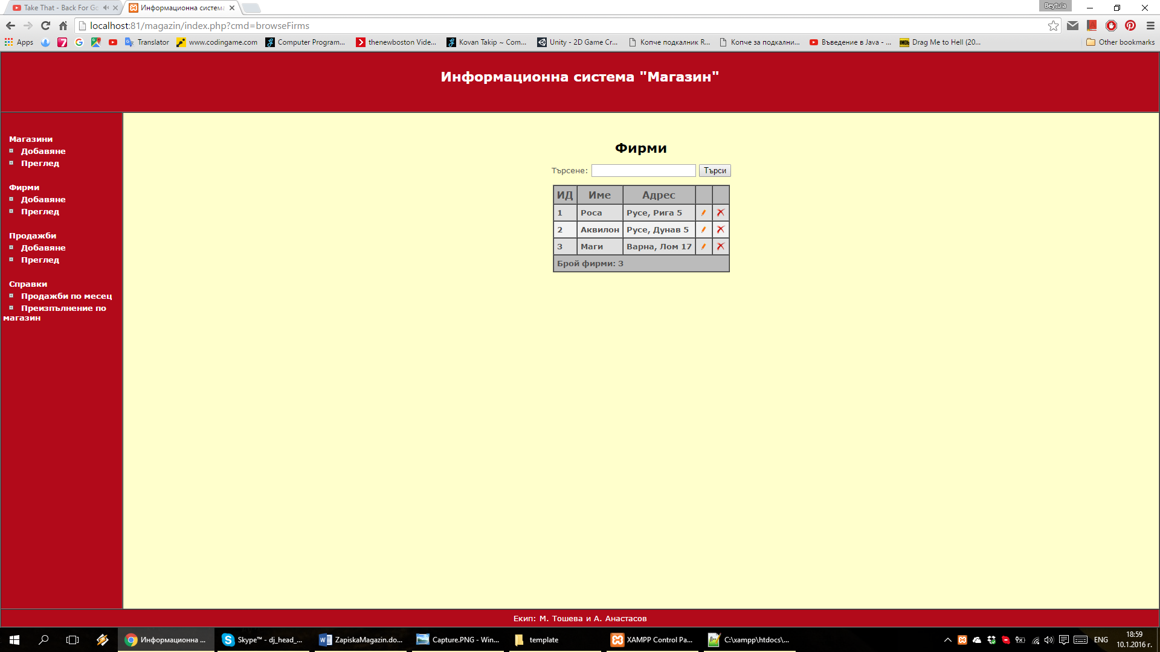

## _addEdit_firms_screen.html

<center>

<br>

<br>

<h3>Добавяне / Редактиране на фирма</h3>

<p><font color="red"><?php print $errorMsg; ?></font></p>

<form action="index.php" method="post">

<input type="hidden" name="cmd" value="<?php print $cmd; ?>">

<input type="hidden" name="sid" value="<?php print $sid; ?>">

<table cellpadding="5">

<tr>

<td align="right">Име:</td>

<td><input type="text" name="data[NameF]" value="<?php print $NameF; ?>" size="30"></td>

</tr>

<tr>

<td align="right">Адрес:</td>

<td><input type="text" name="data[Adres]" value="<?php print $Adres; ?>" size="30"></td>

</tr>

<tr>

<td align="right"><input type="submit" value=" Запази "></td>

<td><input type="button" value=" Откажи " onClick="javascript:window.location='index.php?cmd=browseFirms'"></td>

</tr>

</table>

</form>

</center>

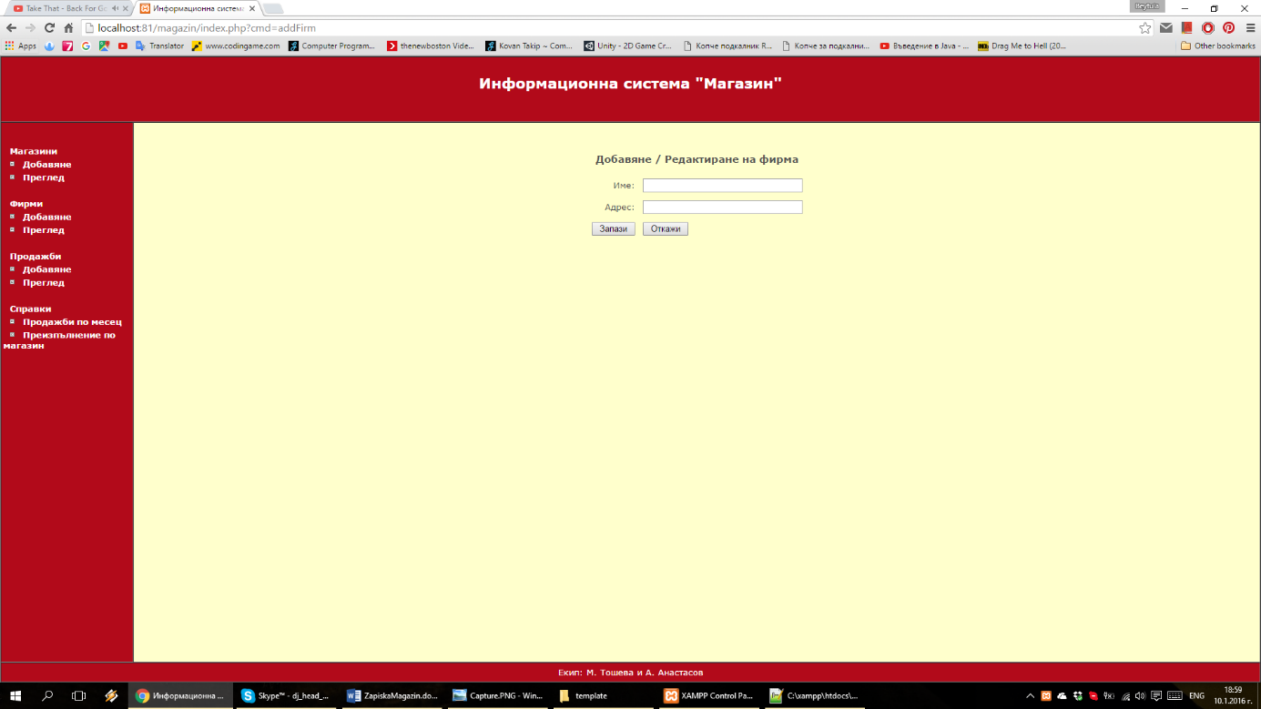

# Модул „Магазини“

## magazin.php

<?php

function browseShops($search = '', $msg = '') {

global $DBH, $tpl, $msgArray;

// ako $search ne e prazna, znachi potrebiteliat e vyvel neshto po koeto da tyrsi

if (!empty($search)) {

$WHERE_SEARCH = "((m.NameM LIKE '%$search%') OR (m.Boss LIKE '%$search%') OR (m.AdresM LIKE '%$search%'))";

$tpl->set('search', $search);

} else {

// a ako e prazna ne se tyrsi po nishto i zatova sled where ima (1), koeto vse edno oznachava che niama where

$WHERE_SEARCH = '(1)';

$tpl->set('search', '');

}

$query = 'SELECT m.CodM, m.Type, m.NameM, m.AdresM, m.Boss, f.NameF FROM magazins m, firms f WHERE m.CodF = f.CodF AND ' . $WHERE_SEARCH;

// izpylniavame zaiavkata

if (!$result = mysql_query($query)) {

print mysql_error();

exit; // s tozi operator prekratiavame ispylnenieto na programata

}

$tpl->set('numberOfShops', mysql_num_rows($result));

$data = '';

$i = 0;

while ($row = mysql_fetch_assoc($result)) {

//zamestvame etiketite v _browse_produkti_row

foreach ($row as $key => $value) {

$tpl->set($key, $value);

}

// i tuk moje vmesto da se pishe set() 2 pyti da se polzva cikyl - ama za dva etiketa ...

if ($i % 2) {

$tpl->set('bgColor', '#F2F2F2');

} else {

$tpl->set('bgColor', '#E0E0E0');

}

$i++;

// obrabotva i izvlicha obrabotenia HTML kod za tekushtia red

$data = $data . $tpl->fetch('_browse_shop_row.html');

}

$tpl->set('tableShops', $data);

if ($i == 0) {

$tpl->set('tableShops', $msgArray['br_no_such']);

}

if (!empty($msg)) {

$tpl->set('msg', $msgArray[$msg]);

} else {

$tpl->set('msg', '');

}

$tpl->set('content', $tpl->fetch('_browse_shop.html'));

print $tpl->fetch('_main_template.html');

}

function addShop($formData = '', $msg='', $PK='') {

global $DBH, $tpl, $msgArray;

if (!empty($msg)) {

$tpl->set('errorMsg', $msgArray[$msg]);

} else {

$tpl->set('errorMsg', '');

}

//pROVERKA dali ima popylnenie danni

if (!empty($formData)) {

foreach ($formData as $k => $v) {

$tpl->set($k, $v);

}

} else {

$tpl->set('CodM', '');

$tpl->set('Type', '');

$tpl->set('NameM', '');

$tpl->set('AdresM', '');

$tpl->set('Boss', '');

$tpl->set('CodF', '');

}

//izvejdane na firmite

$CodF = '';

$query = "Select * FROM firms;";

if (!$result = mysql_query($query)) {

print mysql_error();

exit; // s tozi operator prekratiavame izpylnenieto na programata

}

while ($row = mysql_fetch_assoc($result)) {

$tpl->set('opValue', $row['CodF']);

$tpl->set('opTitle', $row['NameF']);

if (!empty($formData['CodF']) and ($formData['CodF'] == $row['CodF'])) {

$tpl->set('opSelected', 'selected');

} else {

$tpl->set('opSelected', '');

}

$CodF.=$tpl->fetch('_select_box.html');

}

$tpl->set('CodF', $CodF);

$tpl->set('sid', $PK);

$tpl->set('cmd', 'addEditShop');

$tpl->set('content', $tpl->fetch('_addEdit_shop_screen.html'));

print $tpl->fetch('_main_template.html');

}

function addEditShop($FormData='', $PK='') {

$insertFields = ''; //запазваме полетата в които ще въвеждаме данни

$insertValues = ''; //запазваме данните за полетата

if (!empty($PK)) {

$updateFields = '';

foreach ($FormData as $key => $value) {

$updateFields = $updateFields . ',' . $key . "='" . addslashes($value) . "'";

if (empty($value)) {//проверяваме дали има въведени данни в полето

addShop($FormData, 'empty', $PK);

exit;

}

}

$updateFields = substr($updateFields, 1);

$query = "UPDATE magazins SET $updateFields WHERE CodM=$PK";

$msg = 'edited';

} else {

foreach ($FormData as $key => $value) {

$insertFields = $insertFields . ", $key";

$insertValues = $insertValues . ",'" . addslashes($value) . "'";

if (empty($value)) {

addShop($FormData, 'empty', $PK);

exit;

}

}

$insertFields = substr($insertFields, 1);

$insertValues = substr($insertValues, 1);

$query = "INSERT INTO magazins($insertFields) VALUES($insertValues)";

$msg = 'added';

}

if (!$result = mysql_query($query)) {

print mysql_error();

exit; // s tozi operator prekratiavame ispylnenieto na programata

}

browseShops('', $msg);

}

function editShop($PK='') {

global $DBH, $tpl, $msgArray;

$query = 'SELECT * FROM magazins WHERE CodM=' . $PK;

// izpylniavame zaiavkata

if (!$result = mysql_query($query)) {

print mysql_error();

exit; // s tozi operator prekratiavame ispylnenieto na programata

}

if ($row = mysql_fetch_assoc($result)) {

addShop($row, '', $PK);

} else {

browseShops('', 'edit_no_such');

}

}

function deleteShop($PK='') {

global $DBH;

if (empty($PK)){

browseShops('', 'delete_no_such');

}

$query = "DELETE FROM magazins WHERE CodM = '".$PK."'";

if (!mysql_query($query)) {

browseShops('', 'delete_no_such');

} else {

browseShops('', 'deleted');

}

}

?>

## _browse_shop.html

<center>

<br>

<br>

<h2 style="color:black">Магазини</h2>

<p><font color="red"><?php print $msg; ?></font></p>

<form action="index.php" method="get">

<input type="hidden" name="cmd" value="browseShops">

Търси:

<input type="text" name="search" value="<?php print $search; ?>">

<input type="submit" value="Търси">

</form>

<table cellpadding="5" cellspacing="0" border="1">

<tr bgcolor="#BBBBBB">

<th>ИД</th>

<th>Тип</th>

<th>Име</th>

<th>Адрес</th>

<th>Управител</th>

<th>Фирма</th>

<th></th>

<th></th>

</tr>

<?php print $tableShops; ?>

<tr bgcolor="#BBBBBB">

<td colspan="8"><b>Брой магазини: <?php print $numberOfShops; ?></b></td>

</tr>

</table>

</center>

## _browse_shop_row.html

<tr bgcolor="<?=$bgColor;?>">

<td><b><?=$CodM;?></b></td>

<td><b><?=$Type;?></b></td>

<td><b><?=$NameM;?></b></td>

<td><b><?=$AdresM;?></b></td>

<td><b><?=$Boss;?></b></td>

<td><b><?=$NameF;?></b></td>

<td>

<center>

<a class="inner" href="index.php?cmd=editShop&CodM=<?=$CodM;?>">

<img src="images/edit.png" width="16" height="16">

</a>

</center>

</td>

<td>

<center>

<a class="inner" href="index.php?cmd=deleteShop&CodM=<?=$CodM;?>">

<img src="images/delete.png" width="16" height="16">

</a>

</center>

</td>

</tr>

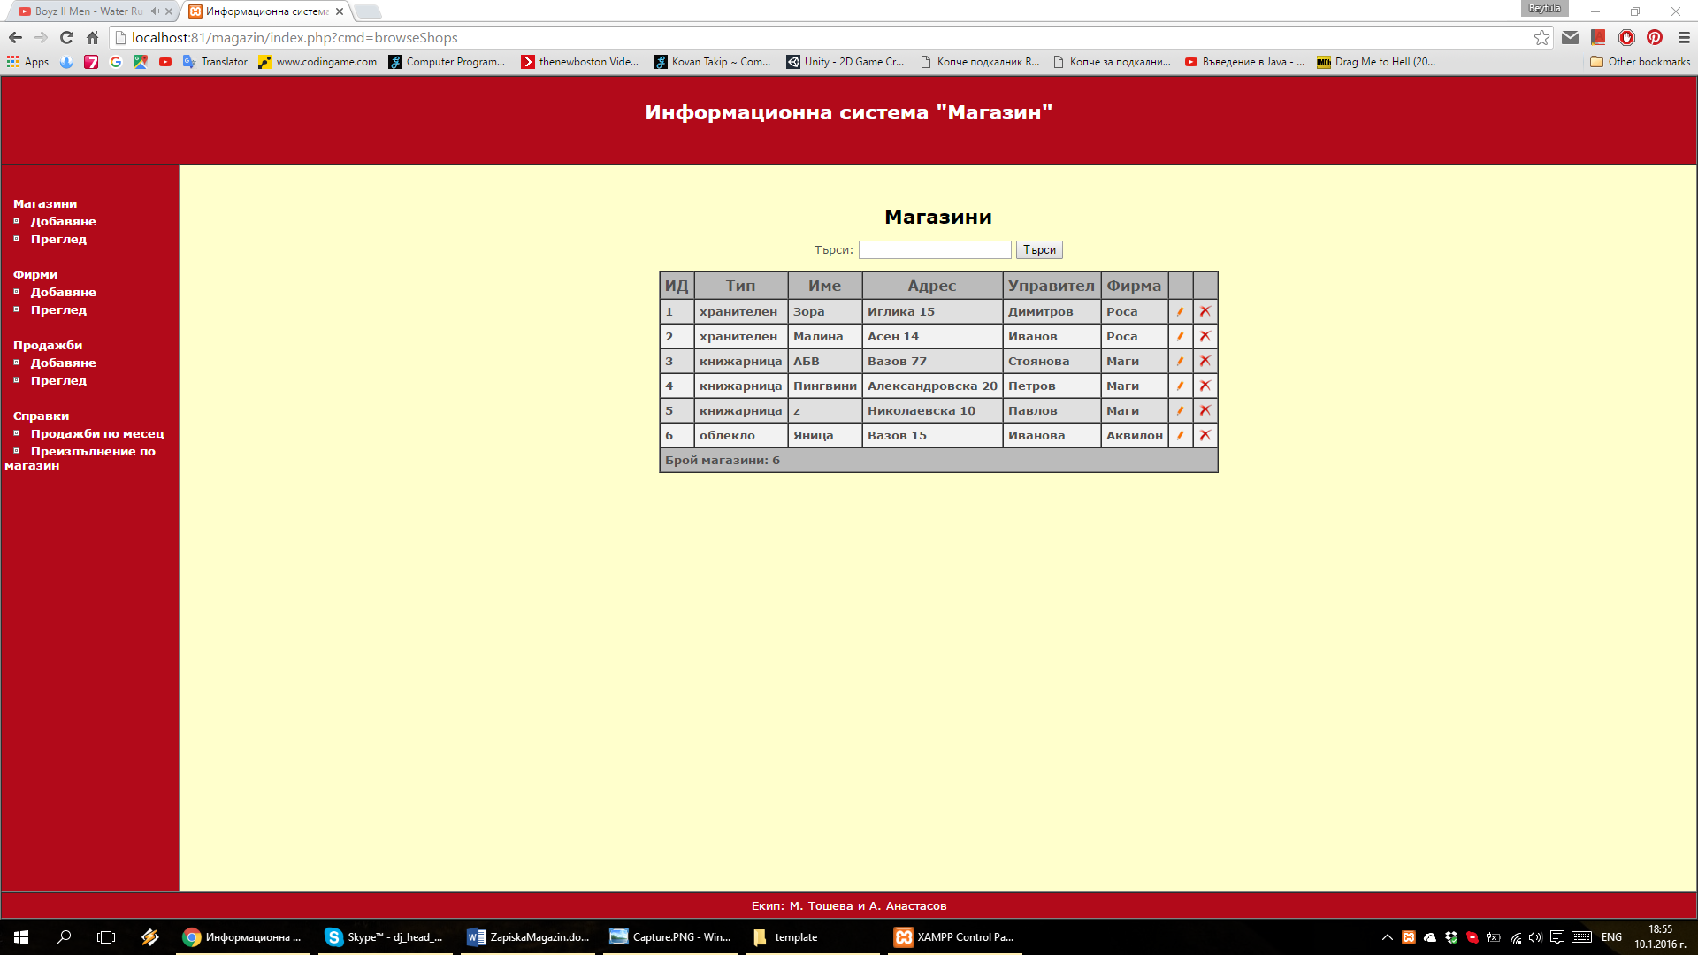

## _addEdit_shop_screen.html

<center>

<br>

<br>

<h3>Добавяне / Редактиране на магазин</h3>

<p><font color="red"><?php print $errorMsg; ?></font></p>

<form action="index.php" method="post">

<input type="hidden" name="cmd" value="<?php print $cmd; ?>">

<input type="hidden" name="sid" value="<?php print $sid; ?>">

<table cellpadding="5">

<tr>

<td align="right">Име:</td>

<td><input type="text" name="data[NameM]" value="<?php print $NameM; ?>" size="30"></td>

</tr>

<tr>

<td align="right">Тип:</td>

<td><input type="text" name="data[Type]" value="<?php print $Type; ?>" size="30"></td>

</tr>

<tr>

<td align="right">Адрес:</td>

<td><input type="text" name="data[AdresM]" value="<?php print $AdresM; ?>" size="30"></td>

</tr>

<tr>

<td align="right">Управител:</td>

<td><input type="text" name="data[Boss]" value="<?php print $Boss; ?>" size="30"></td>

</tr>

<tr>

<td align="right">Фирма:</td>

<td>

<select name="data[CodF]">

<?php print $CodF; ?>

</select>

</td>

</tr>

<tr>

<td align="right"><input type="submit" value=" Запази "></td>

<td><input type="button" value=" Откажи " onClick="javascript:window.location='index.php?cmd=browseShops'"></td>

</tr>

</table>

</form>

</center>

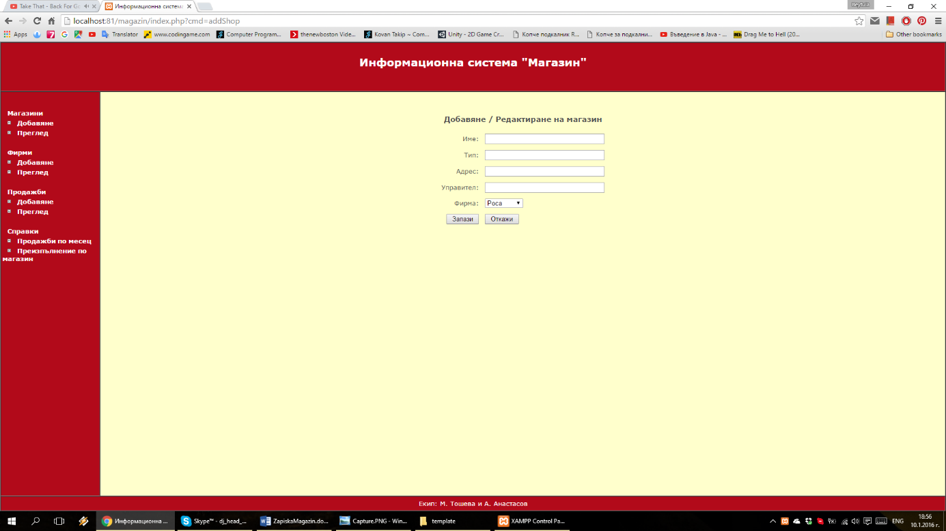

# Модул „Продажби“

<?php

function browseSales($search = '', $msg = '') {

global $DBH, $tpl, $msgArray;

// ako $search ne e prazna, znachi potrebiteliat e vyvel neshto po koeto da tyrsi

if (!empty($search)) {

$WHERE_SEARCH = "((m.NameM LIKE '%$search%') OR (mes.ImeM LIKE '%$search%'))";

$tpl->set('search', $search);

} else {

// a ako e prazna ne se tyrsi po nishto i zatova sled where ima (1), koeto vse edno oznachava che niama where

$WHERE_SEARCH = '(1)';

$tpl->set('search', '');

}

$query = "SELECT m.NameM AS magName, mes.ImeM AS mesName, p.StPlan, p.StIzp, p.Id FROM prodajbi p, magazins m, meseci mes WHERE p.CodM=m.CodM AND p.CodMes=mes.CodM AND " . $WHERE_SEARCH

. " ORDER BY p.Id;";

// izpylniavame zaiavkata

if (!$result = mysql_query($query)) {

print mysql_error();

exit; // s tozi operator prekratiavame ispylnenieto na programata

}

$tpl->set('numberOfSales', mysql_num_rows($result));

$data = '';

$i = 0;

while ($row = mysql_fetch_assoc($result)) {

//zamestvame etiketite v _browse_produkti_row

foreach ($row as $key => $value) {

$tpl->set($key, $value);

}

// i tuk moje vmesto da se pishe set() 2 pyti da se polzva cikyl - ama za dva etiketa ...

if ($i % 2) {

$tpl->set('bgColor', '#F2F2F2');

} else {

$tpl->set('bgColor', '#E0E0E0');

}

$i++;

// obrabotva i izvlicha obrabotenia HTML kod za tekushtia red

$data = $data . $tpl->fetch('_browse_sales_row.html');

}

$tpl->set('tableSales', $data);

if ($i == 0) {

$tpl->set('tableSales', $msgArray['br_no_such']);

}

if (!empty($msg)) {

$tpl->set('msg', $msgArray[$msg]);

} else {

$tpl->set('msg', '');

}

$tpl->set('content', $tpl->fetch('_browse_sales.html'));

print $tpl->fetch('_main_template.html');

}

function addSale($formData = '', $msg='', $PK='') {

global $DBH, $tpl, $msgArray;

if (!empty($msg)) {

$tpl->set('errorMsg', $msgArray[$msg]);

} else {

$tpl->set('errorMsg', '');

}

//PROVERKA dali ima popylnenie danni

if (!empty($formData)) {

foreach ($formData as $k => $v) {

$tpl->set($k, $v);

}

} else {

$tpl->set('CodM', '');

$tpl->set('CodMes', '');

$tpl->set('StPlan', '');

$tpl->set('StIzp', '');

}

//izvejdane na magazinite

$MCode = '';

$query = "Select * FROM magazins;";

if (!$result = mysql_query($query)) {

print mysql_error();

exit; // s tozi operator prekratiavame izpylnenieto na programata

}

while ($row = mysql_fetch_assoc($result)) {

$tpl->set('opValue', $row['CodM']);

$tpl->set('opTitle', $row['NameM']);

if (!empty($formData['CodM']) and ($formData['CodM'] == $row['CodM'])) {

$tpl->set('opSelected', 'selected');

} else {

$tpl->set('opSelected', '');

}

$MCode.=$tpl->fetch('_select_box.html');

}

$tpl->set('CodM', $MCode);

//izvejdane na mesecite

$MesCode = '';

$query = "SELECT * FROM meseci;";

if (!$result = mysql_query($query)) {

print mysql_error();

exit; // s tozi operator prekratiavame izpylnenieto na programata

}

while ($row = mysql_fetch_assoc($result)) {

$tpl->set('opValue', $row['CodM']);

$tpl->set('opTitle', $row['ImeM']);

if (!empty($formData['CodMes']) and ($formData['CodMes'] == $row['CodM'])) {

$tpl->set('opSelected', ' selected');

} else {

$tpl->set('opSelected', '');

}

$MesCode.=$tpl->fetch('_select_box.html');

}

$tpl->set('CodMes', $MesCode);

$tpl->set('sid', $PK);

$tpl->set('cmd', 'addEditSale');

$tpl->set('content', $tpl->fetch('_addEdit_sales_screen.html'));

print $tpl->fetch('_main_template.html');

}

function addEditSale($FormData='', $PK='') {

$insertFields = ''; //запазваме полетата в които ще въвеждаме данни

$insertValues = ''; //запазваме данните за полетата

if (!empty($PK)) {

$updateFields = '';

foreach ($FormData as $key => $value) {

$updateFields = $updateFields . ',' . $key . "='" . addslashes($value) . "'";

if (empty($value)) {//проверяваме дали има въведени данни в полето

addSale($FormData, 'empty', $PK);

exit;

}

}

$updateFields = substr($updateFields, 1);

$query = "UPDATE prodajbi SET $updateFields WHERE Id=$PK;";

$msg = 'edited';

} else {

foreach ($FormData as $key => $value) {

$insertFields = $insertFields . ", $key";

$insertValues = $insertValues . ",'" . addslashes($value) . "'";

if (empty($value)) {

addSale($FormData, 'empty', $PK);

exit;

}

}

$insertFields = substr($insertFields, 1);

$insertValues = substr($insertValues, 1);

$query = "INSERT INTO prodajbi($insertFields) VALUES($insertValues)";

$msg = 'added';

}

if (!$result = mysql_query($query)) {

print mysql_error();

exit; // s tozi operator prekratiavame ispylnenieto na programata

}

browseSales('', $msg);

}

function editSale($PK='') {

global $DBH, $tpl, $msgArray;

$query = "SELECT * FROM prodajbi WHERE Id=$PK;";

// izpylniavame zaiavkata

if (!$result = mysql_query($query)) {

print mysql_error();

exit; // s tozi operator prekratiavame ispylnenieto na programata

}

if ($row = mysql_fetch_assoc($result)) {

addSale($row, '', $PK);

} else {

browseSales('', 'edit_no_such');

}

}

function deleteSale($PK='') {

global $DBH;

if (empty($PK)){

browseShops('', 'delete_no_such');

}

$query = "DELETE FROM prodajbi WHERE Id = '".$PK."'";

if (!mysql_query($query)) {

browseSales('', 'delete_no_such');

} else {

browseSales('', 'deleted');

}

}

?>

## _browse_sales.html

<center>

<br>

<br>

<h2 style="color:black">Продажби</h2>

<p><font color="red"><?php print $msg; ?></font></p>

<form action="index.php" method="get">

<input type="hidden" name="cmd" value="browseSales">

Търсене:

<input type="text" name="search" value="<?php print $search; ?>">

<input type="submit" value="Търси">

</form>

<table cellpadding="5" cellspacing="0" border="1">

<tr bgcolor="#BBBBBB">

<th>ИД</th>

<th>Магазин</th>

<th>Месец</th>

<th>План стокооборот</th>

<th>Изпълнение стокооборот</th>

<th></th>

<th></th>

</tr>

<?php print $tableSales; ?>

<tr bgcolor="#BBBBBB">

<td colspan="7"><b>Брой продажби: <?php print $numberOfSales; ?></b></td>

</tr>

</table>

</center>

## _browse_sales_row.html

<tr bgcolor="<?=$bgColor;?>">

<td><b><?=$Id;?></b></td>

<td><b><?=$magName;?></b></td>

<td><b><?=$mesName;?></b></td>

<td><b><?=$StPlan;?></b></td>

<td><b><?=$StIzp;?></b></td>

<td>

<center>

<a class="inner" href="index.php?cmd=editSale&Id=<?=$Id;?>">

<img src="images/edit.png" width="16" height="16">

</a>

</center>

</td>

<td>

<center>

<a class="inner" href="index.php?cmd=deleteSale&Id=<?=$Id;?>">

<img src="images/delete.png" width="16" height="16">

</a>

</center>

</td>

</tr>

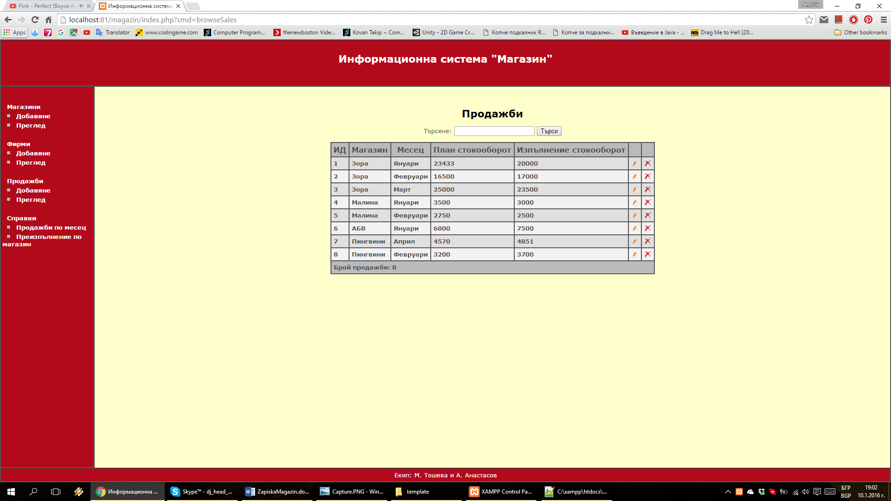

## _addEdit_sales_screen.html

<center>

<br>

<br>

<h3>Добавяне / редактиране на продажба</h3>

<p><font color="red"><?php print $errorMsg; ?></font></p>

<form action="index.php" method="post">

<input type="hidden" name="cmd" value="<?php print $cmd; ?>">

<input type="hidden" name="sid" value="<?php print $sid; ?>">

<table cellpadding="5">

<tr>

<td align="right">Магазин: </td>

<td>

<select name="data[CodM]">

<?php print $CodM; ?>

</select>

</td>

</tr>

<tr>

<td align="right">Месец: </td>

<td>

<select name="data[CodMes]">

<?php print $CodMes; ?>

</select>

</td>

</tr>

<tr>

<td align="right">План стокооборот: </td>

<td>

<input type="text" name="data[StPlan]" value="<?php print $StPlan; ?>">

</td>

</tr>

<tr>

<td align="right">Изпълнение стокооборот: </td>

<td>

<input type="text" name="data[StIzp]" value="<?php print $StIzp; ?>">

</td>

</tr>

<tr>

<td align="right"><input type="submit" value=" Запази "></td>

<td><input type="button" value=" Откажи " onClick="javascript:window.location='index.php?cmd=browseSales'"></td>

</tr>

</table>

</form>

</center>

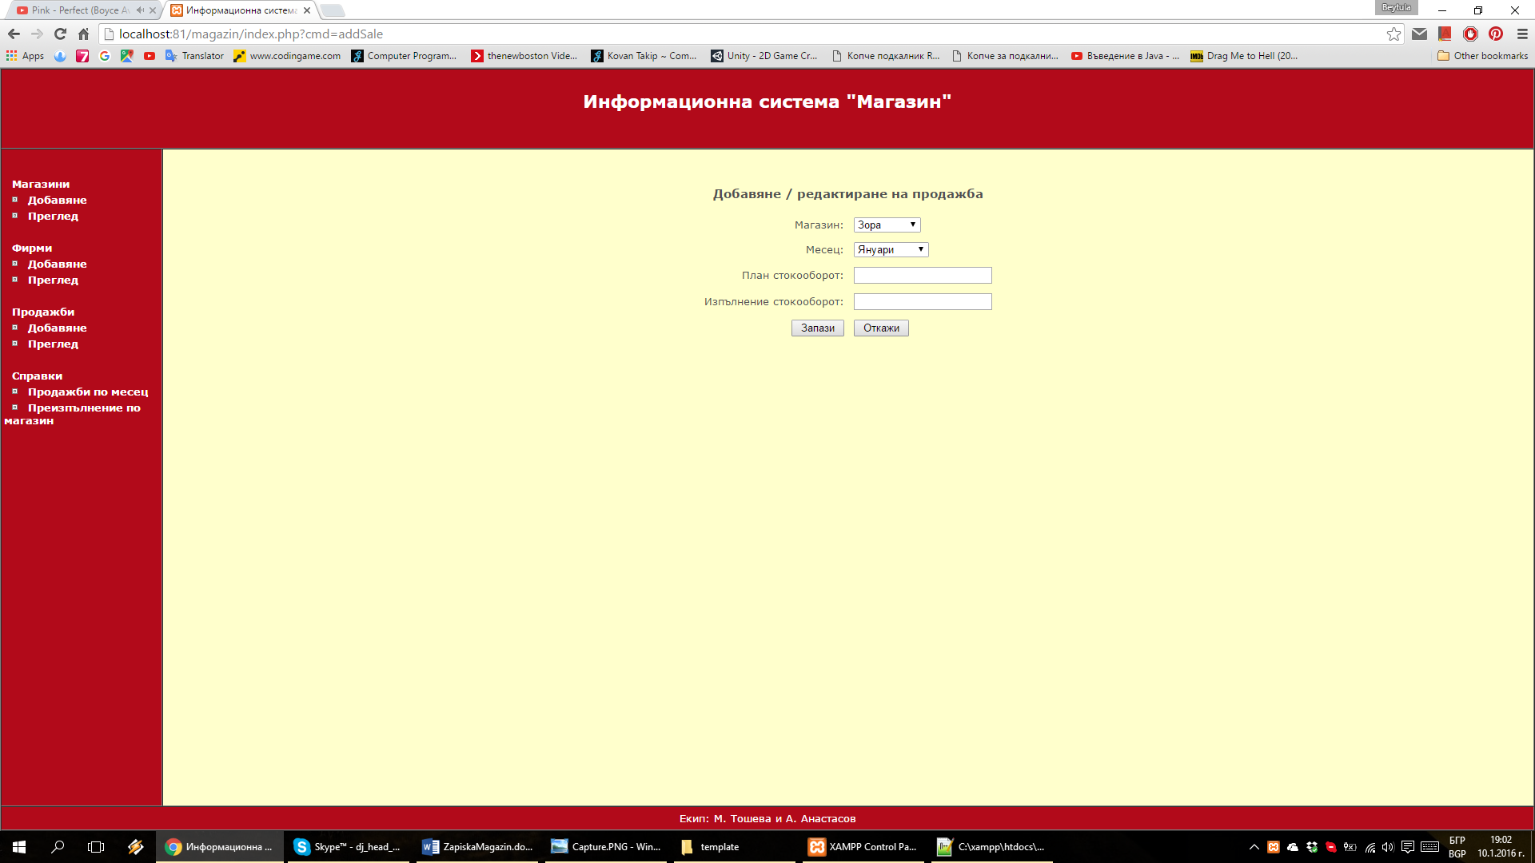

# Модул „Справки“

## reports.php

<?php

function reportSalesByMonth($CodMes='', $msg='') {

global $tpl, $msgArray;

if (!empty($msg)) {

$tpl->set('errorMsg', $msgArray[$msg]);

} else {

$tpl->set('errorMsg', '');

}

$MesCode = '';

$query = "SELECT * FROM meseci;";

if (!$result = mysql_query($query)) {

print mysql_error();

exit; // s tozi operator prekratiavame izpylnenieto na programata

}

while ($row = mysql_fetch_assoc($result)) {

$tpl->set('opValue', $row['CodM']);

$tpl->set('opTitle', $row['ImeM']);

if ($row['CodM'] == $CodMes) {

$tpl->set('opSelected', ' selected');

} else {

$tpl->set('opSelected', '');

}

$MesCode.=$tpl->fetch('_select_box.html');

}

$tpl->set('CodMesS', $MesCode);

if (!empty($CodMes)) {

$data='';

$Where = "mes.CodM = " . $CodMes;

$sql="SELECT p.Id, m.NameM AS magName, m.Boss AS boss, mes.ImeM AS mesName, p.StPlan, p.StIzp FROM prodajbi p, magazins m, meseci mes WHERE p.CodM=m.CodM AND p.CodMes=mes.CodM AND " . $Where;

if (!$result = mysql_query($sql)) {

print mysql_error();

exit; // s tozi operator prekratiavame ispylnenieto na programata

}

while ($row = mysql_fetch_assoc($result)) {

foreach ($row as $key => $value) {

$tpl->set($key, $value);

}

// obrabotva i izvlicha obrabotenia HTML kod za tekushtia red

$data = $data . $tpl->fetch('_reports_sales_section2_row.html');

}

if (empty($data)) {

$tpl->set('section_2', '');

$tpl->set('section_3', '');

$tpl->set('errorMsg', $msgArray['br_no_such']);

}

else {

$tpl->set('row', $data);

$tpl->set('section_2', $tpl->fetch('_reports_sales_section2.html'));

$tpl->set('section_3', '');

}

} else {

$tpl->set('section_2', '');

$tpl->set('section_3', '');

}

$tpl->set('content', $tpl->fetch('_reports_sales_section1.html'));

print $tpl->fetch('_main_template.html');

}

function reportPreizpilnenie($PK='', $msg='') {

global $tpl, $msgArray;

if (!empty($msg)) {

$tpl->set('errorMsg', $msgArray[$msg]);

} else {

$tpl->set('errorMsg', '');

}

$MagCode = '';

$query = "SELECT * FROM magazins;";

if (!$result = mysql_query($query)) {

print mysql_error();

exit; // s tozi operator prekratiavame izpylnenieto na programata

}

while ($row = mysql_fetch_assoc($result)) {

$tpl->set('opValue', $row['CodM']);

$tpl->set('opTitle', $row['NameM']);

if ($row['CodM'] == $PK) {

$tpl->set('opSelected', ' selected');

} else {

$tpl->set('opSelected', '');

}

$MagCode.=$tpl->fetch('_select_box.html');

}

$tpl->set('MagCode', $MagCode);

if (!empty($PK)) {

$data='';

$sql="SELECT m.NameM, mes.ImeM, p.StPlan, p.StIzp, p.StIzp-p.StPlan AS preizp FROM prodajbi p, magazins m, meseci mes WHERE p.StIzp-p.StPlan > 0 AND p.CodM=$PK AND p.CodM=m.CodM AND p.CodMes=mes.CodM;";

if (!$result = mysql_query($sql)) {

print mysql_error();

exit; // s tozi operator prekratiavame ispylnenieto na programata

}

while ($row = mysql_fetch_assoc($result)) {

foreach ($row as $key => $value) {

$tpl->set($key, $value);

}

// obrabotva i izvlicha obrabotenia HTML kod za tekushtia red

$data = $data . $tpl->fetch('_reports_sales_pre_section2_row.html');

}

if (empty($data)) {

$tpl->set('section_2', '');

$tpl->set('section_3', '');

$tpl->set('errorMsg', $msgArray['br_no_such']);

}

else {

$tpl->set('row', $data);

$tpl->set('section_2', $tpl->fetch('_reports_sales_pre_section2.html'));

$tpl->set('section_3', '');

}

} else {

$tpl->set('section_2', '');

$tpl->set('section_3', '');

}

$tpl->set('content', $tpl->fetch('_reports_sales_pre_section1.html'));

print $tpl->fetch('_main_template.html');

}

?>

## _reports_sales_pre_section1.html

<center>

<br>

<br>

<h3>Преизпълнение по магазин</h3>

<p><font color="red"><?php print $errorMsg; ?></font></p>

<form action="index.php" method="get">

<table cellpadding="5">

<tr>

<td align="right">Магазин:</td>

<td>

<select name="data[MagCode]" onchange="window.location.href='index.php?cmd=reportPreizpilnenie&id=' + this.options[this.selectedIndex].value;">

<?php print $MagCode; ?>

</select>

</td>

</tr>

</table>

</form>

<br>

<?php print $section_2; ?>

<br>

<br>

<?php print $section_3; ?>

</center>

## _reports_sales_pre_section2.html

<center>

<table cellpadding="5" border="1">

<tr>

<th>Магазин</th>

<th>Месец</th>

<th>План стокооборот</th>

<th>Изпълнение стокооборот</th>

<th>Преизпълнение</th>

</tr>

<?=$row;?>

</table>

</center>

## _reports_sales_pre_section2_row.html

<tr>

<td><?=$NameM;?></td>

<td><?=$ImeM;?></td>

<td><?=$StPlan;?></td>

<td><?=$StIzp;?></td>

<td><?=$preizp;?></td>

</tr>

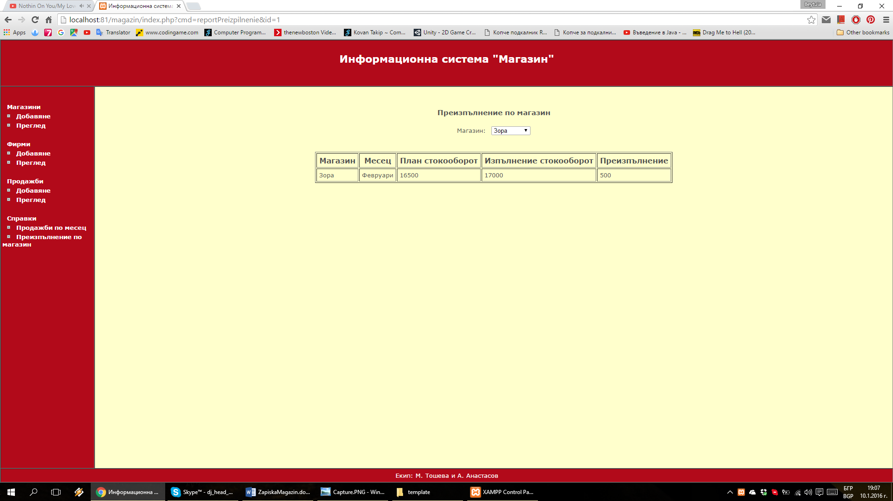

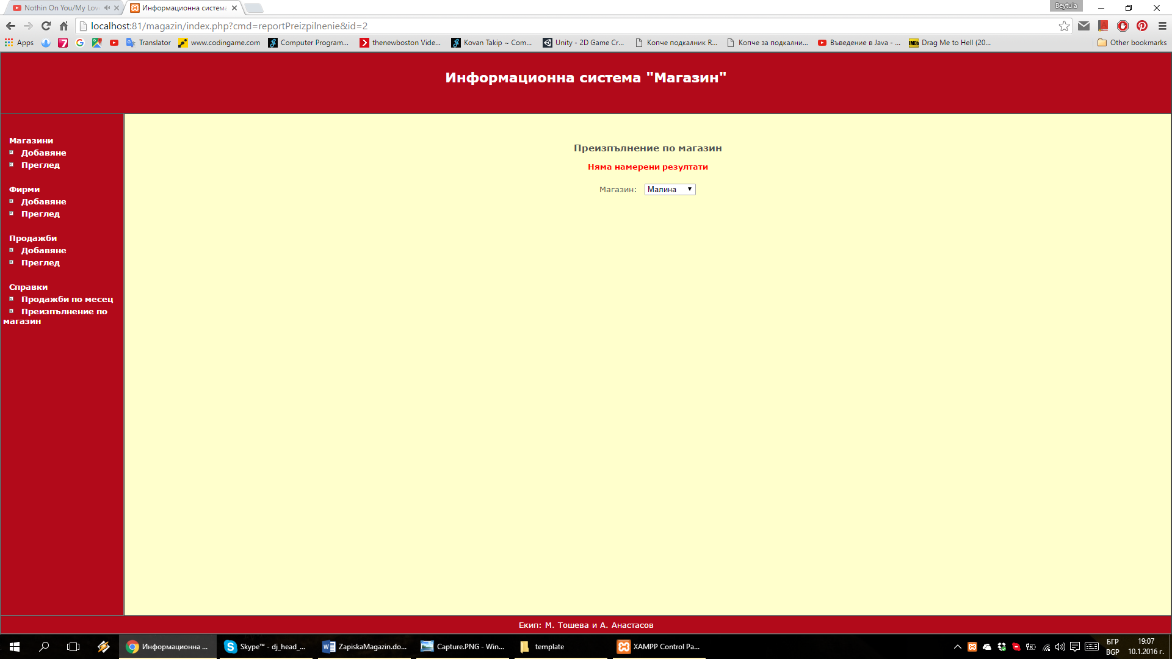

## _reports_sales_section1.html

<center>

<br>

<br>

<h3>Продажби по месец</h3>

<p><font color="red"><?php print $errorMsg; ?></font></p>

<form action="index.php" method="get">

<table cellpadding="5">

<tr>

<td align="right">Месец:</td>

<td>

<select name="data[CodMesS]" onchange="window.location.href='index.php?cmd=reportSalesByMonth&id=' + this.options[this.selectedIndex].value;">

<?php print $CodMesS; ?>

</select>

</td>

</tr>

</table>

</form>

<br>

<?php print $section_2; ?>

<br>

<br>

<?php print $section_3; ?>

</center>

## _reports_sales_section2.html

<center>

<table cellpadding="5" border="1">

<tr>

<th>ИД</th>

<th>Магазин</th>

<th>Управител</th>

<th>Месец</th>

<th>План стокооборот</th>

<th>Изпълнение стокооборот</th>

</tr>

<?=$row;?>

</table>

</center>

## _reports_sales_section2_row.html

<tr>

<td><?=$Id;?></td>

<td><?=$magName;?></td>

<td><?=$boss;?></td>

<td><?=$mesName;?></td>

<td><?=$StPlan;?></td>

<td><?=$StIzp;?></td>

</tr>

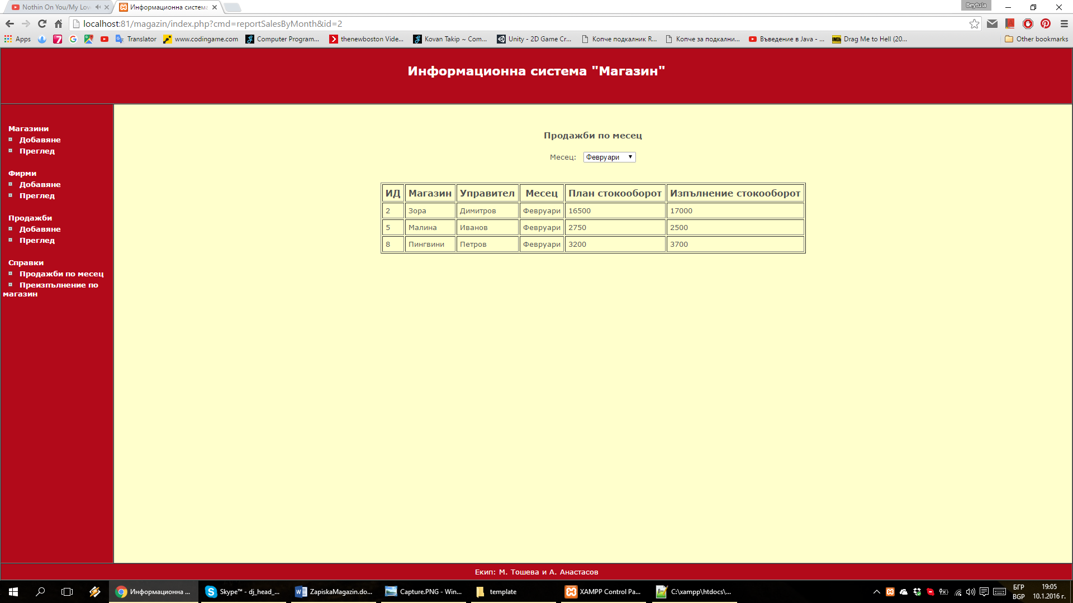

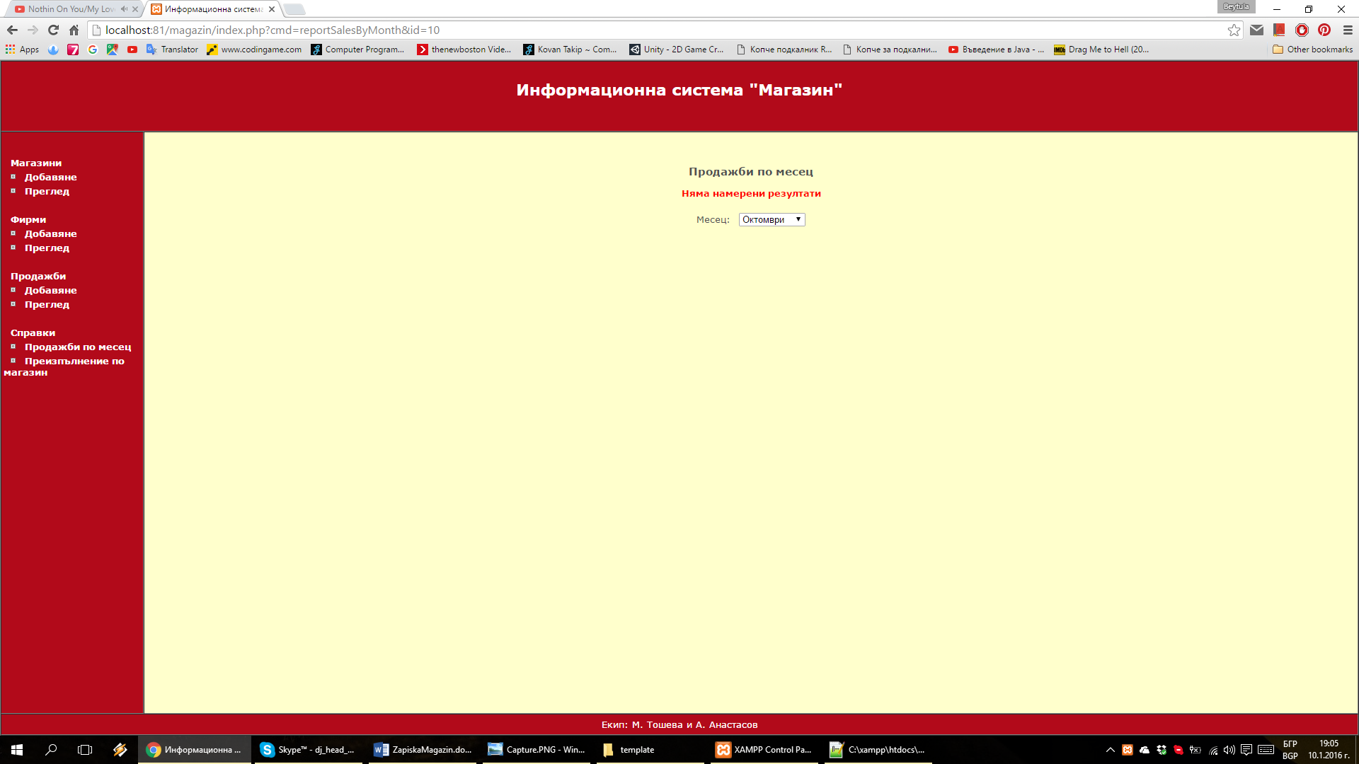

## _select_box.html

<option value="<?=$opValue;?>"<?=$opSelected;?>><?=$opTitle;?></option>