**Due Date: Week 5**

Purpose: By finishing this assignment you will practice to:

* Develop and code a spring app with MVC capabilities.
* Debug and run a spring MVC app.

Read the week 1 – 3 content and lab exercises. This material provides the necessary information you need to complete the exercises.

**Instructions and Rules**

This lab should be completed by every student **individually**.

UPDATED TEXT NEEDED: You will have to demonstrate your solution in a scheduled lab session and submitting the project **through the assignment link on Blackboard**. You must name your Eclipse project according to the following rule:

Your Name_COMP303_AssignementNumber

Example:  John_COMP303_Assignment1

**Description**

DigiTel business plans to sell the smart phones in online due to COVID19. They have approached you to develop an MVC web app to cater their requirements. You are developing an MVC web app for the DigiTel business by creating the following programs: controller java file, Model java file, html Thymeleaf view files, and maven POM.xml.

**Task 1**

Design an html page (Thymeleaf) named “**index.html**” that handles a POST request and an action on “**OrderController**” java using a **@RequestMapping**. The page should have “Online Smart Phone Order Request” form to get user input as shown in this snap shot given in the page below:

Complete this page design with a “Submit Order” button and all other html elements (controls) to make this page user friendly with basic validation (html input type validations and use of appropriate input controls to eliminate the validation).   Your design should use appropriate layout using div or tables and other formatting features with colors, fonts and styles. You can use a reset button to clear user input if needed.

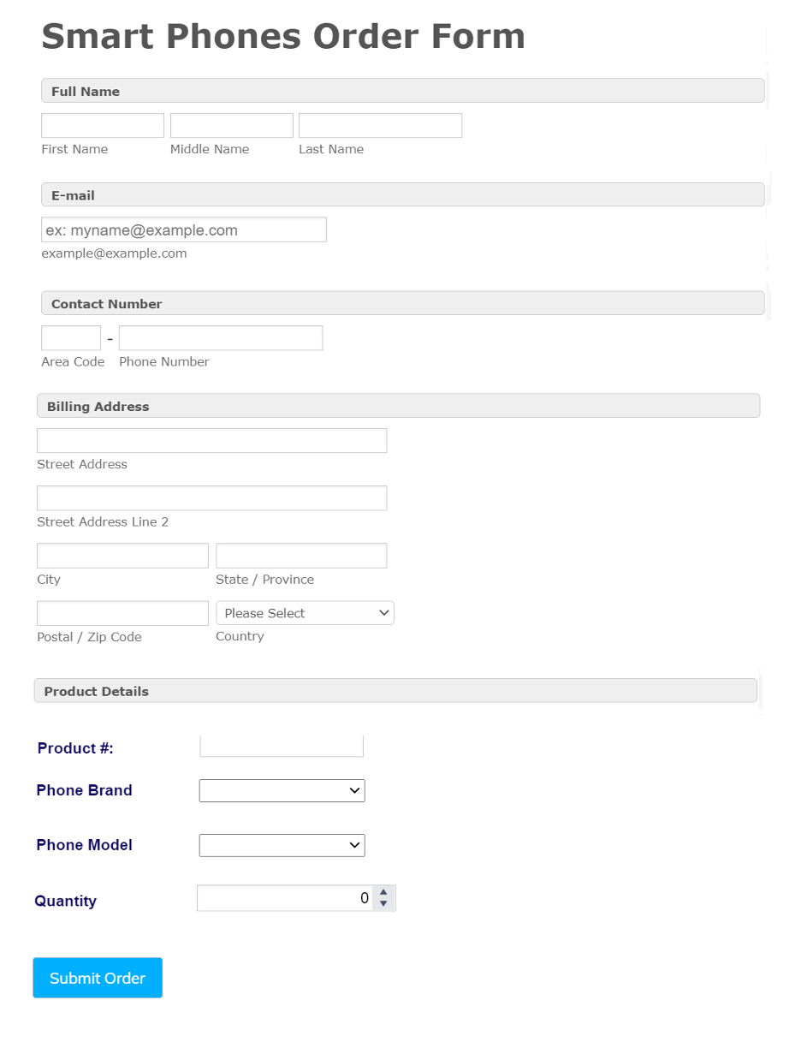

**Hint:** Phone brands are iPhone, Samsung, Google, Black berry etc., and the models are iPhone XR, iPhone 11 Pro for iPhone brand, Samsung Galaxy 20 Plus, Samsung Galaxy S20 for the Samsung brand etc.,

**Task 2**

Define a model bean class “**Order.java**” with the appropriate properties and methods to handle the user input data.

**Task 3**

Define a “**OrderController.java**” class to get the data from “**index.html**” form page and publish the output as the following format in the **show-order.html**page.

You should show the output as given below:

**Welcome Max.**

         Your Order details are as follows:

* + **Email Address:** [amax@yahoo.com](mailto:amax@yahoo.com)
  + **Phone Number**: 600-900-8000
  + **Address**:  18 Progress Ave, Scarborough, ON

**Phone Details.**

**Phone Brand:**iPhone

**Phone Model:**iPhone XR

**Phone Price:**  CAD 979.00

**Quantity:**2

**Total**                CAD 1958.00

**Deliverables**

1. Your app must include at least the following code files:
   * Controller file – java
   * Model file – java
   * View file – show-order.html
   * index.html and other html files if needed
   * Maven file – pom.xml
   * HomePage.html- Brief Intro About yourself. (Brief Picture, courses you are studying)
2. The assignment source code (Eclipse project with the necessary files) submitted as a .zip file format – “YourName_StudentNo_Assign1.zip”.0
3. Submit 2 mins video demonstrating the code and run on the browser. ( show the code and output as shown in the browser).

**Assessment Rubrics**

|  |  |
| --- | --- |
| View and UI Design: Task 1  Developing a web with MVC capabilities including all the necessary files to design UI using Thymeleaf template and Thymeleaf syntax. | 20% |
| Model: Task 2  Defining a model class to support to define properties and business methods (methods to implement functionalities such as calculation etc) | 15% |
| Controller : Task 3  Defining controller class (es) to control the flow of the application execution. | 20% |
| Configuration of XML files | 10% |
| UI friendliness | 10% |
| Form controls validations using HTML and / or JavaScript | 10% |
| Code stands, use of variables, comments, and naming conventions. | 5% |
| Demonstration or submission of recorded video | 10% |
| Total | 100% |

**Submission Rules**

Each file submitted in the solution should have student name, student number and submission date in the top of the code file. (Code standard)

Comments may be necessary inside the functions or predicates but that the names of the functions and predicates and the comments you include to explain each are especially important. (Code standard)

The student must hand in the assignment to the e-Centennial dropbox with a demo video or before in virtual demo.

**Late Submission**

There is a 20% off per day late penalty which means if a student submits an assignment one day late and does perfect work, the most they can obtain is 80/100.

For example, if a student submits one day late and obtains 8/10 as an assignment then the professor will need to deduct 20% from this grade (8 x .20 = 1.6, 8-1.6 = 6.4/10 - record 6.4).  If a student submits two days late then 40% will be deducted, for example, assume the student obtains 9/10 (9 x .40 = 3.6, 9-3.6 = 5.4/10). By day five the student receives zero.

**Academic Honesty (Plagiarism and Cheating)**

All students must follow the academic honesty policies regarding Plagiarism and cheating on assignments, Quizzes or Tests. Centennial college's Academic Policy will be strictly enforced. To support academic honesty at Centennial College, all academic work submitted by students may be reviewed for authenticity and originality, by utilizing software tools.

For more details, please visit the Academic Honesty site on  <https://www.centennialcollege.ca/mycentennial/your-support/academic-support/student->  academic-advising/academic-honesty/