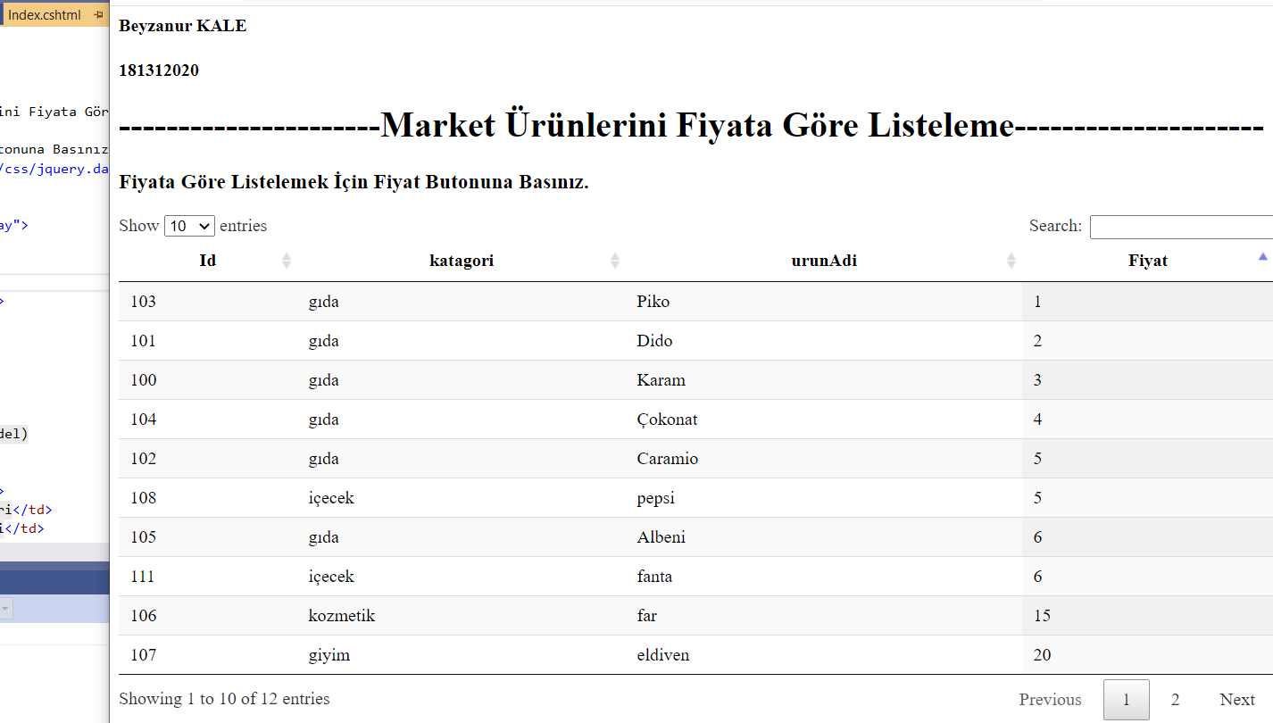

HOME CONTROLLER:

using Microsoft.AspNetCore.Mvc;

using System;

using System.Collections.Generic;

using System.Linq;

using System.Threading.Tasks;

namespace List.Controllers

{

public class HomeController : Controller

{

public ActionResult Index()

{

List<Class> p = new List<Class>();

p.Add(new Class { Id = 100,katagori="gıda", urunAdi = "Karam", Fiyat = 3 });

p.Add(new Class { Id = 101, katagori = "gıda", urunAdi = "Dido", Fiyat = 2 });

p.Add(new Class { Id = 102, katagori = "gıda", urunAdi = "Caramio", Fiyat = 5 });

p.Add(new Class { Id = 103, katagori = "gıda", urunAdi = "Piko", Fiyat = 1 });

p.Add(new Class { Id = 104, katagori = "gıda", urunAdi = "Çokonat", Fiyat = 4 });

p.Add(new Class { Id = 105, katagori = "gıda", urunAdi = "Albeni", Fiyat = 6 });

p.Add(new Class { Id = 106, katagori = "kozmetik", urunAdi = "far", Fiyat = 15 });

p.Add(new Class { Id = 107, katagori = "giyim", urunAdi = "eldiven", Fiyat = 20 });

p.Add(new Class { Id = 108, katagori = "içecek", urunAdi = "pepsi", Fiyat = 5 });

p.Add(new Class { Id = 109, katagori = "oyuncak", urunAdi = "oyuncak araba", Fiyat = 50 });

p.Add(new Class { Id = 110, katagori = "giyim", urunAdi = "şapka", Fiyat = 40 });

p.Add(new Class { Id = 111, katagori = "içecek", urunAdi = "fanta", Fiyat = 6 });

var result =p.OrderBy(a => a.Fiyat).ToList();

return View(p.ToList());

}

}

}

CLASS:

using System;

using System.Collections.Generic;

using System.Linq;

using System.Threading.Tasks;

namespace List

{

public class Class

{

public int Id { get; set; }

public string katagori { get; set; }

public string urunAdi { get; set; }

public float Fiyat { get; set; }

public int OrderBy { get; set; }

internal static object orderby(Func<object, object> p)

{

throw new NotImplementedException();

}

}

}

INDEX:

@{

ViewBag.Title = "Index";

Layout = null;

}

<h4>Beyzanur KALE</h4>

<h4>181312020</h4>

<h1>----------------------Market Ürünlerini Fiyata Göre Listeleme---------------------</h1>

<h3>Fiyata Göre Listelemek İçin Fiyat Butonuna Basınız.</h3>

<link href="//cdn.datatables.net/1.10.16/css/jquery.dataTables.min.css" rel="stylesheet" />

<div class="row">

<div class="col-lg-12">

<table id="myTable" class="display">

<thead>

<tr>

<th> Id </th>

<th> katagori </th>

<th> urunAdi </th>

<th> Fiyat </th>

</tr>

</thead>

<tbody>

@foreach (var item in Model)

{

<tr>

<td>@item.Id</td>

<td>@item.katagori</td>

<td>@item.urunAdi</td>

<td>@item.Fiyat</td>

</tr>

}

</tbody>

</table>

</div>

</div>

<script src="https://ajax.googleapis.com/ajax/libs/jquery/3.3.1/jquery.min.js"></script>

<script src="//cdn.datatables.net/1.10.16/js/jquery.dataTables.min.js" type="text/javascript"></script>

<script type="text/javascript">

$(document).ready(function () {

$('#myTable').DataTable();

});

</script>