

i2i Academy

**Training Document**

|  |  |
| --- | --- |
| **Topic** | Oracle SQL Language Fundamentals I |
| **Document Name** | SQL02-EX-01-05 |

## Copyright of i2i Systems Turkey 2013

The copyright in this work is vested in i2i Systems Turkey and the information contained herein is confidential. This work (either in whole or in part) must not be modified, reproduced, disclosed or disseminated to others or used for purposes other than that for which it is supplied, without the prior written permission of i2i Systems Turkey. If this work or any part hereof is furnished to a third

**Definiton :** Write an SQL query that selects employee’s id, employee’s first name, employee’s last name and employee’s **number of months** from hire_date to today for all employees. (Hint:MONTHS_BETWEEN)

## SQL:

SELECT

employee_id,first_name,last_name, MONTHS_BETWEEN(SYSDATE, hire_date) AS months_from_hire

FROM

HR.EMPLOYEES;

## Screenshot:

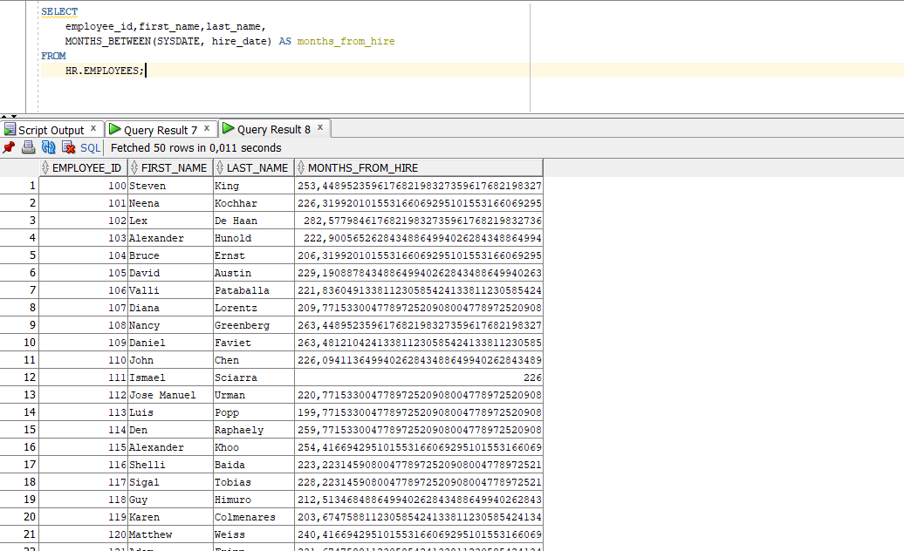

**Definiton :** Write a query that displays the grade of all employees based on the value of the column JOB_ID, using the following data: (Use DECODE)

|  |  |
| --- | --- |
| **Job** | **Grade** |
| AD_PRES | A |
| ST_MAN | B |
| IT_PROG | C |
| SA_REP | D |
| ST_CLERK | E |
| None of the above | 0 |

## SQL:

SELECT employee_id,first_name,last_name,job_id, DECODE(job_id,

'AD_PRES', 'A',

'ST_MAN', 'B',

'IT_PROG', 'C',

'SA_REP', 'D',

'ST_CLERK', 'E',

'0') AS grade FROM HR.EMPLOYEES;

**Screenshot( Exercise SQL02-EX-02 ):**

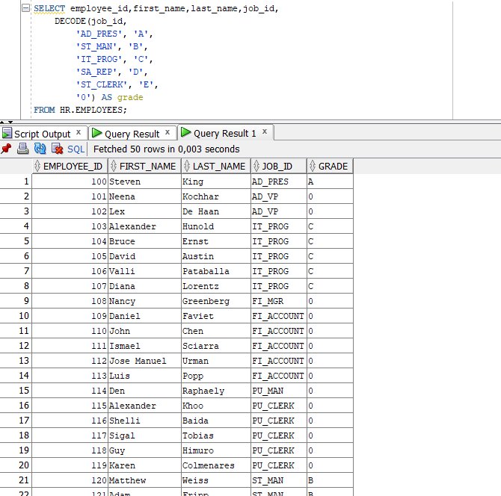

# Exercise SQL02-EX-03:

**Definiton :** Write a query for SQL02-EX-02(previous question) with using **CASE WHEN. SQL:**

SELECT employee_id,first_name,last_name,job_id,

CASE

WHEN job_id = 'AD_PRES' THEN 'A' WHEN job_id = 'ST_MAN' THEN 'B' WHEN job_id = 'IT_PROG' THEN 'C' WHEN job_id = 'SA_REP' THEN 'D' WHEN job_id = 'ST_CLERK' THEN 'E' ELSE '0'

END AS grade

FROM HR.EMPLOYEES;

## Screenshot( Exercise SQL02-EX-03 ):

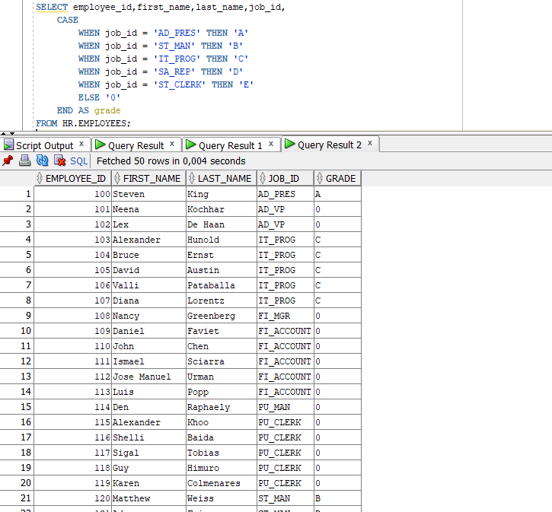

**Definiton :** Write a query that displays the employee number and last name of all employees who

work in a department with any employee whose last name contains a “i”.

## SQL:

SELECT e.employee_id, e.last_name FROM HR.EMPLOYEES e WHERE e.department_id IN (

SELECT DISTINCT e2.department_id FROM HR.EMPLOYEES e2

WHERE e2.last_name LIKE '%i%'

);

## Screenshot:

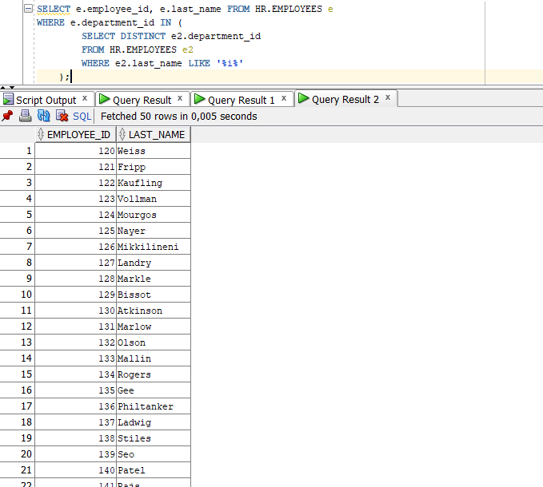

**Definiton :**

* Create a table for MY_EMP_TABLE with following columns
* Insert following rows,
* Update salary with 1.10 times of salary value
* Delete rows which first_name is David
* Truncate table.

|  |  |  |  |
| --- | --- | --- | --- |
| **ID** | **LAST_NAME** | **FIRST_NAME** | **SALARY** |
| 1 | Black | John | 1100 |
| 2 | White | Kent | 1300 |
| 3 | Orange | David | 1700 |
| 4 | Pink | Alissa | 1900 |

## SQL:

CREATE TABLE MY_EMP_TABLE ( ID NUMBER PRIMARY KEY, LAST_NAME VARCHAR2(50), FIRST_NAME VARCHAR2(50), SALARY NUMBER

);

INSERT INTO MY_EMP_TABLE (ID, LAST_NAME, FIRST_NAME, SALARY) VALUES (1, 'Black', 'John', 1100);

INSERT INTO MY_EMP_TABLE (ID, LAST_NAME, FIRST_NAME, SALARY) VALUES (2, 'White', 'Kent', 1300);

INSERT INTO MY_EMP_TABLE (ID, LAST_NAME, FIRST_NAME, SALARY) VALUES (3, 'Orange', 'David', 1700);

INSERT INTO MY_EMP_TABLE (ID, LAST_NAME, FIRST_NAME, SALARY) VALUES (4, 'Pink', 'Alissa', 1900);

UPDATE MY_EMP_TABLE SET SALARY = SALARY * 1.10;

DELETE FROM MY_EMP_TABLE WHERE FIRST_NAME = 'David'; TRUNCATE TABLE MY_EMP_TABLE;

## Screenshot: