Experiment 4 – Light-emitting diodes
Preparation: tasks and questions with worked answers
Name, Group: Beyza Kararti, Saifeldin Ayman Elmoselhy Elnkep – Group 9 Date: 18.11.2026
The tasks and questions are quoted from the lab documentation (shaded boxes with a teal bar); the worked answer follows each box. Lab manual: Optoelectronic lab, Experiment 4: Light-emitting diodes – basics, radiation and optical outcoupling (e_poe_exp4.pdf). The manual contains four calculation / drawing questions (Tasks 1–4) and five measurement tasks (Task 5). Every answer is followed by a short Turkish summary (TR).

0. Background in one page
- pn junction / I-U curve: I = I_{S} (e^{eU/(nkT)} − 1). Forward bias lowers the barrier, electrons and holes are injected into the active zone and recombine. n ≈ 1…2 is the ideality factor, kT/e = 25.9 mV at 300 K. Above the “threshold” the curve is limited by the series resistance R_{S}.
- Double heterostructure: a small-gap layer between two large-gap barriers confines electrons and holes to a layer of sub-µm width (instead of the diffusion length > 10 µm); recombination becomes much more probable and the light is not re-absorbed (barriers are transparent).
- Spectrum: I(E) ∝ √(E − E_{g}) · exp[−(E−E_{g})/kT]; maximum at E_{g} + kT/2, width ≈ 1.8 kT ≈ 47 meV at room temperature. Conversion: λ[nm] = 1240 / E[eV].
- Efficiencies: η_{int} = generated photons / injected electrons; η_{ext} = photons emitted into free space / injected electrons; η_{eff} = η_{ext}/η_{int} (outcoupling efficiency).
- Outcoupling: Snell’s law n₁ sin α = n₂ sin β, Fresnel reflection R, total internal reflection for α > α_{C} = arcsin(n₂/n₁): only a narrow escape cone leaves the chip.
- Lambert radiator: I(θ) ∝ cos θ, half-intensity angle 60°. Luminous flux: Φ_{vis} = K_{m} ∫ V(λ) Φ_{e}(λ) dλ, K_{m} = 683 lm/W at 555 nm.
- White LEDs: additive mixing of several colours (line-like spectra with gaps → poor colour rendering) or blue LED + broadband phosphor (YAG:Ce).

Task 1 – Fresnel reflection at normal incidence
Task 1 (manual §3.1, p. 7): Derive equation (6) from the law of refraction and (4) by using the relationship sin(x) ≈ tan(x) ≈ x for small angles.
Given (manual): Snell’s law (3) n₁ sin α = n₂ sin β, and the Fresnel formulas (4)
R_{S} = sin²(α − β) / sin²(α + β), R_{P} = tan²(α − β) / tan²(α + β)
Goal (6): R = ((n₁ − n₂)/(n₁ + n₂))² for α = β = 0, where (4) is the undefined expression 0/0.
Step 1 – small angles. For α → 0 we also have β → 0, so sin α ≈ α and sin β ≈ β and Snell’s law becomes n₁α ≈ n₂β, i.e.
β ≈ (n₁ / n₂) · α
Step 2 – insert into (4). With sin x ≈ tan x ≈ x both formulas become the same expression:
R_{S} ≈ R_{P} ≈ (α − β)² / (α + β)² = [ (1 − n₁/n₂) / (1 + n₁/n₂) ]²
Step 3 – simplify. Multiply numerator and denominator by n₂ (the angle α cancels, so the 0/0 problem disappears):
R = [ (n₂ − n₁) / (n₂ + n₁) ]² = [ (n₁ − n₂) / (n₁ + n₂) ]² ∎
Because R_{S} = R_{P} at normal incidence, the polarisation does not matter and the average R = (R_{S} + R_{P})/2 equals the same value. Check: GaAs/air: (3.5 − 1)²/(3.5 + 1)² = 6.25/20.25 = 0.309.
TR Küçük açıda sin≈tan≈açı olduğundan Snell β = (n₁/n₂)α olur; bunu (4)’e koyunca α sadeleşir ve R = ((n₁−n₂)/(n₁+n₂))² çıkar. GaAs→hava için R ≈ %31.

Task 2 – Why is the approximation (7) still good?
Task 2 (manual §3.1, p. 7): This formula is also not entirely accurate! The fact that the Fresnel reflection coefficient R is angle-dependent has been neglected. The approximation is still quite good, why? (Tip: Take a look at Fig. 6)
Equation (7) is η_{eff} = ½ (1 − cos α_{C})(1 − R) – it multiplies the geometric escape-cone fraction by a single reflection loss R, the normal-incidence value (6). The exact calculation would have to use R(α) inside the cone:
η_{eff,exact} = ½ · ∫ [1 − R(α)] sin α dα (integral from 0 to α_{C})
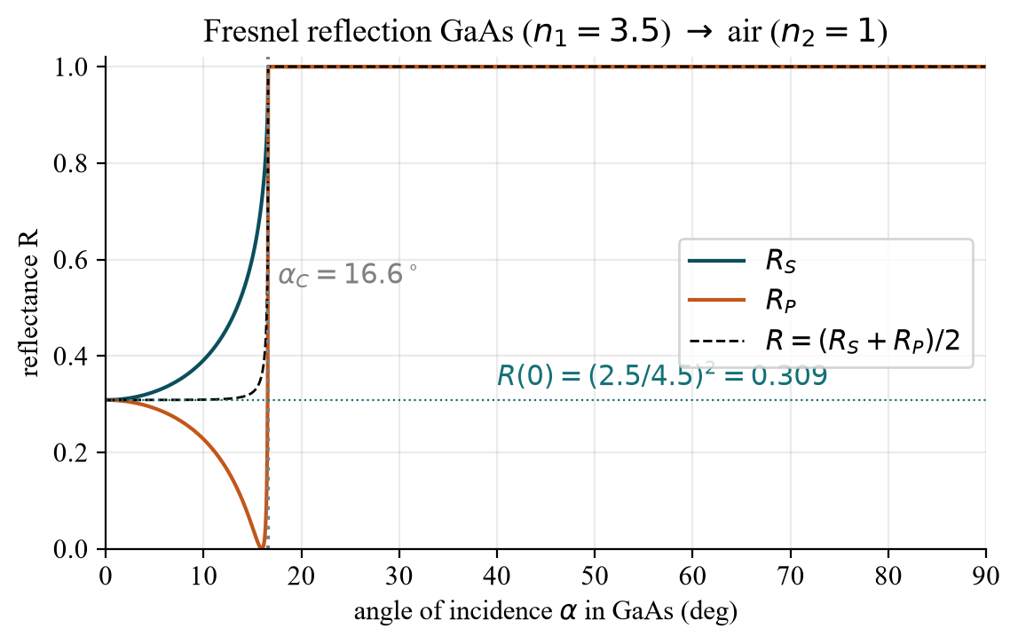
Fig. A – Fresnel reflectance for GaAs → air (n₁ = 3.5, n₂ = 1). The dashed curve is the unpolarised average.
Reasons (read from Fig. 6 / Fig. A):
- The cone is narrow. For GaAs α_{C} = arcsin(1/3.5) = 16.6°. Everything that can leave the chip hits the surface almost perpendicularly.
- R(α) is practically flat in that range. R_{S} rises and R_{P} falls (Brewster angle ≈ 15.9°), and they compensate in the average: R(0°) = 0.309, R(10°) = 0.309, R(14°) = 0.315. Only in the last degree before α_{C} does R climb steeply towards 1.
- Small weight of the critical region. The solid-angle weight sin α is small for small angles, so the steep rise at the edge hardly matters: the cone-averaged reflectance is 0.324 – only 5 % above R(0) = 0.309.
- Numbers: exact integral η = 1.408 %, approximation (7) η = 1.441 %, further simplified (8) η = 1.411 % – all agree within a few percent, far better than the accuracy of the other assumptions (point source, no absorption).
TR Çıkış konisi dar (≈16,6°), yani ışık yüzeye neredeyse dik gelir; bu aralıkta R(α) grafikte neredeyse sabit (≈0,31). Kritik açıya yakın hızlı artış küçük katı açıya denk geldiği için etkisi azdır → tek bir R(0) değeri yeterince iyi.

Task 3 – Outcoupling efficiency of GaAs into air
Task 3 (manual §3.1, p. 7): GaAs has a refractive index of n₁ = 3.5. What is the outcoupling efficiency at the interface to air (n₂ = 1)?
Quantity | Formula | Value
Reflection at normal incidence | R = ((n₁−n₂)/(n₁+n₂))² | (2.5/4.5)² = 0.309
Critical angle | α_{C} = arcsin(n₂/n₁) | arcsin(0.2857) = 16.6°
Cone fraction (no Fresnel) | ½(1 − cos α_{C}) | ½ · 0.0418 = 0.0209
η_{eff} with Eq. (7) | ½(1 − cos α_{C})(1 − R) | 0.0209 · 0.691 = 1.44 %
η_{eff} with Eq. (8) | ¼ (n₂/n₁)² (1 − R) | ¼ · 0.0816 · 0.691 = 1.41 %

Result: only ≈ 1.4 % of the generated light leaves a bare, flat GaAs chip through one surface – 98.6 % is trapped by total internal reflection or Fresnel reflection and finally turned into heat. (For GaN, n = 2.5: η_{eff} ≈ 3.4 %.) This is why the extraction geometry (Task 4) matters more than the internal efficiency.
TR α_{C} = 16,6°, R = 0,309 → η_eff ≈ %1,4. Yani düz GaAs çipinin ürettiği ışığın sadece ~%1,4’ü dışarı çıkar; geri kalanı toplam iç yansıma ve Fresnel yansımasıyla kaybolur.

Task 4 – Shape of the epoxy dome
Task 4 (manual §3.3, p. 10): Consider qualitatively (drawing) how to shape the epoxy dome so that you emit at the smallest possible angle.
The sentence can be read as “so that the light meets the dome surface at the smallest possible angle of incidence” (= smallest angle to the surface normal). This is the extraction problem of the section, so the main answer is a hemispherical dome with the chip in its centre:
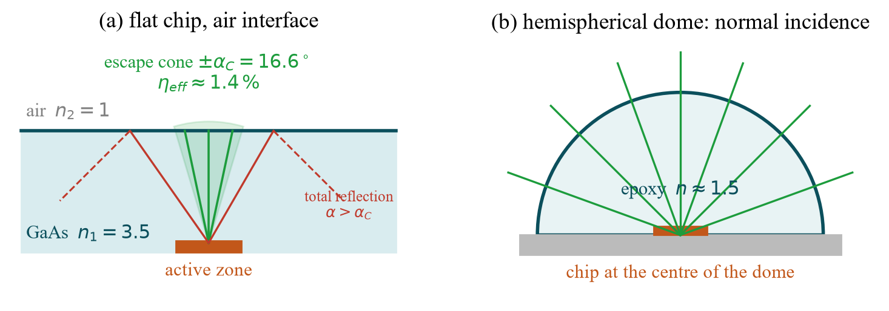
Fig. B – (a) bare chip: only the cone ±16.6° escapes. (b) Hemispherical epoxy dome: every ray from the centre meets the surface along the normal.
- Radial rays = normal incidence: with the emitter in the centre of a sphere every ray hits the epoxy–air surface at α ≈ 0 – no total internal reflection, lowest possible Fresnel loss (R = ((n_{e} − 1)/(n_{e} + 1))² = 4 % for n_{e} = 1.5).
- Condition for a real (not point-like) chip: the chip half-width a must be small against the dome radius r. The largest angle of incidence is arcsin(a/r); it stays below the critical angle arcsin(1/n_{e}) if r ≥ n_{e} · a (Weierstrass condition).
- Two interfaces instead of one: semiconductor→epoxy has a much smaller index step (3.5 → 1.5: R = 16 % instead of 31 %, α_{C} = 25.4° instead of 16.6°), epoxy→air is free of total reflection thanks to the dome shape.
- Gain: η_{eff} rises from 1.4 % to ≈ 3.9 % (n_{e} = 1.5), a factor ≈ 2.7 – the manual says “approximately tripled”, see Fig. C.
- If the question means a small emission angle (narrow beam): a lens-shaped (aspherical/parabolic) dome or a reflector cup collimates the light. The pattern then departs from the Lambert pattern – this is the origin of 15° or 30° half-angle LEDs (Task 5d).
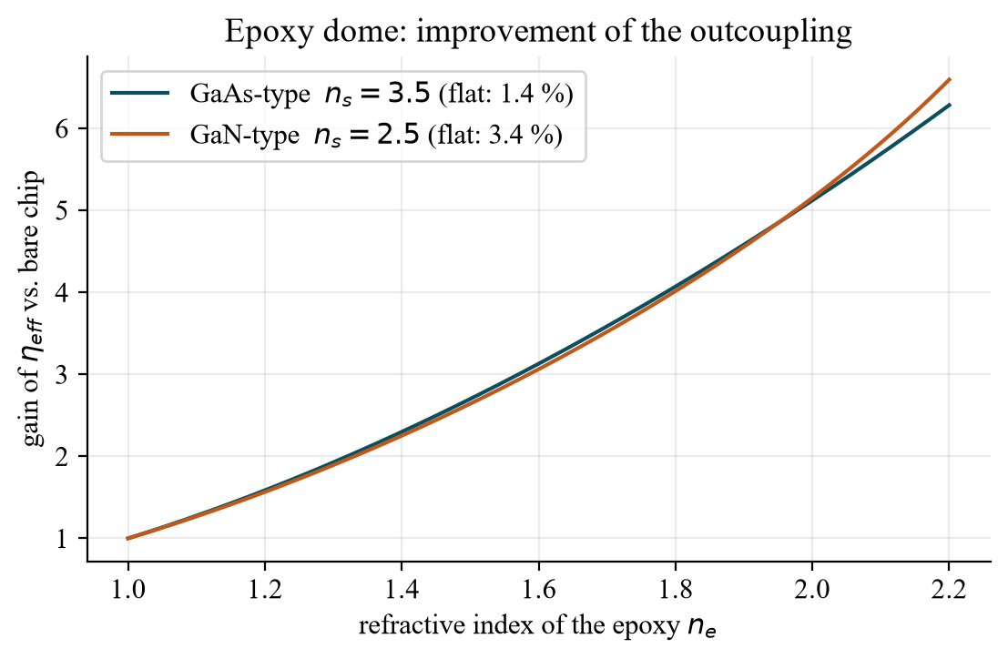
Fig. C – Gain in outcoupling efficiency vs. refractive index of the epoxy (cf. manual Fig. 9), model: ½(1 − cos α_{C})(1 − R₁)(1 − R₂).
TR Çip kubbenin tam merkezinde, yarım küre epoksi: tüm ışınlar yüzeye dik gelir → toplam iç yansıma yok. Çip yarıçapı a, kubbe yarıçapı r için r ≥ n_{e}·a. Verim ≈ %1,4 → %3,9 (yaklaşık 3 kat). Dar ışın isteniyorsa mercek biçimli kubbe/yansıtıcı kullanılır.

Task 5 – Measurements: what to prepare
The manual lists five measurements on a set of diodes “selected by the lab supervisor”. Do not exceed 30 mA (the diodes can be destroyed). For every point the protocol must state: what do I expect from theory, what do I get, and how are deviations explained (error analysis)?
Equipment | Use
Current/voltage source + multimeter | drive the LED (current-limited!), measure I and U
Spectrometer + optical fibre + PC | emission spectra and relative intensities
Integrating sphere (BaSO₄) | total radiant flux independent of the radiation pattern
Rotatable holder | angular radiation pattern

5a – Current/voltage characteristics
Task 5a: Measure the current/voltage characteristics of several LEDs and compare them. Record enough measuring points to be able to carry out a reasonable evaluation. What causes the differences in the I-V curves of the various LEDs?
How to measure: set the current (not the voltage!) in steps from ≈ 1 µA to 30 mA, logarithmic steps at low current (1, 2, 5, 10 … µA/mA) and finer steps near the knee; read U with the multimeter. Same procedure for every LED, wait a few seconds per point (self-heating).
Theory: I = I_{S} (e^{eU/nkT} − 1) − R_{S} limits at high current. Semi-log plot: straight line, slope = n·kT/e·ln 10 ≈ 60 mV/decade × n (n = 2 → 119 mV/decade). Turn-on voltage ≈ E_{g}/e: IR 940 nm ≈ 1.3 V, red 630 nm ≈ 2.0 V, green 570 nm ≈ 2.2 V, blue 460 nm ≈ 2.7–3 V.
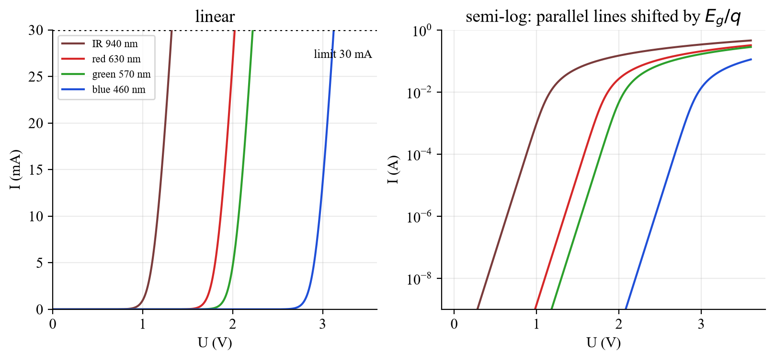
Fig. D – I-U curves of four model LEDs (LTspice, see below): linear and semi-logarithmic. Same ideality factor, only E_{g} differs.
Why do the curves differ? (1) mainly the band gap of the active material (colour) – it shifts the whole curve by ΔE_{g}/e; (2) the ideality factor n and the saturation current I_{S} (defects, non-radiative recombination); (3) the series resistance R_{S} (contacts, doped layers) – slope at high current; (4) temperature (U falls by ≈ 2 mV/K at constant current).
Expected vs. reality / errors: contact and cable resistance (use 4-wire sensing if possible), self-heating at high current, meter accuracy at µA currents, ambient light/leakage in parallel with the diode at very small currents, device-to-device spread.
TR Akımı (gerilimi değil) kademeli artır, düşük akımda logaritmik adımlarla ölç, 30 mA’yi aşma. Eğriler farklıdır çünkü yasak bant aralığı (renk) eğriyi ΔE_{g}/e kadar kaydırır; ayrıca n, I_{S} ve R_{S} farklıdır.

5b – Emission spectra
Task 5b: Record the emission spectra of the LEDs. Determine the emission maxima and half-width from the recorded spectra. How are the characteristic curves related to the emitted color?
How to evaluate: read λ_{peak} at the maximum and the full width at half maximum Δλ (two points at I_{max}/2). Convert to energy: E = 1240/λ and ΔE = 1240·Δλ/λ².
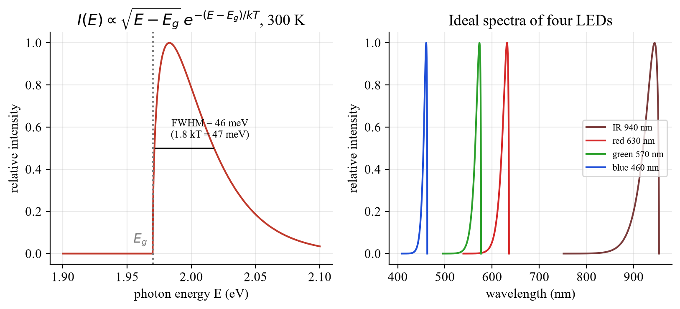
Fig. E – Theoretical LED spectrum (left) and ideal spectra of four LEDs on a wavelength axis (right).
LED (E_{g}) | λ_{peak} = 1240/(E_{g} + kT/2) | ΔE (1.8 kT) | Δλ (theory)
IR (1.30 eV) | 944 nm | 47 meV | 34 nm
red (1.95 eV) | 632 nm | 47 meV | 15 nm
green (2.15 eV) | 573 nm | 47 meV | 12 nm
blue (2.68 eV) | 460 nm | 47 meV | 8 nm

Relation to colour: the photon energy ≈ band gap fixes the wavelength (colour) and the turn-on voltage of the I-U curve: larger gap → shorter wavelength → larger forward voltage. Deviations: measured widths are larger than 47 meV (inhomogeneous composition, quantum-well/dot structure, heating, phosphor in “white” or green InGaN LEDs); the peak shifts to longer wavelength with temperature (E_{g} decreases) and slightly with current; spectrometer resolution and dark-signal subtraction influence Δλ.
TR λ_{tepe} ve yarı genişlik (FWHM) okunur; E = 1240/λ, ΔE = 1240·Δλ/λ². Teorik genişlik ≈ 1,8 kT ≈ 47 meV (kırmızıda ≈ 15 nm). Renk ↔ yasak bant aralığı ↔ açılma gerilimi birbirine bağlıdır; gerçek LED’lerde genişlik teoriden büyüktür.

5c – Radiant flux (P-I curves) with the integrating sphere
Task 5c: Measure the radiant flux (the “light output”) as a function of the current using the integrating sphere and plot the measured values in P-I curves. Compare “super-bright” LEDs with “normal” LEDs. How does the coupled electrical power compare to the radiant flux?
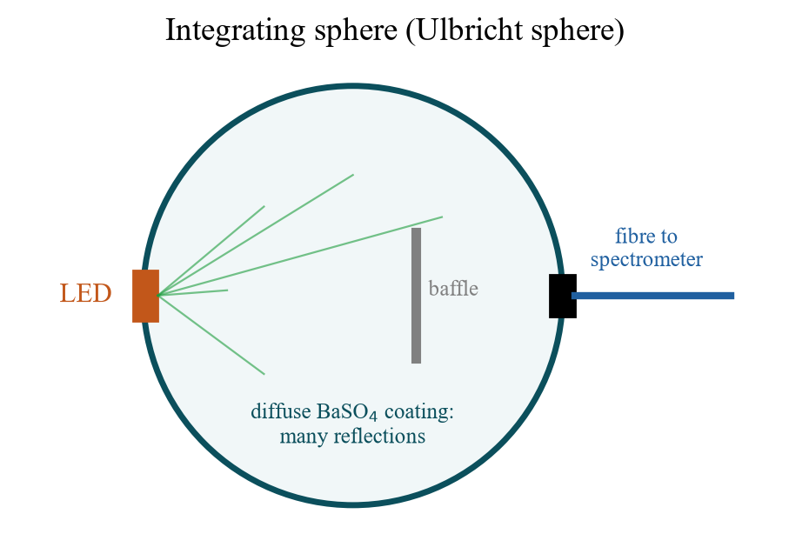
Fig. F – Integrating sphere: diffuse BaSO₄ coating, baffle so that no direct light reaches the exit port.
Principle: after many diffuse reflections the exit port shows a Lambertian field proportional to the total emitted power, independent of the LED’s radiation pattern – therefore different LEDs can be compared in absolute terms. Record the spectrometer signal (integrated over λ) for the same current steps as in 5a.
Evaluation:
η_{ext} = (P/hν) / (I/e) = P·λ[nm] / (1240 · I[A]) η_{WP} = P / (U·I)
Example: P = 5 mW at I = 20 mA, U = 1.95 V, λ = 630 nm → η_{ext} = 5·10⁻³·630/(1240·0.02) = 12.7 %, η_{WP} = 5 mW/39 mW = 12.8 %. The rest of the electrical power (≈ 87 %) becomes heat. The slope of the P-I curve gives the differential efficiency.
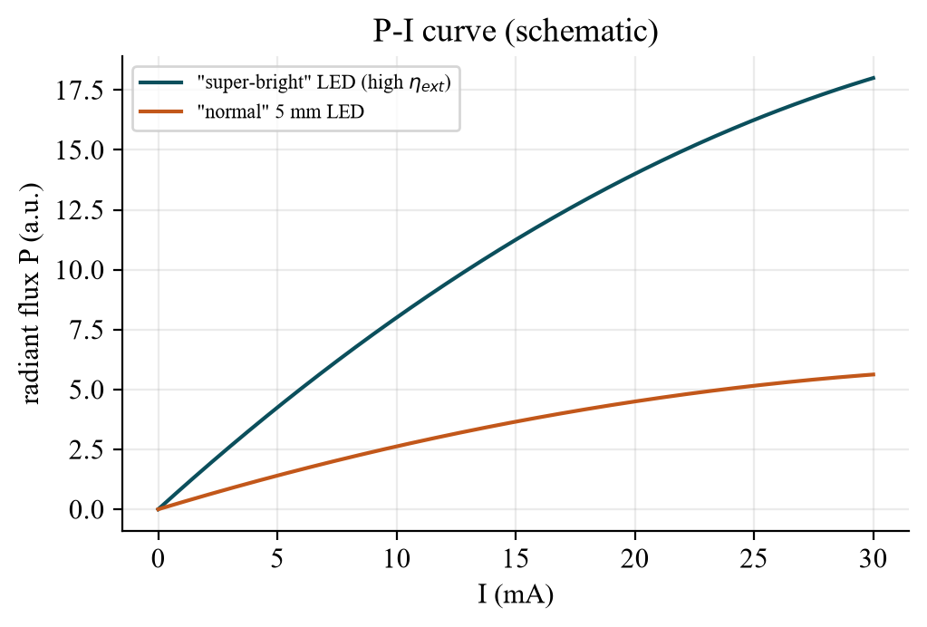
Fig. G – Schematic P-I curves. Super-bright LED: larger slope (better extraction, large chip, dome); both curves bend over at high current (heating, droop).
Super-bright vs. normal: higher η_{ext} via better outcoupling (dome, thin-film, mirror), more efficient active region and better heat removal; for the same current their P is a factor of several higher. Errors: sphere not calibrated (relative values only), LED not positioned identically, stray light, temperature drift during the sweep, spectrometer saturation.
TR Ulbricht küresi, ışıma diyagramından bağımsız toplam gücü verir. η_{ext} = P·λ/(1240·I), η_{WP} = P/(U·I). Elektrik gücünün büyük kısmı ısıya gider (örnekte ≈ %87). “Süper parlak” LED’lerin eğimi (verimi) çok daha yüksektir.

5d – Radiation characteristics (angle scan)
Task 5d: Mount the diodes on a rotatable holder. Consider how the diodes need to be mounted on the bracket in order to measure only the angular dependence and not have to consider any additional displacement of the diodes. Record the radiation characteristics (radiation flux as a function of angle) for different diodes and compare them.
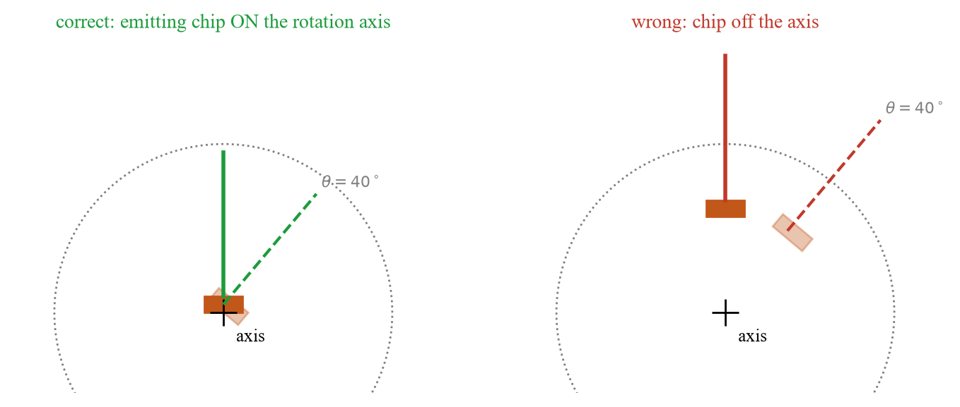
Fig. H – Mounting: the emitting chip must lie on the axis of rotation, otherwise the source moves sideways while the angle changes.
- Mounting: put the emitting chip (not the base of the package) exactly on the rotation axis, optical axis of the LED through the axis, detector/fibre fixed at a distance much larger than the chip size (far field). Then only θ changes.
- Measurement: scan θ = −90° … +90° in 5° steps (finer near the maximum), normalise to I(0°), plot in polar form.
- Evaluation: half-intensity angle θ_{½} where I = ½ I_{max}; compare with the Lambert pattern cos θ (θ_{½} = 60°) and with a fit cos^{m}θ, m = ln 0.5/ln cos θ_{½} (θ_{½} = 30° → m = 4.8; 15° → m = 20).
- Expect: flat chips without dome ≈ Lambert; domed or lens LEDs narrower (Task 4); side-emitting/wide LEDs broader.
- Errors: chip not on the axis, tilted LED, ambient light, finite detector aperture, rotation-angle reading.
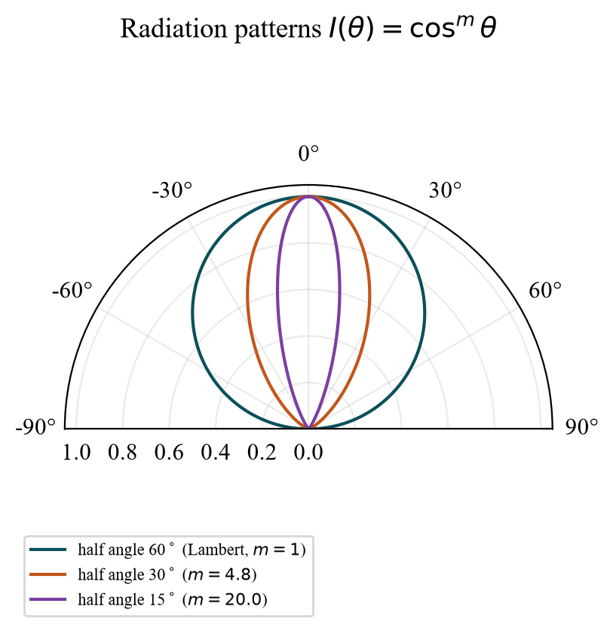
Fig. I – Radiation patterns cos^{m}θ with half angles 60° (Lambert), 30° and 15°.
TR Işıyan çip dönme ekseni üzerinde olmalı (paketin tabanı değil!), dedektör uzakta sabit. θ’yı −90…+90° tara, I(0°)’ye normalle; yarı-şiddet açısını oku (Lambert: 60°). Kubbeli/mercekli LED’ler daha dardır.

5e – White LEDs and colour rendering
Task 5e: Compare the (“subjective”) color rendering of different white LEDs. To do this, display the respective spectra and discuss the differences in the resulting spectra in relation to the color rendering you perceived with your eyes.
- RGB or two-colour white LED: separate narrow peaks with gaps (e.g. between blue-green and orange) → objects whose reflectance lies in the gaps look unnatural (poor colour rendering, low CRI), but colour temperature can be tuned.
- Blue LED + YAG:Ce phosphor: narrow blue peak (≈ 450 nm) plus a broad yellow-green-red band → continuous spectrum, better rendering (typically CRI 70–90), but weak in deep red and not tunable.
- Warm vs. cold white: more red phosphor → lower colour temperature, relatively smaller blue peak.
- Method: display all spectra normalised to the maximum, note peak positions/gaps, then judge a coloured test object (e.g. red, green, skin tone) under each LED and relate the impression to the missing spectral ranges.
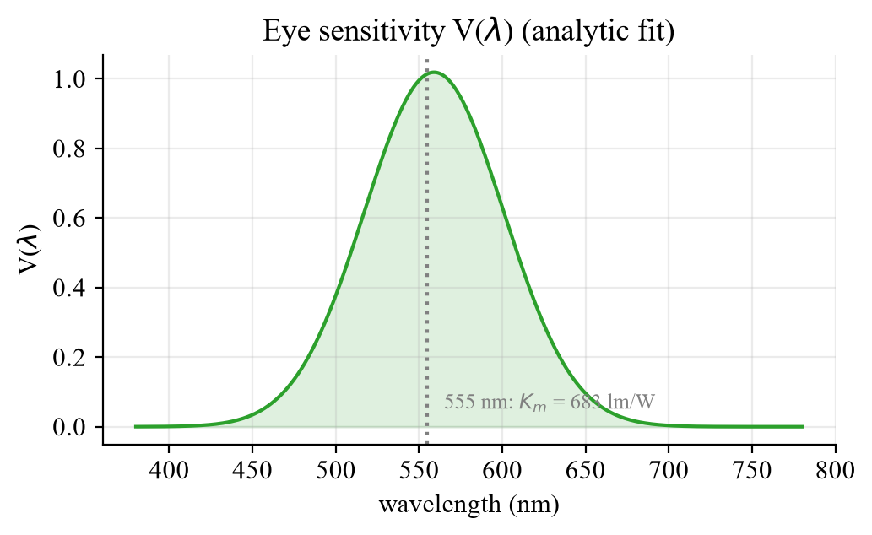
Fig. J – Eye sensitivity V(λ) (analytic approximation). Luminous flux Φ_{vis} = 683 lm/W · ∫ V(λ) Φ_{e}(λ) dλ.
Why watt ≠ lumen: 1 W of radiant power gives 683 lm at 555 nm, but only ≈ 181 lm at 630 nm (V = 0.265) and ≈ 41 lm at 460 nm (V = 0.060). A white LED therefore needs a lot of power in the green–yellow region to look bright.
TR RGB/iki renkli beyaz LED: dar tepeler ve aralarda boşluk → renk geri verimi (CRI) kötü. Mavi LED + YAG:Ce fosfor: sürekli geniş spektrum → daha iyi CRI. Gözün duyarlılığı V(λ) yüzünden 1 W her renkte aynı lümen vermez (555 nm’de 683 lm).

LTspice – optional illustration of the I-U curves
The lab manual does not require any LTspice work for this experiment. To make Task 5a more tangible, the I-U curves of four LEDs were simulated with LTspice 26.1.1 (Shockley diode, ideality factor N = 2, R_{S} = 5 Ω for all LEDs, only the saturation current I_{S} differs so that U(20 mA) = 1.25 / 1.95 / 2.15 / 3.05 V). These are model parameters chosen for illustration, not measured data.
Files (open directly in LTspice): LED_IV_Kennlinien.asc · LED_Vorwiderstand_Arbeitspunkt.asc – or clone the repository and double-click 04_LTspice/LTspice_starten.bat, then type the number of the file.

Simulation 1 – DC sweep of four LEDs (parallel on one source, 0 … 3.6 V)
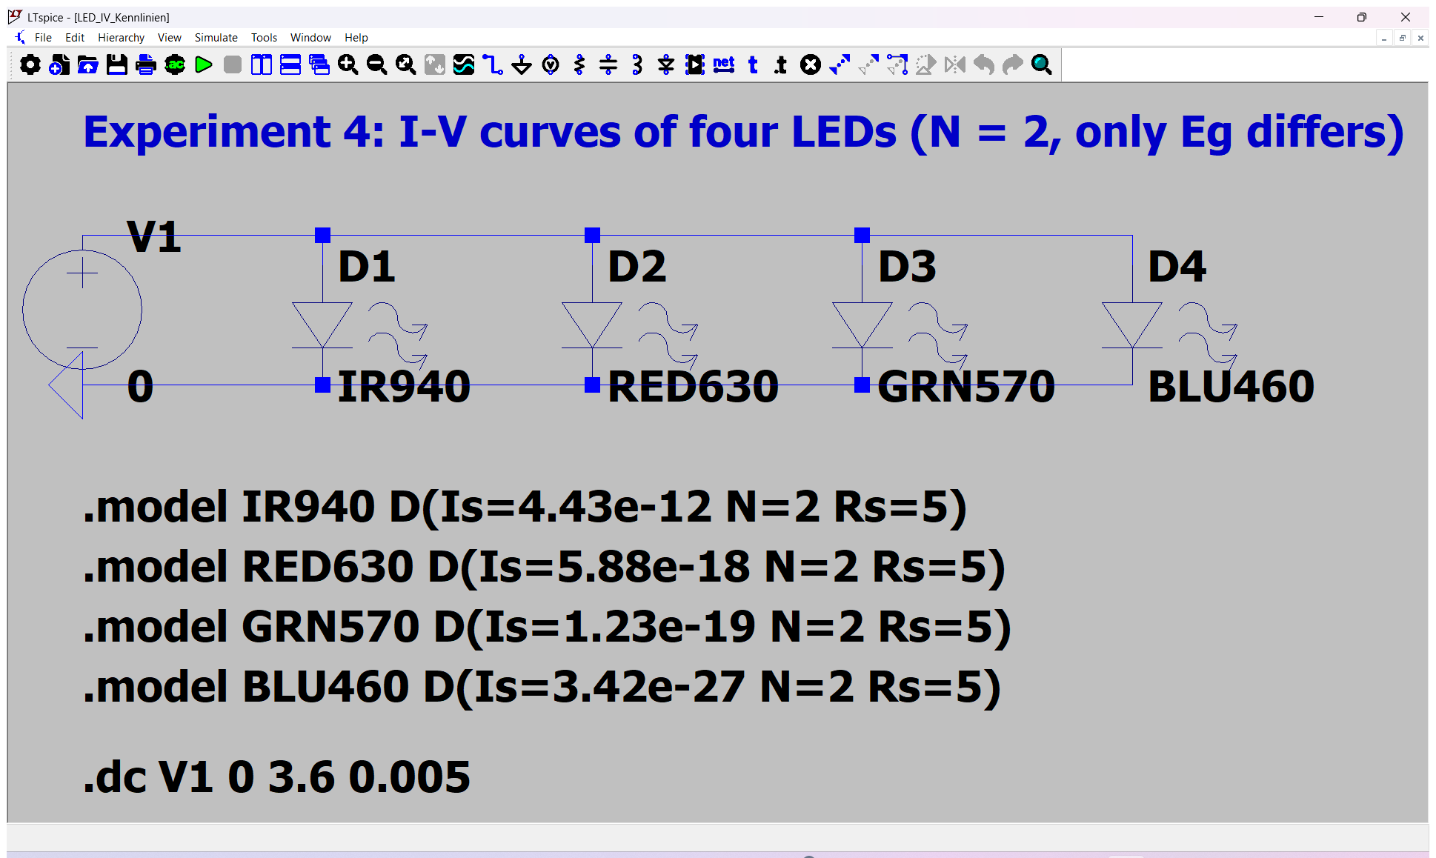
Fig. K – LTspice schematic: V1 sweeps 0–3.6 V (.dc V1 0 3.6 0.005); D1…D4 use the models IR940, RED630, GRN570, BLU460.
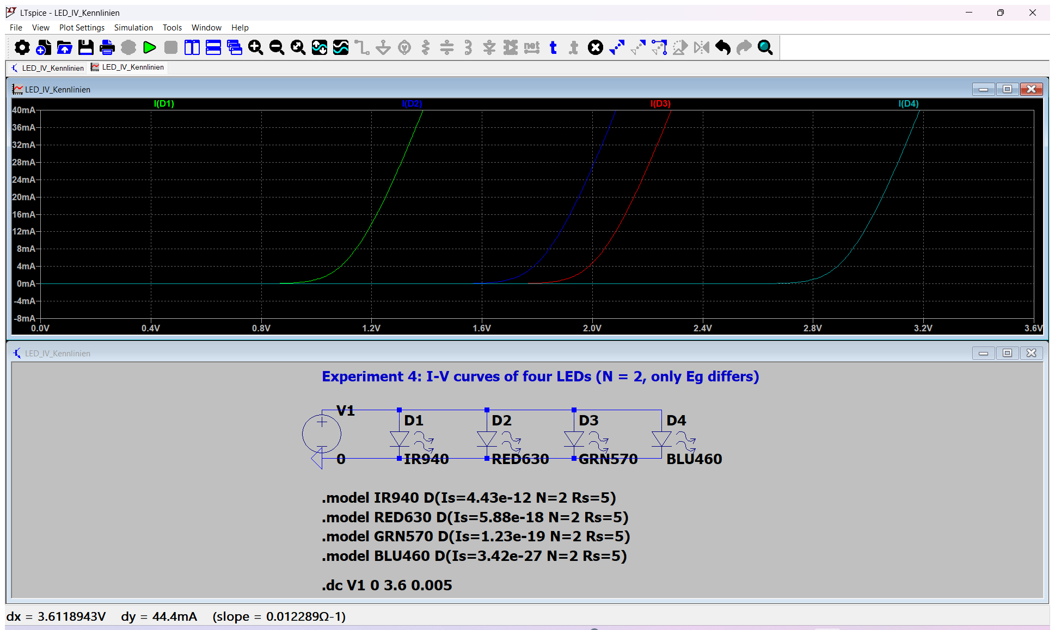
Fig. L – LTspice waveform window (zoomed to 0…40 mA): the knee moves to higher voltage with the photon energy.
LED model | E_{g}/e (λ) | U at 1 mA | U at 20 mA
IR940 | 1.32 V | 1.005 V | 1.250 V
RED630 | 1.97 V | 1.705 V | 1.955 V
GRN570 | 2.18 V | 1.905 V | 2.155 V
BLU460 | 2.70 V | 2.805 V | 3.055 V

Simulation 2 – series resistor and the 30 mA limit (.op, V1 = 5 V, R = 150 Ω)
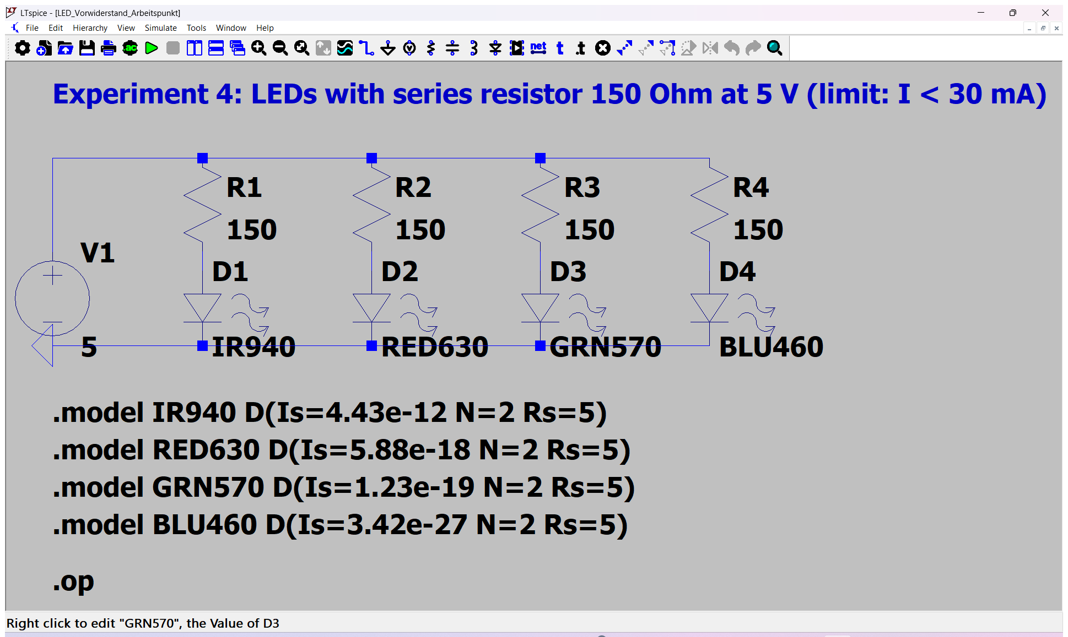
Fig. M – LTspice schematic with series resistors.
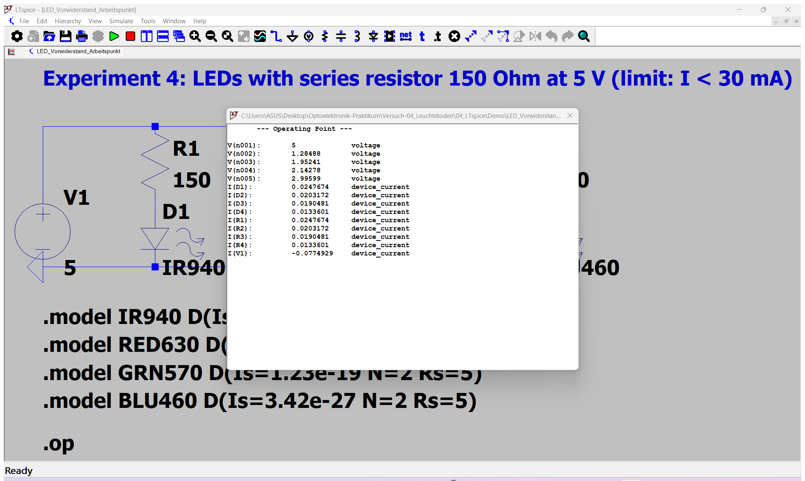
Fig. N – Operating-point result window (.op).
LED | U_{LED} | I = (5 V − U_{LED})/150 Ω
IR940 | 1.285 V | 24.8 mA
RED630 | 1.952 V | 20.3 mA
GRN570 | 2.143 V | 19.0 mA
BLU460 | 2.996 V | 13.4 mA

Lesson: with the same 150 Ω and 5 V, the low-voltage IR LED already draws 25 mA (close to the 30 mA limit) while the blue LED draws only 13 mA – a current-limited source (or a series resistor chosen for the LED with the lowest forward voltage) is necessary.
TR Bu LTspice kısmı föyde istenmiyor; I-U eğrilerini görselleştirmek için eklendi. Dosyalar GitHub’da; depoyu indirip LTspice_starten.bat ile açabilirsin. Aynı 150 Ω ve 5 V’ta IR LED 24,8 mA çekiyor (limite yakın), mavi sadece 13,4 mA → akım sınırlama şart.

Antestat – likely questions with short answers
Question | Short answer
Why does an LED light up only in forward direction? | Forward bias injects electrons and holes into the active zone where they recombine radiatively; in reverse direction the space-charge zone just widens and no carriers meet.
Why is the forward voltage about E_{g}/e? | The photon energy is ≈ E_{g}, and every recombination needs at least that much energy from the injected electron.
Why a double heterostructure? | Confines carriers to a sub-µm layer (higher recombination probability) and the barriers are transparent for the emitted light.
η_{int}, η_{ext}, η_{eff}? | Photons generated / electrons injected; photons emitted into free space / electrons injected; their ratio η_{ext}/η_{int} (outcoupling).
Why does a bare chip emit only ≈ 1–2 %? | Total reflection outside the ±16.6° cone and 31 % Fresnel loss; η = ¼(n₂/n₁)²(1 − R) ≈ 1.4 %.
What does the epoxy dome do? | Smaller index step (larger α_{C}) and hemispherical shape (normal incidence): outcoupling ×≈ 3.
What is a Lambert radiator? | I(θ) ∝ cos θ, same radiance in every direction, half intensity at 60°; ideal for the integrating-sphere exit port.
Why do we need the integrating sphere? | Collects the total emitted power regardless of the pattern, so different LEDs can be compared.
How do you mount an LED for the angle scan? | Emitting chip exactly on the rotation axis, detector in the far field.
Lumen vs. watt? | Lumen is weighted with the eye curve V(λ): 683 lm/W at 555 nm, much less at the ends of the visible range.
Why is white from RGB LEDs “worse” than blue + phosphor? | Separate narrow lines with gaps → low colour-rendering index; phosphor gives a broad continuous band.
Why max. 30 mA? | Heating destroys the junction (and the LED degrades); drive with current limit, not with a voltage.
What changes when the LED heats up? | Forward voltage falls (≈ −2 mV/K), spectrum shifts red, output power and η fall.
How do you get the half-width from a spectrum? | Δλ between the two points at half maximum; ΔE = 1240·Δλ/λ²; theory ≈ 1.8 kT ≈ 47 meV.

Lab-day checklist
- Antestat 14:00, building BC, room BC 119 (WET), group 9, 18 November 2026.
- Bring: this preparation, the lab manual, a USB stick (spectra), calculator, pen; formulas λ = 1240/E, η_{ext} = Pλ/(1240 I).
- Before switching on: set the current limit ≤ 30 mA; check polarity (long leg/anode = +).
- Note for every LED: colour, type (normal/super-bright/white), dome shape, current steps, integration time of the spectrometer, distance and angle step in the angular scan.
- For the protocol: theory vs. measurement and error analysis for each of the five tasks.

