Experiment 4 – Light-emitting diodes
Explanation: goal, principle, procedure and why we need it later

1. The experiment in one sentence
We investigate how an LED behaves electrically (I-V curve), spectrally (colour, line width), energetically (radiant power, efficiency) and spatially (radiation pattern) – and why only a small fraction of the light generated in the chip actually leaves it.

2. Goal of the experiment
- Measure and compare the I-V curves of several LEDs; understand why the forward voltage grows with photon energy (band gap).
- Record emission spectra: determine peak and half-width and compare with theory (≈ 1.8 kT ≈ 47 meV).
- Measure the radiant power versus current (P-I curve) with the integrating sphere; compare the efficiency of “super-bright” and “normal” LEDs.
- Measure the radiation pattern (angular dependence) and compare it with the Lambert radiator.
- Judge white LEDs (RGB, phosphor LED) by their spectra and colour impression.
- Compare theory and measurement and explain deviations with an error analysis.

3. Principle – the logic behind it

3.1 How an LED emits light and what its I-V curve looks like
An LED is a pn junction. Under forward bias electrons (n-side) and holes (p-side) are injected into the active zone and recombine there; the released energy ≈ E_{g} leaves the crystal as a photon. The curve follows the Shockley equation I = I_{S} (e^{eU/(nkT)} − 1): almost no current up to the “threshold”, then an exponential rise, limited at large currents by the series resistance. The threshold is about E_{g}/e – so an IR LED needs ≈ 1.2 V, a red one ≈ 1.9 V, a blue one ≈ 3 V.
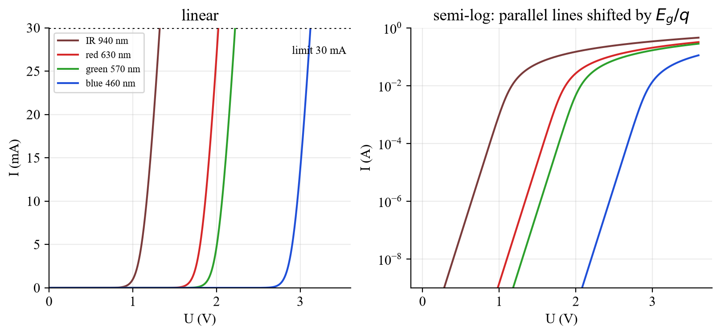
Fig. 1: I-V curves of four model LEDs (LTspice): the curve shifts with photon energy.

3.2 Structure: double heterostructure
Practically all LEDs are double heterostructures: a small-gap material is embedded between two large-gap barriers. Carriers are confined to a layer thinner than 1 µm (instead of the diffusion length > 10 µm in GaAs), so recombination becomes far more probable. The barriers are also transparent to the emitted light, which is therefore not re-absorbed. Quantum wells as active region are even more efficient.

3.3 Spectrum and colour
The ideal spectrum is I(E) ∝ √(E − E_{g}) · exp[−(E − E_{g})/kT]: a square-root edge at E_{g} followed by the thermal (Boltzmann) tail. The maximum is at E_{g} + kT/2, the half-width ≈ 1.8 kT ≈ 47 meV. Conversion to wavelength: λ[nm] = 1240 / E[eV]. A red LED (630 nm) therefore has a theoretical width of only ≈ 15 nm, a blue one (460 nm) ≈ 8 nm; real LEDs are broader (quantum wells, inhomogeneity, heating).
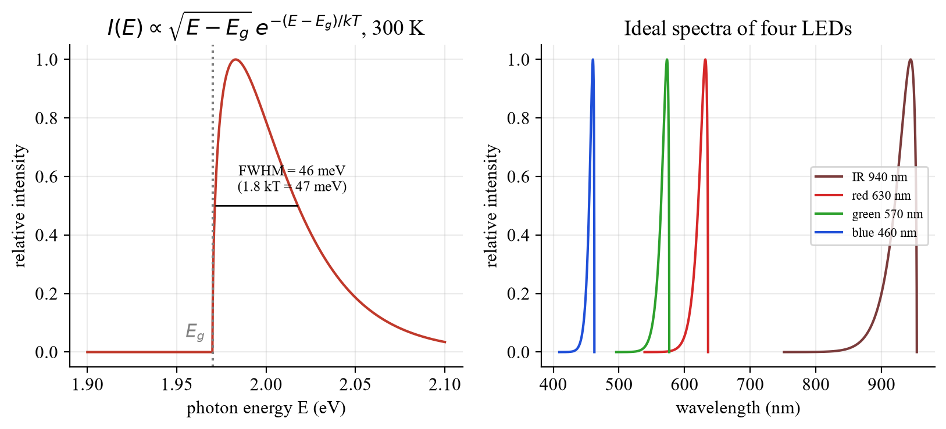
Fig. 2: Idealised spectrum (left) and four LEDs on the wavelength axis (right).

3.4 Efficiencies
- η_{int} = generated photons / injected electrons (quality of the active zone).
- η_{ext} = photons emitted into free space / injected electrons.
- η_{eff} = η_{ext}/η_{int} = outcoupling efficiency – the real bottleneck.
- From the measurement: η_{ext} = P·λ[nm] / (1240·I[A]); wall-plug efficiency η_{WP} = P / (U·I).

3.5 Why does so little light come out?
Semiconductors have high refractive indices (GaAs: n₁ = 3.5). At the interface to air (n₂ = 1) light is lost twice: (a) Fresnel reflection R = ((n₁ − n₂)/(n₁ + n₂))² = 31 % at normal incidence; (b) total internal reflection for incidence angles α > α_{C} = arcsin(n₂/n₁) = 16.6°. Only a narrow cone escapes: η_{eff} ≈ ½(1 − cos α_{C})(1 − R) ≈ ¼ (n₂/n₁)² (1 − R) ≈ 1.4 %. The rest is absorbed in the chip and becomes heat. The plastic epoxy dome (n ≈ 1.5) helps twice: a smaller index step (α_{C} = 25°) and a hemisphere with the chip in its centre, where all rays meet the surface perpendicularly – η_{eff} rises to ≈ 4 % (about a factor of 3). Further ideas: thin-film LEDs, textured surfaces, TIP geometry, mirrors.
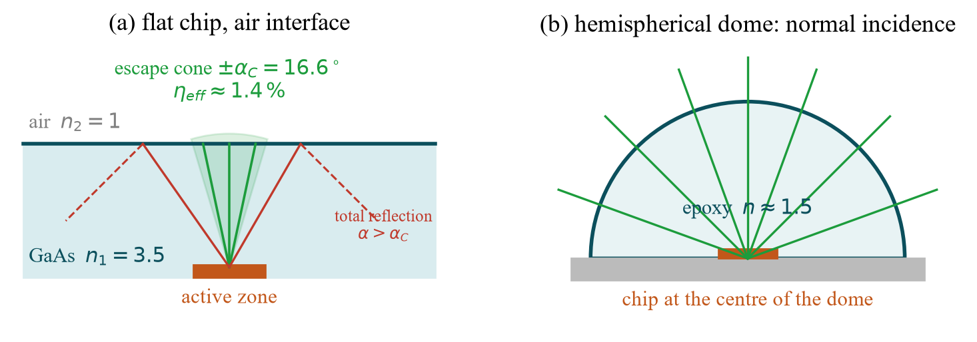
Fig. 3: (a) bare chip: only the ±16.6° cone escapes; (b) hemispherical dome: normal incidence.

3.6 Radiation pattern
A flat diffuse surface radiates according to Lambert’s law I(θ) ∝ cos θ (projection of the area); the half-intensity angle is 60°. An epoxy dome or lens narrows the pattern (e.g. 30° or 15°), described by cos^{m}θ. The integrating sphere provides an almost perfect Lambert field at its exit and is therefore used to measure total power independent of the pattern.
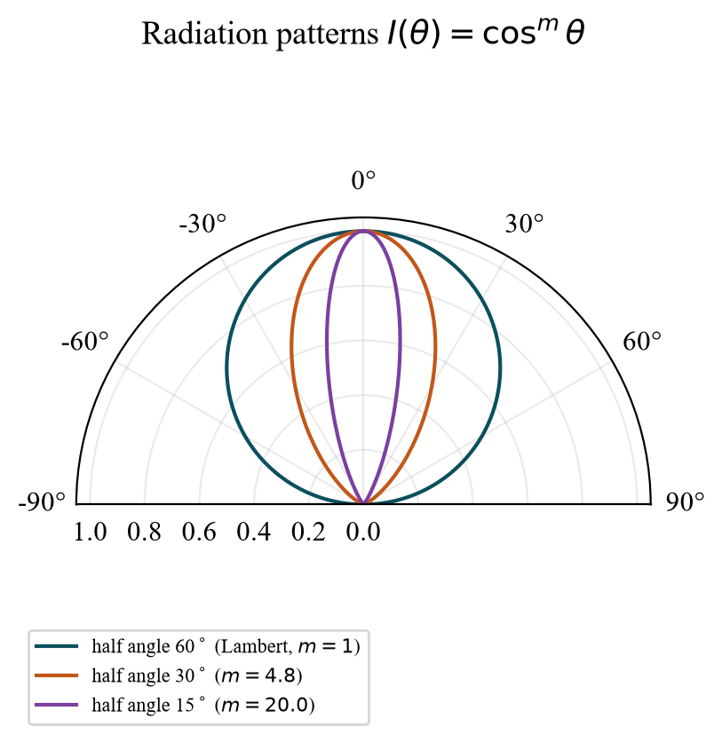
Fig. 4: cos^{m}θ patterns with 60° (Lambert), 30° and 15° half angle.

3.7 Luminous flux and white LEDs
The luminous flux Φ_{vis} = 683 lm/W · ∫ V(λ) Φ_{e}(λ) dλ weights the radiant power with the eye sensitivity V(λ): 1 W at 555 nm = 683 lm, but only ≈ 181 lm at 630 nm and ≈ 41 lm at 460 nm. White light is made (i) by mixing several LEDs (e.g. R+G+B: narrow lines with gaps → poor colour rendering) or (ii) by a blue LED with phosphor (YAG:Ce, broad yellow-green-red band → a more continuous spectrum, better rendering, but not tunable).

4. Procedure step by step
Equipment: current/voltage source, multimeter, spectrometer with optical fibre (PC), integrating sphere, rotatable holder. The supervisor selects the diodes. Never exceed 30 mA!
Task | What to do? | Evaluation
a) I-V | Current 1 µA … 30 mA (logarithmic at low current), U at the multimeter | Semi-log plot, threshold, slope (n), R_{S}
b) Spectrum | Spectrometer + fibre in front of the LED, subtract dark signal | λ_{peak}, Δλ, ΔE = 1240·Δλ/λ²
c) P-I | LED in the integrating sphere, same current steps, signal at the exit | η_{ext}, η_{WP}, bright vs. normal
d) Angle | Chip on the rotation axis, θ = −90…+90° (5°), detector fixed | Half-intensity angle, compare with cos θ
e) White | Spectra of white LEDs, colour impression with test objects | Gaps in the spectrum ↔ colour rendering

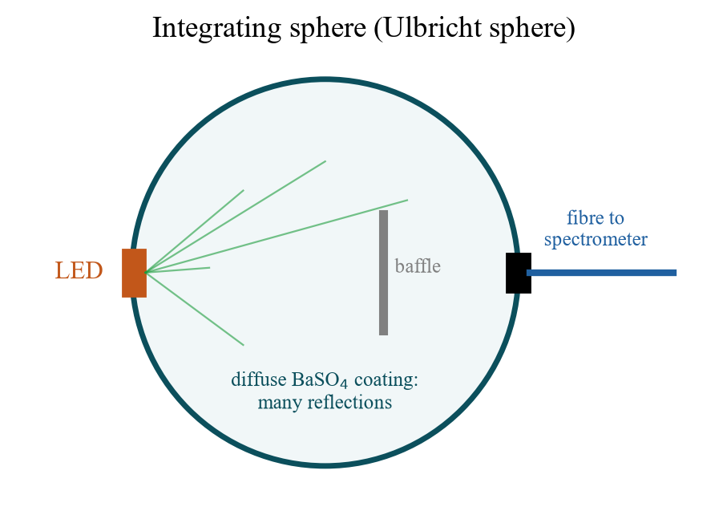
Fig. 5: Integrating sphere with baffle and fibre to the spectrometer.
For preparation there is also a small LTspice demo (optional): the I-V curves of four LEDs and the effect of a series resistor. Files: LED_IV_Kennlinien.asc and LED_Vorwiderstand_Arbeitspunkt.asc (or 04_LTspice/LTspice_starten.bat).

5. What to watch in the lab
- Set the current limit ≤ 30 mA before connecting the LED; mind the polarity (long leg = anode).
- Heating: wait briefly at each point; U falls by ≈ −2 mV/K and the spectrum shifts to longer wavelengths.
- Spectrometer: subtract the dark signal, avoid saturation (adjust integration time), shield ambient light.
- Angle scan: emitting chip on the rotation axis, not the package edge; detector in the far field.
- Protocol: for each task “expectation from theory – measured result – explanation of deviations (error analysis)”.

6. Why do we need this later?
- Experiment 5 – laser diodes: same methods (I-V, P-I, spectrum, beam pattern); a laser diode is an LED with a resonator – its P-I curve additionally has a threshold (spontaneous → stimulated emission).
- Experiment 6 – DFB laser: the broad LED spectrum (47 meV) is the counterpart to the narrow laser line; mode selection turns it into a single sharp peak.
- Experiment 1 – free-space transmission: the LED is the transmitter there; modulation bandwidth and beam angle set the range.
- Experiment 2 – energy conversion: solar cell and LED are “the same device in the opposite direction”; the band gap governs both.
- Practice: lighting, displays, indicator lamps – efficiency (lm/W), colour rendering and beam angle are the key figures.

7. Typical questions – short answers
Question | Short answer
Why does an LED light up only in forward direction? | Only there are electrons and holes injected into the active zone and recombine.
Why U ≈ E_{g}/e? | The photon has ≈ E_{g}; each electron must bring at least that energy.
Why a double heterostructure? | Carriers are confined (more recombination), barriers are transparent.
Why only ≈ 1–2 % outcoupling? | Total reflection outside ±16.6° and 31 % Fresnel loss: η = ¼(n₂/n₁)²(1 − R).
How does the epoxy dome help? | Smaller index step + hemisphere (normal incidence): about a factor 3.
What is a Lambert radiator? | I ∝ cos θ, half-intensity angle 60°.
What is the integrating sphere for? | Measures the total power independent of the radiation pattern.
How do you mount the LED for the angle scan? | Emitting chip exactly on the rotation axis.
Lumen vs. watt? | Lumen = watt weighted with V(λ); 683 lm/W at 555 nm.
RGB white vs. phosphor white? | RGB: narrow lines with gaps → poor rendering; phosphor: broad band → better.
Why max. 30 mA? | Overheating destroys the junction; use a current limit.
How to get the half-width? | Δλ at half the maximum; ΔE = 1240·Δλ/λ²; theory ≈ 1.8 kT ≈ 47 meV.

Date: 18 Nov 2026, pre-test (Antestat) 14:00, building BC, room BC 119 (group 9).

