Experiment 1 – Optical free-beam transmission system
Preparation: comprehension questions, tasks and measurement plan with worked answers
Name, Group: Beyza Kararti, Saifeldin Ayman Elmoselhy Elnkep – Group 9 Date: 20.01.2027 (Antestat 14:00, building LT, room LT 227)
Quoted from the lab manual Optoelectronics Lab: Optical free-beam transmission system (e_poe_exp1.pdf): nine comprehension questions (§2–§4) and the practical tasks a)–g) (§6). Quotes are in shaded boxes with a teal bar; answers follow. Every answer ends with a short Turkish summary (TR). The manual asks that the questions be discussed as part of the preparation.

0. Background in one page
- Optical transmission system: electro-optical converter (LED / laser diode) → transmission path (free space or glass fibre, < 0.2 dB/km at 1.3 µm) → opto-electrical converter (photodiode). Here: LED – 1…80 cm of air – photodiode.
- pn junction: I = I_{S}(e^{U/U_T} − 1), U_{T} = kT/e ≈ 26 mV; space-charge zone, diffusion voltage U_{D} ≈ W_{G}/e; forward: injection, reverse: tiny saturation current.
- Photon energy / wavelength: E = hν; λ[µm] = 1.24 / E[eV]; absorption for E ≥ W_{G} (generation of e-h pairs), radiative recombination for emission (spontaneous in the LED, stimulated in the laser).
- Photodiode: the field of the space-charge zone separates optically generated pairs → photocurrent I_{ph} = S·P (S = responsivity in A/W) even at zero voltage; in reverse bias linear and fast.
- System equation: I_{A} = η_{E} · κ · η_{A} · I_{E} (LED conversion × path transmission × PD conversion).
- Radiation pattern: LED with diffuse coloured housing ≈ Lambert I = I₀ cos θ (beam angle 60°); transparent housing with lens dome ≈ 12°. Beam angle = angle where the intensity falls to ½.
- Dynamic behaviour: the link behaves like an RC low-pass: t_{r} (10–90 %), f_{gr} = 0.35/t_{r}, f_{3dB}, phase shift / signal delay t₀.

Questions §2 – the pn transition
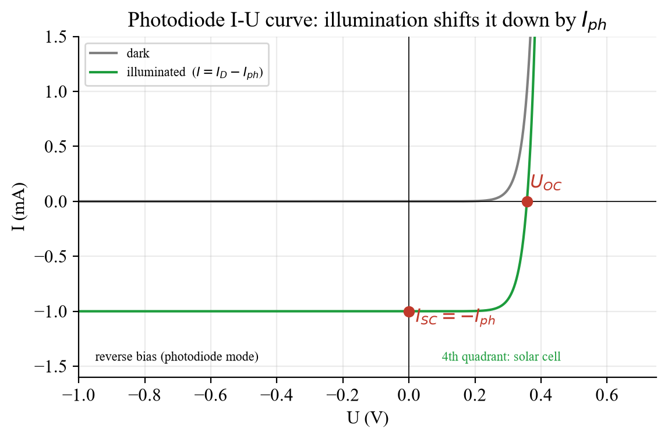
Fig. A – Photodiode I-U curve (model): dark curve and illuminated curve shifted down by I_{ph}.
Question 1 (§2): Which properties of the pn junction result from the band diagram and the characteristic curves?
- Band diagram: equalised Fermi levels → space-charge zone depleted of free carriers with a built-in field and a diffusion voltage U_{D} (≈ W_{G}/e); p-region holes, n-region electrons.
- Characteristic curve: a rectifier: forward current rises exponentially above ≈ U_{D} (injection of minority carriers, recombination → light in the LED), reverse current only the small saturation current I_{S} (generation in the zone; photocurrent adds here).
- Further: temperature dependence (I_{S} ∝ e^{−W_G/kT}, U falls ≈ 2 mV/K), junction capacitance (limits speed), breakdown in reverse direction, ideality factor n = 1…2.
TR Bant diyagramı: uzay yükü bölgesi, difüzyon gerilimi U_D ≈ W_G/e. Eğri: doğrultucu; ileri yönde üstel, ters yönde I_S; sıcaklık, kapasite, çığ kırılması.
Question 2 (§2): How does the characteristic curve shown in Fig. 3 change when the photodiode is illuminated?
It is shifted down along the current axis by the photocurrent: I = I_{S}(e^{U/U_T} − 1) − I_{ph} (superposition, Fig. A). Consequences: at U = 0 the short-circuit current is I_{SC} = −I_{ph}; the curve crosses the voltage axis at the open-circuit voltage U_{OC} = U_{T} ln(I_{ph}/I_{S} + 1) (4th quadrant = solar-cell operation); in reverse bias the current is simply −I_{ph}, proportional to the optical power.
TR Aydınlatınca eğri I_ph kadar aşağı kayar: I = I_S(e^(U/U_T)−1) − I_ph; U=0’da I_SC = −I_ph, açık devrede U_OC = U_T ln(I_ph/I_S+1).
Question 3 (§2): When is there a linear relationship between the optical power P and the electrical measured variable I?
- Photodiode: I_{ph} = (η e/hν)·P is linear when the diode is in reverse bias or short circuit (load resistance so small that the voltage across the diode stays ≈ 0 or reverse) and the optical power is not so large that the carriers screen the field (saturation).
- With a load resistor R (20 kΩ in this experiment): U = R·I_{PD} grows with P; at large P the PD is pushed towards forward bias (U_{OC} log-limit) and the relation becomes sub-linear – use small R or low power.
- LED: P ∝ I (η_{ext} constant) at moderate currents; at high currents heating/droop makes it sub-linear.
TR Fotodiyot: ters gerilim/kısa devre ve doymayan güçlerde I_ph = S·P doğrusal. Yük direnci büyükse veya güç çok yüksekse doyma. LED: orta akımlarda P ∝ I.
Question 4 (§2): How can the transmission properties of the components (LED, photodiode) be determined?
- LED: conversion efficiency η_{E} = Φ_{E}/I_{E} – measure the emitted power (calibrated power meter / reference PD) versus current; or electrical/optical: U-I curve for U_{D}, P(I).
- Photodiode: responsivity S = I_{ph}/P_{opt} in A/W with a known optical power (reference detector); linearity from I_{ph} versus P (here: distance r gives P ∝ 1/r²).
- Dynamic: rise and fall time with a square wave, frequency response (amplitude, phase/delay) with a sinusoidal signal, f_{3dB} – tasks d)–f).
TR LED: P–I (η_E); PD: S = I_ph/P (A/W); dinamik: yükselme/düşme süresi, genlik–faz–frekans eğrisi, f_3dB.

Questions §3 – the optical transmission system
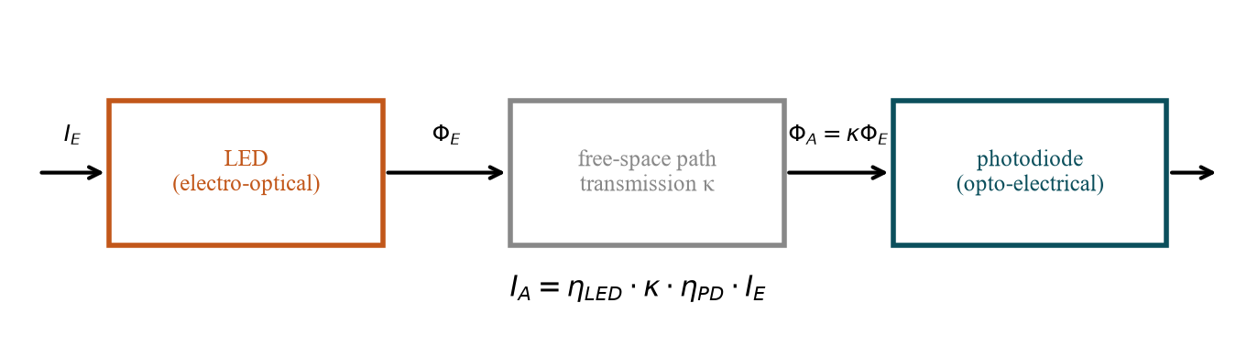
Fig. B – Block diagram of the transmission system.
Question 1 (§3): How is the transmission characteristic of the overall system determined from the individual components?
From the chain: LED (η_{E}: Φ_{E} = η_{E} I_{E}) → path (Φ_{A} = κ Φ_{E}) → PD (I_{A} = η_{A} Φ_{A}):
I_{A} = η_{LED} · κ · η_{PD} · I_{E} (in dB: the individual gains/losses add)
TR Zincir: I_A = η_LED·κ·η_PD·I_E; dB cinsinden halkalar toplanır.
Question 2 (§3): When is the system a linear, time-invariant system and how can this be verified experimentally?
- Linear: superposition – response to a·x₁ + b·x₂ is a·y₁ + b·y₂: LED in its linear P-I region (bias keeps it on), PD in reverse/short circuit, no saturation, no clipping.
- Time-invariant: the parameters (η, κ, temperature, path) do not change in time: a time-shifted input gives the same, equally shifted output.
- Verify: a sine input gives a sine of the same frequency (no harmonics); double the amplitude → double output; sum of two frequencies → sum of the responses; repeat the measurement after a time delay → identical curve.
TR Doğrusal: süperpozisyon (genlik ×2 → çıkış ×2, sinüs → aynı frekanslı sinüs); zamanla değişmeyen: parametreler sabit (zaman kaydır → aynı kayma).
Question 3 (§3): What changes if the length of the transmission path is changed?
- κ changes: the radiation spreads over a larger area: far from the LED (r much larger than the component size) the irradiance ∝ 1/r², so I_{PD} ∝ 1/r² (−20 dB per decade in I, −40 dB in electrical power I²R). In this experiment r is only 0 … 2.5 cm (comparable to the 5 mm components), so the near-field law I_{PD} = I₀/(1 + r/r₀)² with an effective source distance r₀ describes it better (see task b).
- Delay: t = r/c ≈ 3.3 ns per metre – negligible against the µs time constants here.
- Bandwidth and linearity of the components do not change – only the overall gain I_{A}/I_{E} (the system stays linear).
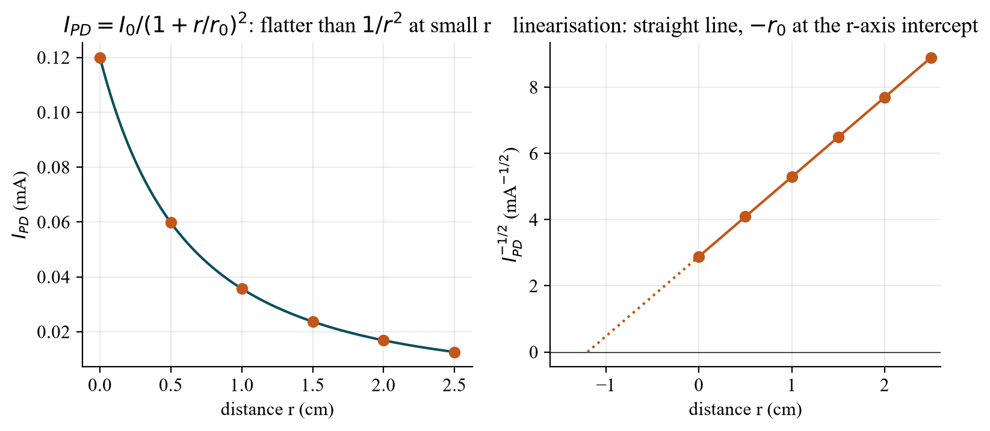
Fig. C – Model for the template distances r = 0 … 2.5 cm: I_{PD} = I₀/(1 + r/r₀)²; plotting I_{PD}^{−1/2} versus r gives a straight line whose r-axis intercept is −r₀.
TR Mesafe değişince yalnızca κ değişir: uzak alanda I_PD ∝ 1/r²; bu deneyde r = 0…2,5 cm (bileşen boyutu mertebesi) → I = I_0/(1+r/r_0)²; I^(−1/2)–r doğrusu. Gecikme r/c ihmal edilebilir; sistem doğrusal kalır.

Questions §4 – radiation properties
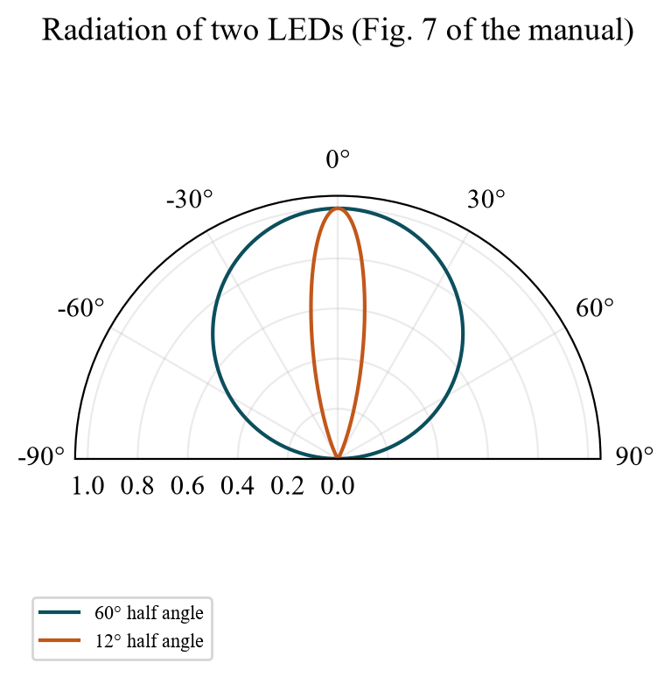
Fig. D – The two LED patterns of the manual: Lambert (beam angle 60°) and a lens LED (12°).
Question 1 (§4): Where can both LEDs be used?
- 60° (Lambert, diffuse coloured housing): indicator and signal lamps, displays, backlighting, short-distance links where the receiver position is not exactly known – wide coverage, tolerant to misalignment.
- 12° (clear lens housing): free-space links over longer distance, light barriers, remote controls, sensors, illuminating a spot – much higher intensity on the axis for the same power, but alignment is critical.
Question 2 (§4): What designs do they have?
- 60°: coloured, diffusely scattering plastic housing (scattering centres), roughly flat/low dome, no focusing.
- 12°: highly transparent uncoloured housing with a lens-shaped dome (and often a reflector cup around the chip) that collimates the light; the chip sits near the focus.
Why the on-axis intensity differs: the same total power is concentrated into a much smaller solid angle (Ω ≈ π·(sin(φ))²); 12° versus a hemisphere-like pattern gives roughly a factor 10–25 higher intensity on the axis, so the 12° LED delivers a much larger I_{PD} at the same distance r.
TR 60°: difüz renkli gövde, geniş alan (gösterge, kısa menzil, hizaya toleranslı); 12°: şeffaf mercekli kubbe, dar ışın (serbest uzay hattı, bariyer, kumanda), eksen yoğunluğu yaklaşık 10–25 kat yüksek.

Practical tasks §6 – what to prepare
Equipment: LED and photodiode on a rail (distance r adjustable), two multimeters (HP 3478A for current, Kontron for voltage), voltage source (U_{Netz} = 7 V for the LED), Keysight EDUX1022G oscilloscope with function generator. The protocol template prescribes the measuring points (quoted below).

a) LED I-U characteristic
Task a): The current-voltage characteristic of the LED must be determined. Use a digital multimeter (Hewlett Packard) to determine the current through the diode and a second digital multimeter (Kontron) to measure the voltage across the LED. Apply: I(U). Determine: U_{D}.
Template table: you set the source voltage U_{Quelle} = −1.0, −0.5, 0, 0.5, 1.0, 1.2, 1.4, 1.6, 1.8, 2.0, 2.5, 3.0, 3.5, 4.0, 4.5, 5.0, 6.0, 7.0 V (fine steps at the knee) and read U_{LED} (Kontron multimeter across the LED) and I_{LED} (HP multimeter in series); plot I_{LED}(U_{LED}). Forward voltage U_{F} (= U_{D}): the voltage at which the current becomes noticeable – state a clear definition, e.g. U_{LED} at 1 mA, or the intercept of the linear extrapolation of the steep part with the voltage axis. Expectation U_{F} ≈ W_{G}/e: IR ≈ 1.2 V, red ≈ 1.8–2.0 V, green ≈ 2.1 V, blue ≈ 3 V. In reverse direction (U_{Quelle} < 0) the current is ≈ 0 – the LED is a diode. (U_{Quelle} − U_{LED})/I_{LED} gives the series resistance of the test circuit – a useful cross-check; it also limits the current at 7 V.

b) PD – the I(P_PD) characteristic
Task b): The I(P_{PD}) characteristic curve of the PD is to be recorded via the proportionality of the distance r between the LED and PD and the power P_{PD} generated at the photodiode. The load resistance at the PD is R = 20 kΩ. To do this, the voltage across the load resistor R: I_{PD} = U/R must be recorded with the HP digital multimeter and the distance r must be changed appropriately. The voltage at the power supply unit for the LED should be set to U_{Netz} = 7 V. Apply: I(r), I_{PD}(P_{PD}) (P_{PD} in W and dBm).
Template tables: distance r = 0, 0.5, 1.0, 1.5, 2.0, 2.5 cm (0 = smallest adjustable distance); measure U_{PD} across the 20 kΩ resistor (HP multimeter) and compute I_{PD} = U_{PD}/R (mA), P_{PD} = U_{PD}·I_{PD} = U_{PD}²/R (W) and P_{PD} in dBm = 10 log₁₀(P/1 mW); diagrams: I_{PD}(r), P_{PD}(I_{PD}) in W and in dBm. Example: U_{PD} = 2.0 V → I = 0.10 mA, P = 0.20 mW = −7 dBm; U = 0.4 V → I = 20 µA, P = 8 µW = −21 dBm.
What to expect: the optical power at the PD falls with r (far-field law ∝ 1/r²). With r ≤ 2.5 cm – comparable with the 5 mm size of LED and PD – the point-source law does not hold from r = 0; use the effective-distance form I_{PD} = I₀/(1 + r/r₀)² (Fig. C): the plot of I_{PD}^{−1/2} against r is a straight line with the r-axis intercept at −r₀ (distance from the emitting chip/lens to the effective source plane). Linearity of the PD: I_{PD} ∝ optical power as long as the PD is not saturated; with R = 20 kΩ the voltage U_{PD} may reach several volts at r = 0 and the diode leaves the reverse/short-circuit regime → sub-linear at the smallest r.
TR Şablon: r = 0, 0,5 … 2,5 cm; U_PD ölç → I_PD = U/R (R = 20 kΩ), P = U²/R, dBm = 10 log(P/1 mW). I^(−1/2)–r doğrusu r_0’ı verir; r = 0’da PD doyabilir.

c) Overall efficiency
Task c): For the smallest adjustable distance r_{min}, the electrical power consumed by the LED P_{LED} (U_{Netz} = 7 V, I_{LED} = ?) and the electrical power emitted by the photodiode P_{PD} (R = 20 kΩ, I_{PD} = ?) should be determined. Determine: P_{LED}, P_{PD}(r_{min}), η(r_{min}).
P_{LED} = U_{Netz} · I_{LED} P_{PD} = I_{PD}² · R η(r_{min}) = P_{PD} / P_{LED}
Example (illustrative numbers): I_{LED} = 15 mA → P_{LED} = 7 V · 15 mA = 105 mW; I_{PD} = 20 µA → P_{PD} = (20 µA)²·20 kΩ = 8 µW; η = 8·10⁻⁶ / 0.105 ≈ 8·10⁻⁵ ≈ −41 dB. Explain the tiny value: LED conversion (a fraction of the electrical power becomes light), geometric coupling κ (solid angle of the PD), PD conversion, and the electrical power in a high-ohmic load of 20 kΩ is far below the PD’s possible output. P_{LED} = U_{Netz}·I_{LED} uses the supply voltage (7 V), i.e. it includes the loss in the series resistor.

d) Rise and fall time, cut-off frequency
Task d): For these AC measurements, the signal generator (offset 5 V, amplitude 5 V, square-wave voltage) must be connected to the LED via the series resistor. The dual-channel oscilloscope should tap the voltage across the LED and series resistor on channel 1 and the voltage across the resistor on the PD on channel 2. Triggering takes place on channel 1. At a frequency of ν = 20 kHz, the rise time t_{rise} and the fall time t_{fall} are to be determined. Provided that the system can be described by an RC low-pass filter, it is possible to determine the cut-off frequency f_{gr} using f_{gr} = (ln 0.9 − ln 0.1)/(2π·(t_{rise}+t_{fall})/2) ≅ 0.35 / ((t_{rise}+t_{fall})/2).
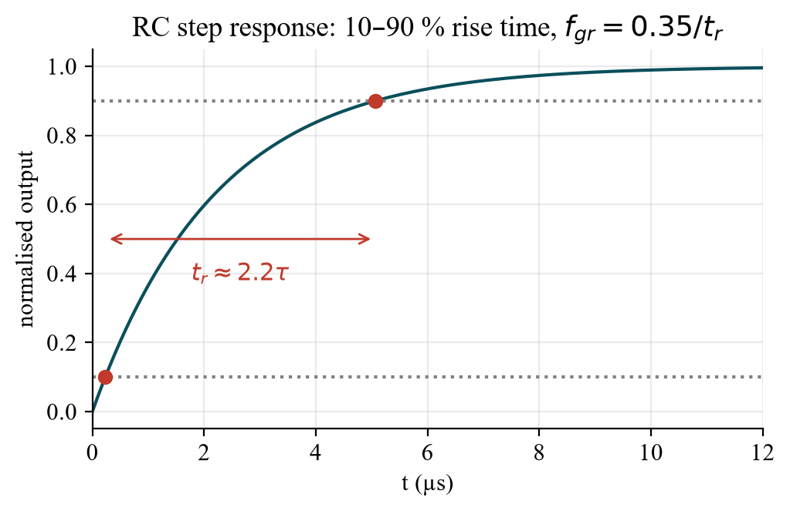
Fig. E – RC step response: the 10–90 % rise time is 2.2 τ.
RC low-pass: step response y = 1 − e^{−t/τ}; the 10 % and 90 % points lie at t = 0.105τ and 2.30τ → t_{r} = 2.2 τ; f_{gr} = 1/(2πτ) = 2.2/(2π t_{r}) = 0.35/t_{r} (the manual’s ln-expression is the same). Measure t_{rise} (10 % → 90 % of the final value) on the rising edge and t_{fall} (90 % → 10 %) on the falling edge of channel 2; use a fast time base so that the edge fills the screen, and check that the signal reaches its final value within the half period (20 kHz → 25 µs). Example: t_{r} = 4.0 µs, t_{f} = 4.4 µs → f_{gr} = 0.35/4.2 µs ≈ 83 kHz.

Fig. F – LTspice demo (optional): RC low-pass with R_{s} = 1k, 2.2k, 4.7k and C = 1 nF; t_{rise} = 2.2 / 4.8 / 10.3 µs, f_{gr} = 159 / 72 / 34 kHz.
TR RC: t_r(10–90 %) = 2,2 τ, f_gr = 1/(2πτ) = 0,35/t_r; örnek t_r = 4 µs, t_f = 4,4 µs → f_gr ≈ 83 kHz. Seri direnç büyürse τ=RC büyür, f_gr düşer.

e) Signal delay and phase shift
Task e): The frequency range ν = 1 kHz … 80 kHz should be scanned with the signal generator (offset 5 V, amplitude 5 V, sinusoidal voltage) and the signal delay t₀ between channel 1 and channel 2 should be measured. Apply: t₀, φ(ν).
Template table (f in kHz): 1, 2, 5, 10, 20, 30, 40, 50, 60, 70, 80 → columns t₀ (µs), φ (rad), φ (°). Measure the time shift t₀ between the same phase points (zero crossings, same slope) of channel 1 and 2; φ[°] = 360° · f · t₀, φ[rad] = 2π f t₀. For an RC low-pass φ = arctan(f/f_{gr}) (≈ 45° at f_{gr}, → 90° for f ≫ f_{gr}), hence t₀ = φ/(360° f): constant ≈ RC = 1/(2πf_{gr}) at low frequency, falling ∝ 1/f at high frequency (it is a low-pass, not a pure delay line). Plot t₀(f) and φ(f) (Fig. 5 of the template).
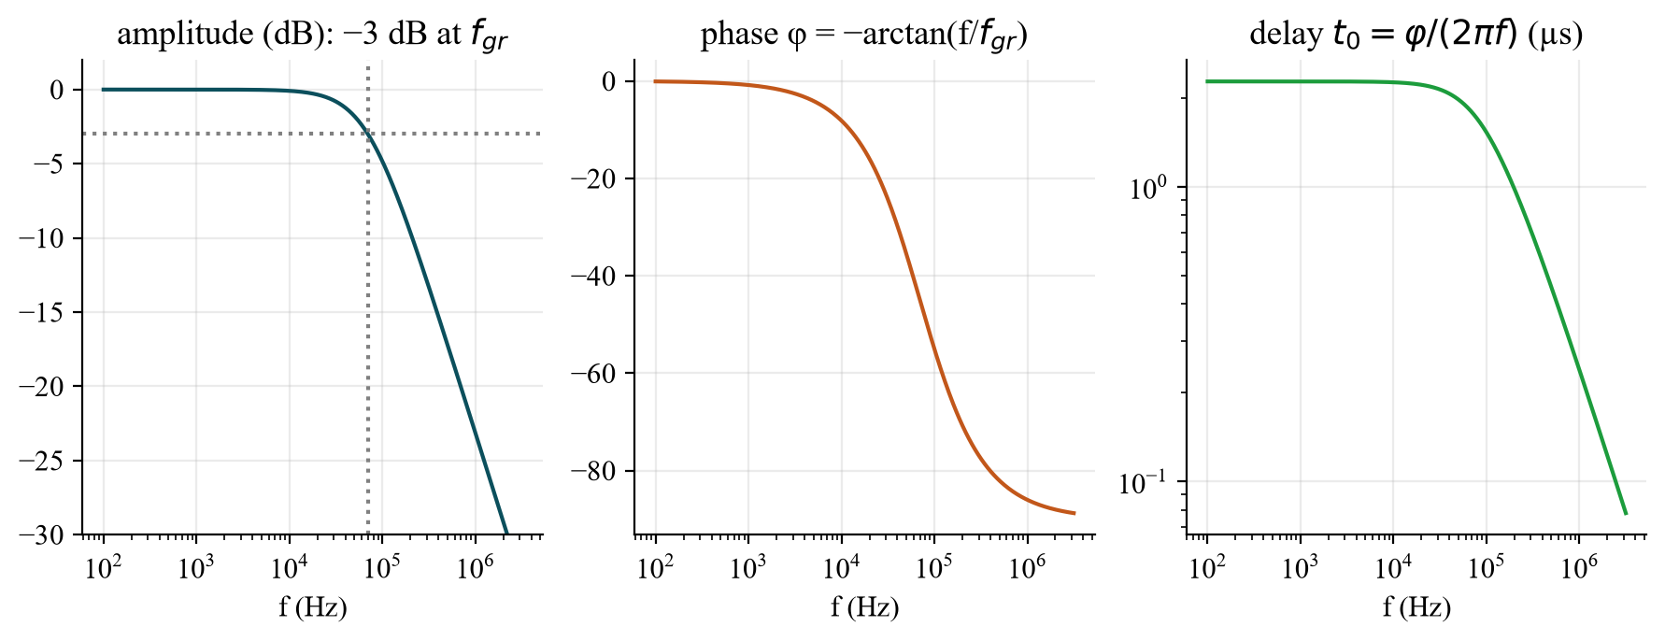
Fig. G – Model low-pass (f_{gr} = 70 kHz): amplitude, phase and delay versus frequency.

f) Cut-off frequency (−3 dB)
Task f): The frequency must be increased at the signal generator (offset 5 V, amplitude 5 V, sinusoidal voltage) from ν = 250 Hz until the amplitude of the signal at the PD has fallen by 3 dB. Determine: cut-off frequency f_{3dB}.
Template table: f = 250, 500, 1000 Hz … (continue upward as needed) with columns U_{PD} (V), P_{PD} (dBm), level (dB); the level is 0 dB at 250 Hz: level = 20 log(U_{PD}(f)/U_{PD}(250 Hz)) (= P_{PD}[dBm](f) − P_{PD}[dBm](250 Hz)). Raise f until the level is −3 dB (amplitude 0.708 ×) → f_{3dB}; plot the Bode diagram (level in dB over f on a log axis, Fig. 6). Compare f_{3dB} with f_{gr} from the rise time (task d): for a first-order low-pass they agree; differences indicate non-ideal behaviour (LED/PD are not a single RC element, nonlinearities, oscilloscope bandwidth, probe capacitance).

g) Optical audio transmission
Task g): Construct an optical free-beam transmission system with an LED as the signal source and a photodiode as the signal receiver and then transmit audio signals. The length of the free-beam path should be at least 1 m. (Protocol: describe the differences between analog and digital signal transmission.)
- Set-up: audio source → amplifier/offset (bias so that the LED current stays positive and in its linear region) → LED; 1 m free path, aligned (use the narrow 12° LED for more signal); photodiode (reverse biased) → amplifier/load → loudspeaker/headphones.
- Analog: the audio waveform modulates the LED intensity continuously; needs linearity (bias + small modulation index), noise and distortion add directly to the signal, quality degrades gradually with distance; simple and cheap.
- Digital: the signal is sampled and coded as bits (LED on/off); a threshold decision regenerates the signal, so noise below the threshold does no harm and errors can be corrected, but more bandwidth (rise time, f_{gr} ≫ sample rate) and converters (ADC/DAC) are needed; quality is constant until the error rate suddenly rises.
- Practice: ambient light (steady offset, 100 Hz hum from lamps) disturbs the PD – block it with AC coupling, shade the receiver, increase R_{load} for more signal (but lower bandwidth).
TR Analog: ses LED şiddetini sürekli modüle eder (doğrusallık, bias, gürültü doğrudan karışır); dijital: bit/eşik kararı, gürültüye dayanıklı ama daha geniş bant ve ADC/DAC gerekir. Ortam ışığı (100 Hz) AC kuplajla engellenir.

Antestat – likely questions with short answers
Question | Short answer
What are the three elements of an optical transmission system? | Electro-optical converter (LED/laser), transmission path (air/fibre), opto-electrical converter (photodiode).
What is the transmission equation of this system? | I_{A} = η_{LED} · κ · η_{PD} · I_{E}.
How does the I-U curve of a photodiode change with light? | Shifted down by I_{ph}; I_{SC} = −I_{ph}, U_{OC} = U_{T} ln(I_{ph}/I_{S} + 1).
When is I proportional to P? | Photodiode in reverse/short circuit with small load and no saturation; LED at moderate currents.
How does I_{PD} depend on the distance? | Far field: ∝ 1/r² (irradiance of a point-like source); at r = 0…2.5 cm: I₀/(1 + r/r₀)²; electrical power ∝ I², i.e. −40 dB per decade in the far field.
What is the beam angle? | The angle at which the intensity falls to half of its maximum: 60° (Lambert) vs. 12° (lens LED).
Why is the efficiency so small (≈ 10⁻⁴)? | Conversion in the LED, geometric coupling κ and conversion in the PD multiply; the load of 20 kΩ extracts little electrical power.
What is the relation between rise time and cut-off frequency? | RC low-pass: t_{r} = 2.2 τ, f_{gr} = 1/(2πτ) = 0.35/t_{r}.
What does the phase shift of the link look like? | φ = arctan(f/f_{gr}): 45° at f_{gr}, 90° for f ≫ f_{gr}; delay t₀ = φ/(360° f).
How do you measure the −3 dB frequency? | Increase the sine frequency from 250 Hz until the PD amplitude has dropped to 0.708 of the low-frequency value.
Why offset 5 V and amplitude 5 V? | The LED conducts only in forward direction: 0…10 V keeps the LED current positive; the offset is the bias point.
Linear, time-invariant – how to check? | Sine in → sine out, double the amplitude → double output, shift in time → same shift.
Analog vs. digital transmission? | Analog: continuous intensity modulation, noise adds; digital: bits with threshold decision, robust but needs bandwidth and converters.

Lab-day checklist
- Antestat 14:00, building LT, room LT 227, group 9, 20 January 2027.
- Bring (manual §7): calculator, pencil, 30-cm ruler, linearly divided graph paper; this preparation; the protocol template (it prescribes the measuring points).
- The written elaboration (graphs, explanations) is done after the lab; the tasks a)–g) must be finished during the lab – prepare the tables with the template’s points.
- a) U_{Quelle} = −1 … 7 V with fine steps at 1.2–1.8 V (read U_{LED}, I_{LED}); b) r = 0…2.5 cm in 0.5 cm steps with U_{Netz} = 7 V and R = 20 kΩ; c) P_{LED} = 7 V·I_{LED} and P_{PD} = I_{PD}²R at r_{min}; d) 20 kHz square (offset 5 V, amplitude 5 V), 10–90 %; e) f = 1, 2, 5, 10 … 80 kHz delay and phase; f) 250, 500, 1000 Hz … −3 dB; g) ≥ 1 m free path.
- Note the LED type (colour, beam angle), the series resistor value, and all cursor/time-base settings.

