Experiment 1 – Optical free-beam transmission system
Explanation: goal, principle, procedure and why we need it later

1. The experiment in one sentence
An LED sends light through the air to a photodiode: we measure the characteristics of both components and the transmission behaviour of the whole system – efficiency, distance dependence, rise time, cut-off frequency – and finally transmit music.

2. Goal of the experiment
- Record the LED I-V curve and determine the forward voltage U_{D}.
- Measure the photodiode current versus distance r; give P_{PD} in W and dBm.
- Determine the overall efficiency η = P_{PD}/P_{LED} at r_{min}.
- Determine rise/fall time (20 kHz square wave), signal delay and phase (1–80 kHz) and the cut-off frequency (−3 dB).
- Build a music transmission over ≥ 1 m; compare analog and digital transmission.

3. Principle – the logic behind it

3.1 The system as a chain
An optical transmission system consists of an electro-optical converter (LED/laser), a transmission path (air, glass fibre) and an opto-electrical converter (photodiode). The chain formula I_{A} = η_{LED} · κ · η_{PD} · I_{E} (in dB the terms add) explains every measurement: η are conversion efficiencies, κ the path transmission.
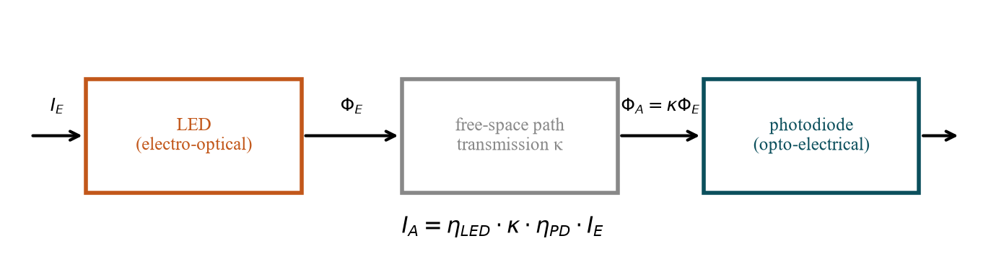
Fig. 1: Block diagram of the transmission system.

3.2 LED and photodiode
Both are pn junctions: I = I_{S}(e^{U/U_T} − 1). In the LED injected carriers recombine and emit photons; the forward voltage is ≈ W_{G}/e. In the photodiode the field of the space-charge zone separates optically generated pairs: the photocurrent I_{ph} = S·P is proportional to the light power and shifts the curve down by I_{ph} (I_{SC} = −I_{ph}; in the 4th quadrant solar-cell operation). I_{ph}(P) is linear in reverse bias/short circuit and without saturation; a large load resistance (here 20 kΩ) reduces linearity and bandwidth.
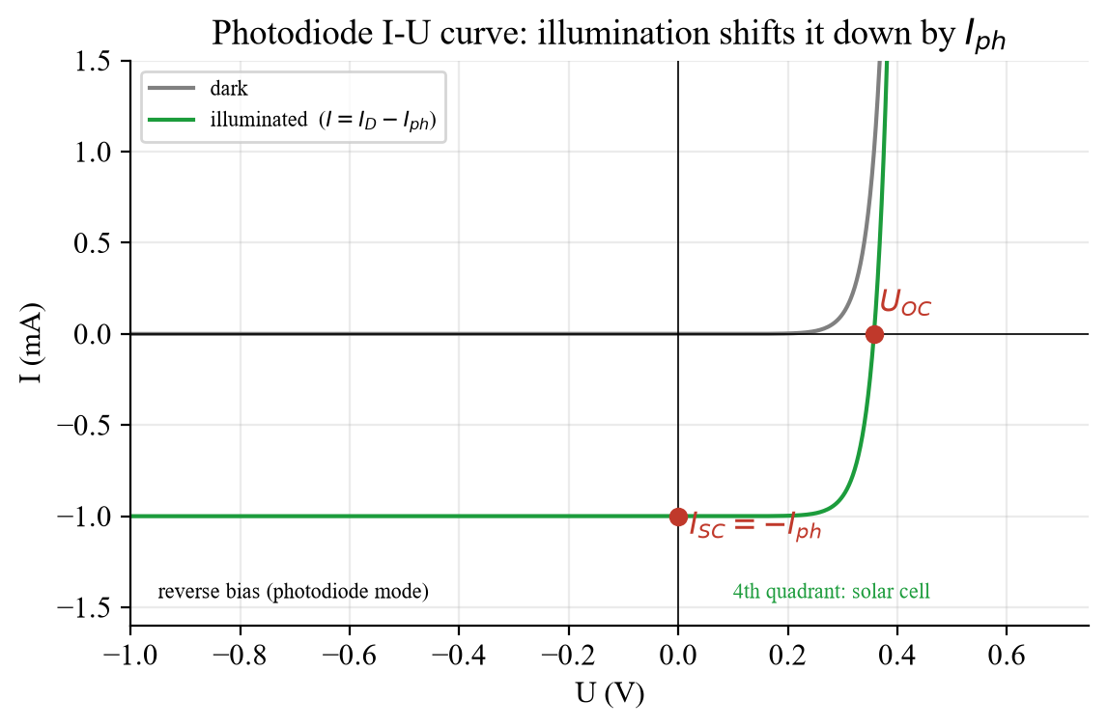
Fig. 2: Photodiode curve dark and illuminated (model).

3.3 Distance and radiation
Far from the LED the irradiance falls as 1/r². In the experiment r is only 0 … 2.5 cm (the size of the 5 mm components): I_{PD} ≈ I₀/(1 + r/r₀)²; plotting I_{PD}^{−1/2} against r gives a straight line with the intercept −r₀. An LED with a Lambert pattern (60°, diffuse housing) radiates broadly, a lens LED (12°) concentrates the same power into a small solid angle (≈ 10–25 times the on-axis intensity).
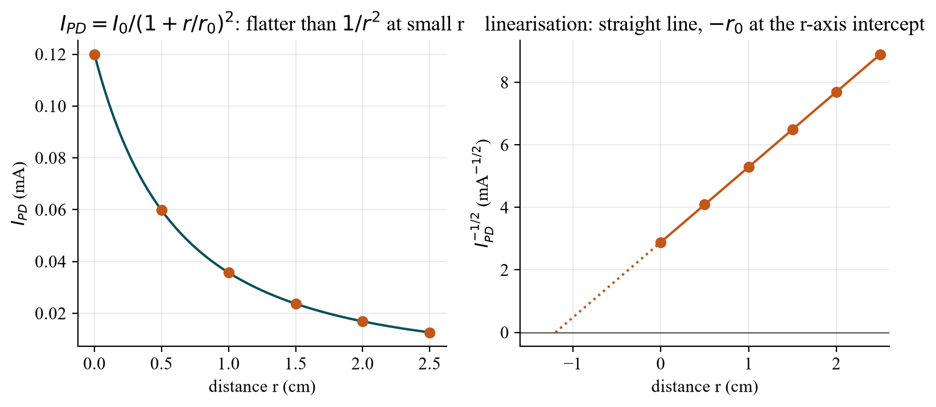
Fig. 3: Model for r = 0 … 2.5 cm and linearisation.

3.4 Dynamics: the RC low-pass
Capacitances and the series resistor form an RC low-pass: step response 1 − e^{−t/τ}, rise time (10–90 %) t_{r} = 2.2 τ, cut-off frequency f_{gr} = 1/(2πτ) = 0.35/t_{r}. In the frequency domain the amplitude is −3 dB at f_{gr}, the phase is φ = arctan(f/f_{gr}) and the delay t₀ = φ/(360°·f) – constant ≈ RC at low frequency, ∝ 1/f at high frequency.
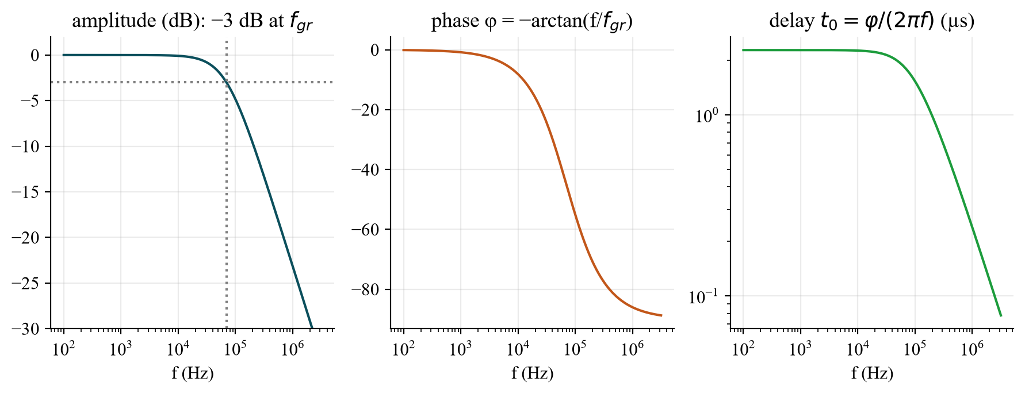
Fig. 4: Low-pass: amplitude, phase, delay.

4. Procedure step by step
Task | What to do? | Evaluation
a) I-U | U_{source} = −1 … 7 V (fine at 1.2–1.8 V); read U_{LED} and I_{LED} | I(U_{LED}), forward voltage U_{F}
b) PD | r = 0 … 2.5 cm (0.5 cm steps), U_{supply} = 7 V, R = 20 kΩ; measure U_{PD} | I = U/R, P = U²/R, dBm
c) η | P_{LED} = U_{supply}·I_{LED}, P_{PD} at r_{min} | η = P_{PD}/P_{LED} (≈ 10⁻⁴)
d) t_{r}, t_{f} | Square wave 20 kHz, offset 5 V, amplitude 5 V; CH1 before, CH2 after the system | 10–90 %, f_{gr} = 0.35/t_{r}
e) t₀, φ | Sine 1 … 80 kHz; time shift between CH1 and CH2 | φ = 360°·f·t₀
f) f_{3dB} | Raise the sine from 250 Hz until −3 dB | Bode diagram, f_{3dB}
g) Audio | LED + PD, ≥ 1 m, align, bias/offset | Describe analog vs. digital

Optional: LTspice demo of the RC low-pass (rise time): Freistrahl_RC_Tiefpass.asc (or 04_LTspice/LTspice_starten.bat).

5. What to watch in the lab
- Bring: calculator, pencil, 30 cm ruler, linearly divided graph paper.
- Mind the current limit of the LED (high voltages only with the series resistor).
- Ambient light (100 Hz from lamps) disturbs the photodiode – shield it.
- At small distances the photodiode may saturate (large U_{PD}) – check linearity.
- Measure the rise time between 10 % and 90 % of the final value; make sure the signal reaches it within the half period.
- The written elaboration is done after the lab; all measurements must be finished on site.

6. Why do we need this later?
- Experiment 4: LED characteristic, radiation pattern and efficiency are deepened there.
- Experiment 2: the photodiode in the 4th quadrant is the solar cell.
- Experiments 5/6: laser diodes as transmitters; bandwidth and linearity are the same questions.
- Practice: remote controls, light barriers, fibre and free-space communication (Li-Fi).

7. Typical questions – short answers
Question | Short answer
Three elements of the system? | Electro-optical converter, path, opto-electrical converter.
Chain formula? | I_{A} = η_{LED} · κ · η_{PD} · I_{E}.
Illuminated photodiode? | Curve shifted down by I_{ph}: I_{SC} = −I_{ph}, U_{OC} = U_{T} ln(I_{ph}/I_{S} + 1).
When is I ∝ P? | Photodiode in reverse/short circuit without saturation; LED at moderate currents.
Distance law? | Far field 1/r²; here near: I₀/(1 + r/r₀)².
Beam angle? | Angle where the intensity falls to ½: 60° (Lambert) / 12° (lens).
Why η ≈ 10⁻⁴? | LED conversion × geometric coupling × PD conversion; small power in the 20 kΩ resistor.
t_{r} and f_{gr}? | t_{r} = 2.2 τ; f_{gr} = 0.35/t_{r}.
Phase and delay? | φ = arctan(f/f_{gr}) = 360°·f·t₀.
−3 dB frequency? | Amplitude falls to 0.708 of the value at 250 Hz.
Why offset 5 V? | The LED conducts only forward: 0…10 V keeps the current positive.
Analog vs. digital? | Analog: continuous intensity modulation, noise adds; digital: bits with threshold decision, robust, needs bandwidth.

Date: 20 Jan 2027, pre-test (Antestat) 14:00, building LT, room LT 227 (group 9).

