Experiment 2 – Optoelectronic energy conversion (solar cell)
Preparation: tasks, evaluation plan and worked examples
Name, Group: Beyza Kararti, Saifeldin Ayman Elmoselhy Elnkep – Group 9 Date: 03.02.2027 (Antestat 14:00, building LT, room LT 227)
Quoted from the lab manual Optoelectronic energy conversion (e_poe_exp2.pdf). This manual has no numbered questions; it has the experiment tasks (a)–(e) (§5), seven evaluation items I–VII (§6) and the theory (§2) that you must be able to derive. Quotes are in shaded boxes with a teal bar, the worked answers and formulas follow. Every section ends with a short Turkish summary (TR). An Excel evaluation template (06_Auswertung) calculates all parameters from your measured I-U tables.

0. Background in one page
- Photovoltaics: absorbed photons (E ≥ W_{G}) create electron-hole pairs; the field of the pn junction separates them → photocurrent I_{SC} ∝ irradiance; an external load turns it into electrical power.
- Radiometry: irradiance E in W/m²; spectral irradiance in W m⁻² nm⁻¹ (1 µW/(cm²·nm) = 0.01 W/(m²·nm)); AM1.5G: 1000 W/m², standard test conditions (STC): AM1.5G, 1000 W/m², 25 °C.
- Dark curve (diode): I_{D} = I_{S}(e^{U/(nU_T)} − 1), U_{T} = kT/e ≈ 26 mV; I_{S}(T) ∝ exp(−W_{G}/(n k T)) – rises very fast with temperature.
- Light curve: I = I_{SC} − I_{D} (eq. 7); with R_{S}, R_{P}: I = I_{SC} − I_{S}(e^{(U+IR_S)/(nU_T)} − 1) − (U+IR_{S})/R_{P}.
- Characteristic numbers: I_{SC} = η_{ext} (e/hν) P_{opt} (eq. 8); U_{OC} = nU_{T} ln(I_{SC}/I_{S} + 1) (eq. 10); MPP: P_{MPP} = U_{MPP} I_{MPP}; FF = P_{MPP}/(U_{OC} I_{SC}); η = P_{MPP}/P_{opt} = FF·U_{OC}·I_{SC}/P_{opt}.
- Losses: reflection, non-absorption (E < W_{G}), thermalisation (E > W_{G}), recombination, series/parallel resistance.
- Instruments: LED solar simulator (960 LEDs, warm + cold white, ≤ 300 W/m², PWM-dimmed), spectrometer getSpec-3648 (360–1100 nm, 2.4 nm), Keysight/Keithley B2901A source-measure unit, a fan with two solar cells + LED bypass diodes.

Task (a) – Spectral irradiance of the sun simulator
Task (a) (§5): Use the spectrometer to measure the spectral irradiance of the solar simulator in µW/(cm²·nm).
Evaluation items I and II use this spectrum: (I) compare it with AM1.5G; (II) integrate it over wavelength and compare with the measured irradiance and with 1000 W/m²:
E = ∫ E_{λ}(λ) dλ ≈ Σ E_{λ,i} · Δλ_{i} [µW/cm²] · 0.01 = [W/m²]
Unit conversion | Value
1 µW/cm² | 0.01 W/m²
1 mW/cm² | 10 W/m²
100 mW/cm² (= 1 sun) | 1000 W/m²
simulator maximum | 300 W/m² = 30 mW/cm² = 30 000 µW/cm²

Example: an average of 75 µW/(cm²·nm) over 400 nm width (400–800 nm) gives 30 000 µW/cm² = 300 W/m². Expected differences to the sun: the white LED spectrum has a blue peak (≈ 450 nm) from the LED chip and a broad phosphor band (500–700 nm) but almost nothing above ≈ 780 nm, while AM1.5G continues smoothly into the infrared. A silicon cell (band edge 1107 nm) therefore uses less of the simulator spectrum than of sunlight (spectral mismatch) – for a 5900 K black body ≈ 80 % of the power lies below the Si band edge (Fig. A).
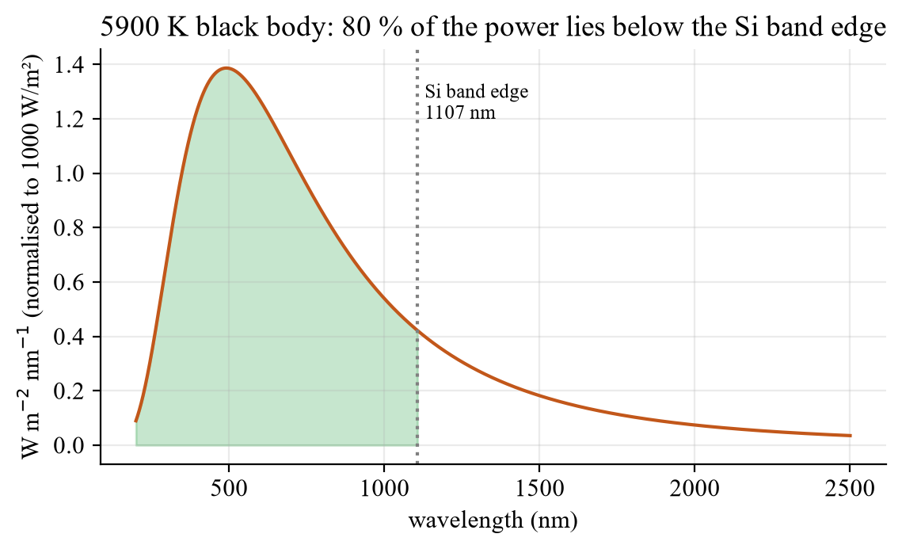
Fig. A – Black-body spectrum 5900 K (≈ solar spectrum without absorption), normalised to 1000 W/m²; green: part below the Si band edge.
TR E = Σ E_λ·Δλ; 1 µW/cm² = 0,01 W/m². LED simülatörü maviye ve 500–700 nm’ye sahip, 780 nm üstünde neredeyse hiç yok → Si pili güneşe göre daha az kullanır (spektral uyumsuzluk).

Task (b) – Area of the solar cell
Task (b) (§5): Determine the area of the solar cell to be measured.
Measure the active area A (length × width with a ruler/caliper); decide and state whether contact fingers/busbars are included. A is needed for the incident power P_{opt} = E·A and for the current density J_{SC} = I_{SC}/A (A/cm²), which allows comparing cells of different size. Example: 2 cm × 2 cm = 4 cm² → at 100 mW/cm²: P_{opt} = 400 mW; at 30 mW/cm² (max. of the simulator): 120 mW.
TR Aktif alanı ölç (parmak/busbar dahil mi, yaz): P_opt = E·A, J_SC = I_SC/A.

Task (c) – Dark I-U curves at different temperatures
Task (c) (§5): Record I-U characteristics (dark) at different temperatures. Note: Experiments (c) and (d) must be planned (with the help of the supervisor) in such a way that reliable statements can be made about the band gap of the semiconductor material used and the intensity dependence of the power efficiency.
Plan: at least 4–5 temperatures (e.g. 20, 30, 40, 50, 60 °C), wait for thermal equilibrium at each, sweep U from ≈ 0 to ≈ 0.7 V (forward) with fine steps (the current spans 6–8 decades – use a log-friendly step), plus a short reverse sweep (−0.5 … 0 V) for R_{P}. Keep the cell dark and the compliance current below the cell rating.
Evaluation item III (dark parameters):
- Semi-log plot ln I (or log I) versus U: in the exponential range a straight line: slope = 1/(n U_{T}) → n = 1/(slope · U_{T}), intercept → I_{S} = e^{intercept} (U_{T} = kT/e from the measured cell temperature in K).
- Series resistance R_{S}: at high current the curve bends away from the straight line; R_{S} ≈ ΔU_{deviation}/I (or the slope dU/dI in the linear region at the highest currents).
- Parallel resistance R_{P}: at small |U| (and in reverse bias) the curve is ohmic: R_{P} = ΔU/ΔI near U = 0 (the shunt leakage hides the diode current there).
- Band gap W_{G} (eq. 6): I_{S}(T) ∝ T³ exp(−W_{G}/(nkT)); plot ln I_{S} versus 1/T (T in K) for all temperatures: slope = −W_{G}/(n k) → W_{G} = −n · k · slope (k = 8.617·10⁻⁵ eV/K); correct for the T³ prefactor by plotting ln(I_{S}/T³) if you want a better fit. Si: W_{G} = 1.12 eV.
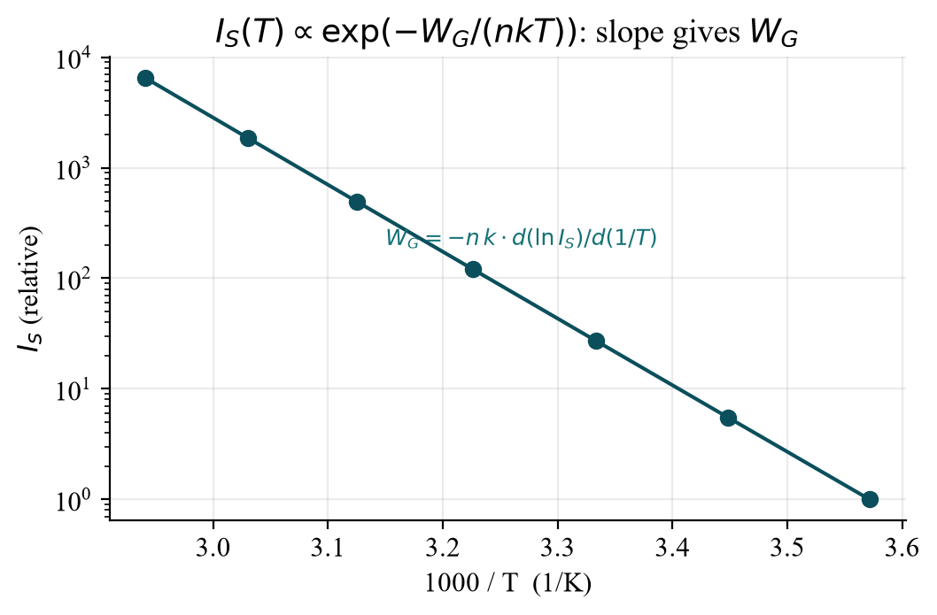
Fig. B – I_{S}(T) on a logarithmic axis versus 1000/T (model for W_{G} = 1.12 eV): a straight line, the slope gives the band gap.
Why does the dark curve move to lower voltage when T rises? I_{S} grows exponentially with T (exp(−W_{G}/nkT)), so the same current is reached at a lower U (≈ −2 mV/K) – this is also why U_{OC} falls with temperature. Errors: the measured temperature is the cell stage, not the junction; self-heating at high currents; leakage at small U; n and W_{G} are strongly coupled (use the n from the same fit).
TR ln I – U doğrusunun eğimi 1/(n·U_T) → n; kesişim → I_S. R_S yüksek akımda sapma, R_P U≈0’da omik eğim. ln I_S – 1/T doğrusunun eğimi −W_G/(n·k) → W_G (Si: 1,12 eV). T ↑ → I_S ↑ → eğri sola kayar, U_OC düşer.

Task (d) – Bright I-U curves at different intensities
Task (d) (§5): Record I-U characteristics (bright) at different intensities.
Intensities 25 %, 50 %, 75 % and 100 % of the simulator (PWM duty cycle); constant cell temperature (use short sweeps; at 300 W/m² the cell heats – let it cool between runs). Sweep from U ≤ 0 (reverse, shows I_{SC} region) to beyond U_{OC} (≈ 0.6 V for Si, a bit more for 100 %). P_{opt} for every intensity: P_{opt} = E·A with the irradiance E from task (a) (scaled with the duty cycle) and the area A from task (b).
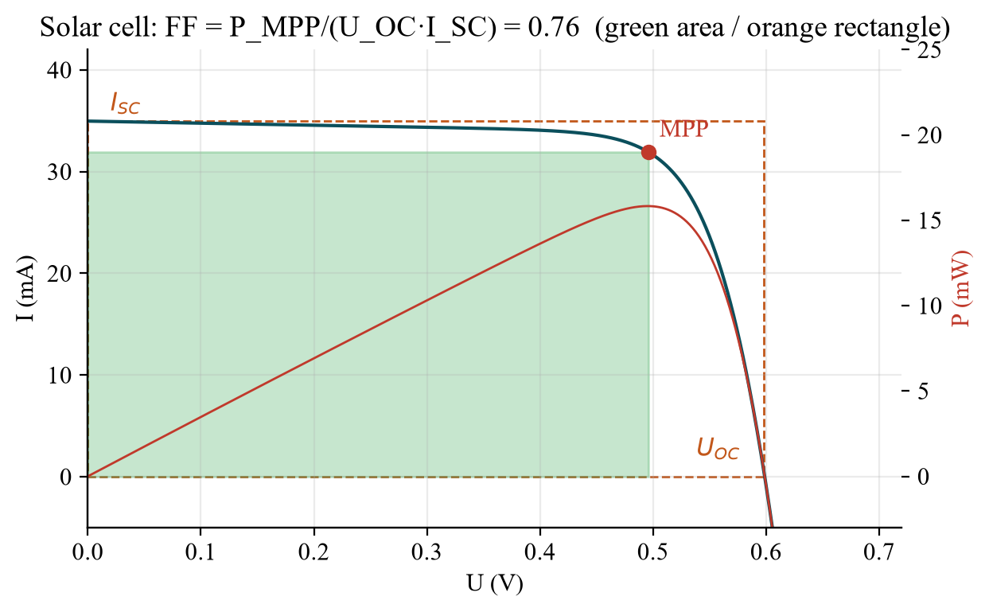
Fig. C – Bright I-U curve with I_{SC}, U_{OC}, the maximum power point and the fill factor (model: Si, 1 cm², I_{SC} = 35 mA, R_{S} = 0.5 Ω, R_{P} = 500 Ω).
Evaluation item IV: read from each curve I_{SC} (current at U = 0), U_{OC} (voltage at I = 0, interpolate the zero crossing), P = U·I for every point → P_{MPP} (maximum) with U_{MPP}, I_{MPP}, P_{opt} = E·A,
FF = P_{MPP} / (U_{OC} · I_{SC}) η = P_{MPP} / P_{opt} = FF · U_{OC} · I_{SC} / P_{opt}
Worked example (the model of Fig. C, 1 cm², 100 mW/cm²): I_{SC} = 35.0 mA, U_{OC} = 0.598 V, P_{MPP} = 15.8 mW at U_{MPP} = 0.50 V → FF = 15.8/(0.598·35.0) = 0.76, η = 15.8 mW/100 mW = 15.8 %.

Evaluation item V – intensity dependence (eq. 13–14)
At C-fold intensity P_{opt} → C·P_{opt}, the generated carriers and I_{SC} → C·I_{SC} (linear). From eq. (10) U_{OC} → n U_{T} ln(C·I_{SC}/I_{S} + 1) ≈ U_{OC} + n U_{T} ln C (about +70 mV per decade for n = 1.2). With FF roughly constant,
η(C)/η(1) = U_{OC}(C)/U_{OC}(1) ≈ 1 + n U_{T} ln C / U_{OC}(1)
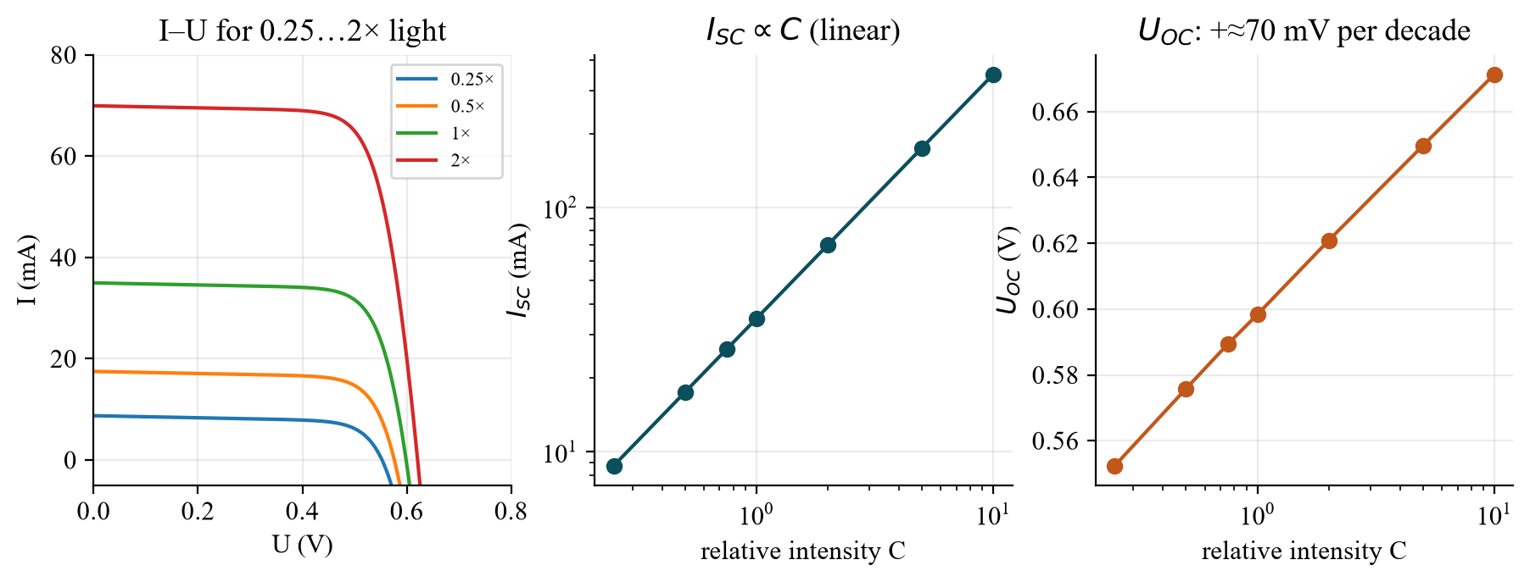
Fig. D – Intensity dependence (model): I_{SC} is proportional to C, U_{OC} grows only logarithmically; hence the efficiency rises slowly with intensity.
C (relative intensity) | I_SC (mA) | U_OC (V) | P_MPP (mW) | FF | η (%)
0.25 | 8.7 | 0.552 | 3.4 | 0.70 | 13.6
0.50 | 17.5 | 0.576 | 7.5 | 0.74 | 15.0
0.75 | 26.2 | 0.589 | 11.6 | 0.75 | 15.5
1.00 | 35.0 | 0.598 | 15.8 | 0.76 | 15.8
2.00 | 69.9 | 0.621 | 32.5 | 0.75 | 16.2

Discussion for V: η rises with intensity (logarithmically, the U_{OC} term), flattens and finally falls at high intensity because the series resistance loss I²R_{S} grows with C² (FF drops, Fig. E left) and the cell heats. At low intensity the shunt resistance R_{P} (leakage) and recombination reduce U_{OC} and FF (right) – so the efficiency is smaller in the weak-light winter months. The LTspice demo reproduces these curves: (see below).
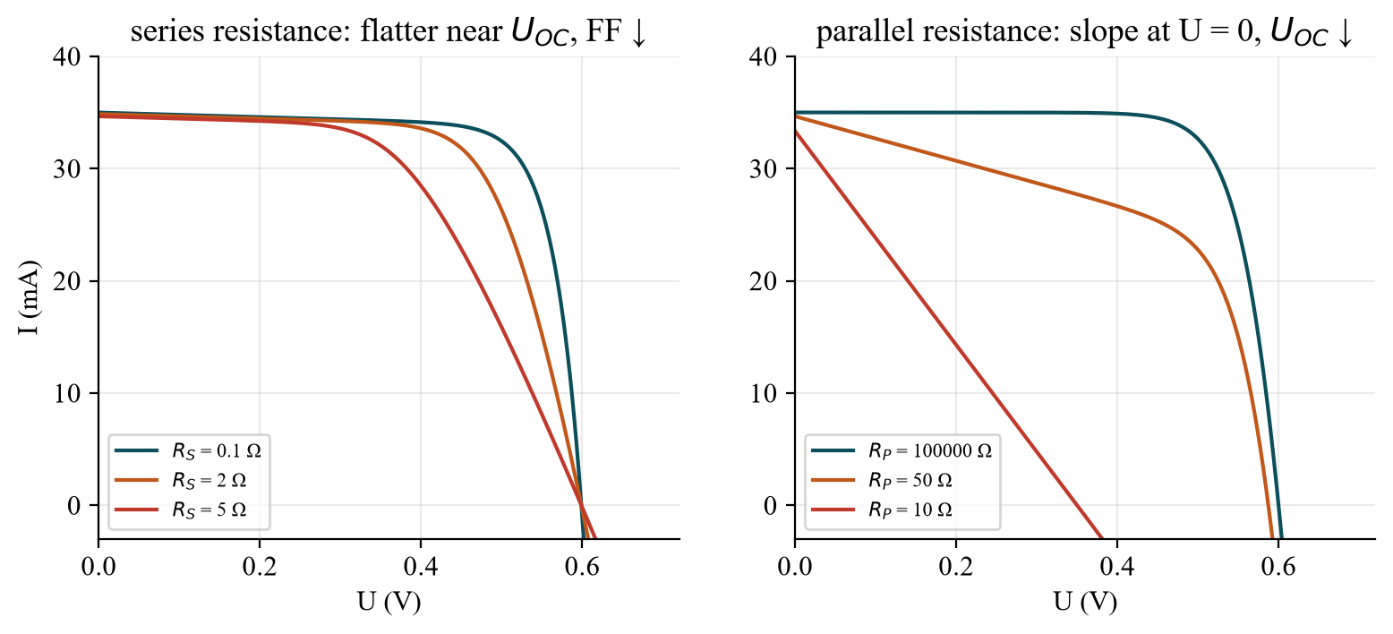
Fig. E – Effect of the series and the parallel resistance on the light curve.
TR η = FF·U_OC·I_SC/P_opt; I_SC ∝ C, U_OC ≈ U_OC(1) + n·U_T·ln C → η yavaşça artar, yüksek şiddette R_S (I²R_S) ve ısınma yüzünden düşer; düşük ışıkta R_P/rekombinasyon U_OC ve FF’yi düşürür.

Task (e) – Solar cells with fan and bypass LEDs
Task (e) (§4/§5): Set up the circuits described in section 4 and investigate the effects of a change in intensity (25 %, 50 %, 75 % and 100 %) on the speed of rotation of the fan and the brightness of the LEDs (bypass diodes). (§4: a solar cell and a light-emitting diode are connected in parallel, whereby the polarity of the components must be observed; the fan is connected in series with this circuit; a second parallel circuit of solar cell and LED is added – Fig. 3-9.)
- Circuit: [solar cell 1 ‖ LED 1] in series with [solar cell 2 ‖ LED 2] in series with the fan. Each LED is connected antiparallel to its cell (polarity!): it conducts only if the cell voltage reverses.
- Equal illumination: both cells deliver current to the fan (≈ I_{SC} ∝ intensity); the LEDs stay dark, the fan speed rises with the intensity (it is driven by the voltage/current available: the fan stands still at low intensity until the current overcomes friction).
- One cell shaded/weaker: in the series connection the weakest cell limits the current. The stronger cell wants to push a larger current than the shaded cell can give – the surplus flows through the bypass diode (LED) of the shaded cell: the LED lights up (brightness ∝ current), the shaded cell is protected from being forced into reverse breakdown/hot spots, and the fan keeps running with a reduced voltage.
- Record: a table with 25/50/75/100 % × (both cells lit / one cell shaded): fan speed (qualitative: stops / slow / medium / fast or counted rpm), LED 1 and 2 brightness, and the measured voltage/current if possible.
Evaluation item VI: summarise the observations in tabular form and discuss the visual impression at the different illuminance levels. Why a bypass diode? Without it a shaded cell in a series string becomes a high-resistance load and is driven in reverse (hot-spot heating, lost power of the whole string); with it the string loses only the voltage of the shaded cell.
TR LED, pile antiparalel bağlı (kutup!); iki pil eşit aydınlanırsa LED’ler yanmaz, fan hızı şiddetle artar. Bir pil gölgelenince seride en zayıf hücre akımı sınırlar; fazla akım bypass-LED’den geçer → LED yanar, fan düşük gerilimle döner.

Evaluation item VII – annual energy yield and cost per kWh
Item VII (§6): Determine the annual energy yield and the cost of a kWh generated with a service life of 20 years and acquisition costs of 4000 EUR/kWp (including all expected maintenance costs) of the measured solar cell: a) by means of a radiation map; b) using a radiation map and Duisburg radiation distribution; c) using the specified parameters from Tarifa (Spain).

Formulas (manual §2.4, eq. 15–17)
E_{Jahr} = ∫ P_{Sonne}(t) · η(t) dt ≈ P_{Jahr} · η (a: constant η at 1000 W/m², eq. 16)
E_{Jahr} = Σ_{i} P_{Jahr} · a_{i} · η(S_{i}) (b, c: η from your intensity series for every irradiance class S_{i}, eq. 17; a_{i} = share of the cumulative energy in the class)
P_{Jahr} (kWh/m² per year) from the radiation map of the appendix: Duisburg lies in the green/yellow-green area of the winter map (≈ 230–240 kWh/m² in October–March) and in the red/orange area of the summer map (≈ 760–770 kWh/m² in April–September) – read the exact colour yourself: P_{Jahr}(Duisburg) ≈ 1000 kWh/m²/a. Tarifa: 654.55 + 1264.67 = 1919.22 kWh/m²/a (given).
Irradiance class S_X | Duisburg winter % | Duisburg summer % | Tarifa winter % | Tarifa summer %
up to 50 W/m² | 28.5 | 16.5 | 11.4 | 8.9
up to 100 W/m² | 27.4 | 13.2 | 9.2 | 6.6
up to 200 W/m² | 24.0 | 18.6 | 14.7 | 9.8
up to 300 W/m² | 11.5 | 13.1 | 12.3 | 8.7
up to 500 W/m² | 7.2 | 18.8 | 22.0 | 15.0
up to 1000 W/m² | 1.4 | 19.8 | 30.4 | 51.0

Use for every class a representative irradiance (e.g. the class mean 25, 75, 150, 250, 400, 750 W/m²) and take η(S) from your intensity series (interpolated; note that your simulator only reaches 300 W/m², so extrapolate carefully for 500–1000 W/m² and say so).

Worked example (η = 15 %, constant – variant a)
Quantity | Value
area for 1 kWp (STC: 1000 W/m²) | A = 1 kW / (1 kW/m² · 0.15) = 6.67 m²
Duisburg: yield per kWp | 0.15 · 1000 kWh/m²/a · 6.67 m² = 1000 kWh/kWp/a
cost per kWh (20 years, 4000 €/kWp) | 4000 € / (20 · 1000 kWh) = 0.20 €/kWh
Tarifa: yield per kWp | 0.15 · 1919 · 6.67 = 1919 kWh/kWp/a
cost per kWh (20 years) | 4000 € / (20 · 1919 kWh) = 0.10 €/kWh

Variant b/c are slightly lower, because η(S) is smaller at low irradiance (the weak-light shares dominate in Duisburg: 56 % of the winter energy comes in classes up to 100 W/m²). Conclusion: the same cell produces ≈ twice the energy in Tarifa and the kWh is about half as expensive – the location (irradiance and its distribution) matters as much as the efficiency. Degradation, inverter and maintenance are not included in the simple numbers (the manual says maintenance is part of the 4000 €/kWp).
TR E_Jahr = P_Jahr·η (sabit η) veya Σ P_Jahr·a_i·η(S_i). Duisburg ≈ 1000 kWh/m²/yıl, Tarifa 1919. 1 kWp = 6,67 m² (η = %15): kWh maliyeti 4000 €/(20·verim) → Duisburg ≈ 0,20 €, Tarifa ≈ 0,10 €.

LTspice – optional: solar-cell model (intensity and series resistance)
The manual does not require a simulation. The one-diode model (photocurrent source I_{ph} = C·35 mA, diode I_{S} = 1.4·10⁻¹⁰ A with n = 1.2, R_{S} = 0.5 Ω, R_{P} = 500 Ω) reproduces Fig. C–E and shows cause and effect: Solarzelle_IU_Intensitaet.asc (C = 0.25 … 1) and Solarzelle_IU_Serienwiderstand.asc (R_{S} = 0.1, 2, 5 Ω) – or 04_LTspice/LTspice_starten.bat. The .meas lines in the log give I_{SC} and P_{max}: C = 0.25/0.5/0.75/1 → I_{SC} = 8.7/17.5/26.2/35.0 mA, P_{max} = 3.4/7.5/11.6/15.8 mW; R_{S} = 0.1/2/5 Ω → P_{max} = 16.2/14.3/11.5 mW.
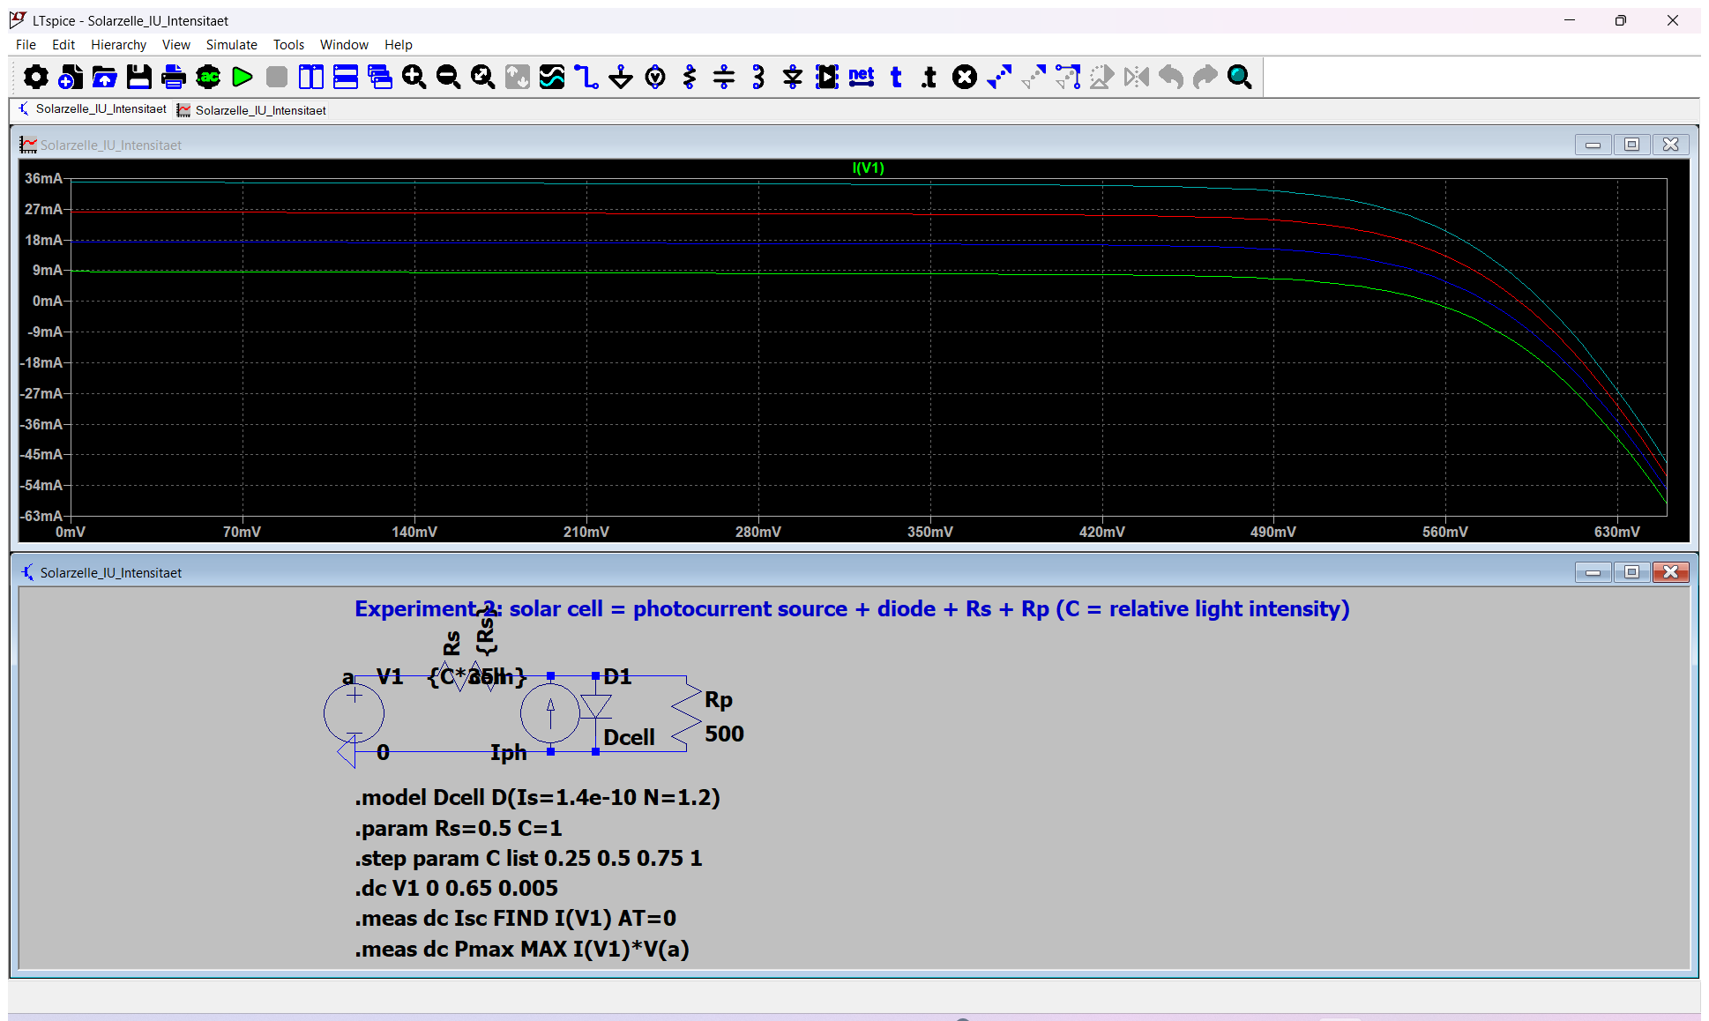
Fig. F – LTspice: four intensities (.step param C list 0.25 0.5 0.75 1).
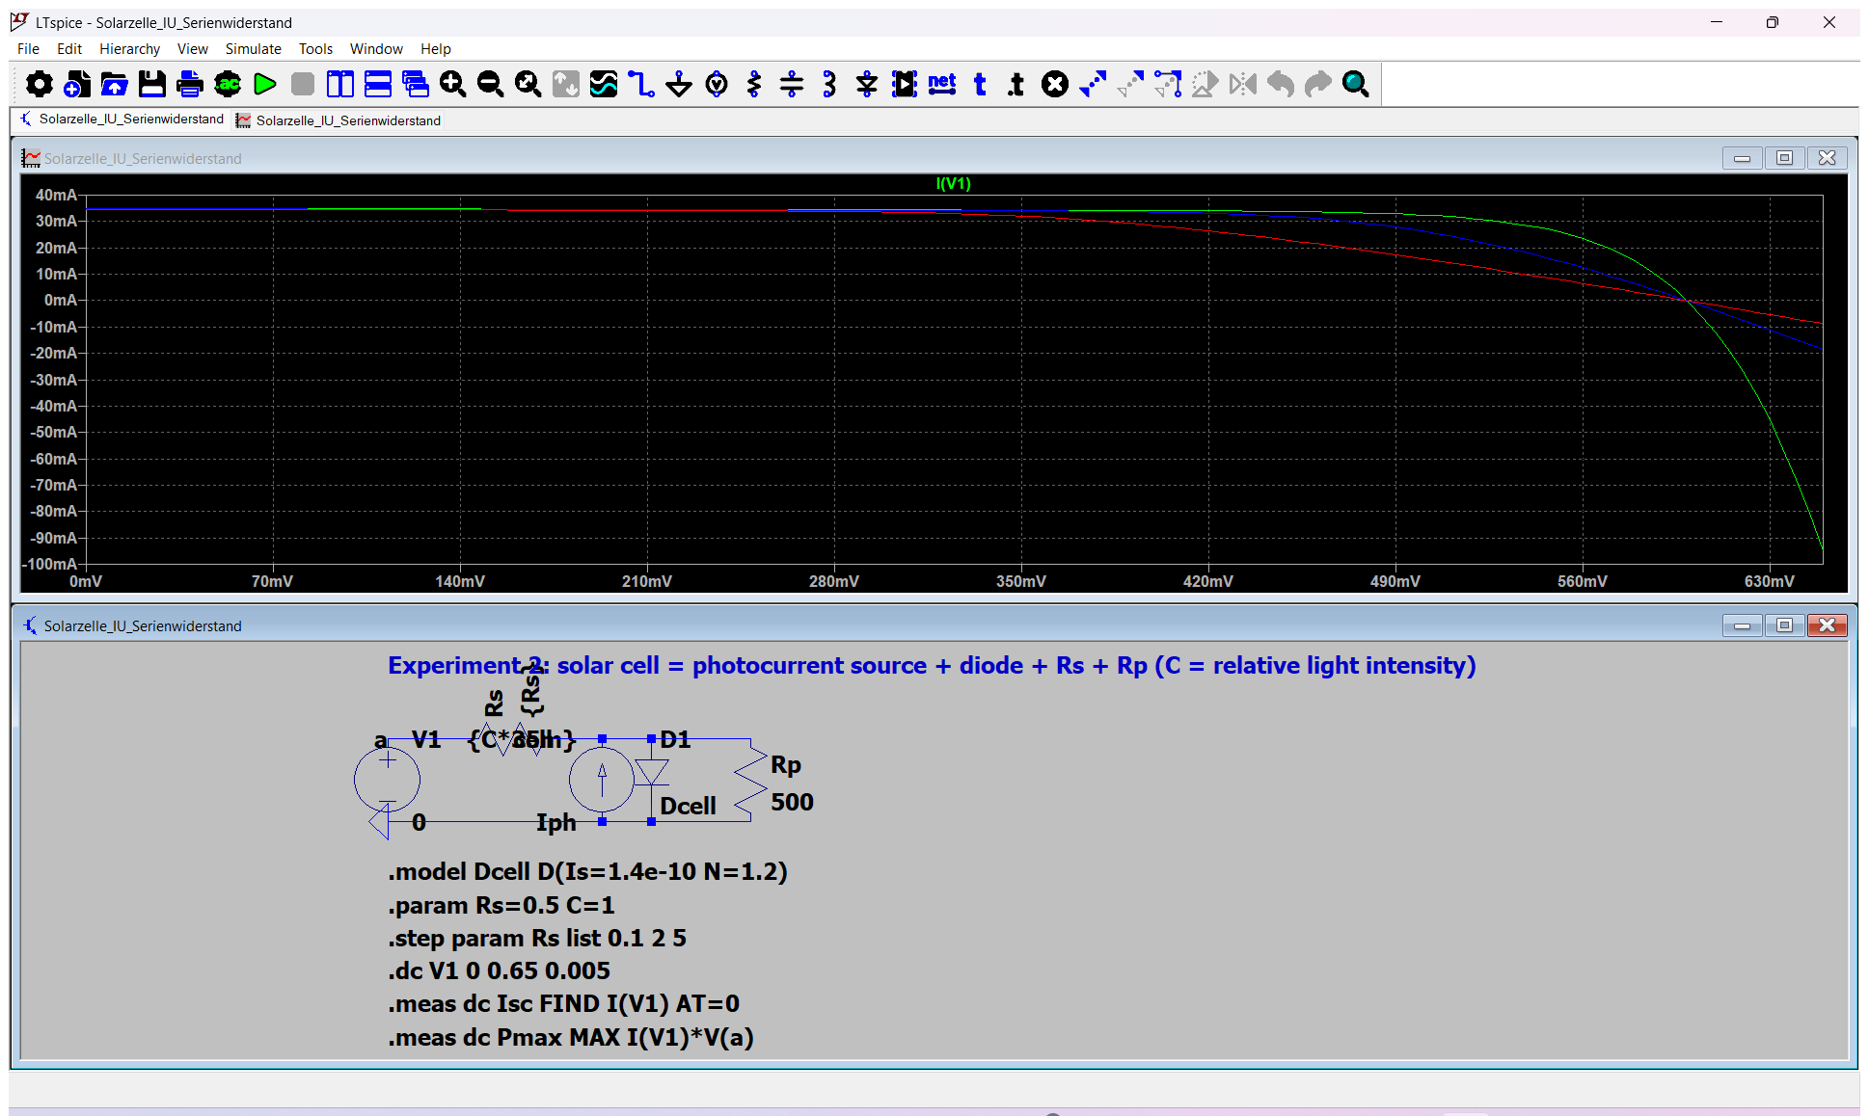
Fig. G – LTspice: series resistance steps (0.1, 2, 5 Ω): the curve rounds off and FF falls.

Antestat – likely questions with short answers
Question | Short answer
How does a solar cell work? | Photons with E ≥ W_{G} create e-h pairs; the pn field separates them → photocurrent; the load turns it into power.
Equivalent circuit? | Current source I_{ph} ∥ diode ∥ R_{P}, in series with R_{S}.
Define I_{SC}, U_{OC}, MPP, FF, η. | I at U = 0; U at I = 0; maximum of U·I; FF = P_{MPP}/(U_{OC}I_{SC}); η = P_{MPP}/P_{opt}.
How do I_{SC} and U_{OC} depend on intensity? | I_{SC} ∝ intensity; U_{OC} ∝ nU_{T} ln(I_{SC}/I_{S}) – logarithmic.
How does temperature change a solar cell? | I_{S} ↑ exponentially → U_{OC} ↓ (≈ −2 mV/K), I_{SC} slightly ↑ (smaller W_{G}), η ↓.
What does R_{S} do? R_{P}? | R_{S} ↑: flatter curve near U_{OC}, FF ↓; R_{P} ↓: slope at U = 0, U_{OC} ↓ at low light, FF ↓.
How do you get the band gap from the dark curves? | I_{S}(T) ∝ exp(−W_{G}/(nkT)): plot ln I_{S} against 1/T, slope = −W_{G}/(nk).
Why does a bad cell have a low fill factor? | Large R_{S}, small R_{P}, recombination (n ≈ 2).
Which loss mechanisms limit η? | Reflection, non-absorption (E < W_{G}), thermalisation, recombination, ohmic losses.
Why is there an optimum band gap? | Small W_{G}: many photons but small U_{OC} and thermalisation loss; large W_{G}: high U_{OC} but few absorbed photons; optimum ≈ 1.1–1.5 eV.
What is AM1.5G / STC? | Reference solar spectrum, 1000 W/m², cell temperature 25 °C; basis of the W_{p} rating.
What is a bypass diode for? | It carries the current of the string around a shaded cell (protects it from reverse stress, hot spots).
Why is the spectrum of the LED simulator a problem? | No infrared, blue peak: different from AM1.5G → spectral mismatch for Si.
How do you estimate the annual yield? | E_{Jahr} = P_{Jahr} · η (or the irradiance-class sum with η(S)); cost = 4000 €/kWp ÷ (20 years × kWh/kWp/a).

Lab-day checklist
- Antestat 14:00, building LT, room LT 227, group 9, 3 February 2027.
- Plan with the supervisor the temperatures (dark) and intensities (bright) so that W_{G} and η(C) can be evaluated (manual note under §5).
- Task order: (a) spectrum → (b) area → (c) dark curves at several T → (d) bright curves at 25/50/75/100 % → (e) fan circuit (observations table).
- Write down for every curve: temperature, intensity setting, sweep range, compliance current, area; save the data (USB stick) as tables U, I.
- Use the Excel template 06_Auswertung/Auswertung_Versuch2.xlsx afterwards (enter data → FF, η, n, I_{S}, W_{G}, yield are computed).
- For the protocol: theory vs. measurement and error analysis for each item I–VII.

