Experiment 2 – Optoelectronic energy conversion
Explanation: goal, principle, procedure and why we need it later

1. The experiment in one sentence
A solar cell is a photodiode in the 4th quadrant: we measure its dark and bright characteristics, determine I_{SC}, U_{OC}, MPP, fill factor and efficiency, the band gap from the temperature dependence, and calculate the annual yield and electricity cost.

2. Goal of the experiment
- Measure the spectrum of the LED sun simulator, compare it with AM1.5G; determine the integrated irradiance.
- Dark curves at several temperatures: I_{S}, n, R_{S}, R_{P}, band gap W_{G}.
- Bright curves at 25–100 % intensity: I_{SC}, U_{OC}, MPP, FF, η and η(intensity).
- Cells with bypass LEDs and a fan: observe the effect of intensity.
- Estimate the annual yield and cost per kWh (Duisburg, Tarifa).

3. Principle – the logic behind it

3.1 From the pn junction to the solar cell
Photons with E ≥ W_{G} create electron-hole pairs; the field of the space-charge zone separates them and produces the photocurrent I_{SC} ∝ irradiance. The dark curve is the diode curve I_{D} = I_{S}(e^{U/(nU_T)} − 1); illuminated: I = I_{SC} − I_{D} (equivalent circuit: current source ∥ diode ∥ R_{P}, in series R_{S}). I_{S} ∝ exp(−W_{G}/(nkT)) rises very fast with temperature – this gives the band gap (ln I_{S} versus 1/T) and the fall of U_{OC} with T (≈ −2 mV/K).

3.2 Characteristic numbers
- I_{SC} (U = 0) = η_{ext}(e/hν)P_{opt} – linear in intensity.
- U_{OC} (I = 0) = nU_{T} ln(I_{SC}/I_{S} + 1) – logarithmic in intensity.
- MPP: maximum of P = U·I; FF = P_{MPP}/(U_{OC} I_{SC}); η = P_{MPP}/P_{opt} = FF·U_{OC}·I_{SC}/P_{opt}.
- R_{S} ↑: curve flatter at U_{OC}, FF ↓. R_{P} ↓: slope at U = 0, U_{OC} ↓ at low light.
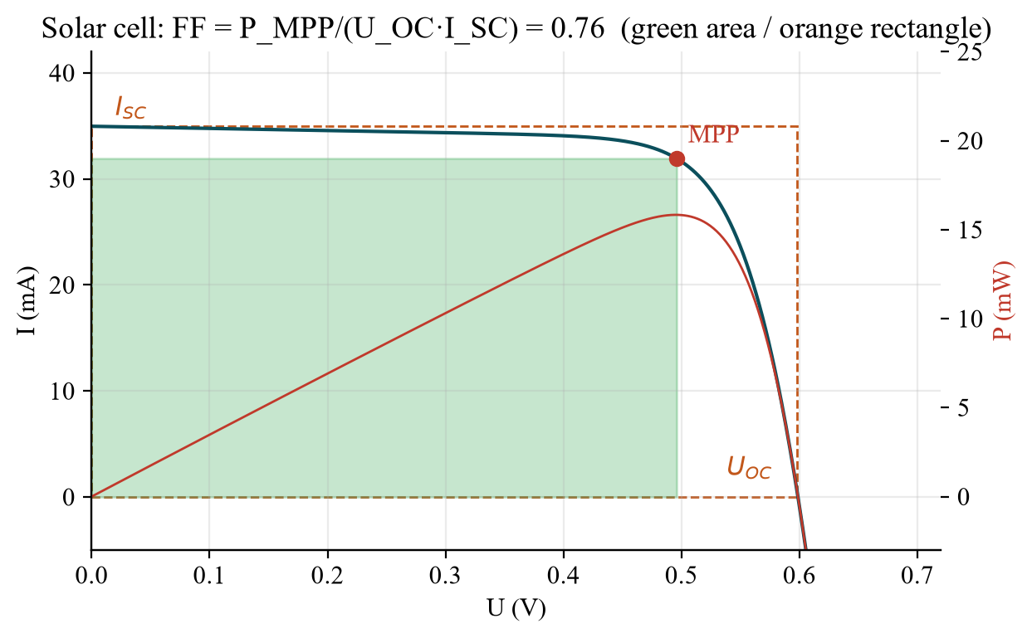
Fig. 1: Bright curve with I_{SC}, U_{OC}, MPP and fill factor (model).

3.3 Intensity, temperature, losses
At C-fold intensity I_{SC} → C·I_{SC} and U_{OC} → U_{OC} + nU_{T} ln C (≈ +70 mV per decade); the efficiency therefore rises slowly with intensity (η(C)/η(1) ≈ 1 + nU_{T} ln C/U_{OC}) and falls at very high intensity through I²R_{S} losses and heating. Losses: reflection, non-absorption (E < W_{G}), thermalisation (E > W_{G}), recombination, R_{S}/R_{P}. This gives the optimum band gap ≈ 1.1–1.5 eV (Si 1.12 eV). The LED spectrum of the simulator has almost no infrared (spectral mismatch to AM1.5G).
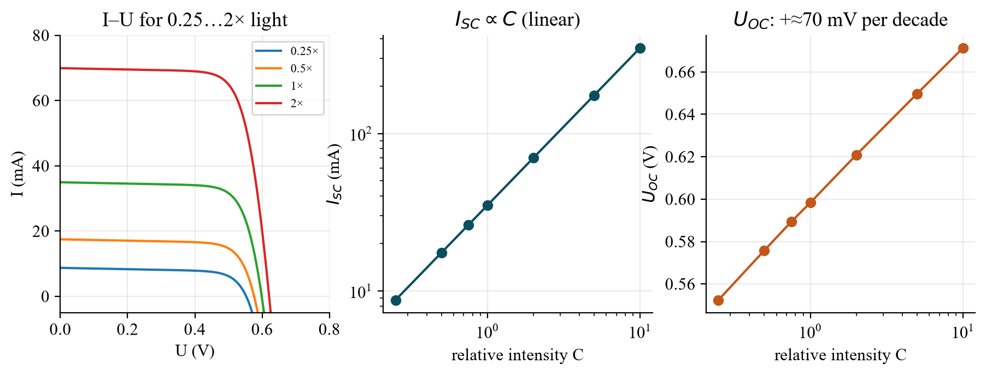
Fig. 2: Intensity dependence (model).
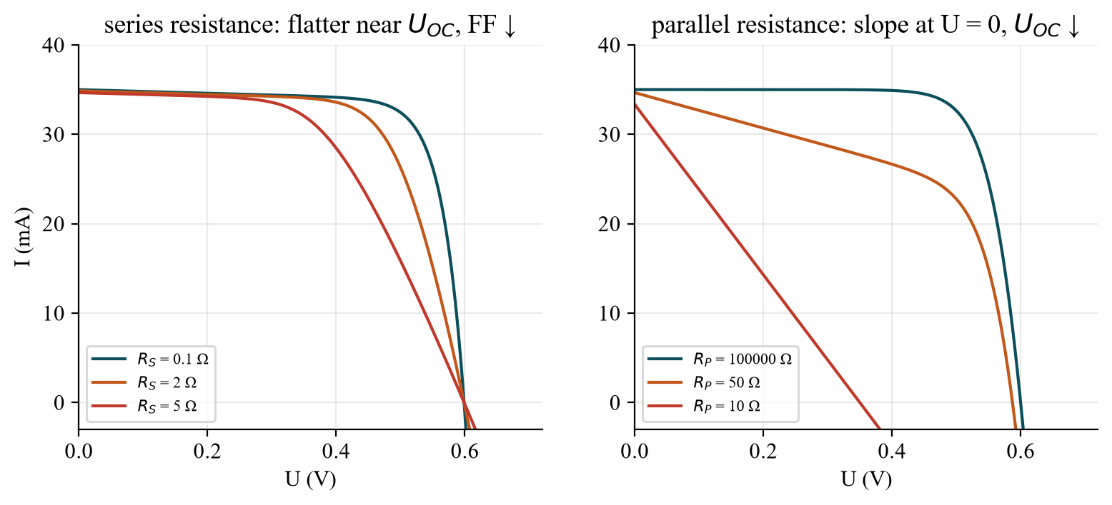
Fig. 3: Effect of R_{S} and R_{P}.

3.4 Annual yield and cost
E_{year} = P_{year} · η (constant at 1000 W/m²) or Σ P_{year} · a_{i} · η(S_{i}) (irradiance classes). Duisburg ≈ 1000 kWh/m²/a, Tarifa 1919 kWh/m²/a. Example η = 15 %: 1 kWp = 6.67 m² → Duisburg ≈ 1000 kWh/kWp/a → at 4000 €/kWp and 20 years ≈ 0.20 €/kWh; Tarifa ≈ 0.10 €/kWh.

4. Procedure step by step
Task | What to do? | Evaluation
(a) | Spectrometer (getSpec-3648, 360–1100 nm): spectrum of the simulator in µW/(cm²·nm) | E = ∫E_{λ}dλ; compare with AM1.5G
(b) | Measure the cell area | P_{opt} = E·A
(c) | Dark curves at ≥ 4 temperatures (Keithley B2901A) | I_{S}, n, R_{S}, R_{P}; ln I_{S}(1/T) → W_{G}
(d) | Bright curves at 25/50/75/100 % | I_{SC}, U_{OC}, MPP, FF, η; η(intensity)
(e) | Cell ∥ LED (antiparallel), two strings in series with the fan; intensity 25–100 % | Table: fan speed, LED brightness

Evaluation (§6 I–VII) and Excel template: 06_Auswertung/Auswertung_Versuch2.xlsx. Optional LTspice demos: Solarzelle_IU_Intensitaet.asc, Solarzelle_IU_Serienwiderstand.asc.

5. What to watch in the lab
- Plan (c) and (d) with the supervisor so that W_{G} and η(intensity) can be determined reliably.
- The cell heats up under light – let it cool after each run, note the temperature.
- Note the area (with/without contact fingers) and the simulator setting (PWM) for every curve.
- Polarity of the bypass LED (antiparallel to the cell!).
- Save the data as a U, I table (USB stick) – the Excel template calculates everything.

6. Why do we need this later?
- Experiment 1: the photodiode in the 4th quadrant is the solar cell; short-circuit current ∝ light.
- Experiment 4: LED and solar cell are “the same device in the opposite direction”; the band gap governs both.
- Experiments 3/5/6: the same diode equation, the same temperature dependence (I_{S}, U shift).
- Practice: photovoltaics, energy transition, sensing, space; economics = efficiency × location.

7. Typical questions – short answers
Question | Short answer
How does a solar cell work? | E ≥ W_{G} → pairs; the field of the space-charge zone separates them → photocurrent.
I-V equation? | I = I_{SC} − I_{S}(e^{U/(nU_T)} − 1) (with R_{S}, R_{P}).
FF and η? | FF = P_{MPP}/(U_{OC} I_{SC}); η = P_{MPP}/P_{opt}.
Intensity dependence? | I_{SC} linear; U_{OC} logarithmic; η rises slowly.
Temperature dependence? | I_{S} ↑ exponentially → U_{OC} ↓ (≈ −2 mV/K), η ↓.
Determine the band gap? | ln I_{S} versus 1/T: slope = −W_{G}/(nk).
R_{S} and R_{P}? | R_{S} ↑: FF ↓; R_{P} ↓: leakage, U_{OC} ↓.
Loss mechanisms? | Reflection, non-absorption, thermalisation, recombination, ohmic losses.
Optimum band gap? | ≈ 1.1–1.5 eV: compromise between photon number and voltage.
AM1.5G / STC? | Reference spectrum, 1000 W/m², 25 °C.
Bypass diode? | Carries the string current around a shaded cell.
Annual yield and cost per kWh? | E = P_{year}·η; cost = 4000 €/kWp ÷ (20 a · kWh/kWp/a).

Date: 3 Feb 2027, pre-test (Antestat) 14:00, building LT, room LT 227 (group 9).

