Experiment 5 – Laser diodes
Preparation: questions, tasks and measurement plan with worked answers
Name, Group: Beyza Kararti, Saifeldin Ayman Elmoselhy Elnkep – Group 9 Date: 02.12.2026 (Antestat 14:00, building BC, room BC 119)
Quoted from the lab manual Optoelectronic lab, Experiment 5: Laser diodes (e_poe_exp5.pdf): one calculation question (§1.1) and three measurement tasks (§3). The tasks are quoted in shaded boxes with a teal bar; the answers and the measurement plan follow. Each answer ends with a short Turkish summary (TR).

0. Background in one page
- Laser = LED + gain + resonator. Forward current pumps electrons into the conduction band (population inversion); photons stimulate further recombination with the same energy, phase and direction (stimulated emission).
- Resonator: the cleaved crystal facets are the mirrors (Fabry-Perot). GaAs/air: R = 31 % – weak mirrors, so high gain (= high current density) is needed.
- Structure: double heterostructure / separate-confinement heterostructure with a quantum well; the waveguide guides the light; confinement factor Γ = fraction of the light power in the active layer.
- Threshold: gain = losses, g_{th} = α₀ + (1/2L) ln(1/R₁R₂). Below: spontaneous emission (LED-like), above: P = ½·η_{i}η_{e}(hν/q)(I − I_{th}).
- Temperature: I_{th}(T) = I_{th,0} e^{T/T0} (T₀ = 50…200 °C); the slope falls, the wavelength rises ≈ 0.2–0.3 nm/K (gain peak), modes hop.
- Spectrum: longitudinal modes Δν = c/(2nL), Δλ = λ²/(2nL); only the few modes near the gain maximum lase.
- Beam: strongly divergent and elliptical: Θ = λ/(πd); thin direction (≈ 1 µm) diffracts most (≈ 90° vs. ≈ 15° quoted by the manual). Near field = image of the facet, far field = its Fourier transform.
- Safety: 660 nm, up to 2.5 mW – never look into the beam, use gray filters before detectors and the camera, protect the spectrometer CCD.

Question – reflection at the GaAs/air facet
Question (manual §1.1, p. 1): How high is the reflection for the GaAs (n = 3.5) – air (n = 1) interface?
Normal incidence, equation (1) of the manual (derived in Experiment 4, Task 1):
R = ((n_{HL} − n_{Luft})/(n_{HL} + n_{Luft}))² = (2.5/4.5)² = 0.309 ≈ 31 %
Consequence – why a laser diode needs a high current density: with R₁ = R₂ = R the mirror loss is α_{m} = (1/L) ln(1/R) = ln(3.24)/L = 1.175/L. For a cavity of L = 300 µm this is α_{m} ≈ 39 cm⁻¹ – much more than for conventional laser mirrors (R ≈ 99 %) – so the gain, and therefore the current density, must be high. The same 31 % also means that 69 % of the light is transmitted (this is the output coupling, η_{e} is the fraction of generated photons that leave).
TR R = ((3,5−1)/(3,5+1))² = 0,31. Aynalar zayıf (%31) olduğundan kayıp büyük → kazanç (yani akım yoğunluğu) yüksek olmalı: L = 300 µm için α_m ≈ 39 cm⁻¹.

Theory you must be able to derive (Antestat)

Threshold condition (manual eq. 2–3)
In one round trip the field gains e^{gL} per pass and loses e^{−α0 L} and the mirror factors R₁, R₂: the threshold is reached when the round-trip amplification equals one:
R₁ R₂ · e^{2(g − α0)L} = 1 ⇒ g_{th} = α₀ + (1/2L) · ln(1/(R₁R₂))
In a diode only the fraction Γ of the light sees the gain: Γ·g_{th} = α₀ + (1/2L) ln(1/R₁R₂) (eq. 3). The gain is proportional to the inversion N₂ − N₁ and, in steady state, the inversion is fed by the current density j (eq. 4–6), giving
j_{th} = (8π q d τ ν² n² / (c² g(ν))) · (1/Γ) · [ α₀ + (1/L) ln(1/R) ] (eq. 7, qualitatively)
What lowers j_{th} (manual §1.3.1) | Why
long wavelength | the factor ν² (first fraction) is small
thin active layer d (quantum well) | fewer carriers are needed per unit area to reach inversion
high confinement factor Γ (ideal 1) | all of the light sees the gain
long resonator, high reflectivity | smaller mirror loss (1/L) ln(1/R) – but the cavity must be ≥ ≈ 100 µm

The measured quantity is the threshold current I_{th} = j_{th} · (area of the active zone).

P-I curve above threshold (eq. 9–10)
P = ½ · η_{i} · η_{e} · (hν/q) · (I − I_{th}) dP/dI = ½ η_{i}η_{e} hν/q = η_{d} · hν/q
The factor ½ appears because only one of two identical mirrors is used for output; hν/q is the energy per photon in eV (660 nm → 1240/660 = 1.88 V). The differential quantum efficiency η_{d} = η_{i}η_{e} is read from the slope: η_{d} = (dP/dI) · q/(hν) = (dP/dI [mW/mA]) / 1.88 V.
TR Eşik: tur başına kazanç = kayıp → g_th = α0 + (1/2L)ln(1/R1R2). Eşik üstü: P = ½η_iη_e(hν/q)(I−I_th); eğimden η_d = (dP/dI)/1,88 V (660 nm).

Task 1 – P-I curves at 20, 30, 40 °C
Task 1 (manual §3): Record the P-I characteristic curves for T = 20 °C, T = 30 °C and T = 40 °C. Determine the threshold current I_{th} and the gradient dP/dI for the respective temperatures and from this the differential quantum efficiency. Determine the values for T₀ and I_{th,0} from your measurements (see Eq. 8).
Procedure (laser diode controller, constant-current mode): turn the current knob F9 fully to the left → press F24 until F22 lights (constant current) → press F17/F18 until the ILD diode (F13) lights → switch on with F8 → raise the current slowly with F9. Laser operation starts at ≈ 20 mA; F17/F18 toggles the display between current and output power. Set the temperature in the software by choosing the sensor resistance (kΩ, from the calibration curve) and wait until the actual temperature is stable before every curve.
Measurement plan: current steps of 1 mA from 10 mA up to the point where P reaches the 2.5 mW limit (≈ 24–26 mA); finer steps (0.5 mA) around the knee; use the gray filters in front of the power meter if it saturates; same current grid for all three temperatures.
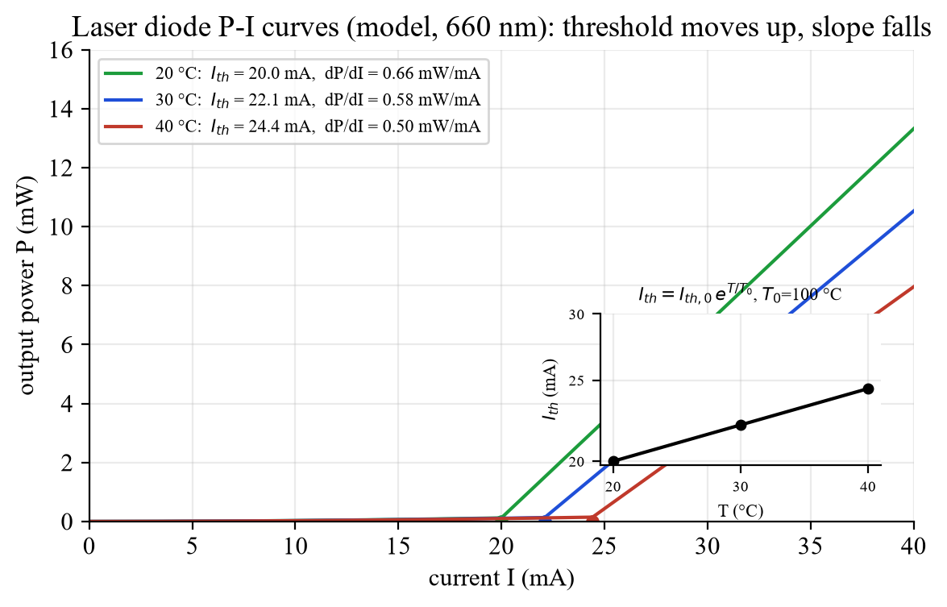
Fig. A – Model P-I curves (same model as the LTspice demo below; in the lab you stop at 2.5 mW). Inset: ln I_{th} is linear in T.
Evaluation (per temperature):
- Fit a straight line P = m·I + b through the points clearly above threshold (e.g. 1.1–1.5 · I_{th}).
- I_{th} = −b/m (zero crossing of the extrapolated line). Cross-check with the position of the kink; state which definition you use.
- dP/dI = m, then η_{d} = m·q/(hν) = m [mW/mA] / 1.88 V (for 660 nm).
- For T₀ and I_{th,0}: take ln I_{th} versus T (°C) – Eq. (8) is a straight line: ln I_{th} = ln I_{th,0} + T/T₀. T₀ = ΔT / ln(I_{th,2}/I_{th,1}) (or the inverse slope of the fit) and I_{th,0} = I_{th} · e^{−T/T0}.
T (°C) | I_th (mA) | dP/dI (mW/mA) | η_d = (dP/dI)/1.88 V
20 | 20.0 | 0.66 | 0.35
30 | 22.1 | 0.58 | 0.31
40 | 24.4 | 0.50 | 0.27

Worked example with the model numbers: T₀ = 20 °C / ln(24.4/20.0) = 20/0.199 = 100 °C, I_{th,0} = 20.0 mA · e^{−0.2} = 16.4 mA. (Real devices: T₀ = 50…200 °C; the higher T₀, the less temperature-sensitive the laser.)
Why does I_{th} rise and the slope fall with T? non-radiative processes (phonon scattering, Auger recombination) grow, the gain profile broadens and shifts, so more current is needed for the same gain and fewer injected carriers become photons (η_{d} falls).
Expected vs. reality / errors: temperature not yet stable or not the one indicated (calibration curve!), the “threshold” is not sharp (spontaneous background; use the extrapolation), power-meter calibration and gray-filter factors, current display resolution, device heating during the sweep (sweep quickly but wait at each point), only three temperatures → T₀ has a large error bar.
TR Her sıcaklıkta eşik üstü doğruya P = m·I + b uydur: I_th = −b/m, dP/dI = m, η_d = m/(1,88 V). ln I_th – T doğrusundan T0 = ΔT/ln(I_th2/I_th1) ve I_th,0 = I_th·e^(−T/T0). Sıcaklık tam oturmadan ölçme!

Task 2 – Spectra below and above threshold
Task 2 (manual §3): Record spectra below (e.g. I = 15 mA) and above the laser threshold (e.g. I = 25 mA) for the temperature range between T = 20 °C and T = 40 °C in 5 °C steps. Display the respective spectra (if possible in a diagram) and discuss the observed changes. For the spectra above the threshold, also show the dependence of the wavelength on the temperature (diagram) and determine dλ/dT.
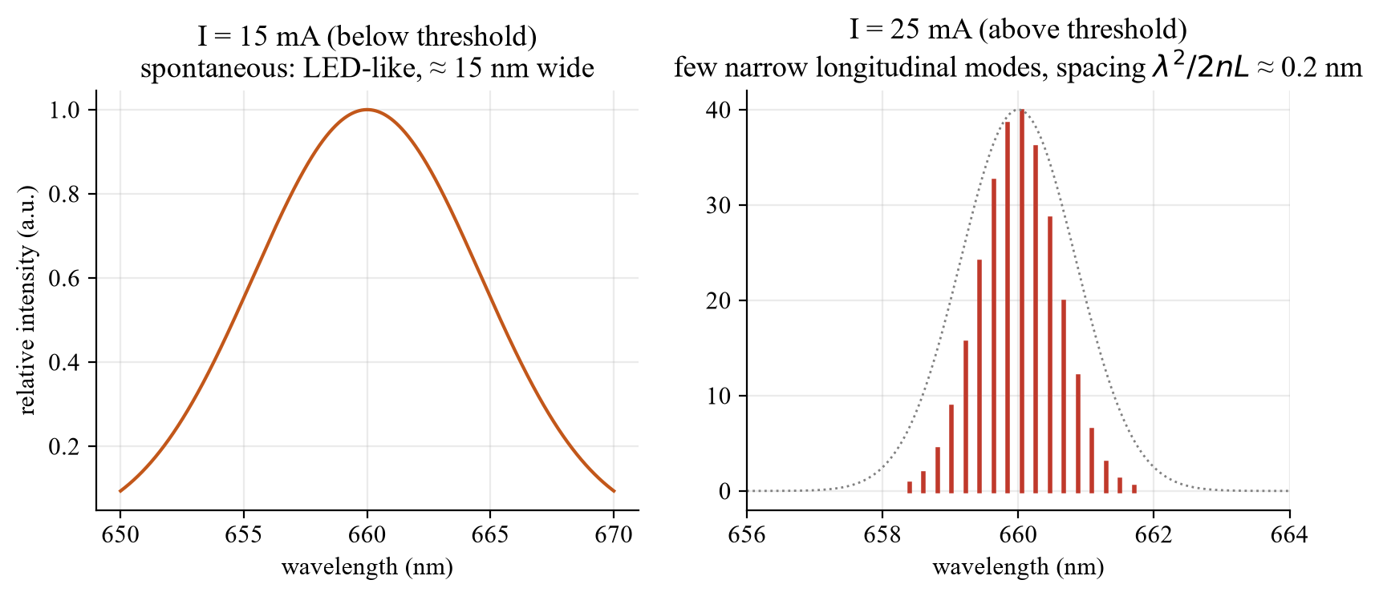
Fig. B – Expected spectra: below threshold broad and LED-like, above threshold a few narrow longitudinal modes (L = 300 µm, n = 3.5 → Δλ = 0.21 nm).
- Below threshold (15 mA): spontaneous emission, broad band (≈ 10–20 nm), low power. With T it shifts to longer wavelength (W_{G} falls) and gets slightly broader.
- Above threshold (25 mA): stimulated emission – the spectrum collapses to one to several narrow modes with spacing Δλ = λ²/(2nL) (L = 300 µm, n = 3.5, λ = 660 nm → 0.21 nm; Δν = c/2nL = 143 GHz). Only modes near the gain maximum exceed threshold.
- Watch out: at 40 °C the threshold (≈ 24.4 mA in the model) comes close to 25 mA – the laser may barely lase or even stay below threshold. Check the power display for every temperature and increase the current if necessary; otherwise the spectrum at 40 °C is not “above threshold”.
- Spectrometer: the maximum of the spectrum must not reach the full count for long – shorten the integration time or use gray filters; subtract the dark spectrum; note the resolution (it limits the narrowest mode you can see).
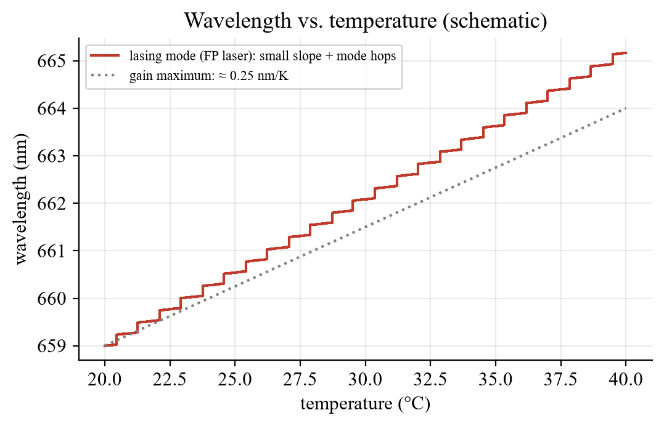
Fig. C – Peak wavelength vs. temperature: slope of the gain maximum ≈ 0.25 nm/K, the lasing mode follows in steps (mode hops).
dλ/dT: plot the peak wavelength of the strongest mode (above threshold) versus T and take the slope of the straight line through the points (not through the individual steps). Expected order of magnitude 0.2–0.3 nm/K (band gap shrinkage shifts the gain maximum; the mode positions λ_{m} = 2nL/m move only with n(T)·L(T), ≈ 0.06 nm/K, so the lasing mode jumps to the next mode when the gain maximum has moved by one mode spacing – mode hops). 20 K → ≈ 5 nm.
Discussion points: why the spectrum narrows (gain/loss balance; only modes with net gain survive); why the width of the spontaneous spectrum is much larger than the mode spacing; why the wavelength rises with T (W_{G} ↓, refractive index ↑, cavity expands); why a current increase also shifts the spectrum (ohmic heating ∝ I², plus carrier-density dependence of n).
TR Eşik altı: geniş (≈10–20 nm) LED benzeri spektrum; eşik üstü: Δλ = λ²/(2nL) ≈ 0,21 nm aralıklı birkaç dar mod. 40 °C’de eşik ≈ 25 mA’ye yaklaşır – güç göstergesini kontrol et! dλ/dT ≈ 0,2–0,3 nm/K (kazanç tepesi), mod atlamaları olur.

Task 3 – Near field and far field
Task 3 (manual §3): Use the microscope objective to take a picture of the near field with the camera. Start with low currents (below the laser threshold) and carefully increase the current until laser operation begins. Always attenuate the light appropriately using gray filters. After taking the near-field image, bring the additional far-field lens into the beam path and take the far-field image. Bring a millimeter grid into the beam path in the near field and image it on the CCD … Estimate the width of the near field using the known grid (d_{square} = 1 mm) and then calculate the width of the laser facet. To do this, the distance between the intermediate image plane and the microscope objective must be measured and be included in the calculation together with the focal length of the microscope objective of f = 6 mm. Describe the resulting far field qualitatively and explain any differences from the near field.
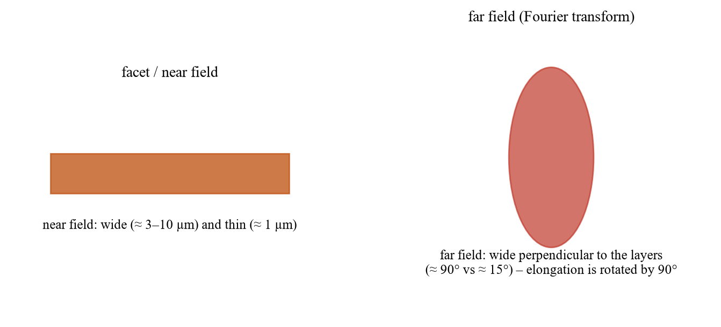
Fig. D – Near field (facet image) and far field (Fourier transform): the elongations are perpendicular to each other.
Facet width from the near-field image (microscope = objective + imaging lens). The objective (f = 6 mm) forms a magnified real intermediate image of the facet at distance b from the objective. With the lens equation 1/s + 1/b = 1/f the magnification is
M = b/s = b/f − 1
The millimetre grid (1 mm squares) sits in the intermediate image plane and is seen by the camera together with the near field, so it gives the scale there: if the near field covers x grid squares (x·1 mm) in the intermediate image,
w_{facet} = (x · 1 mm) / M = x · 1 mm / (b/f − 1)
Example: b = 160 mm → M = 160/6 − 1 = 25.7; a near field 0.06 mm wide in the intermediate plane → w = 0.06 mm/25.7 = 2.3 µm (a typical single-mode stripe; broad-area lasers: ≈ 100 µm). Measure b as exactly as possible; an error of 5 mm changes M by 3 %.
Qualitative expectations:
- Below threshold: a weak, broad, rather homogeneous glow (spontaneous emission, LED-like); above threshold: a bright, narrow stripe at the stripe waveguide – the light is concentrated in the guided mode.
- Near field: very small and elongated (wide laterally, ≈ 1 µm thin vertically). Far field: elliptical beam; the far field is the Fourier transform of the near field – the thin direction (waveguide d ≈ 1 µm) diffracts strongly (Θ = λ/(πd), vertical typically ≈ 90° according to the manual), the wide lateral direction little (≈ 15°) – the ellipse is rotated by 90° compared with the near field.
- Where the far field begins: at distances of the order of w²/λ from the facet (the manual quotes a multiple of it, ≈ 20 w²/λ): for w = 3 µm, λ = 660 nm that is ≈ 14 µm (×20 ≈ 0.3 mm) – small compared with the set-up, so the far-field lens image really shows angles.
- The far-field lens moves the virtual image to infinity (the camera records angles instead of positions); fringes can appear from the facet/window reflections.
Errors: overexposure of the camera (always use gray filters), focus, grid not exactly in the intermediate plane, pixel calibration, estimating the edge of a Gaussian-like near field (use FWHM and say so).
TR Mikroskop: M = b/f − 1 (f = 6 mm, b = ara görüntü düzlemi–objektif mesafesi). Izgara (1 mm kareler) ölçek verir: w_facet = (x·1 mm)/M. Yakın alan ince ve uzun, uzak alan eliptik ve 90° dönmüş (kırınım Θ = λ/(πd)); gri filtre şart.

LTspice – optional: P-I curve vs. temperature
The manual does not require a simulation. To see the cause-and-effect relations of Task 1, a behavioural model was built (V(in) = current in mA, V(P) = output power in mW): P = η(T)·(I − I_{th}(T)) above threshold, I_{th} = I_{th,0} e^{T/T0} with I_{th,0} = 16.37 mA, T₀ = 100 °C, slope 0.66 mW/mA at 20 °C falling by 1.2 %/K. Model parameters are illustrative; the sweep to 40 mA only shows the shape – the real diode is limited to 2.5 mW.
File: Laserdiode_PI_Temperatur.asc (or 04_LTspice/LTspice_starten.bat).
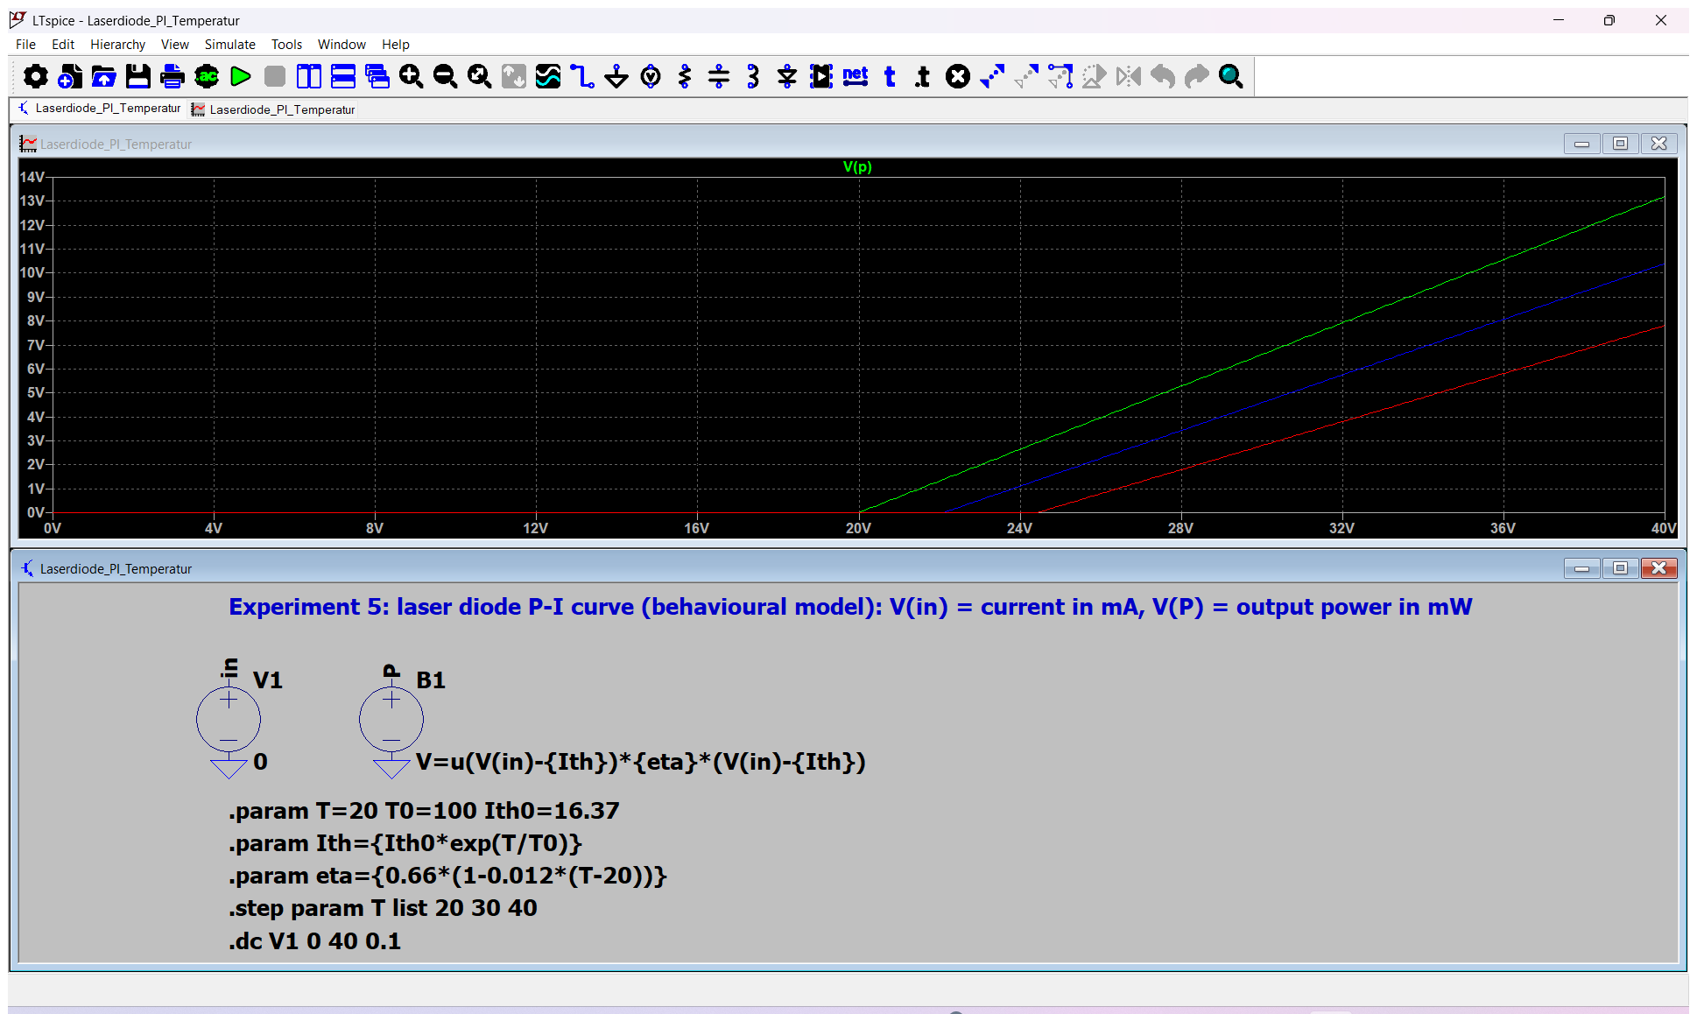
Fig. E – LTspice: .step param T list 20 30 40; green 20 °C, blue 30 °C, red 40 °C (threshold 20.0 / 22.1 / 24.4 mA).

Antestat – likely questions with short answers
Question | Short answer
What is the difference between an LED and a laser diode? | The laser has population inversion and a resonator: stimulated emission dominates above the threshold – narrow spectrum, directed, coherent light, linear P-I curve.
What is population inversion and how is it made in a diode? | More electrons in the conduction band than in the valence band at the same energy; by injecting carriers with a forward current into a heavily doped pn junction (double heterostructure).
Why are the facets enough as mirrors? | Refractive index n = 3.5 → R = 31 %. Weak, so the gain must be high – the threshold current density is high.
Give the threshold condition. | Round-trip gain = loss: g_{th} = α₀ + (1/2L) ln(1/R₁R₂) (with Γ in a diode).
What lowers the threshold? | Thin active layer/quantum well, high confinement Γ, long wavelength, long resonator, high reflectivity, low temperature.
What does the P-I curve look like and what do you read from it? | Flat (spontaneous) below I_{th}, linear above; I_{th} from the extrapolation, slope = η_{d}·hν/q.
What is the differential quantum efficiency? | η_{d} = η_{i}η_{e} = photons out per injected electron above threshold = (dP/dI)·q/(hν).
What is T₀? | Characteristic temperature in I_{th} = I_{th,0}e^{T/T0}; large T₀ = small temperature sensitivity (50–200 °C).
How does the wavelength change with T and why? | Rises ≈ 0.2–0.3 nm/K: band gap shrinks (gain maximum), refractive index rises; mode hops occur.
How far apart are the longitudinal modes? | Δλ = λ²/(2nL) (Δν = c/2nL): L = 300 µm, n = 3.5, 660 nm → 0.21 nm.
Why is the beam elliptical? | Thin waveguide (≈ 1 µm) → strong diffraction vertically (≈ 90°), wide stripe → weak laterally (≈ 15°): Θ = λ/(πd).
Near field vs. far field? | Near field = image of the facet; far field = its Fourier transform, so the elongation is rotated by 90°.
Safety? | Never look into the beam (up to 2.5 mW already damages the retina), gray filters before camera/detectors, protect the spectrometer CCD, drive with constant current and increase slowly.
Why does the spectrum narrow above threshold? | Gain exceeds loss only for modes near the gain maximum; stimulated emission amplifies them preferentially.

Lab-day checklist
- Antestat 14:00, building BC, room BC 119, group 9, 2 December 2026; bring this preparation, the manual, calculator, USB stick for spectra/images.
- Laser: current knob fully left → constant-current mode → ILD → on → raise slowly; stop at 2.5 mW; wear the protection required by the supervisor; keep the gray filters in the beam.
- Temperature: set the sensor resistance from the calibration curve, wait until stable (check TACT/actual temperature) before each curve and spectrum.
- Same current grid for the three P-I curves; finer steps at the knee; write down the filter factors.
- Spectra: 20–40 °C in 5 °C steps at 15 mA and 25 mA (check lasing at 40 °C!), dark spectrum, integration time.
- Camera: near field below/above threshold, grid image, measure b (intermediate image plane ↔ objective), then the far field with the extra lens.
- For the protocol: expectation from theory, result, error analysis for each of the three tasks.

