Experiment 5 – Laser diodes
Explanation: goal, principle, procedure and why we need it later

1. The experiment in one sentence
A laser diode is an LED with a resonator: we measure the current (threshold) above which spontaneous LED light turns into amplified, narrow-band laser light, how this depends on temperature, and what the beam looks like (near and far field).

2. Goal of the experiment
- Record P-I curves at 20, 30, 40 °C; determine the threshold current I_{th}, the slope dP/dI and the differential quantum efficiency.
- Determine T₀ and I_{th,0} from I_{th}(T).
- Record spectra below and above threshold (20–40 °C) and determine dλ/dT.
- Take near- and far-field pictures with the camera, estimate the facet width and explain the differences.

3. Principle – the logic behind it

3.1 From LED to laser
In a laser diode the pn junction is pumped so strongly in forward direction that there are more electrons in the conduction band than in the valence band (at the same energy) – population inversion. Existing photons then trigger further recombinations with the same energy, phase and direction (stimulated emission). The cleaved crystal facets form a Fabry-Perot resonator; with n ≈ 3.5 they reflect only R = ((3.5−1)/(3.5+1))² = 31 % – the losses are high, hence the high threshold current density.

3.2 Structure and threshold
As for the LED a double heterostructure is used (today mostly a quantum well with a separate-confinement waveguide, SCH); the waveguide guides the light in the active zone (confinement factor Γ ≤ 1). Threshold: gain = losses, g_{th} = α₀ + (1/2L) ln(1/R₁R₂). Low threshold current density: thin active layer, high Γ, long wavelength, long resonator (≥ ≈ 100 µm), high reflectivity.

3.3 The P-I curve
Below I_{th} spontaneous emission dominates (LED-like, little power); above it the power rises linearly: P = ½ η_{i} η_{e} (hν/q)(I − I_{th}). The slope gives the differential quantum efficiency η_{d} = (dP/dI)·q/(hν) (660 nm: hν/q = 1.88 V). With temperature the threshold current rises, I_{th} = I_{th,0} e^{T/T0}, and the slope falls: non-radiative processes (phonon scattering, Auger) increase. A large T₀ (50–200 °C) means low temperature sensitivity.
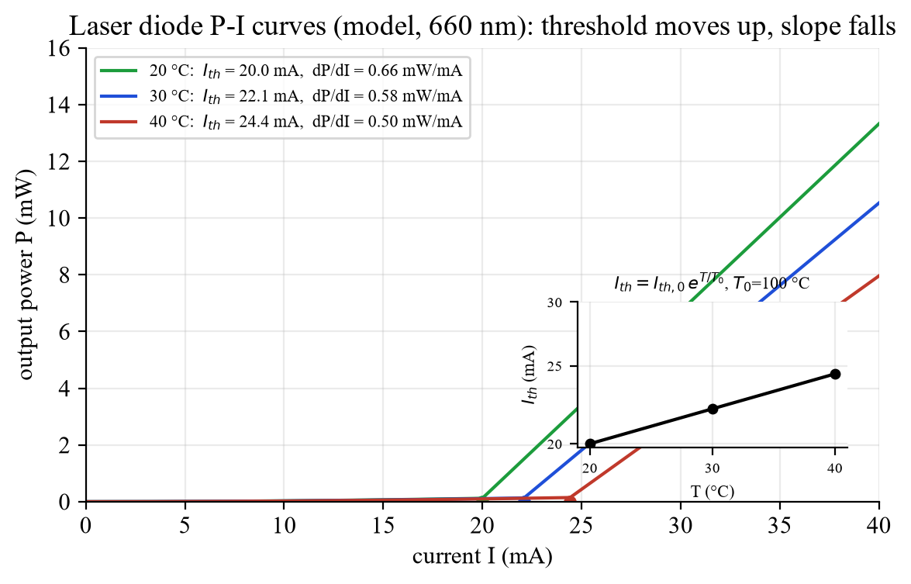
Fig. 1: P-I curves (model): the threshold moves up, the slope falls.

3.4 Spectrum and wavelength
Below threshold: broad spectrum (≈ 10–20 nm). Above: a few narrow longitudinal modes spaced by Δλ = λ²/(2nL) (≈ 0.2 nm for L = 300 µm). With rising temperature the gain maximum (band gap ↓) moves ≈ 0.2–0.3 nm/K towards red, the modes only ≈ 0.06 nm/K – hence mode hops. Current → heating → similar effect.
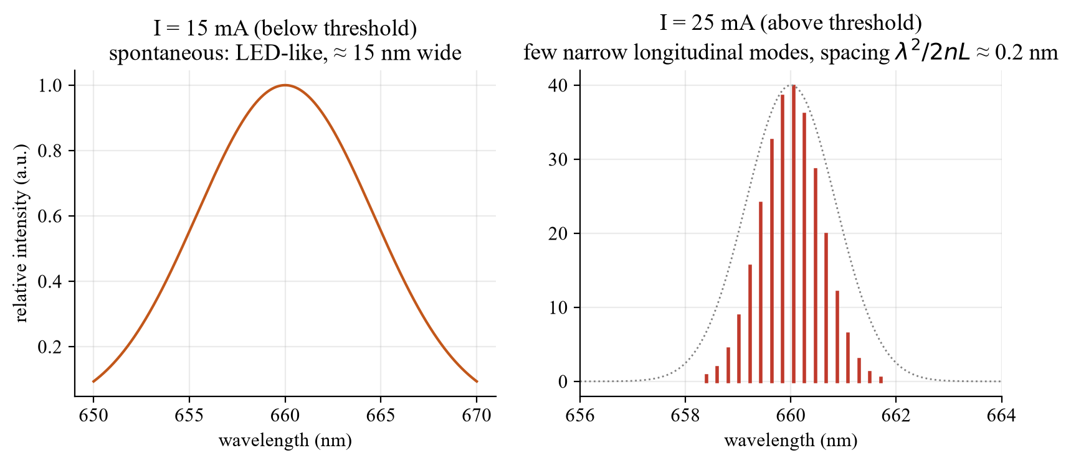
Fig. 2: Spectrum below and above threshold (schematic).

3.5 Beam profile
The waveguide is thin (≈ 1 µm) and wide (5–200 µm): the near field (image of the facet) is small and elongated, the far field (Fourier transform) is elliptical and rotated by 90°: diffraction angle Θ = λ/(πd) – perpendicular to the layers ≈ 90°, lateral ≈ 15°. Collimating optics are therefore needed. Near field: microscope (M = b/f − 1, f = 6 mm), scale via a mm grid.
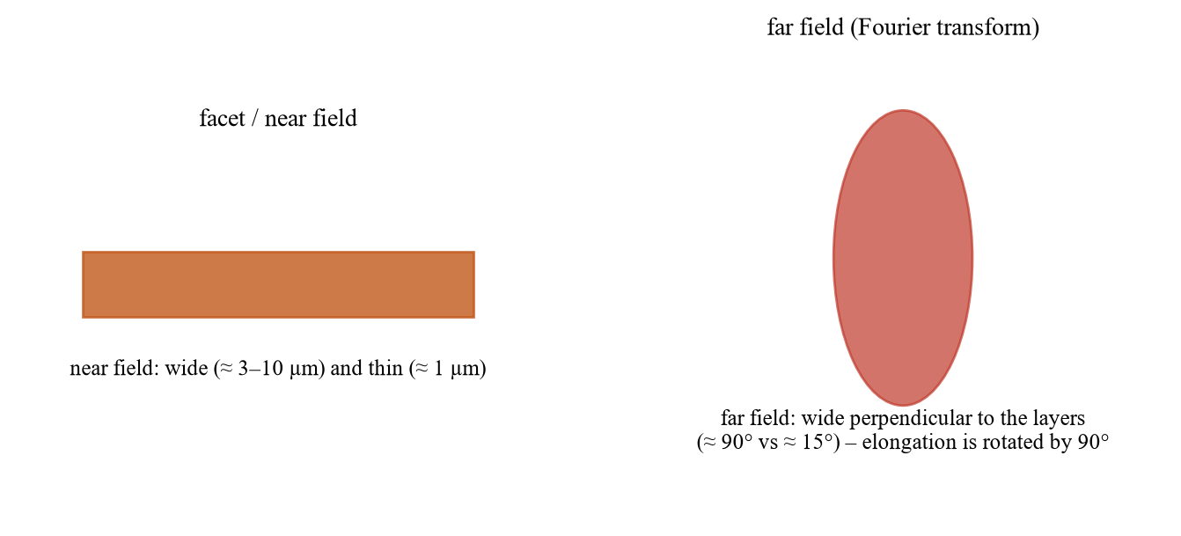
Fig. 3: Near field and far field (schematic).

4. Procedure step by step
Task | What to do? | Evaluation
1 P-I | Set T = 20/30/40 °C (sensor resistance in kΩ), wait; current in 1 mA steps (0.5 mA at the knee) up to 2.5 mW | Line above threshold: I_{th}, dP/dI, η_{d}; ln I_{th}(T) → T₀, I_{th,0}
2 Spectrum | 15 mA and 25 mA, 20–40 °C in 5 °C steps; dark spectrum; avoid saturation (check the threshold at 40 °C!) | Overlay spectra, λ(T) → dλ/dT
3 Near/far field | Camera, gray filters; current below → above threshold; mm grid; measure b; then far-field lens | M = b/f − 1, facet width = near-field width/M; describe the far field

Optional: LTspice model of the P-I curves at 3 temperatures: Laserdiode_PI_Temperatur.asc (or 04_LTspice/LTspice_starten.bat).

5. What to watch in the lab
- Laser safety: never look into the beam (even 2.5 mW can damage the retina); gray filters before camera/detectors; do not overload the spectrometer CCD.
- Raise the current slowly (constant current, knob fully left first); laser action from ≈ 20 mA; stop at 2.5 mW.
- Wait until the temperature is stable (calibration kΩ → °C); otherwise the data belong to a wrong temperature.
- Determine the threshold by extrapolating the straight line, not by eye.
- Protocol: expectation – measurement – error analysis for every task.

6. Why do we need this later?
- Experiment 6 (DFB laser): the same FP laser has several modes and mode hops; the DFB laser selects exactly one mode with a grating – temperature tuning becomes continuous.
- Experiment 4: threshold, P-I curve and spectrum explain the difference between LED and laser.
- Experiment 1: laser diodes are the transmitters in fibre systems (1.3/1.55 µm); temperature control and beam shaping are decisive there.
- Practice: laser pointers, bar-code readers, data links, laser printers, pumping solid-state lasers.

7. Typical questions – short answers
Question | Short answer
LED vs. laser diode? | Laser: inversion + resonator → stimulated emission, narrow, directed, linear P-I above threshold.
Reflection GaAs-air? | R = ((3.5−1)/(3.5+1))² ≈ 31 %.
Threshold condition? | Gain = losses: g_{th} = α₀ + (1/2L) ln(1/R₁R₂).
What lowers the threshold? | Thin active layer, high Γ, long resonator, high reflectivity, low temperature.
How to get η_{d}? | η_{d} = (dP/dI)·q/(hν) from the slope above threshold.
What is T₀? | Characteristic temperature in I_{th} = I_{th,0} e^{T/T0}; large = insensitive.
λ(T)? | ≈ 0.2–0.3 nm/K (gain maximum), mode hops.
Mode spacing? | Δλ = λ²/(2nL), Δν = c/(2nL).
Why is the beam elliptical? | Thin waveguide → strong diffraction (Θ = λ/(πd)) perpendicular, weak lateral.
Near vs. far field? | Near field = image of the facet, far field = Fourier transform (rotated by 90°).
Facet width from the image? | M = b/f − 1; width = intermediate-image width (from the mm grid)/M.
Safety? | Never look into the beam, gray filters, constant current, raise slowly.

Date: 2 Dec 2026, pre-test (Antestat) 14:00, building BC, room BC 119 (group 9).

