Experiment 6 – Mode selection in laser diodes: DFB laser
Preparation: questions, tasks and measurement plan with worked answers
Name, Group: Beyza Kararti, Saifeldin Ayman Elmoselhy Elnkep – Group 9 Date: 16.12.2026 (Antestat 14:00, building BA, room BA 114)
Quoted from the lab manual Optoelectronic practical course, Experiment 6: DFB laser (e_poe_exp6_preliminary.pdf – the English version is marked preliminary). The manual contains a set of questions inside the text (resolution/finesse, calibration, unit conversion, 1 mm resonator) and the task list of §14.6. Quotes are in shaded boxes with a teal bar, answers follow. Each answer ends with a short Turkish summary (TR).

0. Background in one page
- Fabry-Perot (FP) resonator: two mirrors, length L, index n. Transmission = Airy function; maxima at ν_{m} = m·c/(2nL); spacing FSR = c/(2nL); sharpness = finesse F = π√R/(1 − R); FWHM = FSR/F.
- FP laser: the facets (R = 31 %) do not select wavelength; all longitudinal modes with net gain oscillate: spacing Δν = c/(2n_{eff}L), Δλ = λ²/(2nL) (L = 1 mm, n = 3.5: 43 GHz = 0.34 nm). Transverse modes are suppressed by the waveguide (TE₀₀).
- Bragg grating: period Λ reflects only λ_{B} = 2 n_{eff} Λ / m. DBR laser: grating outside the gain region replaces one mirror; DFB laser: the refractive index (index coupling) or gain (gain coupling) is modulated in the gain region itself.
- Single mode: the allowed modes are so far apart (spacing × L/L_{Bragg}) that ideally only one lies in the gain range; side modes are suppressed.
- Tuning: FP: gain maximum shifts with T (≈ 0.4–0.5 nm/K at 1550 nm) → mode hops. DFB/DBR: only n_{eff}(T, N) changes → smooth tuning (≈ 0.1 nm/K), no hops; the grating period sets the coarse wavelength.
- Instruments: DFB laser 1576 nm, FP laser 1550 nm (both invisible, max 2.5 mW), temperature-controlled holders, grating monochromator, FP spectrometer (piezo-tuned FP resonator + InGaAs photodiode; resolution 67 MHz, FSR 10 GHz), oscilloscope.
- Safety: invisible infrared laser radiation – never look into the beam, laser safety goggles.

Theory – Airy formula and finesse (manual §11, eq. 27–34)
One round trip of a wave in the cavity gives the phase φ = 2kL = 4πnL/λ₀ (eq. 27); two transmitted partial waves are in phase for φ = 2πm. Summing all multiply reflected waves (geometric series) with R = r², T = t² = 1 − R:
E_{t} = E₀ · T · e^{iφ/2} / (1 − R e^{iφ}) I_{t}/I₀ = (1 − R)² / (1 + R² − 2R cos φ) = 1 / (1 + (4R/(1−R)²) · sin²(φ/2))
This is the Airy formula (32). Maxima (100 % transmission) at φ = 2πm, i.e. at λ_{m} = 2nL/m, ν_{m} = m·c/(2nL), spacing FSR = Δν = c/(2nL). Setting I_{t}/I₀ = ½ near a maximum and using sin x ≈ x gives φ_{½} = (1 − R)/√R, so
FWHM = FSR / F, F = π√R / (1 − R) (finesse, depends only on the mirror reflectivity)
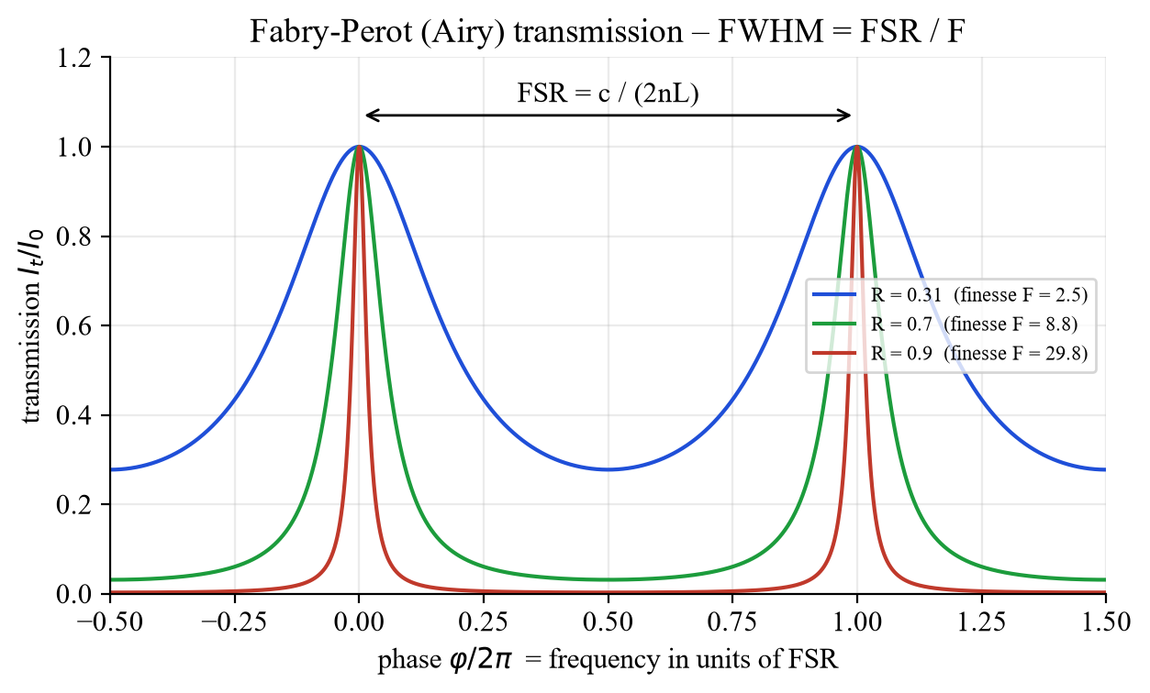
Fig. A – Airy transmission for R = 0.31 (bare GaAs facets), 0.7 and 0.9. The higher R, the sharper the peaks.
R | finesse F = π√R/(1−R) | FWHM / FSR = 1/F
0.31 (cleaved GaAs facet) | 2.5 | 0.41
0.70 | 8.8 | 0.11
0.90 | 29.8 | 0.034
0.98 (spectrometer, F ≈ 150) | ≈ 150 | 0.0067

TR Airy: I_t/I_0 = (1−R)²/(1+R²−2R cosφ). Pikler ν_m = m·c/(2nL), aralık FSR = c/(2nL), keskinlik finesse F = π√R/(1−R), FWHM = FSR/F. R büyüdükçe pikler daralır.

Question 1 – Resolution, FSR and finesse of the FP spectrometer
Question (manual §14.5, p. 38): The resolution of the Fabry-Perot spectrometer used is given as 67 MHz, the free spectral range as 10 GHz. Convert these values into wavelength differences in the wavelength range around 1500 nm. What is the finesse of the spectrometer?
From ν = c/λ: |dν| = (c/λ²)|dλ|, equivalently Δλ/λ = Δν/ν (see Question 5). With λ = 1500 nm (ν = 199.9 THz):
Δλ = λ² Δν / c = (1500 nm)² · Δν / (2.998·10⁸ m/s)
Quantity | Δν | Δλ at 1500 nm | Δλ at 1550 nm
resolution (FWHM of a line) | 67 MHz | 0.50 pm | 0.54 pm
free spectral range FSR | 10 GHz | 75 pm = 0.075 nm | 80 pm = 0.080 nm

Finesse = FSR / resolution = 10 GHz / 67 MHz = 149 ≈ 150, which corresponds to mirror reflectivities of R ≈ 98 % (F = π√R/(1−R) = 149 → R ≈ 0.979). With the FSR of 10 GHz the resonator length is L = c/(2n·FSR) = 15 mm (n = 1).
TR Δλ = λ²Δν/c: 67 MHz → 0,50 pm, 10 GHz → 75 pm (1500 nm’de). Finesse = 10 GHz/67 MHz ≈ 149 → R ≈ %98.

Question 2 – Why does the distance between two lines equal the FSR?
Question (manual §14.5, p. 39): Calibration is simple: Select the amplitude of the sawtooth voltage so that two lines are visible. The distance between the two lines corresponds to the FSR of the spectrometer (why??). This can be used to convert the oscilloscope’s time axis into wavelengths or frequencies.
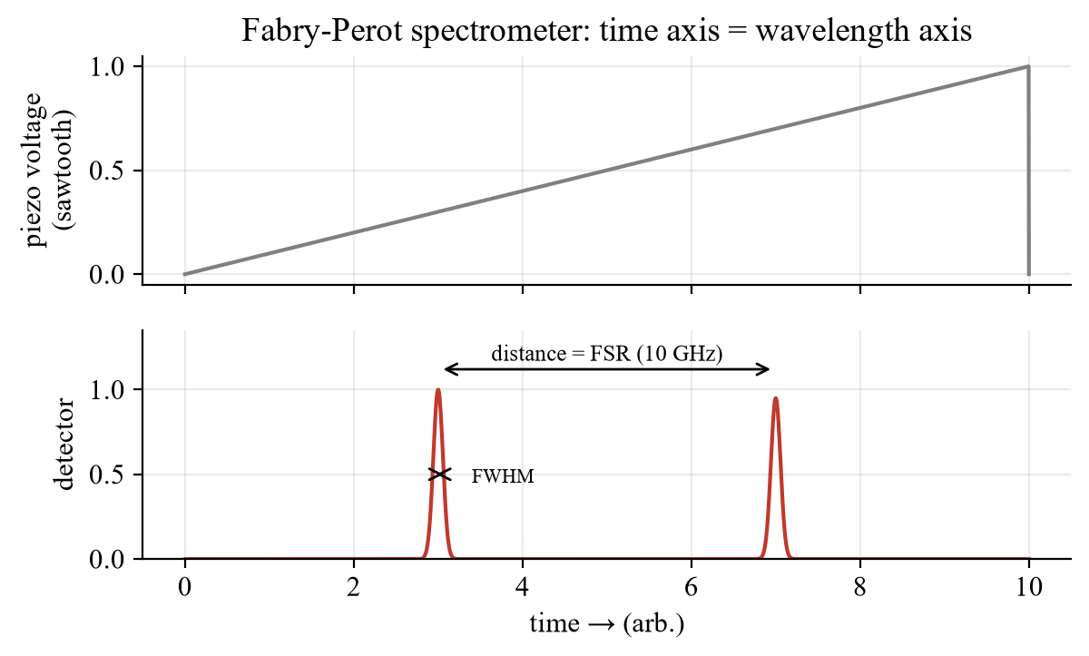
Fig. B – Sawtooth on the piezo element and detector signal: the laser line is transmitted twice per sweep.
The piezo element changes the mirror distance L linearly in time. A fixed laser line (λ, ν) is transmitted whenever L = m·λ/2. If the sweep amplitude is large enough to change L by λ/2, the condition is fulfilled again for m → m + 1, i.e. the same laser line appears a second time. A change of L by λ/2 shifts the resonance frequencies ν_{m} = m·c/(2nL) by exactly one spacing c/(2nL) – one free spectral range. So the time between the two peaks corresponds to the frequency change FSR = 10 GHz:
1 time unit ↔ FSR/Δt_{lines} = 10 GHz / Δt_{lines}, Δν_{line} = (FSR/Δt_{lines}) · Δt, Δλ = λ² Δν / c
Example: two lines 4.0 ms apart (sawtooth 100 Hz, 10 ms period) → 2.5 GHz/ms; a line of FWHM 0.1 ms is 250 MHz wide (> 67 MHz resolution, so it is a real width); a shift of the line by 1.6 ms is 4 GHz. Choose the amplitude so that exactly two lines are visible (one line gives no scale, three lines waste time resolution).
TR Piezo L’yi λ/2 değiştirince m. mertebe yerine (m+1). mertebe geçer: aynı lazer çizgisi tekrar görünür; bu iki çizgi arası tam bir FSR’dir (10 GHz) → zaman ekseni frekansa çevrilir: 10 GHz/Δt_çizgi.

Question 3 – Line width of the DFB laser vs. spectrometer resolution
Task (manual §14.6): Use the calibration to determine the line width of the DFB laser emission, i.e. the width of the displayed peak at half the maximum intensity (FWHM). Is this above or below the resolution of the spectrometer?
Read the FWHM Δt_{½} of the peak on the oscilloscope and convert: Δν = (FSR/Δt_{lines})·Δt_{½}. A DFB laser typically has a line width of the order 1–10 MHz, below the 67 MHz resolution. Therefore the displayed peak is probably limited by the instrument: the measured FWHM is an upper bound (≈ 67 MHz, resolution = width of the instrument function, the measured width is the convolution of both). If the measured width is clearly larger than 67 MHz (e.g. 200 MHz), then laser noise, mode hopping within a sweep, vibration or a drift of the temperature/current contribute. Adjust the coupling so that the lines are as narrow as possible (Fig. 13 of the manual) – this is also the alignment criterion.
TR Δν = (10 GHz/Δt_çizgiler)·Δt_½. DFB çizgi genişliği tipik 1–10 MHz < 67 MHz → ölçülen genişlik cihaz çözünürlüğüyle sınırlı, “üst sınır” olarak yaz.

Task – Temperature and current tuning of the DFB laser
Task (manual §14.6): Now systematically change first the temperature at constant current and then the current at constant temperature of the laser diode. Record at least ten measured values in each case and ensure that you do not exceed the free spectral range of the Fabry-Perot spectrometer. Using the calibration, graph the dependence of the wavelength on the temperature and the current and determine Δλ/ΔT and Δλ/ΔI for the DFB laser.
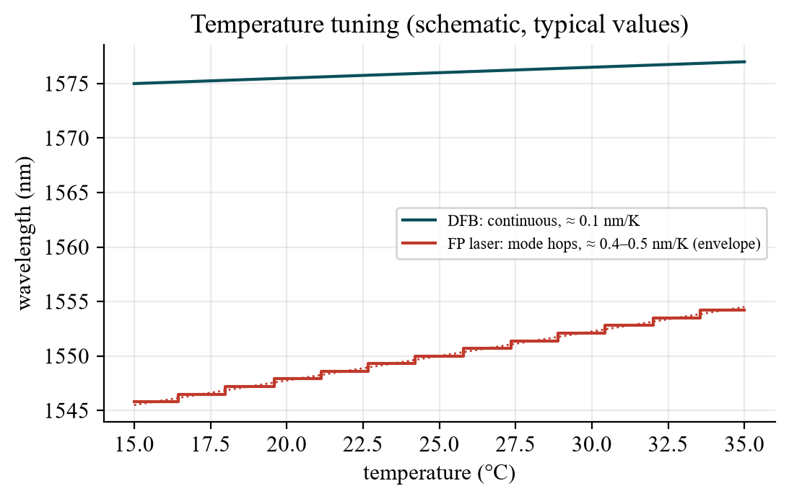
Fig. C – Expected tuning: DFB smooth (≈ 0.1 nm/K), FP laser with mode hops (≈ 0.4–0.5 nm/K envelope). Typical values, to be replaced by your measurement.
Physics of the DFB tuning. The wavelength is fixed by the grating: λ_{B} = 2 n_{eff} Λ/m, so
dλ/dT = λ_{B} · (1/n_{eff}) · dn_{eff}/dT (the length L does not matter); dλ/dI via heating (∝ I²) and carrier density in n_{eff}
With n_{eff} ≈ 3.2 and dn/dT ≈ 2·10⁻⁴ K⁻¹: dλ/dT ≈ 1576 nm · 6·10⁻⁵ K⁻¹ ≈ 0.1 nm/K (≈ 12 GHz/K). The grating period for first order (m = 1) is Λ = λ/(2n_{eff}) ≈ 246 nm. No mode hops, because the mode is defined by the grating, not by the cavity length.
Planning around the FSR (10 GHz = 80 pm): 0.1 nm/K corresponds to ≈ 12 GHz/K – already more than one FSR per kelvin. For at least ten points inside one free spectral range you need small steps: ΔT ≈ 0.05–0.08 K (resolution of the temperature controller permitting) – or accept that the line wraps around to the next order, count the orders and use the coarse wavelength from the monochromator/the known tuning rate. For the current, the coefficient is much smaller (order of 0.01–0.02 nm/mA ≈ 1.5–3 GHz/mA), so 1 mA steps fit well into the FSR. In both cases keep the other parameter constant and wait until the temperature has settled.
Evaluation: convert every peak position t_{i} into Δν_{i} = (FSR/Δt_{lines})(t_{i} − t₀) and into Δλ_{i} = λ² Δν_{i}/c; plot λ (or Δλ) versus T and versus I; the slope of the fitted line is Δλ/ΔT and Δλ/ΔI (give units pm/K, pm/mA); mention the fit error. Remember: the temperature controller is set through the sensor resistance (kΩ) – use the calibration curve of the manual (Fig. 10) to convert to °C.
TR DFB: dλ/dT = λ_B·(dn_eff/dT)/n_eff ≈ 0,1 nm/K (L önemli değil), mod atlaması yok. FSR (10 GHz ≈ 80 pm) 0,1 nm/K ≈ 12 GHz/K’den küçük: ΔT adımlarını çok küçük (≈0,05–0,08 K) al ya da mertebeleri say. Birimler: pm/K, pm/mA.

Tasks – Fabry-Perot laser: spectrum, mode hops, mode spacing
Tasks (manual §14.6): Now connect the Fabry-Perot laser to the laser diode and temperature controller and couple the emission of the laser into the Fabry-Perot spectrometer. Describe the differences between the emission spectra of the two lasers. Are mode jumps visible in the Fabry-Perot laser with small changes in current or temperature? Analyze the emission of the Fabry-Perot laser. Determine the number of visible modes and the mode spacing.
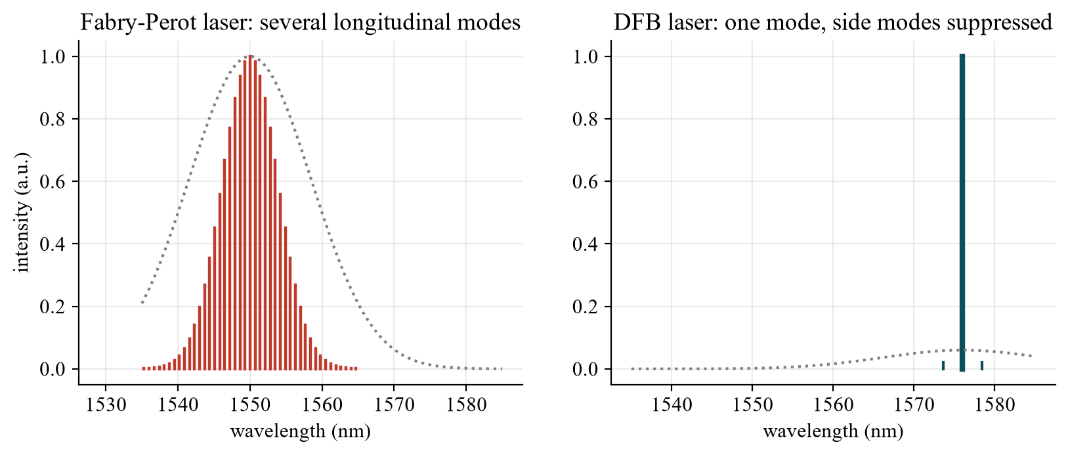
Fig. D – Expected spectra: FP laser with several longitudinal modes, DFB laser with one mode and suppressed side modes.
- Differences: FP (1550 nm): several lines spaced by Δν = c/(2n_{eff}L); the strongest mode changes when T or I change (mode hops, intensity exchange between modes); DFB (1576 nm): one narrow line, side-mode suppression, smooth tuning.
- Mode hops: with small changes of I or T the lasing mode of the FP laser jumps to the neighbouring mode when the gain maximum has moved by one mode spacing; the peak positions jump and the intensities of neighbouring modes exchange. They are not seen in the DFB laser.
- Number of modes and spacing: count the peaks in the sweep and convert the distances with the calibration. Caution: the FSR of the spectrometer (10 GHz) is much smaller than the mode spacing of a typical diode laser (tens of GHz): the modes of different longitudinal order are folded into the same sweep window (see Question 4) – use the grating monochromator (resolution ≈ 0.1 nm) to count the modes and measure Δλ ≈ 0.3 nm, and use the FP spectrometer for the fine structure.
TR FP lazer: birkaç boylamsal mod (Δν = c/2nL), akım/sıcaklık değişince mod atlaması; DFB: tek çizgi, atlama yok. Mod aralığı 10 GHz FSR’den büyük olduğu için FP spektrometrede katlanır → mod sayısını/aralığı monokromatörle bul.

Question 4 – Mode spacing for L = 1 mm
Question (manual §14.6): What mode spacing do you expect for a resonator length of 1 mm (see formula 9, assume n = 3.5)? Can you measure this mode spacing with the Fabry-Perot spectrometer? If not, what kind of signal do you expect? Does this contradict your measurement? If necessary, discuss the experiment with your supervisor.
Δν = c / (2nL) = 2.998·10⁸ / (2 · 3.5 · 10⁻³) = 42.8 GHz Δλ = λ²/(2nL) = (1550 nm)² / (7 mm) = 0.343 nm
The free spectral range of the spectrometer is only 10 GHz, i.e. smaller than the laser mode spacing (42.8 GHz = 4.28 FSR). Each laser mode is transmitted when the piezo position matches its own order, so every mode shows up once per sweep but at the position (ν mod FSR). Successive modes therefore appear shifted by 42.8 GHz mod 10 GHz = 2.8 GHz: with the first mode at 0 the peaks follow at 2.8, 5.6, 8.4, then 1.2 (11.2 − 10), 4.0, 6.8 … GHz – a comb of apparently irregularly spaced peaks that does not show the mode spacing directly.
No contradiction: the measured peak pattern is the aliased version of the true mode comb; the true spacing follows from the known L (or from the monochromator). The spectrometer would only measure the mode spacing directly if FSR > mode spacing (e.g. a very short laser or a spectrometer with a shorter cavity). The consequence for the measurement: the peaks in one sweep belong to different longitudinal orders – do not read their distance as Δν_{mode}.
TR Δν = c/2nL = 42,8 GHz (Δλ = 0,34 nm), spektrometre FSR’si 10 GHz’den büyük → modlar “katlanır” (ν mod FSR): zirveler 2,8 GHz kayarak sıralanır, mod aralığını doğrudan göstermez. Çelişki yok.

Question 5 – Δλ/λ = Δν/ν, never Δν = c/Δλ
Note (manual §14.6): The easiest way to convert wavelength differences into frequency differences is to use the formula Δλ/λ = Δν/ν (where does it come from? Hint: error calculation). Never use Δν = c/Δλ, this formula is WRONG (why?) !!!
- Where it comes from: ν = c/λ. Differentiate: dν = −(c/λ²) dλ. Divide by ν = c/λ: dν/ν = −dλ/λ; for small differences |Δν|/ν = Δλ/λ (error propagation of a quotient: relative errors are equal).
- Why Δν = c/Δλ is wrong: c/Δλ is the frequency belonging to the wavelength Δλ, not the difference between two frequencies. Example: Δλ = 1 nm gives c/Δλ = 3·10¹⁷ Hz, while the true frequency difference of two lines 1 nm apart at 1550 nm is 125 GHz. The mapping λ ↔ ν is non-linear; differences must be converted with the derivative.
TR ν = c/λ → dν/ν = −dλ/λ (türev / hata hesabı). Δν = c/Δλ yanlıştır: c/Δλ, Δλ’ya karşılık gelen mutlak frekanstır, iki frekansın farkı değil (1 nm → 125 GHz, 3·10¹⁷ Hz değil).

LTspice – optional: Airy transmission vs. mirror reflectivity
The manual does not require a simulation. The behavioural model T(φ) = (1 − R)²/(1 + R² − 2R cos φ) (sweep φ = 0 … 4π, R = 0.3, 0.7, 0.9) shows that the peaks become sharper when the mirrors are better – the origin of the finesse of the spectrometer. File: FabryPerot_Airy_Transmission.asc (or 04_LTspice/LTspice_starten.bat).
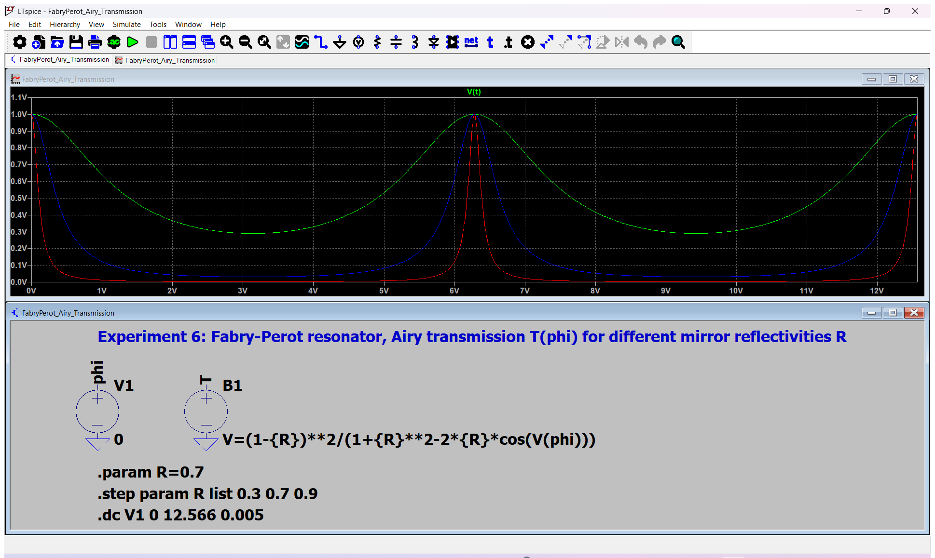
Fig. E – LTspice: .step param R list 0.3 0.7 0.9 (green, blue, red = increasing R and finesse).

Antestat – likely questions with short answers
Question | Short answer
What is a Fabry-Perot resonator and what is its transmission? | Two parallel mirrors; Airy function I_{t}/I₀ = (1−R)²/(1+R²−2R cos φ), maxima at L = mλ/2.
Free spectral range and finesse? | FSR = c/(2nL); F = π√R/(1−R); FWHM = FSR/F.
Why is a normal diode laser multimode? | The facet mirrors are not wavelength selective: every longitudinal mode with net gain oscillates; spacing Δλ = λ²/(2nL).
How does a DFB laser get single-mode operation? | A periodic grating in the gain region reflects only the Bragg wavelength λ_{B} = 2n_{eff}Λ/m; modes at other wavelengths see less feedback.
DBR vs. DFB? | DBR: grating outside the gain region (acts as a wavelength-selective mirror); DFB: grating (index or gain modulation) in the gain region itself.
Index coupling vs. gain coupling? | Real part n modulated (reflection) vs. gain g modulated (periodic amplification/loss).
How is the wavelength of a DFB laser tuned? | Coarse: grating period; fine: temperature (≈ 0.1 nm/K) and current via n_{eff} – smooth, no mode hops.
Why does the FP laser show mode hops? | The gain maximum shifts much faster with T (≈ 0.4–0.5 nm/K) than the mode positions (n(T), L(T)); the lasing mode jumps to the next one.
How does the FP spectrometer work? | FP resonator with piezo-adjustable length followed by a photodiode; sawtooth voltage → time axis = wavelength axis; two lines = one FSR.
Resolution, FSR, finesse of the instrument? | 67 MHz, 10 GHz, F ≈ 150 (≈ 0.5 pm and 75–80 pm at 1500–1550 nm).
Why Δλ/λ = Δν/ν? | From ν = c/λ: dν = −(c/λ²)dλ.
Mode spacing of a 1 mm diode laser? | c/(2nL) = 42.8 GHz = 0.34 nm at 1550 nm (n = 3.5).
Why can the FP spectrometer not resolve this directly? | The FSR (10 GHz) is smaller than the mode spacing: different orders overlap (aliasing).
Safety? | Invisible IR radiation up to 2.5 mW: never look into the beam, laser goggles, constant-current mode, raise current slowly.

Lab-day checklist
- Antestat 14:00, building BA, room BA 114, group 9, 16 December 2026; bring this preparation, the manual, calculator, USB stick.
- Laser goggles on. Laser controller as in Experiment 5: knob left → constant current → ILD → on → raise slowly (laser action from ≈ 20 mA); temperature via sensor resistance (calibration curve), wait until stable.
- Couple the laser into the FP spectrometer; sawtooth ≈ 10 V / 100 Hz; adjust until the lines are as narrow as possible; amplitude so that two lines are visible → calibration (FSR = 10 GHz).
- DFB: FWHM, then temperature series (≥ 10 values, constant current), then current series (≥ 10 values, constant temperature); keep within one FSR.
- FP laser: describe the spectrum, check for mode hops, count modes, estimate the spacing (use the monochromator for the coarse structure).
- Convert only with Δλ/λ = Δν/ν. For the protocol: theory vs. measurement and error analysis for each task.

