Experiment 6 – Mode selection in laser diodes: DFB laser
Explanation: goal, principle, procedure and why we need it later

1. The experiment in one sentence
A normal diode laser (Fabry-Perot) oscillates on several modes; a DFB laser selects exactly one with a grating – we compare both with a Fabry-Perot spectrometer and measure how the wavelength changes with temperature and current.

2. Goal of the experiment
- Calibrate the Fabry-Perot spectrometer (sawtooth → time axis → frequency via the FSR of 10 GHz).
- Determine the line width of the DFB laser and compare it with the resolution (67 MHz).
- Determine Δλ/ΔT and Δλ/ΔI of the DFB laser from ≥ 10 values each.
- Analyse the spectrum of the Fabry-Perot laser: number of modes, mode spacing, mode hops.

3. Principle – the logic behind it

3.1 The Fabry-Perot resonator
Two mirrors a distance L apart (index n) transmit only waves that are in phase after one round trip (φ = 4πnL/λ = 2πm). The transmission follows the Airy formula I_{t}/I₀ = (1−R)²/(1+R²−2R cos φ). Maxima at ν_{m} = m·c/(2nL), spacing FSR = c/(2nL), sharpness finesse F = π√R/(1−R), FWHM = FSR/F. The better the mirrors, the sharper the maxima.
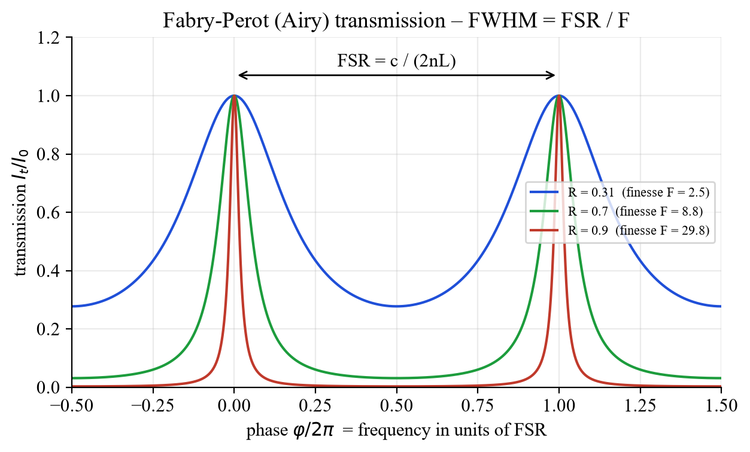
Fig. 1: Airy transmission for R = 0.31 / 0.7 / 0.9.

3.2 Fabry-Perot laser: many modes
The crystal facets (R ≈ 31 %) are not wavelength selective: all longitudinal modes with net gain oscillate, spacing Δν = c/(2nL), Δλ = λ²/(2nL) (L = 1 mm, n = 3.5: 43 GHz = 0.34 nm). Transverse modes are suppressed by the waveguide (TE₀₀).

3.3 Bragg grating, DBR and DFB
A grating of period Λ reflects constructively only at λ_{B} = 2 n_{eff} Λ / m (“the wavelength has to fit into the grating”). DBR: a grating outside the gain region replaces one mirror. DFB: the refractive index (index coupling) or the gain (gain coupling) is periodically modulated in the active zone itself. The allowed mode spacing becomes larger by the factor L/L_{Bragg} – ideally only one mode lies in the gain range, side modes are suppressed.
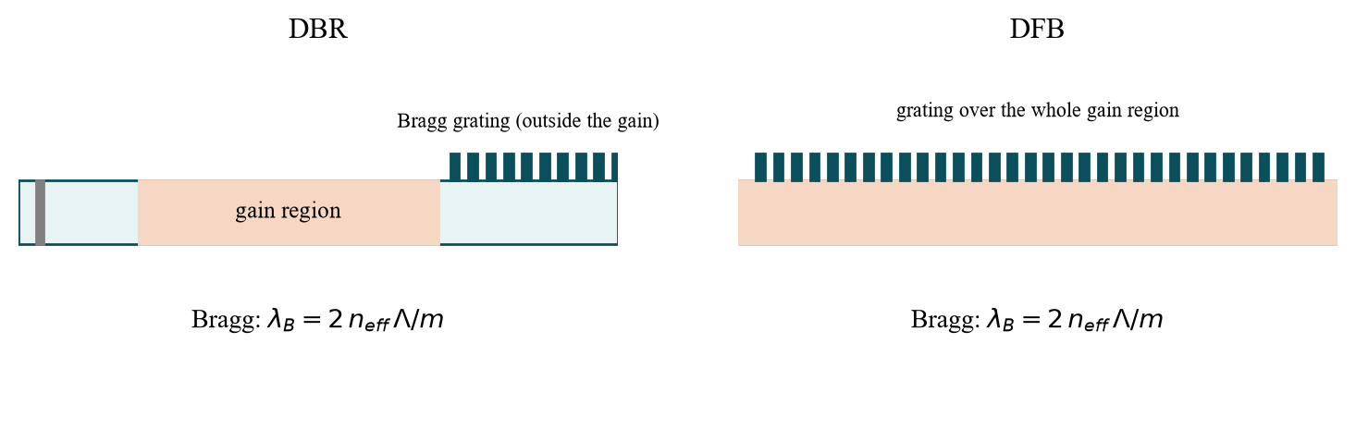
Fig. 2: DBR and DFB structure (schematic).
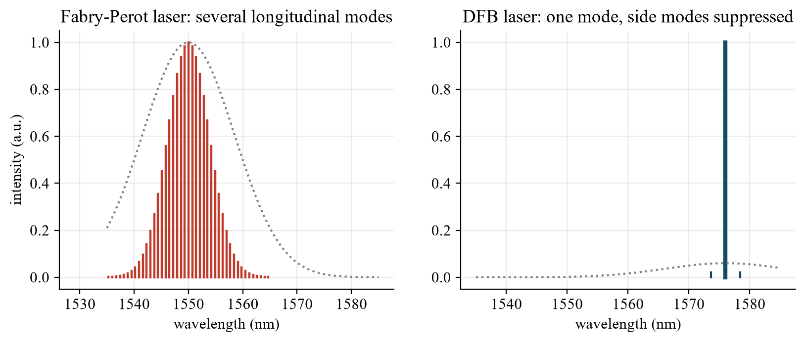
Fig. 3: Spectrum of the FP laser (many modes) and the DFB laser (one mode).

3.4 Wavelength tuning
FP laser: the gain maximum moves quickly with T (≈ 0.4–0.5 nm/K at 1550 nm), the modes slowly → mode hops. DFB laser: only n_{eff}(T, carrier density) changes: dλ/dT = λ_{B}·(dn_{eff}/dT)/n_{eff} ≈ 0.1 nm/K (≈ 12 GHz/K), smooth and without jumps. The current acts through heating (∝ I²) and carrier density; the grating fixes the coarse wavelength.
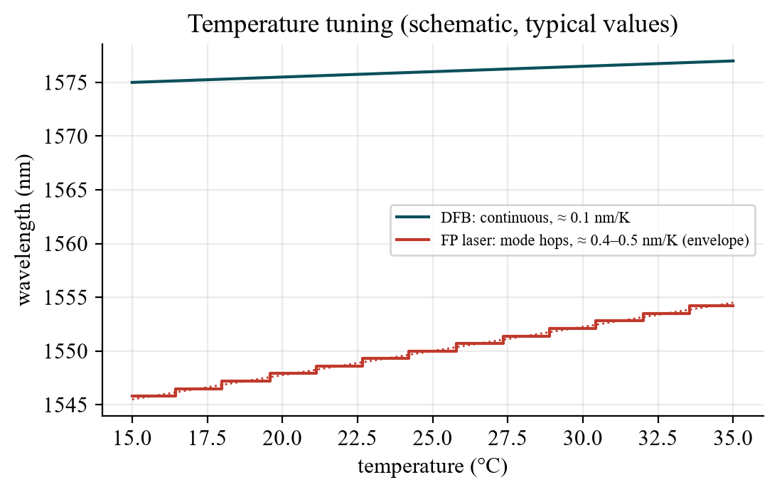
Fig. 4: Tuning with temperature (schematic, typical values).

3.5 The Fabry-Perot spectrometer
A Fabry-Perot resonator with piezo-adjustable length followed by an InGaAs photodiode: a sawtooth voltage (≈ 10 V, 100 Hz) sweeps L – the time axis becomes the wavelength axis. When L changes by λ/2 the same laser line is transmitted again (m → m+1): the distance between two lines = FSR = 10 GHz (calibration). Resolution 67 MHz, finesse ≈ 150. Conversion: Δλ/λ = Δν/ν (from ν = c/λ), never Δν = c/Δλ. At 1550 nm: 10 GHz = 80 pm, 67 MHz = 0.54 pm.
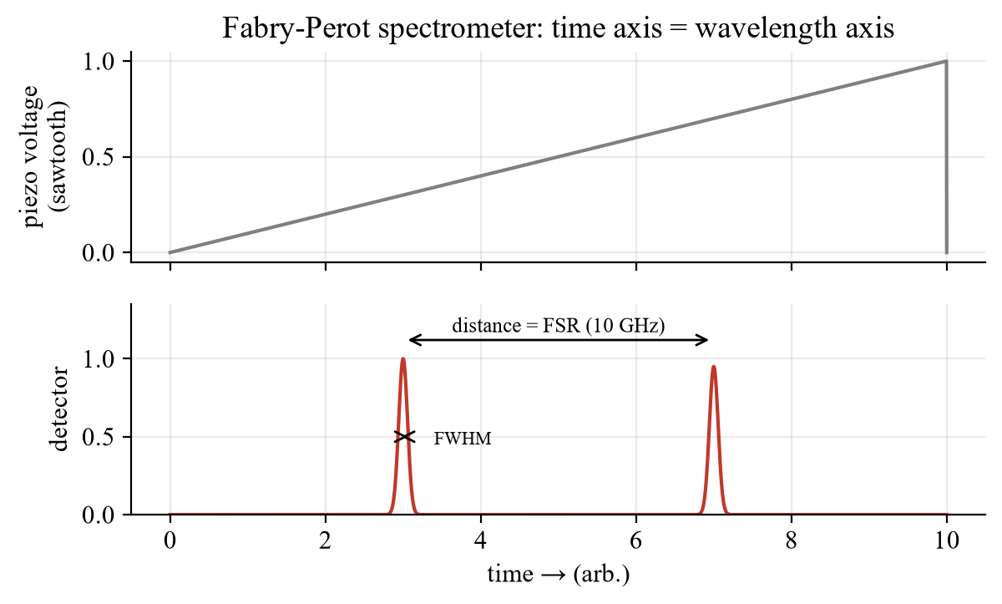
Fig. 5: Sawtooth and detector signal – two lines = one FSR.

4. Procedure step by step
Step | What to do? | Evaluation
1 | DFB laser on the current/temperature controller (constant current: knob left, ILD, on, raise slowly; lasing from ≈ 20 mA), couple into the FP spectrometer; adjust for the narrowest lines | —
2 | Choose the sawtooth amplitude so that two lines are visible | Calibration: 10 GHz/Δt_{lines}
3 | Read the FWHM of the DFB line | Δν = calibration factor · Δt_{½}; compare with 67 MHz
4 | Vary T (constant current), ≥ 10 values; then vary I (constant T), ≥ 10 values; do not exceed the FSR | Δλ = λ²Δν/c; slope Δλ/ΔT, Δλ/ΔI
5 | Couple in the FP laser: describe the spectrum, look for mode hops, count modes | Mode spacing; for L = 1 mm: 42.8 GHz = 0.34 nm (> FSR → orders overlap)

Optional: LTspice demo of the Airy function: FabryPerot_Airy_Transmission.asc (or 04_LTspice/LTspice_starten.bat).

5. What to watch in the lab
- Invisible IR radiation (1550/1576 nm), up to 2.5 mW: laser goggles, never look into the beam.
- Set the temperature via the sensor resistance (kΩ, calibration curve) and wait until it is stable.
- The DFB line moves at ≈ 12 GHz/K, faster than the FSR (10 GHz): use small temperature steps or keep count of the orders.
- Use only Δλ/λ = Δν/ν – never Δν = c/Δλ.
- Protocol: expectation – measurement – error analysis for every point.

6. Why do we need this later?
- Fibre communication: DFB lasers are the standard sources (narrow line, stable wavelength, wavelength-division multiplexing).
- Sensing and spectroscopy: gas measurement (absorption lines) needs tunable single-mode lasers.
- Experiment 5 → 6: FP laser (threshold, mode hops) ↔ DFB laser (one mode, continuous tuning).
- Metrology: the Fabry-Perot interferometer is a tool with extremely high spectral resolution.

7. Typical questions – short answers
Question | Short answer
Airy formula, FSR, finesse? | I_{t}/I₀ = (1−R)²/(1+R²−2R cos φ); FSR = c/(2nL); F = π√R/(1−R); FWHM = FSR/F.
Why many modes in the FP laser? | Facets are not wavelength selective; all modes with net gain oscillate.
How does the DFB laser get one mode? | Grating in the gain region: only λ_{B} = 2n_{eff}Λ/m is fed back.
DBR vs. DFB? | DBR: grating outside the gain; DFB: in the active region.
Index vs. gain coupling? | Real part n modulated (reflection) vs. gain g modulated.
Tuning DFB vs. FP? | DFB ≈ 0.1 nm/K smooth; FP ≈ 0.4–0.5 nm/K with jumps.
Why two lines = FSR? | Change of L by λ/2 → next order m+1 → the same line again.
Resolution/finesse of the device? | 67 MHz; FSR 10 GHz; F = 149.
Δλ ↔ Δν? | Δλ/λ = Δν/ν; 10 GHz ≈ 80 pm at 1550 nm.
Mode spacing for L = 1 mm? | c/(2nL) = 42.8 GHz = 0.34 nm; > FSR → aliasing in the FP spectrometer.
Line width of the DFB? | Typically 1–10 MHz < resolution: the measured value is an upper bound.
Safety? | Invisible IR: laser goggles, never look into the beam.

Date: 16 Dec 2026, pre-test (Antestat) 14:00, building BA, room BA 114 (group 9). Note: the English manual is marked “preliminary”.

