Optoelectronics Lab – Experiment 3: Optical Signal Processing
Preparation: Task 1 and Questions 1–4
Name, Group: ____________________________ Date: ______________

Task 1

a) Simulation of the feedback optocoupler
Simulation: LTspice 26.1.1 with the course files (Optokoppler_var_R1/R2/R3/Rv.asc; PC817 model with base drive I_{B} = 2e-3·I_{LED}, B_{F} = 1200 and B-E leakage I_{SE} = 3e-15 A). The source is swept 0 → 15 V → 0 (quasi-static, 1 s per ramp), the current I is plotted against U_{AB}. Basic values: R₁ = 1.5 kΩ, R₂ = 1 kΩ, R₃ = 7 kΩ, R_{V} = 1 mΩ.
Variation | Value | U_{on} / V (jump 1) | U_{off} / V (jump 2) | ΔU / V
R₁ | 1.3 kΩ | 9.00 | 6.72 | 2.28
 | 1.5 kΩ | 8.20 | 6.27 | 1.93
 | 1.7 kΩ | 7.59 | 5.92 | 1.67
R₂ | 0.8 kΩ | 7.83 | 5.30 | 2.53
 | 1.0 kΩ | 8.20 | 6.27 | 1.93
 | 1.2 kΩ | 8.60 | 7.23 | 1.37
R₃ | 6 kΩ | 7.50 | 6.24 | 1.26
 | 7 kΩ | 8.20 | 6.27 | 1.93
 | 9 kΩ | 9.64 | 6.30 | 3.34
R_{V} (U_{source} at the jumps) | 1 Ω | 8.20 | 6.27 | 1.93
 | 100 Ω | 8.40 | 6.75 | 1.65
 | 1 kΩ | – | – | no hysteresis
Table 1: Switching voltages of the feedback optocoupler (LTspice).
- R₁: the LED starts to conduct when I·R₁ ≈ U_{F}. On the OFF branch I = U/(R₁+R₂+R₃), hence U_{on} ≈ U_{F}·(R₁+R₂+R₃)/R₁. Increasing R₁ lowers both switching voltages.
- R₂: in series in both states and dominant on the ON branch (slope ≈ 1/R₂). Increasing R₂ raises both thresholds, flattens the ON branch and reduces the loop gain: the hysteresis narrows (2.53 V → 1.37 V).
- R₃: short-circuited by the phototransistor in the ON state, so it only sets the OFF-branch slope and U_{on}. U_{off} is practically unchanged, so the hysteresis widens with R₃ (1.26 V → 3.34 V).
- R_{V}: U_{AB} = U_{source} − I·R_{V} (load line). The jumps run along the load line with slope −1/R_{V}, while the fold points in U_{AB} stay at about 8.2 V / 6.3 V. The largest negative differential resistance of the curve is about 0.82 kΩ. For R_{V} > 0.82 kΩ (e.g. 1 kΩ) only one intersection exists, so the hysteresis disappears and the full S-shaped curve (branch 3 of Fig. 5) is traced.
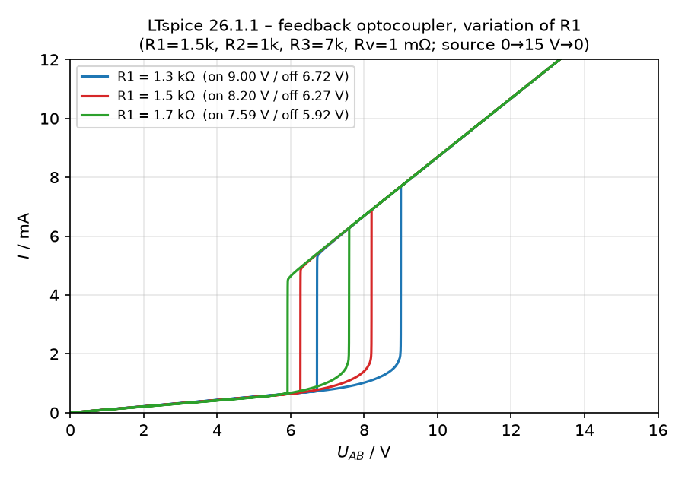
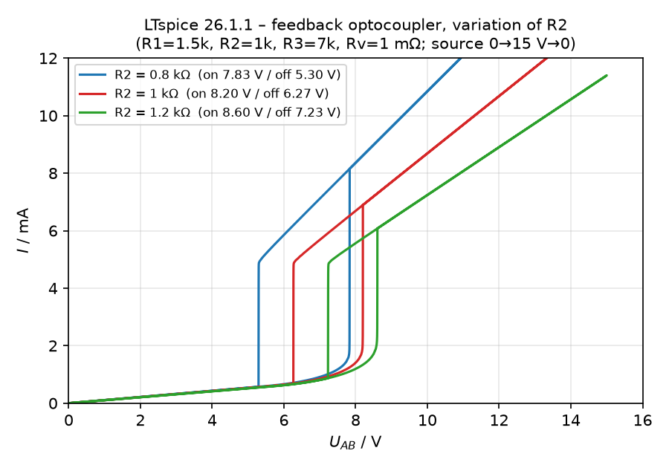
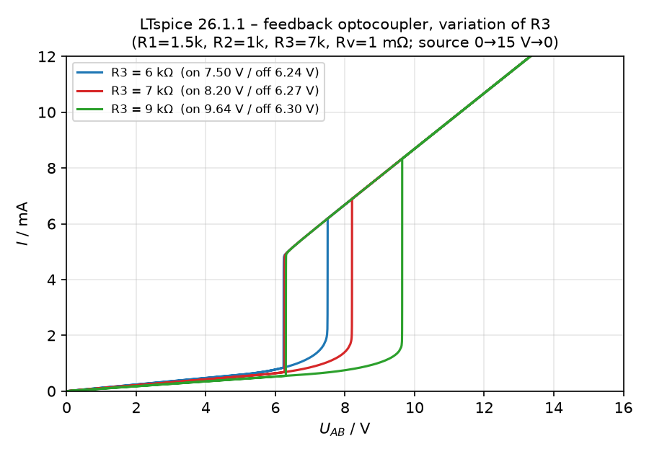
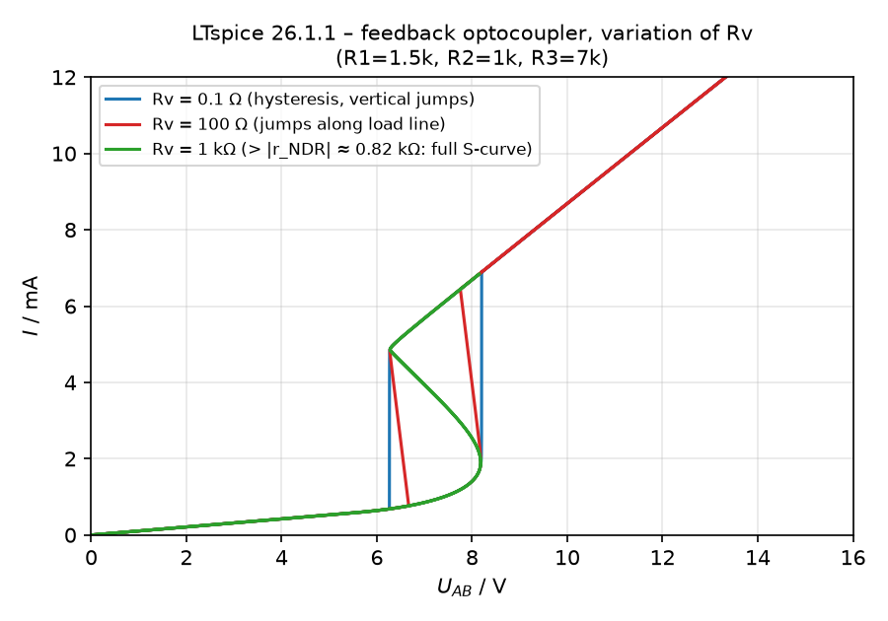
Fig. 1: I–U_{AB} characteristics simulated with LTspice.

b) Positive feedback – closed-loop gain
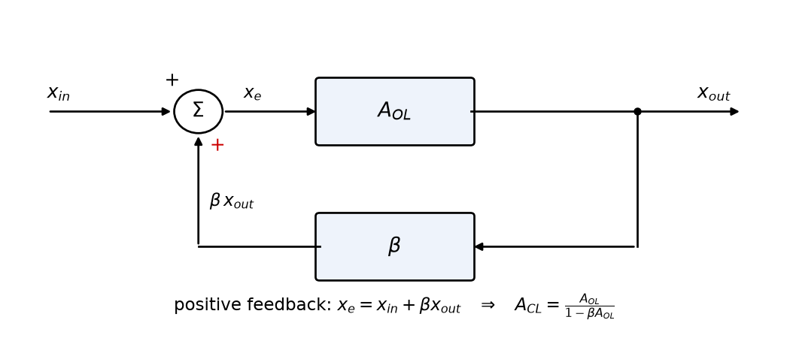
Fig. 2: Block diagram of positive feedback.
With x_{e} = x_{in} + β·x_{out} and x_{out} = A_{OL}·x_{e}:
x_{out} = A_{OL}·x_{in} + β·A_{OL}·x_{out} ⇒ A_{CL} = x_{out}/x_{in} = A_{OL} / (1 − β·A_{OL})
- β·A_{OL} < 1: the gain is increased (A_{CL} > A_{OL}), the system is still stable.
- β·A_{OL} → 1: A_{CL} → ∞; the system becomes unstable.
- β·A_{OL} > 1: the output runs into saturation and stays there. This latching gives two stable states (bistability, hysteresis).
(For comparison, negative feedback gives A_{CL} = A_{OL} / (1 + β·A_{OL}).) In the optocoupler, the loop LED → light → phototransistor → current through R₁ → LED is a positive feedback loop. Its loop gain is about CTR·R₃/(R₂+R₃). In the switching region the differential resistance is dU/dI ≈ R₂ + R₃·(1 − CTR), which becomes negative for CTR·R₃ > R₂ + R₃ (loop gain > 1). Because the CTR of the phototransistor grows with the LED current, this condition is only met above a certain current, so the circuit switches.

c) NPN transistor at the operating point – load line
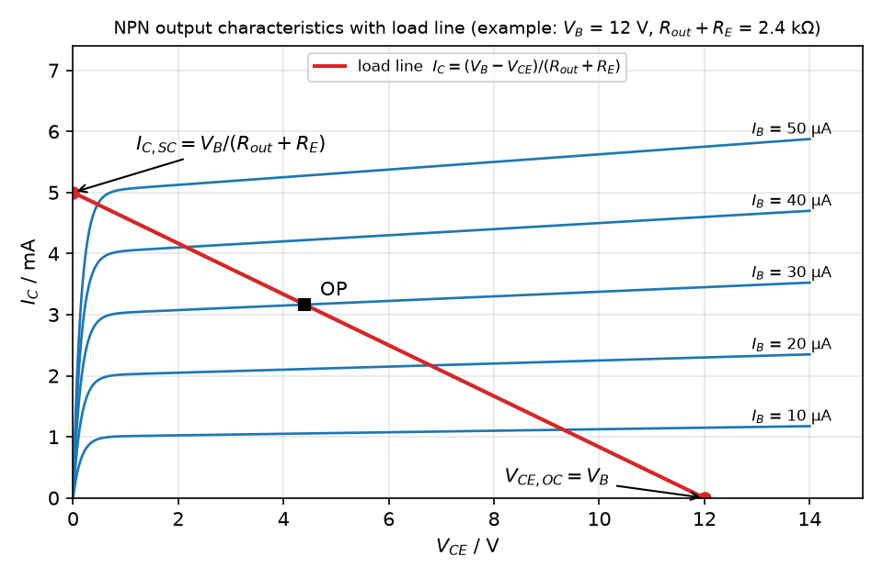
Fig. 3: Output characteristics I_{C}(V_{CE}) for different I_{B} with the load line of R = R_{out} + R_{E}.
Mesh equation (Fig. 6): V_{B} = I_{C}·R_{out} + V_{CE} + I_{E}·R_{E}. With I_{E} = I_{C} + I_{B} ≈ I_{C} (B ≫ 1):
I_{C} = (V_{B} − V_{CE}) / (R_{out} + R_{E}) (straight line with slope −1/R)
- Open-circuit voltage (I_{C} = 0): V_{CE,OC} = V_{B}
- Short-circuit current (V_{CE} = 0): I_{C,SC} = V_{B} / (R_{out} + R_{E})
The operating point is the intersection of the load line with the characteristic for the given I_{B}. The same construction is used for the load line of R_{V} in the I–U characteristic of the feedback optocoupler.

Question 1
a) Forward voltage: the voltage across the LED at which it carries a noticeable current. It is usually specified at the nominal current, e.g. 20 mA. Because the diode characteristic is exponential, this voltage stays almost constant. It is set mainly by the band gap: U_{F} ≈ E_{g}/e ≈ h·c/(e·λ). Typical values: IR (GaAs, 940 nm) ≈ 1.2 V, red ≈ 1.8–2.0 V, green ≈ 2.1–3 V, blue/white ≈ 3–3.5 V. Temperature coefficient ≈ −2 mV/K.
b) Current-transfer ratio CTR = I_{C}/I_{F}·100 %. With a phototransistor the CTR is typically 20 % to several 100 % (PC817: 50–600 %, rank A: 80–160 %), because the photocurrent is amplified by the transistor current gain B. With a photodiode it is only about 0.1–1 %, because there is no internal gain. A phototransistor gives a high CTR but is slow (µs, Miller capacitance). A photodiode is fast (ns).

Question 2
a) Origin of the characteristic: at low voltage the LED and the phototransistor are off and I = U/(R₁+R₂+R₃) (flat branch). When I·R₁ reaches U_{F}, the LED emits and the phototransistor starts to conduct. It shunts R₃, so the current rises, the LED gets brighter and the phototransistor conducts more. This positive feedback makes the current jump to the ON branch. When the voltage is reduced, the phototransistor keeps R₃ short-circuited down to a lower voltage. The result is hysteresis, i.e. memory.
b) Ranges (1) and (2): below jump (1) the curve is set by R₁+R₂+R₃, and the jump is triggered by the LED threshold (U_{F}, R₁). Above jump (2), on the ON branch, the curve is set by R₂, the LED and U_{CE,sat}. The jump down happens when the phototransistor can no longer stay saturated (CTR·I_{LED} < I − U_{CE}/R₃, i.e. the holding current is reached).
c) At the jump points: dU/dI = 0 (fold points) and the loop gain equals 1. The operating point merges with the unstable middle branch and disappears, so the circuit jumps along the load line to the other stable branch. In between lies a region of negative differential resistance, which is unstable under voltage control. Like a thyristor, the curve is S-shaped (current-controlled).
d) Influence of the resistors: see Task 1a. R₁↑ lowers both thresholds; R₂↑ raises them and flattens the ON branch; R₃↑ raises U_{on} and widens the hysteresis; R_{V}↑ tilts the load line, and for R_{V} > |r_{NDR}| ≈ 0.82 kΩ the S-curve becomes visible. Because U_{AB} is measured between A and B, R_{V} itself does not appear in the U_{AB} axis. It only decides which part of the curve can be reached.

Question 3
a) LED₂: in series with the whole circuit. It shifts the characteristic to the right by its forward voltage (≈ 1.7–2 V; LTspice: U_{on} 8.20 → 9.93 V, U_{off} 6.27 → 8.05 V) and adds a small series resistance. It also serves as the optical output: it lights up brightly only in the ON state.
b) Current and optical power: LED: P_{opt} ≈ η_{ext}·(h·ν/e)·I, roughly linear (sublinear at high currents due to heating and droop). Photodiode: I_{ph} = S·P_{opt} with S = η·e/(h·ν) (≈ 0.5–0.6 A/W for Si near 850–900 nm), linear over many decades.
c) Illuminating PD₂: the photocurrent flows in parallel to R₃ into the loop, so the total current and I·R₁ rise. The LED switches on and the positive feedback latches the circuit in the ON state (SET), which remains after the light is switched off. LTspice (with LED₂, U_{source} = 9 V, i.e. between the jump points 8.05 V and 9.93 V): an optical input equivalent to ≥ 0.3 mA input-LED current sets the memory (I: 0.96 → 5.9 mA); 0.2 mA is not sufficient.
d) LDR (light-dependent resistor, photoresistor, e.g. CdS): its resistance drops from MΩ in the dark to about 100 Ω under illumination. Connected in parallel to R₁, it reduces the voltage across the LED. The LED goes off, the phototransistor opens and the circuit returns to the OFF state (RESET). LTspice: reset for R_{LDR} ≲ 3 kΩ (5 kΩ is not sufficient).
e) Schmitt trigger: a comparator with positive feedback and two thresholds U_{T+} > U_{T−} (hysteresis). It turns slow or noisy signals into clean digital edges and is used for debouncing, signal regeneration and relaxation oscillators. A plain comparator has only one threshold, so noise near the threshold causes multiple toggling (chatter). In the optical circuit, the memory and the Schmitt trigger differ only in the operating point. If the dark state is bistable, the circuit is a memory. If only OFF exists in the dark, it is a Schmitt trigger and needs a continuous input to stay ON. LTspice (R₁ = 800 Ω, R₂ = 400 Ω, R₃ = 5 kΩ, U_{source} = 5 V, R_{V} = 0.1 Ω): ON at I_{in} ≈ 1.24 mA, OFF at ≈ 1.01 mA; the hysteresis narrows with R_{V} and disappears for R_{V} ≳ 300 Ω.

Question 4
a) A photodiode (light-sensitive element) in parallel to R₃, illuminated by the R and S signals.
b) R_{V} = 0: both elements see the same voltage and switch independently. For identical elements the result is one hysteresis with double current (LTspice: both ON at 9.94 V, OFF at 8.05 V). For different elements it is a twin hysteresis with two steps (R₁ = 1k, R₄ = 2k: 8.64 V and 12.54 V). Both elements can be ON at the same time, so the network is no flip-flop.
c) Load line R_{V}: it must be chosen so that (i) the state with one element ON is stable, i.e. U_{AB} = U_{source} − I₁·R_{V} lies between U_{off} and U_{on}; and (ii) the state with both ON is unstable, i.e. U_{source} − 2·I·R_{V} < U_{off}. Switching on one element then pulls U_{AB} so far down that the other one cannot stay ON. LTspice (R₁ = R₄ = 1.5 kΩ, R₂ = 1 kΩ, R₃ = 7 kΩ, LEDs in series): with R_{V} = 450 Ω the network works as an RS flip-flop for U_{source} ≈ 10.6–11.6 V (light ≙ 1 mA input-LED current; 0.3 mA is too weak). With R_{V} = 0.1 Ω both LEDs stay ON after S and R, so the flip-flop fails.
R | S | Q̄ (LED₁) | Q (LED₂)
0 | 0 | Q̄_{n} (hold) | Q_{n} (hold)
1 | 0 | 1 | 0
0 | 1 | 0 | 1
1 | 1 | forbidden | forbidden
Table 2: Truth table of the RS flip-flop (theory). For R = S = 1 the optical circuit drives both LEDs ON (Q = Q̄ = 1); after both inputs are released the final state is a race (undefined).
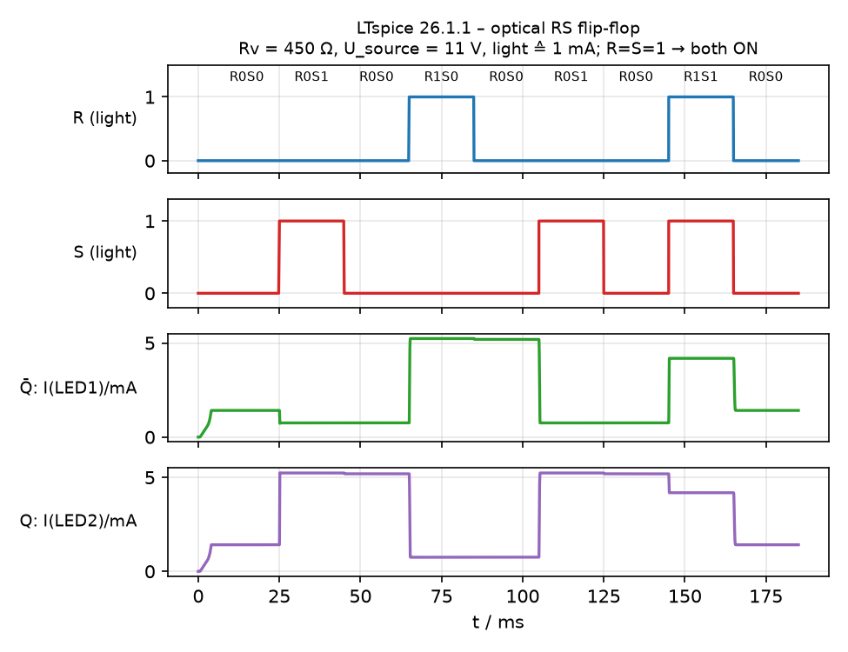
Fig. 4: Optical RS flip-flop simulated with LTspice (R_{V} = 450 Ω, U_{source} = 11 V).

