Experiment 3 – Optical Signal Processing
Explanation: purpose, principle, procedure and why it matters later

1. The experiment in one sentence
An optocoupler whose output is fed back to its own input becomes a bistable switch. A single cell can store one bit (optically addressed memory) or act as a Schmitt trigger, and two coupled cells form an RS flip-flop. Light is used for writing, erasing and reading out.

2. Purpose of the experiment
- Understand how optical bistability (hysteresis) arises from a nonlinear element combined with positive feedback.
- Measure and interpret current–voltage (I–U) characteristics, quasi-statically with a plotter and dynamically with an oscilloscope in X-Y mode.
- Understand the role of every resistor and of the load line set by the series resistor R_{V}.
- Build an optically addressed memory, an optical Schmitt trigger and an optical RS flip-flop, and verify the truth table.
- Compare simulation (LTspice) and measurement.

3. Principle – the logic behind it

3.1 Optical bistability
A bistable element has two possible output states for the same input. Which one it shows depends on its history, so it is a memory and a switch at the same time. Light beams do not interact in a linear medium, so light cannot directly switch light. Either special nonlinear materials are needed, or a hybrid optoelectronic solution: light → photocurrent → electronics → light. This experiment uses the hybrid route, an "artificial optical nonlinearity".
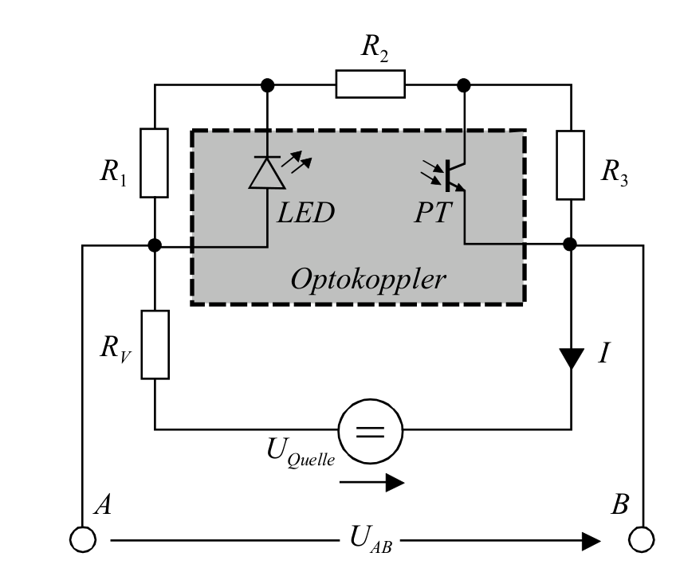
Fig. 1: Feedback optocoupler (from the lab documentation).

3.2 The feedback optocoupler
The current flows through the chain (R₁ ∥ LED) → R₂ → (R₃ ∥ phototransistor). At low voltage the LED is dark, the phototransistor is off and the large resistance R₁+R₂+R₃ limits the current (flat OFF branch). As soon as the voltage across R₁ reaches the LED forward voltage (I·R₁ ≈ U_{F}), the LED emits light and the phototransistor starts to conduct. It short-circuits the largest resistor R₃, so the current rises, the LED gets brighter and the transistor conducts even more. This positive feedback (loop gain > 1) makes the current jump to the steep ON branch. When the voltage is reduced, the transistor keeps R₃ short-circuited down to a lower voltage. Switch-on and switch-off happen at different voltages, which is the hysteresis.
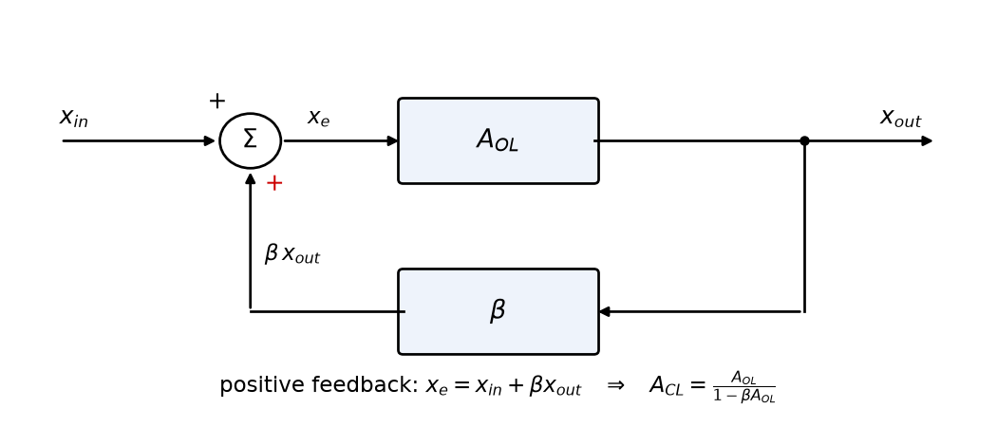
Fig. 2: Positive feedback, A_{CL} = A_{OL}/(1 − β·A_{OL}). For β·A_{OL} ≥ 1 the system latches.
Rule of thumb for the switch-on voltage: U_{on} ≈ U_{F}·(R₁+R₂+R₃)/R₁. Increasing R₁ lowers both thresholds. Increasing R₂ raises them and narrows the hysteresis. Increasing R₃ raises only U_{on}, so the hysteresis widens.

3.3 S-curve, negative resistance and the load line
Plotted against the current, the characteristic is S-shaped. In the middle part the voltage decreases while the current increases (negative differential resistance), and this part is unstable when the voltage is imposed. The series resistor defines a load line U_{AB} = U_{source} − I·R_{V}. With small R_{V} the circuit jumps (hysteresis). With R_{V} larger than the negative resistance (≈ 0.82 kΩ in LTspice) the whole S-curve can be traced. A thyristor has the same kind of curve.
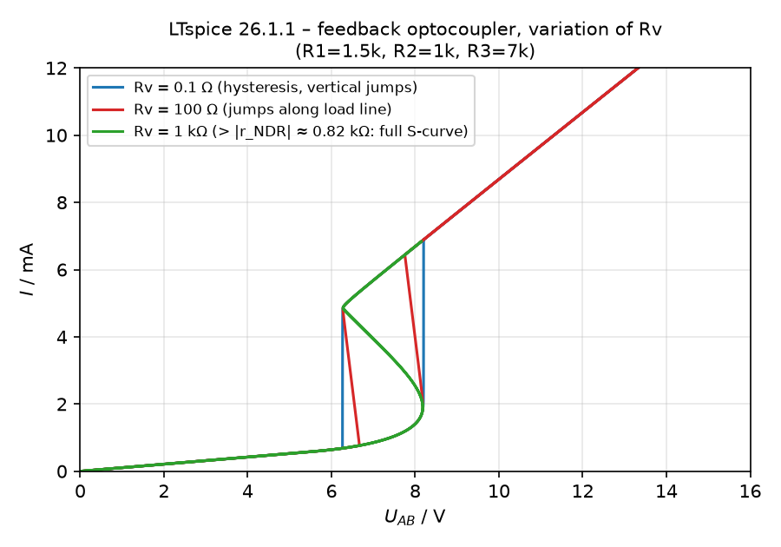
Fig. 3: LTspice – the series resistor R_{V} turns the hysteresis into the S-curve.

3.4 Three circuits from one cell
- Memory: the operating point lies inside the bistable range. Light on a photodiode in parallel to R₃ switches ON (SET), and the state remains after the light is switched off. Light on an LDR in parallel to R₁ switches OFF (RESET).
- Schmitt trigger: the operating point lies outside the bistable range in the dark, so the input light itself is the input signal. The output switches at two different input thresholds and needs a continuous input to stay ON.
- RS flip-flop: two identical cells share one series resistor R_{V}. When one cell switches ON, the voltage U_{AB} drops so far that the other cell cannot stay ON, so only one LED lights (Q or Q̄).
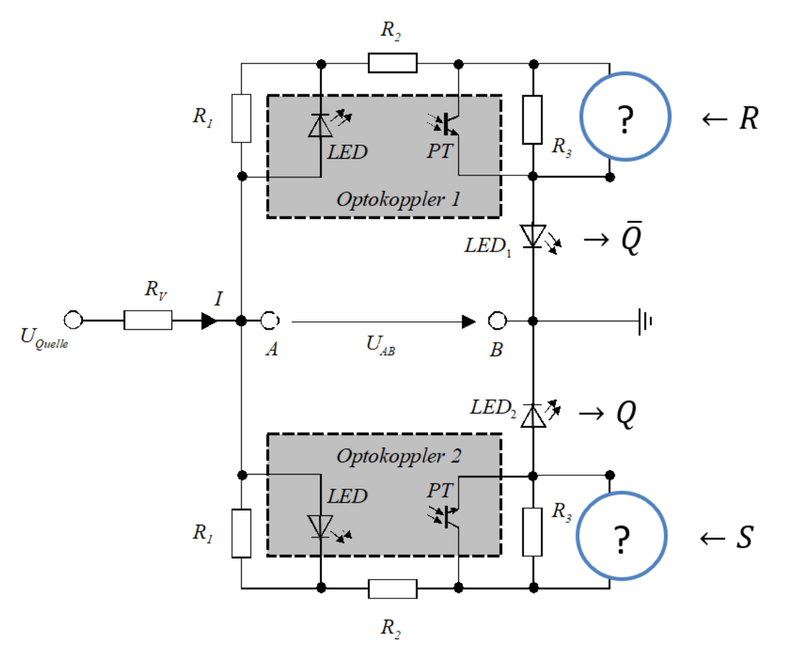
Fig. 4: Two cells coupled to an RS flip-flop (from the lab documentation).

4. Procedure step by step

6.1 Feedback optocoupler
- Quasi-static: DC source + plotter (or function generator at ≈ 0.1 Hz). Dynamic: triangular voltage + oscilloscope in X-Y mode.
- Basic values R₁ = 20 %, R₂ = 50 %, R₃ = 80 %, R_{V} = 0 %. Change one resistor at a time and record U_{on} and U_{off}.
- Expected (LTspice, nominal values): switch-on 8.20 V, switch-off 6.27 V; the trends follow section 3.2.

6.2 Optically addressed memory
- Record the I–U curve, then set the DC voltage between the two jump points.
- Illuminate the photodiode ∥ R₃: the circuit switches ON and stays ON. Illuminate the LDR ∥ R₁: it switches OFF. (LTspice: SET for an input of ≥ 0.3 mA LED current, RESET for R_{LDR} ≲ 3 kΩ.)

6.3 Optical Schmitt trigger
- U_{source} = 5 V; LED₃ is driven by the function generator and illuminates the detector ∥ R₃. Display I_{out} versus I_{in} in X-Y mode.
- Triangle 50 Hz: hysteresis loop. Square 50 Hz: only two points (no intermediate values). Square 2 kHz: the loop is distorted because the phototransistor is slow (µs), giving a dynamic hysteresis.
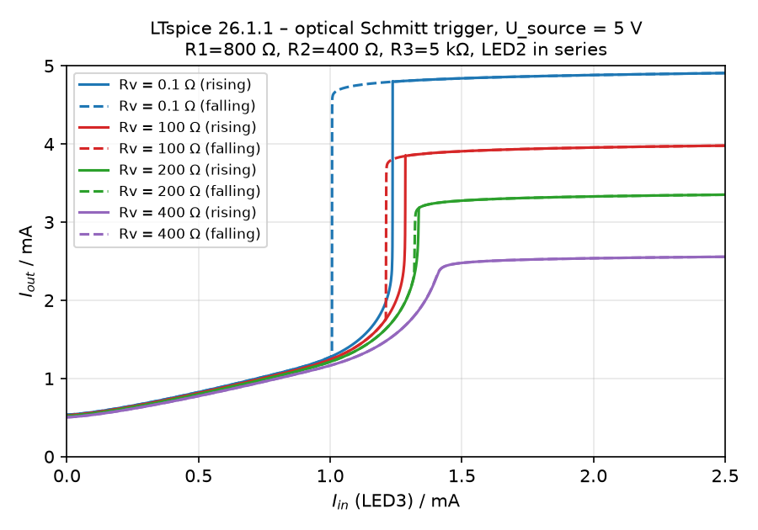
Fig. 5: LTspice – Schmitt trigger (R₁ = 800 Ω, R₂ = 400 Ω, R₃ = 5 kΩ). The hysteresis narrows with increasing R_{V}.

6.4 Optical RS flip-flop
- R₁ = 20 %, R₂ = 50 %, R₃ = 100 %. Find a suitable R_{V} with the oscilloscope, then use the DC source. Illuminate S and R alternately and fill in the truth table.
R | S | Q̄ (LED₁) | Q (LED₂)
0 | 0 | hold | hold
1 | 0 | 1 | 0
0 | 1 | 0 | 1
1 | 1 | forbidden | forbidden

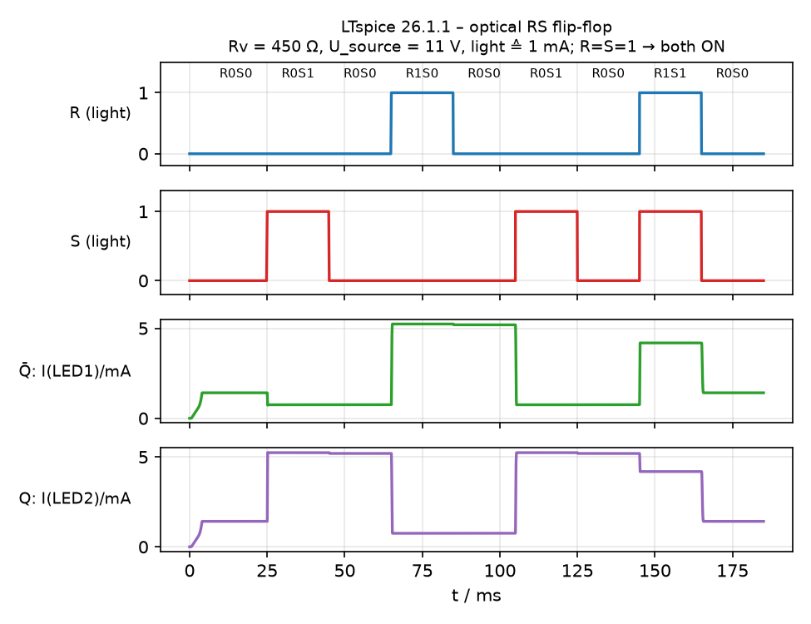
Fig. 6: LTspice – truth table with light pulses (R_{V} = 450 Ω, U_{source} = 11 V). With R_{V} ≈ 0 both LEDs stay ON, so R_{V} is essential.

5. Pay attention during the lab
- Never exceed 15 V source voltage.
- Change only one resistor at a time and write down all potentiometer positions.
- Ambient light (room light, phone torch) can switch the photodiode or LDR. Shade the box.
- Sweep the voltage up and down, otherwise there is no hysteresis to see. With R_{V} > 0, the x-axis is U_{AB}, not U_{source}.
- Oscilloscope: DC coupling, both probe grounds on the same node, current via the voltage across a shunt (use INV if the sign is wrong).

6. Why do we need this later?
- Optocouplers everywhere: galvanic isolation in power electronics (gate drivers, PLC inputs, medical devices). The PC817 used here sits in the feedback loop of almost every switch-mode power supply (together with a TL431). CTR, speed and temperature drift are exactly the limits you meet there.
- Schmitt triggers: every robust digital input (74HC14), push-button debouncing, light barriers, sensor signal conditioning and simple oscillators.
- Positive feedback and bistability: latches, flip-flops and SRAM cells, the thyristor/TRIAC (same S-shaped curve), comparators with hysteresis, thermostats.
- Load-line thinking: transistor biasing, LED drivers, the maximum power point of solar cells, and the stability of negative-resistance devices (tunnel diode, Gunn diode, oscillators).
- Photonics and optical computing: optical switching in fibre networks (WDM, ROADM), spatial light modulators, optical neural networks and all-optical flip-flops. These are the research directions this hybrid circuit illustrates.
- Lab skills: X-Y measurements, quasi-static versus dynamic measurements, and the comparison of simulation and measurement. You will need these in every later lab and in your thesis.

7. Typical questions – short answers
- Where does the hysteresis come from? From positive feedback with a loop gain above 1.
- Is the system linear? Time-invariant? It is not linear, because superposition fails. It is time-invariant: having a memory does not make a system time-variant.
- Why can the middle branch not be measured with R_{V} = 0? Its negative differential resistance is unstable under voltage control. It needs current control, i.e. R_{V} > |r_{NDR}|.
- What is the difference between the memory and the Schmitt trigger? Only the operating point: bistable in the dark gives a memory, monostable in the dark gives a Schmitt trigger.
- Why is R = S = 1 forbidden? Both cells are forced ON (Q = Q̄). When the light is released, the result is a race and the final state is undefined.
- Phototransistor or photodiode? The phototransistor has a high CTR (≈ 50–600 %) but is slow (µs). The photodiode has a CTR of only about 0.1–1 % but is fast (ns).

